**MDCK**

**+**

**Compound C (10µM)**

**MDCK**

**+**

**Compound C (50µM)**

**Ca2+ Switch**

**SMEM**

**AMPKt**

**pAMPK**

**pACC**

**α-MEM**

**SMEM**

**Ca2+ Switch**

**α-MEM**

**SMEM**

**α-MEM**

**Ca2+ Switch**

**MSC**

**MDCK**

**Co-culture MSC/MDCK**

**MDCK**

**+**

**DMSO**

A

Supplementary Data

**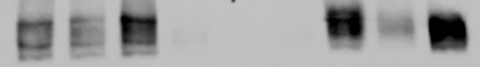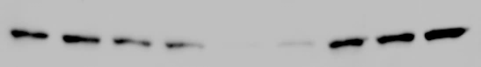****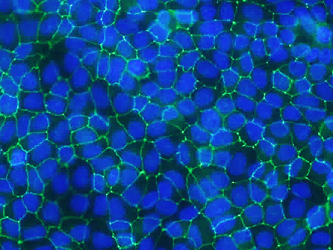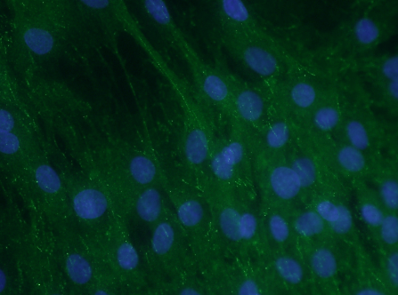**

*62 kDa*

*62 kDa*

*280 kDa*

*62 kDa*

*62 kDa*

*280 kDa*

**SMEM**

**Ca2+ Switch**

**SMEM**

**Ca2+ Switch**

**Ca2+ Switch**

**SMEM**

**AMPKt**

**pAMPK**

**pACC**

**MDCK**

**α-MEM**

**MSC**

C

B