Galectin-3 Secreted by Human Umbilical Cord Blood-derived Mesenchymal Stem Cells Reduces Aberrant Tau Phosphorylation in an Alzheimer’s Disease Model
Hoon Lim^{1§}, Dahm Lee¹, Wan Kyu Choi¹, Soo Jin Choi¹, Wonil Oh¹, Dong Hyun Kim^{1*}
¹Biomedical Research Institute, R&D Center, MEDIPOST Co., Ltd, Gyeonggi-do, Republic of Korea
§This author is the main contributor to the study.
Running head: Galectin-3 Reduces Aberrant Tau Phosphorylation
Correspondence should be addressed to: Dong Hyun Kim, Ph.D.
Biomedical Research Institute, MEDIPOST Co., Ltd,
Gyeonggi-do 13494, Republic of Korea
Phone: +82-2-3465-6787
Fax: +82-2-3465-6754
E-mail: pooh1994@medi-post.co.kr
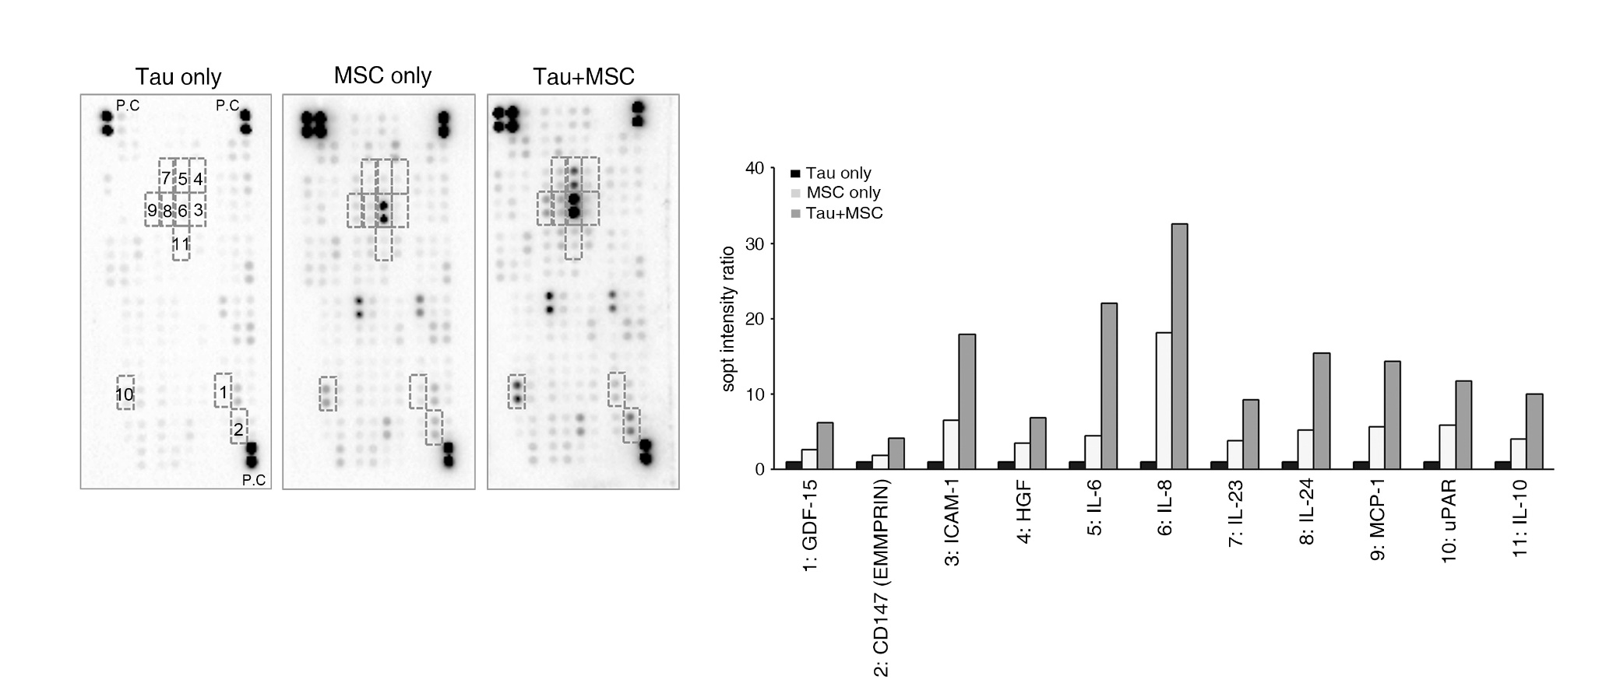

Supplementary Figure 1. Analysis of human cytokines secreted from hUCB-MSCs in conditioned media. The co-cultured medium was analyzed using a human cytokine antibody array (R&D Systems, Proteome Profiler Human XL Cytokine Array). Box indicates the expression levels of respective protein under each condition. Bar graph represents expressed protein levels determined using densitometric analysis. These proteins were remarkably increased in the hUCB-MSCs⁺ aggregation-induced tau K18 group compared with the aggregation-induced tau K18 only group (control).

