Figure S1: Schematic overview of the electrophotographic process.
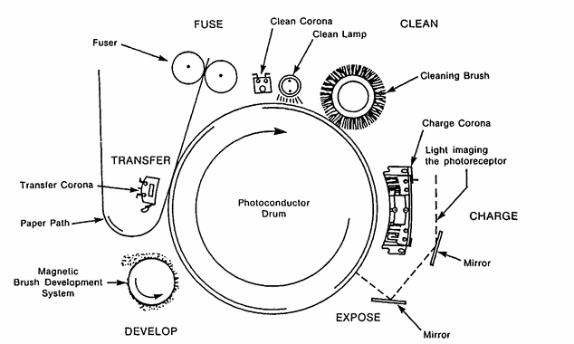

Figure S2: The variation of pH and temperature during the synthesis process of the toner composites.

