Evaluation of commercial disinfectants against Staphylococcus lentus and Micrococcus spp. of poultry origin
Otun Saha ¹, Nadira Naznin Rakhi ², Arif Istiaq ³, Israt Islam¹, Munawar Sultana ¹, M. Anwar Hossain ^{1,4,+} and Md. Mizanur Rahaman ^{1,*}
¹ Department of Microbiology, University of Dhaka, Dhaka 1000, Bangladesh.
² Department of Biotechnology and Genetic Engineering, Bangabandhu Sheikh Mujibur Rahman Science and Technology University, Gopalganj, Bangladesh.
³ Department of Developmental Neurobiology, Graduate School of Medical Sciences, Kumamoto University, Kumamoto, Japan.
+Present Position: Vice-Chancellor, Jashore Science and Technology University, Bangladesh.
* Correspondence: razu002@du.ac.bd; +8801796585290

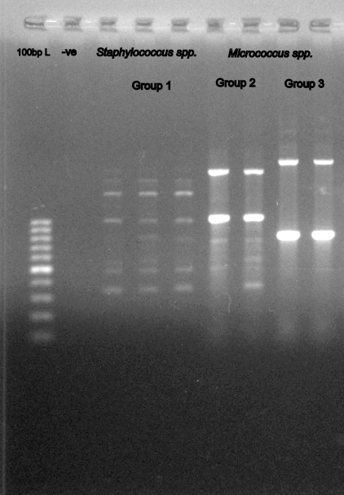

Supplementary Figure 1. Gel electrophoretograms is image of RAPD typing. (Lane 1: 100bp ladder as molecular size DNA marker. Lane 2: -ve control, Lanes 3, Lane 4, Lane 5 represent group 1 (Staphylococcus lentus), Lane 6, Lane 7 represent group 2 (Micrococcus luteus), Lane 8 and Lane 9 represent group 3 (Micrococcus aloeverae).
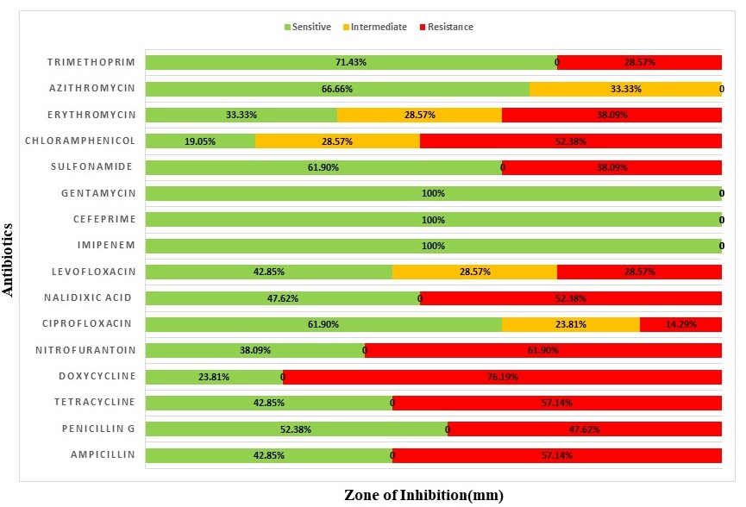
Supplementary Figure 2. Diagrammatic representation of antibiotic resistance pattern of the isolates. AMP= Ampicillin, P= Penicillin G, Te= Tetracycline, DO= Doxycycline, F= Nitrofuran CIP= Ciprofloxacin, Na= Nalidixic acid, Lev= Levofloxacin, IMP= Imipenem, FEP= Cefeprime, CN= Gentamycin, S3= Sulfonamide, C= Chloramphenicol, E= Erythromycin, Atm= Azithromycin, and Tm= Trimethoprim. Green indicated sensitive isolates, Yellow indicated intermediate stage and red shows resistant number if the isolates.
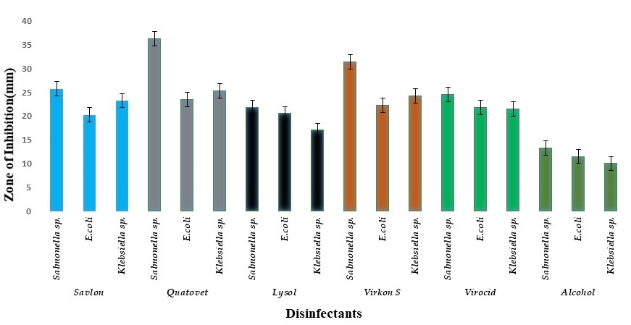
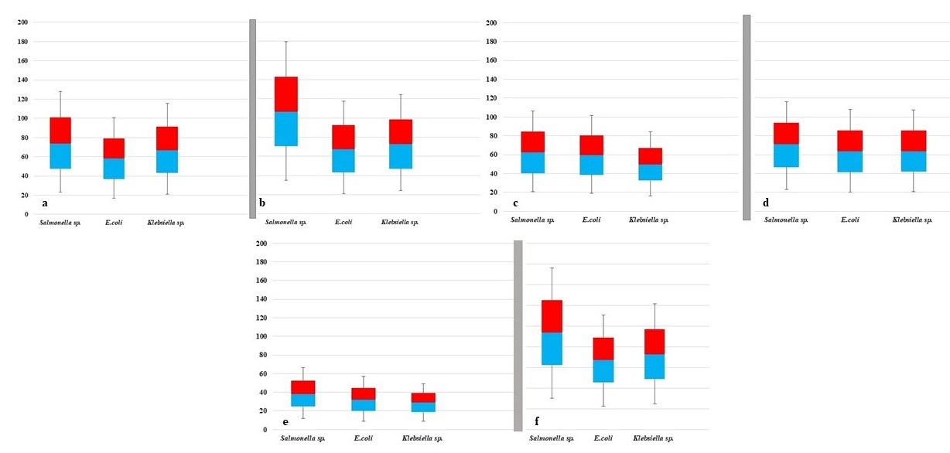
Supplementary Figure 3. Diagrammatic representation in vitro efficacy of disinfectant (100% conc.) against gram negative bacteria. Y axis represents the diameter of inhibition zone. Blue indicated Savlon, Gray Quatovet, black represented the Lysol, orange virocid and green show Alcohol.

Supplementary Figure 4. Box and Whisker plot (min/max, lower/upper quartiles and median) showing overall disinfection efficacy of various disinfectants against gram negative bacteria-axis shows most common zone of diameter area. a) Lysol; b) Quatovel; c) Lysol; d) Virocid; e)Alcohol; f) Virkon S
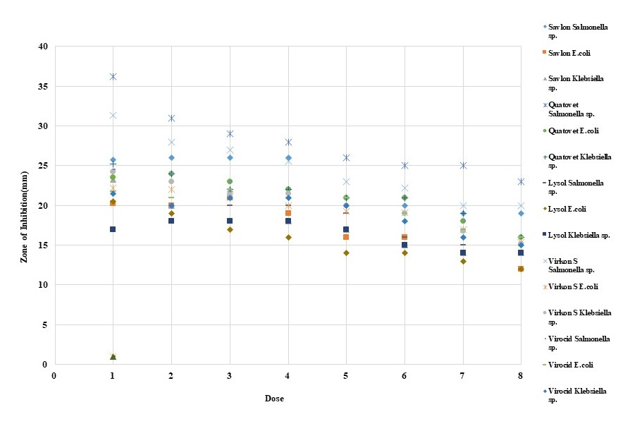
Supplementary Figure 5. Percentage of resistance of isolated gram negative microorganisms against Specific disinfectant at 100% to 30% dose Conc; X axis represent the dose percentages. Y axis represented the zone of inhibition in mm.

Supplementary Table 1. Antimicrobial susceptibility of the isolates as suggested by CLSI guideline
Sample ID | AMP | PG | TE | DO | F | CIP | NA | Lux | IMP | FEP | GN | S3 | C | E | Atm | Tm | No. of R | Biofilm(OD)
SL5 | R | S | R | R | R | S | R | R | S | S | S | S | I | R | S | R | 8 | 0.28
SL1 | R | S | R | R | S | S | R | R | S | S | S | S | I | R | S | S | 6 | 0.106
SL10 | R | S | R | R | R | I | S | I | S | S | S | S | I | I | S | S | 4 | 0.034
SL14 | R | S | S | R | R | I | R | I | S | S | S | R | I | I | I | S | 5 | 0.0273
SL9 | R | R | R | R | R | I | S | R | S | S | S | R | I | I | I | R | 8 | 0.31
SL29 | R | R | S | S | R | S | S | R | S | S | S | S | S | S | I | R | 5 | 0.027
SL40 | S | S | R | S | R | S | S | I | S | S | S | R | S | S | S | S | 3 | 0.035
SL19 | S | R | S | R | R | I | R | S | S | S | S | S | S | S | S | S | 4 | 0.033
SL12 | R | R | S | S | S | S | S | S | S | S | S | S | R | R | I | R | 5 | ND
SL37 | S | S | R | S | R | R | R | S | S | S | S | R | R | R | I | S | 7 | 0.24
SL41 | S | R | R | R | R | R | R | S | S | S | S | S | R | R | S | S | 8 | 0.21
SL28 | R | S | S | R | R | S | S | S | S | S | S | R | R | R | S | S | 6 | 0.062
SL30 | R | R | R | S | S | R | R | R | S | S | S | S | R | R | S | S | 8 | 0.132
SL34 | S | S | R | R | S | S | S | I | S | S | S | S | R | S | I | S | 3 | 0.041
SL15 | S | S | R | R | S | S | R | S | S | S | S | S | R | I | S | S | 4 | ND
SL17 | R | R | S | R | S | S | R | S | S | S | S | R | R | R | S | R | 8 | 0.13
ML9 | S | R | S | R | R | S | S | R | S | S | S | S | R | I | S | R | 6 | 0.27
ML7 | R | S | R | R | R | S | S | I | S | S | S | R | S | S | S | S | 5 | 0.104
ML3 | S | S | S | R | S | I | R | I | S | S | S | S | I | S | S | S | 2 | 0.028
MA1 | S | R | R | R | R | S | R | S | S | S | S | R | R | S | S | S | 7 | 0.173
MA4 | R | R | S | R | R | S | S | S | S | S | S | S | R | R | S | S | 6 | 0.053
Here, (AMP=ampicillin; PG=Penicillin, Te=Tetracycline, Do=Doxycycline, F=Nitrofurantoin, CIP=Ciprofloxacin, Na=Nalidixic acid, Lev=Levofloxacin, IPM=Imipenem, EFP= Cefeprime, CN=Gentamycin, S3=Sulfonamide, C=Chloramphenicol, E=Erythromycin, Atm=Azithromycon, Tm=Trimethoprim. R=Resistant; I=Intermediate, S=Sensitive. OD=Optical Density of biofilm assay.

Supplemental Table 2: Zone of inhibition size (Mean±SD) Descriptive statistics for of the tested gram negative organisms by for the disinfectants comparison at 100% ConC.
Organism | Savlon | Virocid | Lysol | Virkon S | Quatovet | Alcohol
Salmonella spp. | 25.75±  0.96 | 24.5±  0.09 | 21.75±  0.102 | 31.25±  0.16 | 36.25±  0.0009 | 13.25±  0.03
E.coli | 20.25±  0.02 | 21.75±  0.88 | 20.5±  0.85 | 22±  0.32 | 23.5±  0.65 | 11.5±  0.03
Klebsiella spp. | 23.25±  0.33 | 21.5±  1.00 | 17±  0.01 | 24.25±  0.05 | 25.25±  0.09 | 10±  0.004

