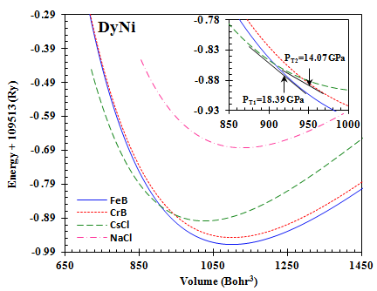
Fig. 2. Plots of total energies as function of cell volumes in FeB, CrB, CsCl and NaCl phases of DyNi

