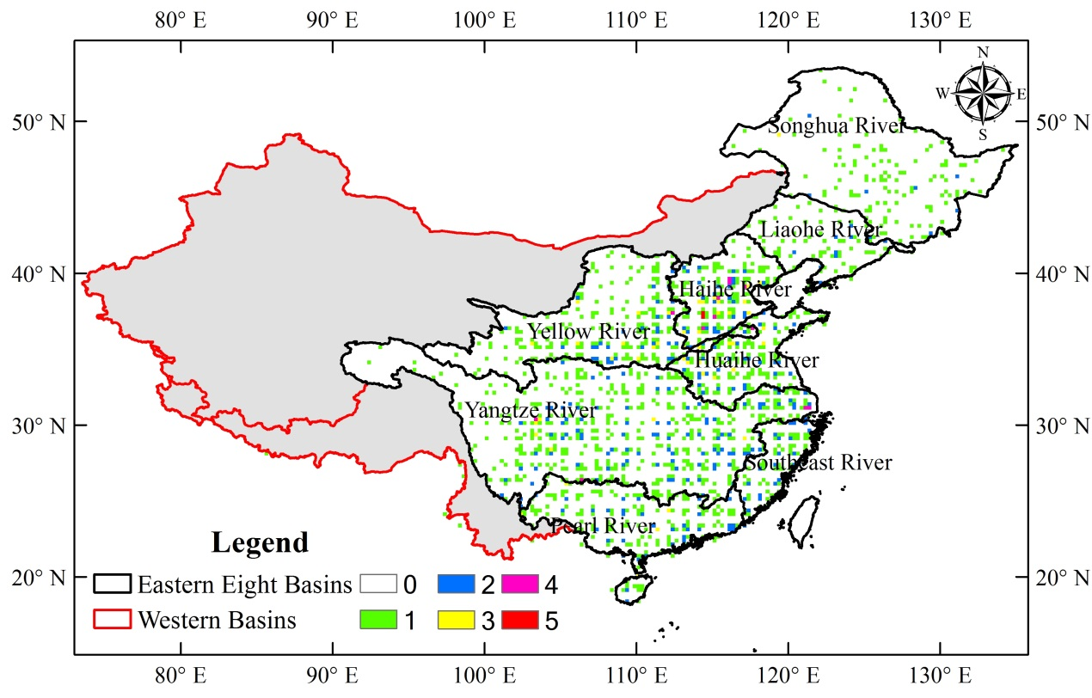
Figure A1 Spatial density distribution of gauge station used to generate CPAP product in the study area.
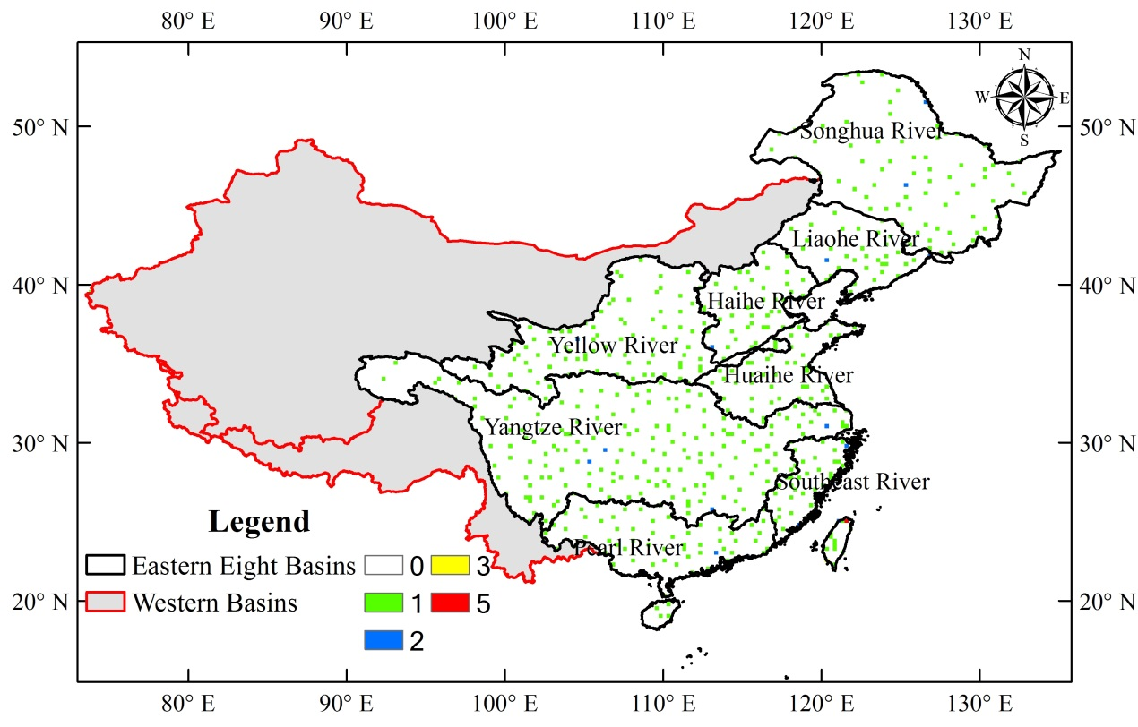
Figure A2 Spatial density distribution of gauge station used to adjust GPCC product in the study area.

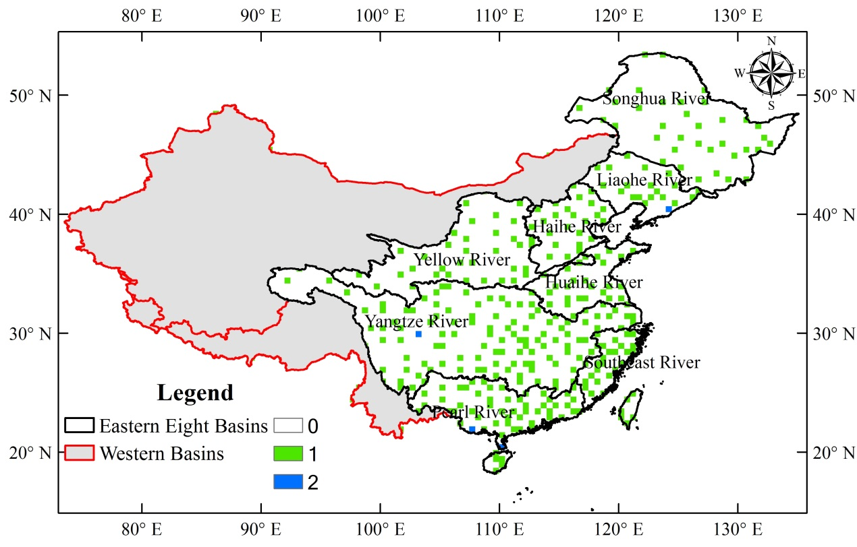
Figure A3 Spatial density distribution of gauge station used to generate and adjust CPC product in the study area.
Table A1 Gauge stations used for generating or adjusting the three products and the same stations numbers between CPAP and CPC, GPCC products for eight river basins.
 | CPAP | CPAP&CPC | CPAP&GPCC | CPC | GPCC
Songhua River | 140 | 14 | 5 | 36 | 74
Liaohe River | 78 | 13 | 5 | 21 | 34
Haihe River | 239 | 21 | 16 | 24 | 42
Yellow River | 293 | 23 | 13 | 37 | 88
Huaihe River | 197 | 23 | 25 | 24 | 44
Yangtze River | 645 | 49 | 38 | 115 | 182
Southeast River | 102 | 21 | 12 | 31 | 54
Pearl River | 223 | 31 | 15 | 60 | 64
Station Numbers | 1917 | 195 | 129 | 348 | 582
Note: GPAP&CPC means the same stations used in CPAP and CPC products, the same for CPAP&GPCC

