Supplementary Materials
Self-assembly investigations of sulfonated poly(methyl methacrylate-block-styrene) diblock copolymer thin films
Claudia Piñón-Balderrama, César Leyva-Porras, Roberto Olayo-Valles, Javier Revilla-Vázquez, Ulrich S. Schubert, Carlos Guerrero-Sanchez⁵*, and José Bonilla-Cruz¹*
Small-angle X-ray scattering results are shown in Figure S1.
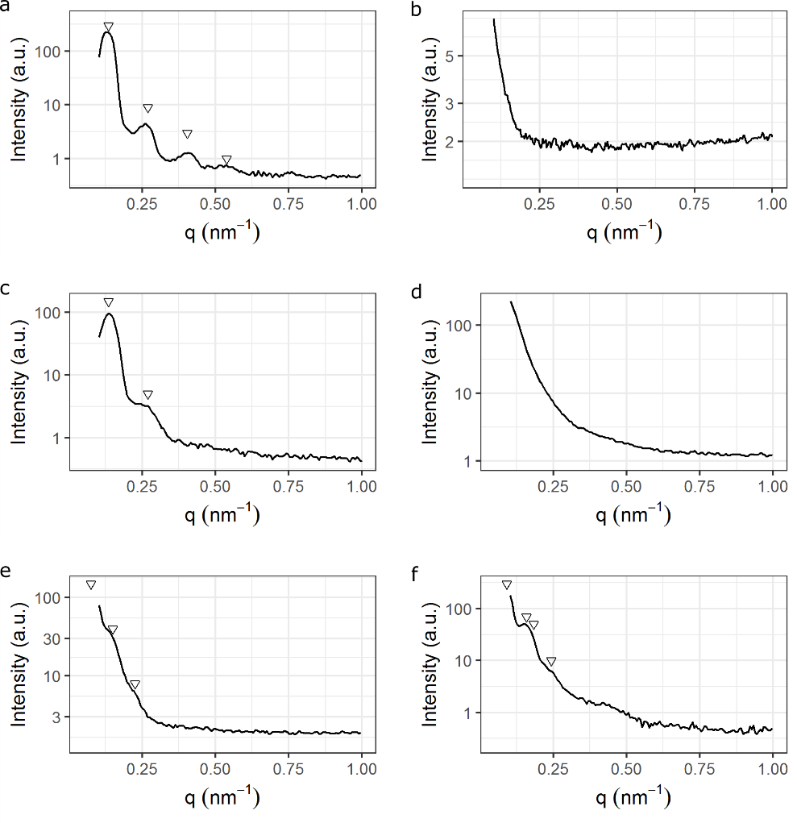
Figure S1. SAXS results for bulk samples a) M2_52/48, b) M2_52/s48, c) M2_56/44, d) M2_56/s44, e) M3_60/40, f) M3_60/s40. Triangles show peak positions used for determination of the morphology. In plots e) and f) the first triangle represents the estimation for the position of the first Bragg reflection.

Advanced Functional Materials & Nanotechnology Group. Polymer Science and Nanotechnology Lab. Centro de Investigación en Materiales Avanzados S.C. (CIMAV-Unidad Monterrey), Av. Alianza Norte # 202, PIIT, Autopista Monterrey-Aeropuerto Km 10, C.P. 66628, Apodaca, N.L., México.
Centro de Investigación en Materiales Avanzados S. C. (CIMAV). Miguel de Cervantes # 120, Complejo Industrial Chihuahua, C.P. 31136, Chihuahua, Chih., México.
Departamento de Física, Universidad Autónoma Metropolitana - Iztapalapa, Av. San Rafael Atlixco 186, C.P. 09340, México City, México.
Departamento de Ingeniería y Tecnología. División Ciencias Químicas. Facultad de Estudios Superiores Cuautitlán-UNAM. Av. Primero de Mayo s/n Cuautitlán Izcalli, C.P. 54740, Edo. de México, México.
Laboratory of Organic and Macromolecular Chemistry, Friedrich-Schiller-University Jena, Humboldtstr. 10, 07743 Jena, Germany and Jena Center for Soft Matter (JCSM), Friedrich Schiller University Jena, Philosophenweg 7, 07743 Jena, Germany. * jose.bonilla@cimav.edu.mx, carlos.guerrero.sanchez@uni-jena.de

