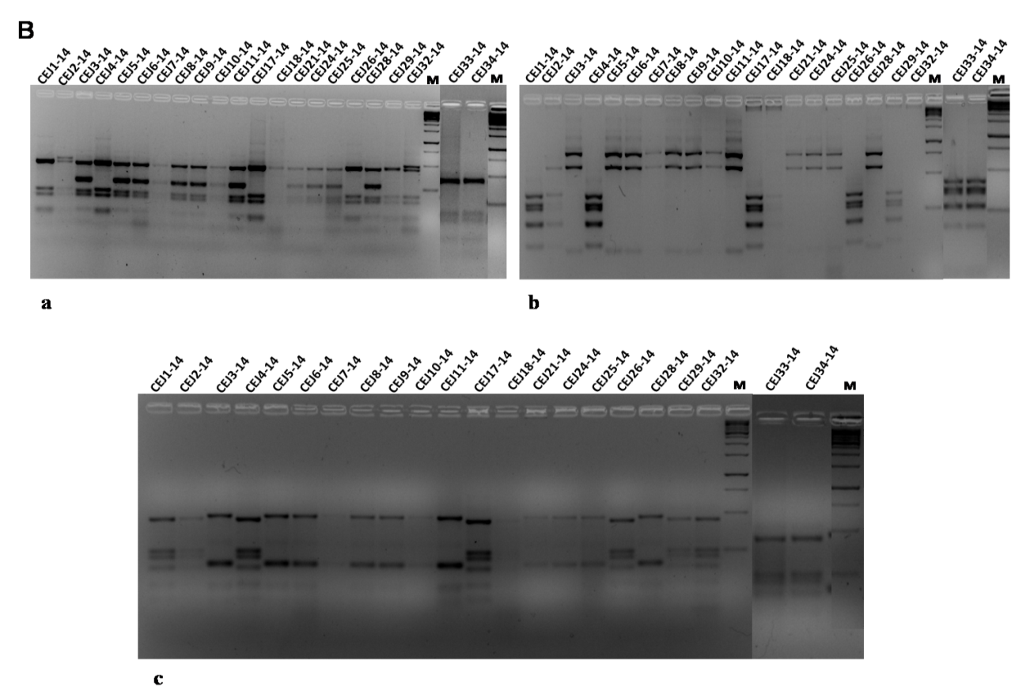
Figure S4: (A) Restriction digestion of amplified 16S rRNA of isolates cleaving with AluI (a), MboI (b) and HaeIII (c) from the sample S1-10 and (B) from the samples S6M-14 and S6W-14. Lane M represents molecular size marker 1 Kb DNA ladder.

