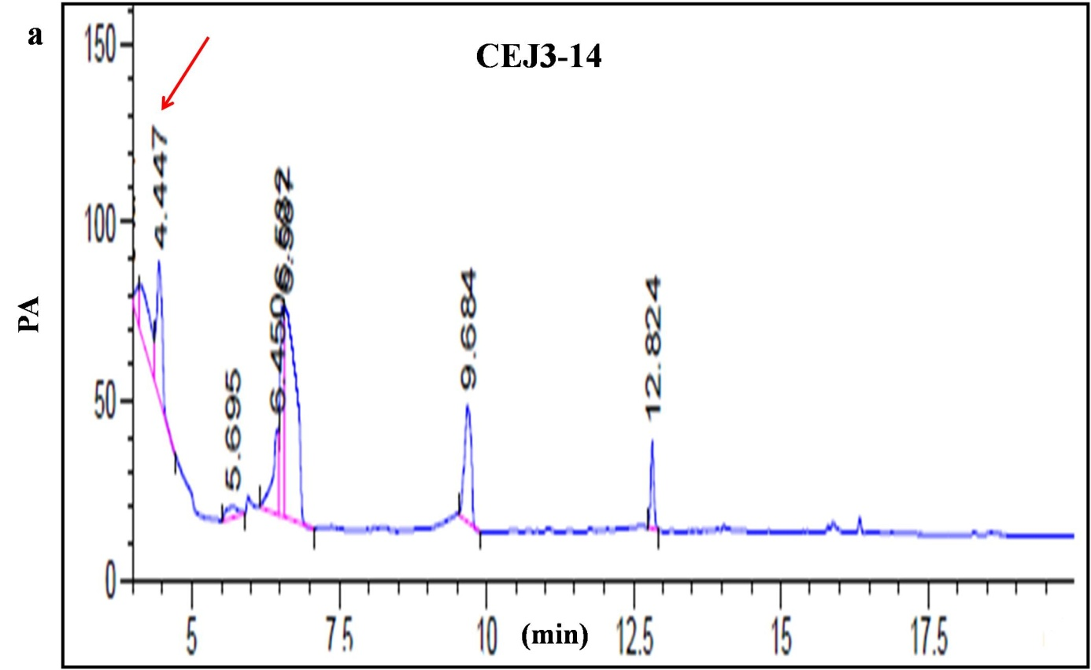

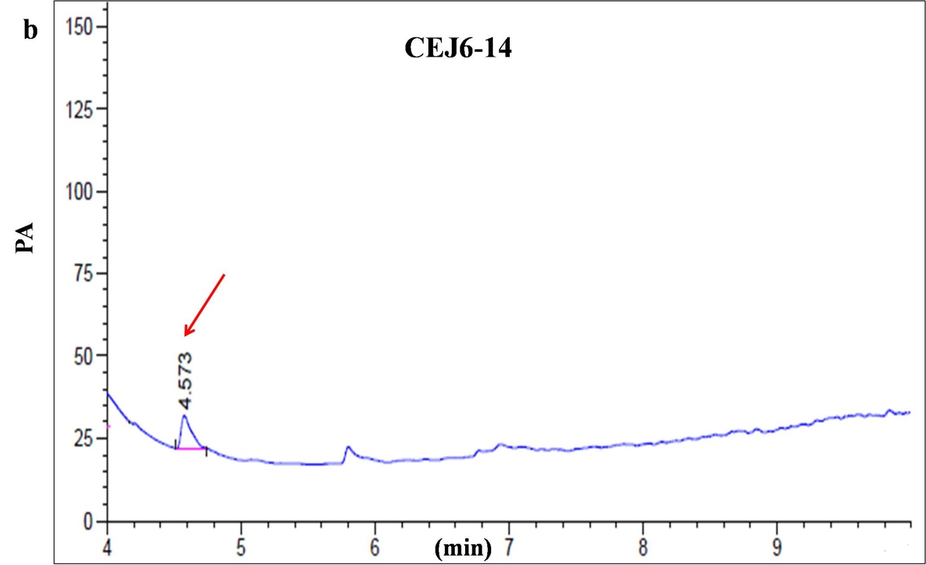

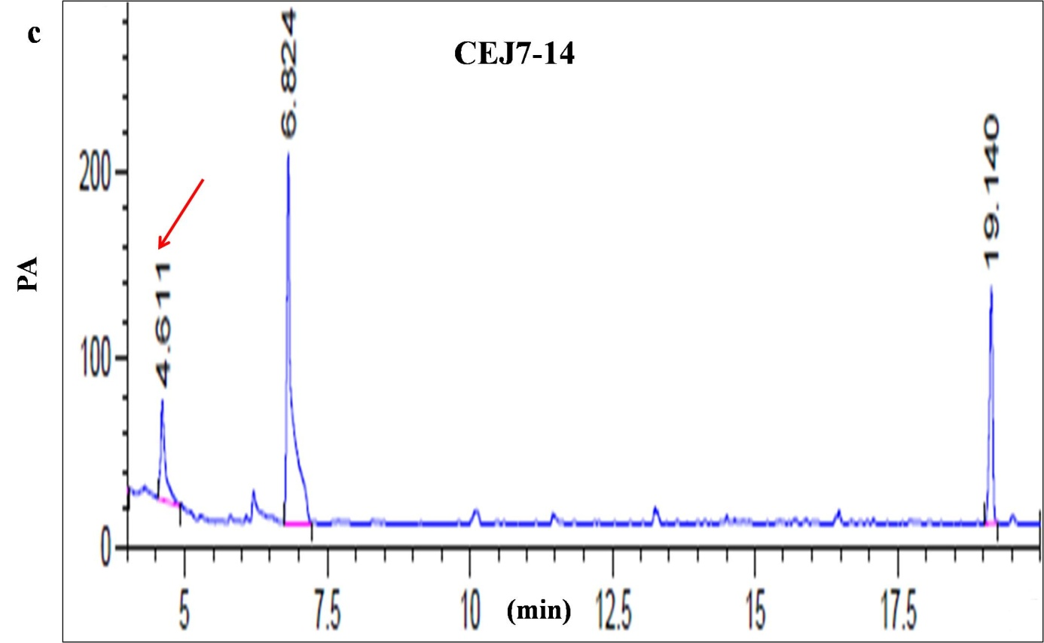

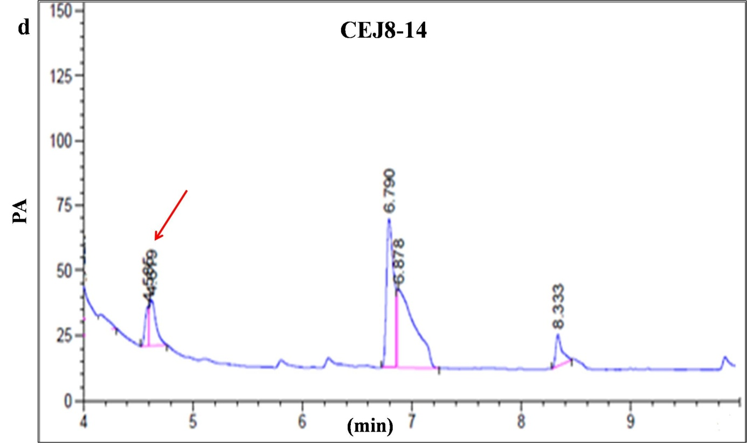

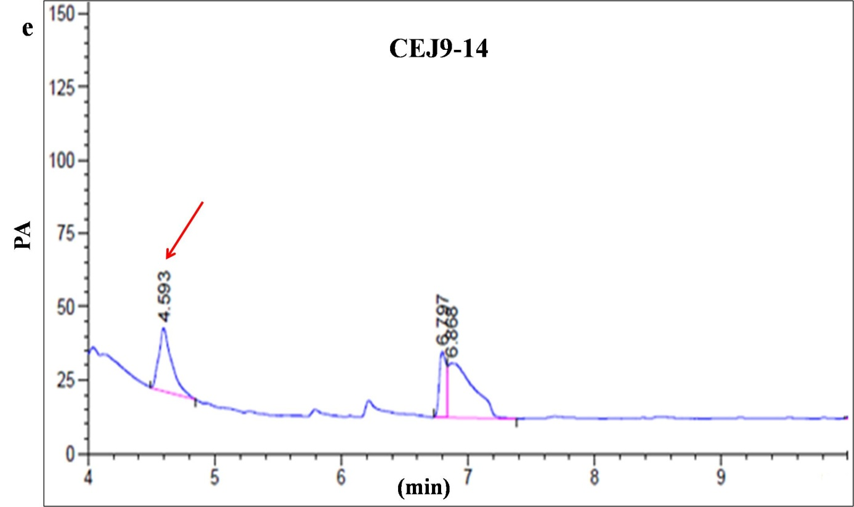

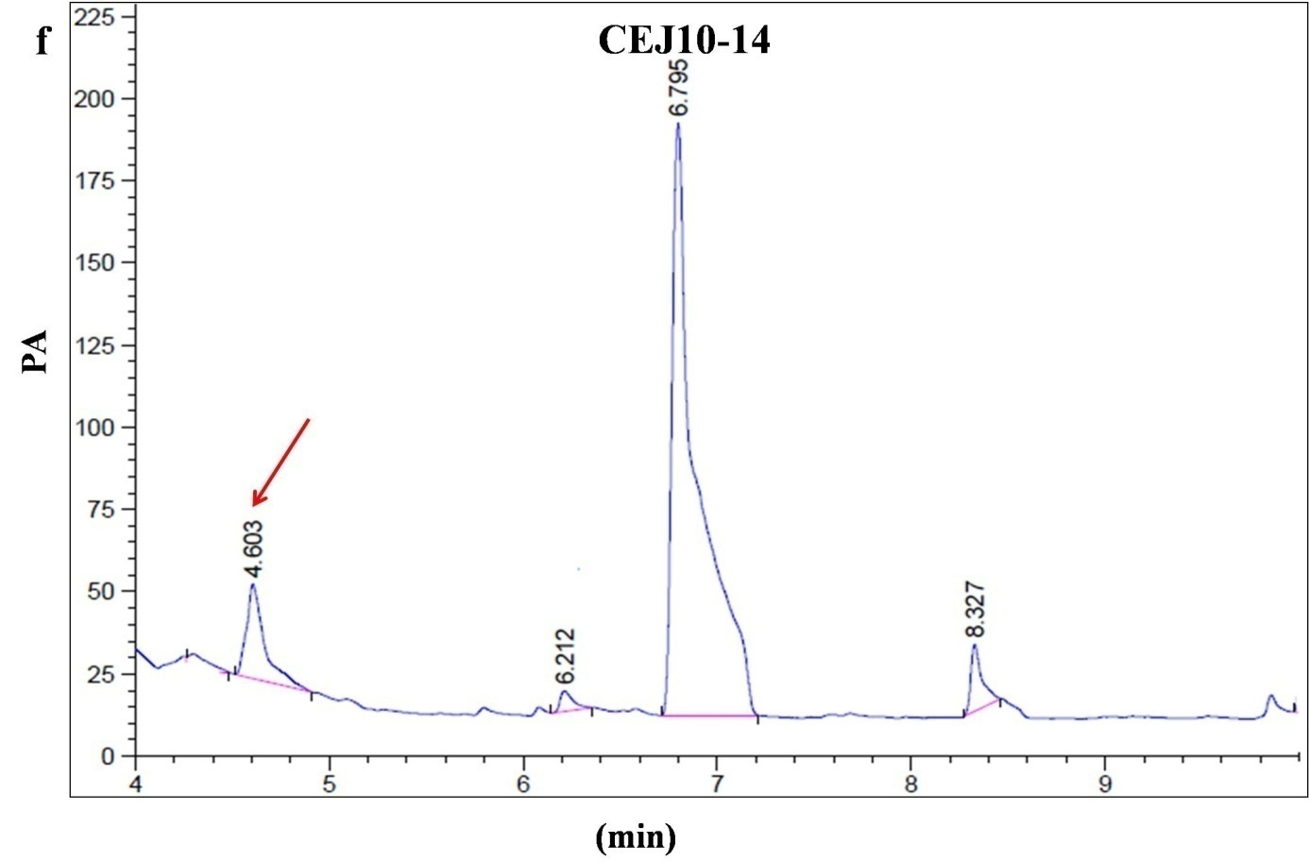

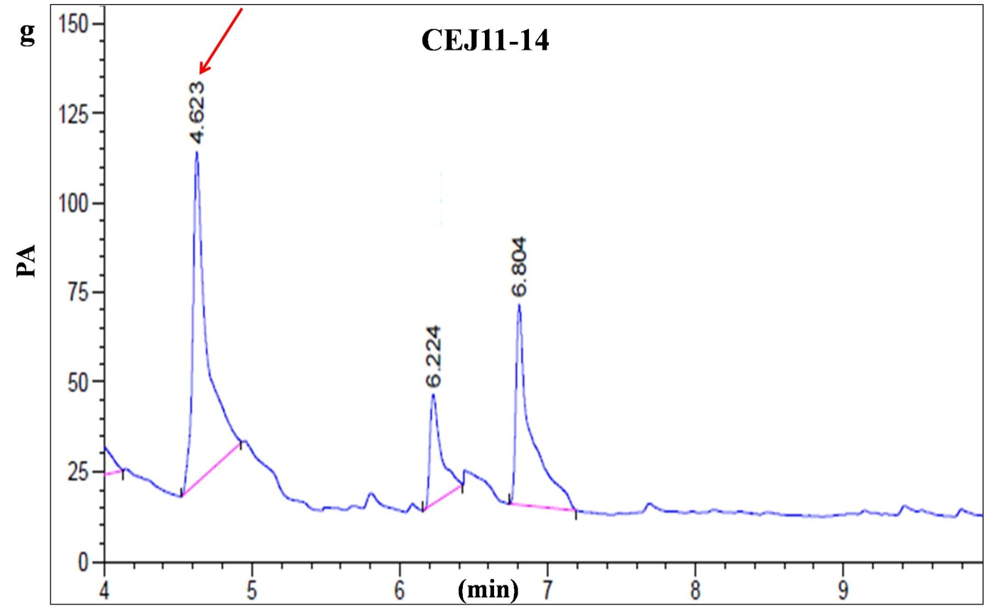

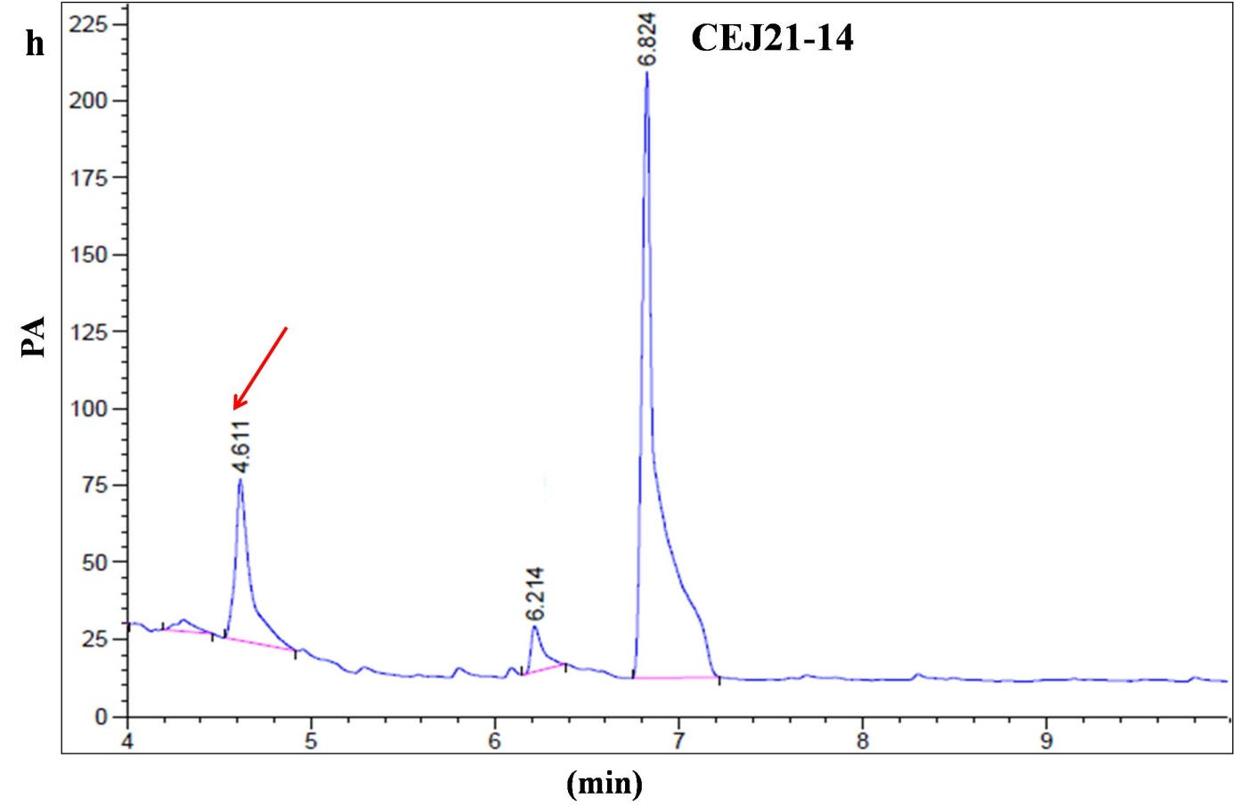

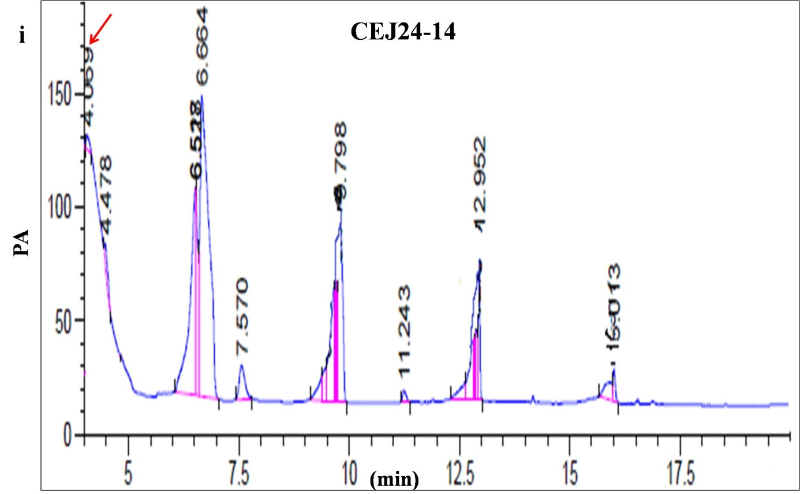

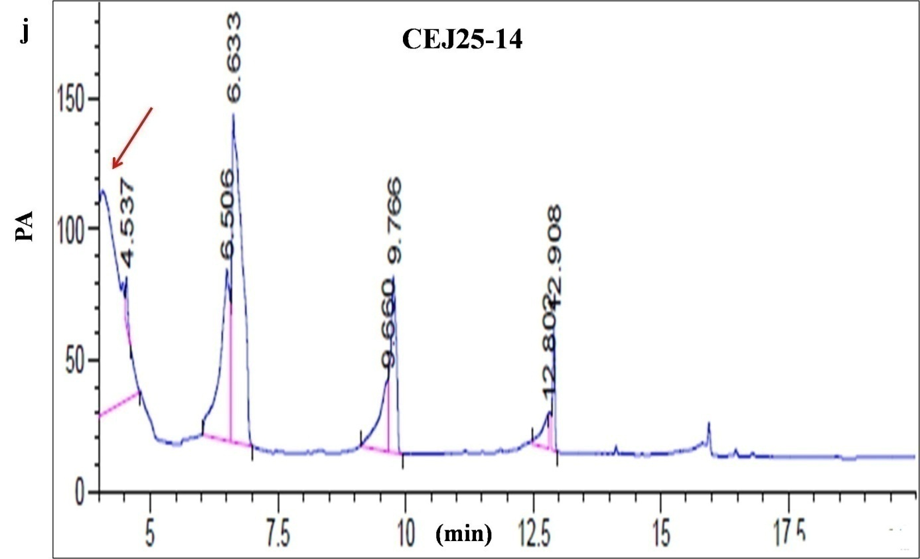

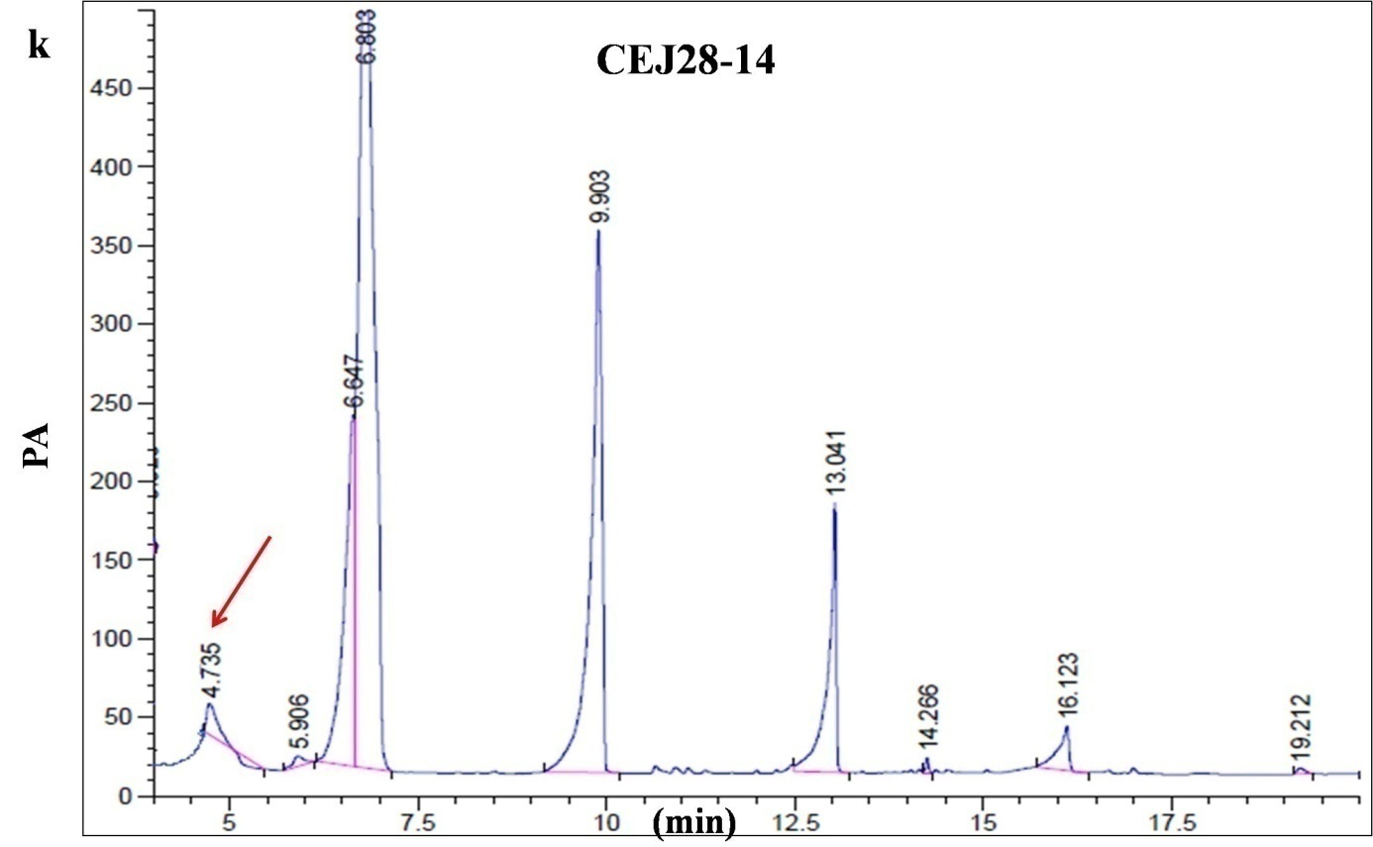

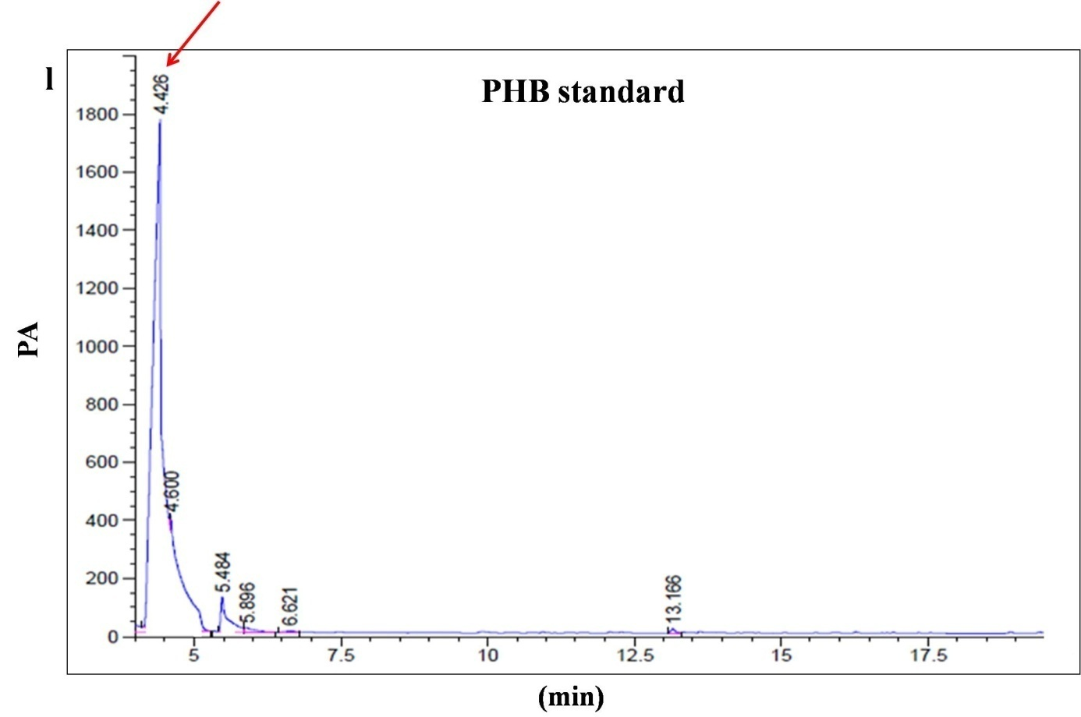

**Figure S6:** Chromatograms of PHB obtained from cultures of the isolates (a) CEJ3-14; (b) CEJ6-14; (c) CEJ7-14; (d) CEJ8-14; (e) CEJ9-14; (f) CEJ10-14; (g) CEJ11-14; (h) CEJ21-14; (i) CEJ24-14; (j) CEJ25-14; (k) CEJ28-14; (l) PHB standard (Sigma).