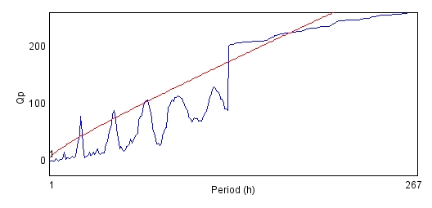
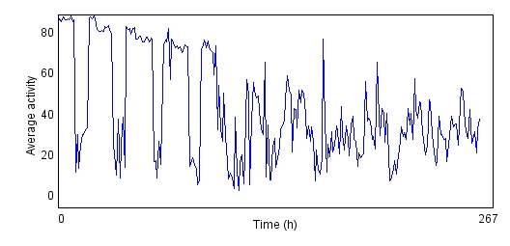
(a) (b)
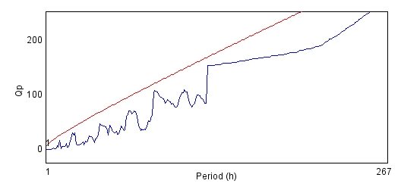
Fig. S1 (a) and (b) shows the average activity pattern and chi-square periodogram respectively for the control flies (N=20).
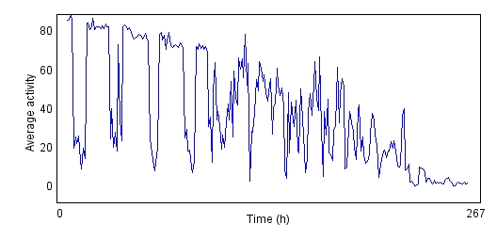
(a) (b)
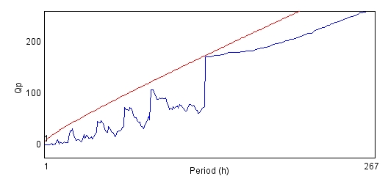
Fig. S2 (a) and (b) shows the average activity pattern and chi-square periodogram respectively for the PD flies (N=20).
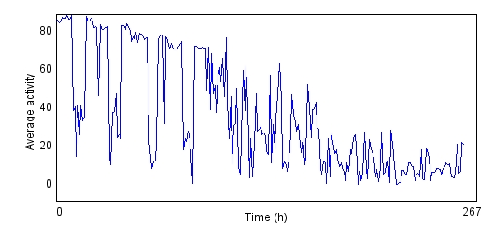
(a) (b)
Fig. S3 (a) and (b) shows the average activity pattern and chi-square periodogram respectively for the PD flies exposed to 25µM of curcumin in diet (N=20).

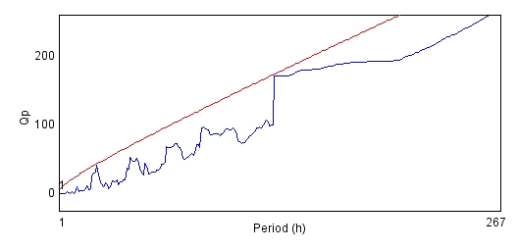
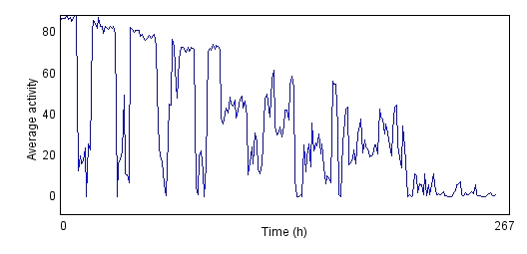

(a) (b)
Fig. S4 (a) and (b) shows the average activity pattern and chi-square periodogram respectively for the PD flies exposed to 50µM of curcumin in diet (N=20).
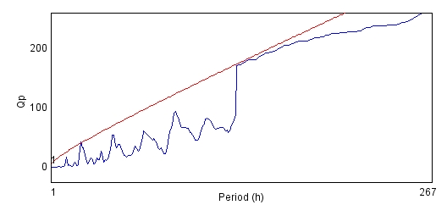
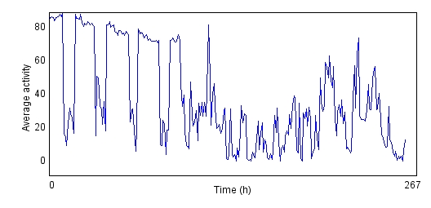
(a) (b)
Fig. S5 (a) and (b) shows the average activity pattern and chi-square periodogram respectively for the PD flies exposed to 100µM of curcumin in diet (N=20).
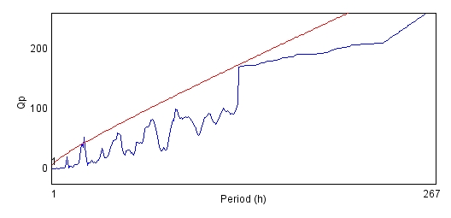
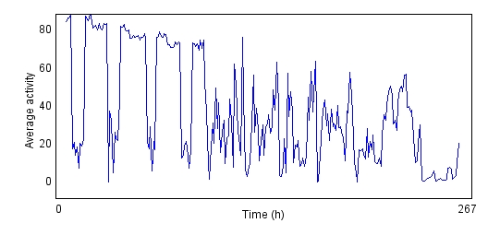

(a) (b)
Fig. S6 (a) and (b) shows the average activity pattern and chi-square periodogram respectively for the control flies exposed to 25µM of curcumin in diet (N=20).

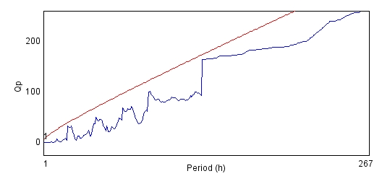
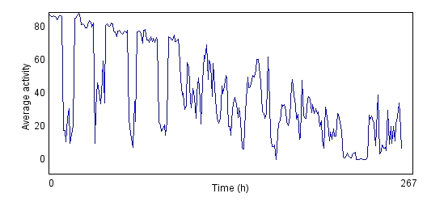

(a) (b)
Fig. S7 (a) and (b) shows the average activity pattern and chi-square periodogram respectively for the control flies exposed to 50µM of curcumin in diet (N=20).
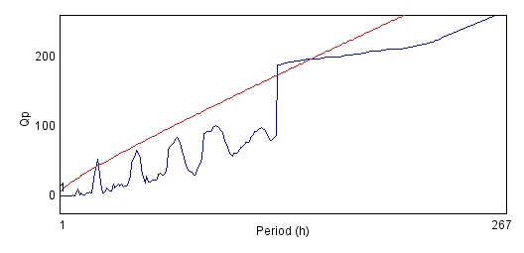
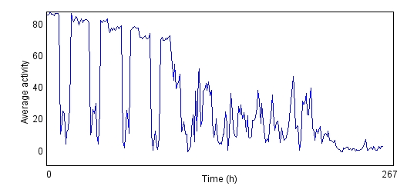
(a) (b)
Fig. S8 (a) and (b) shows the average activity pattern and chi-square periodogram respectively for the control flies exposed to 100µM of curcumin in diet (N=20).

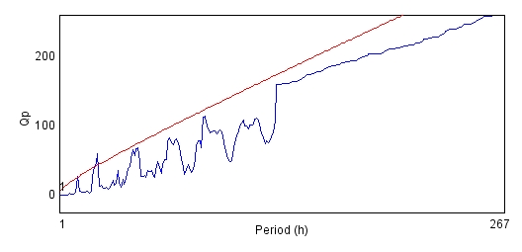
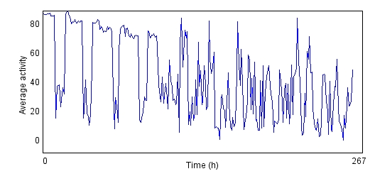
(a) (b)

Fig. S9 (a) and (b) shows the average activity pattern and chi-square periodogram respectively for the PD flies exposed to 10⁻³µM of L-dopamine in diet (N=20).

