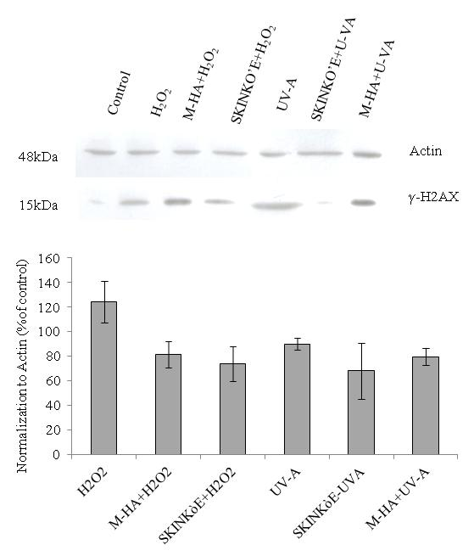
Supplementary file: Western blotting analyses relative to γ-H2AX protein evaluated as biomarkers of DNA damage following oxidative stress. M-HA and Skinkò support a lower damage on HaCat cells to both H2O2 and UV-A induced stress.

