Supplementary Figures and Tables
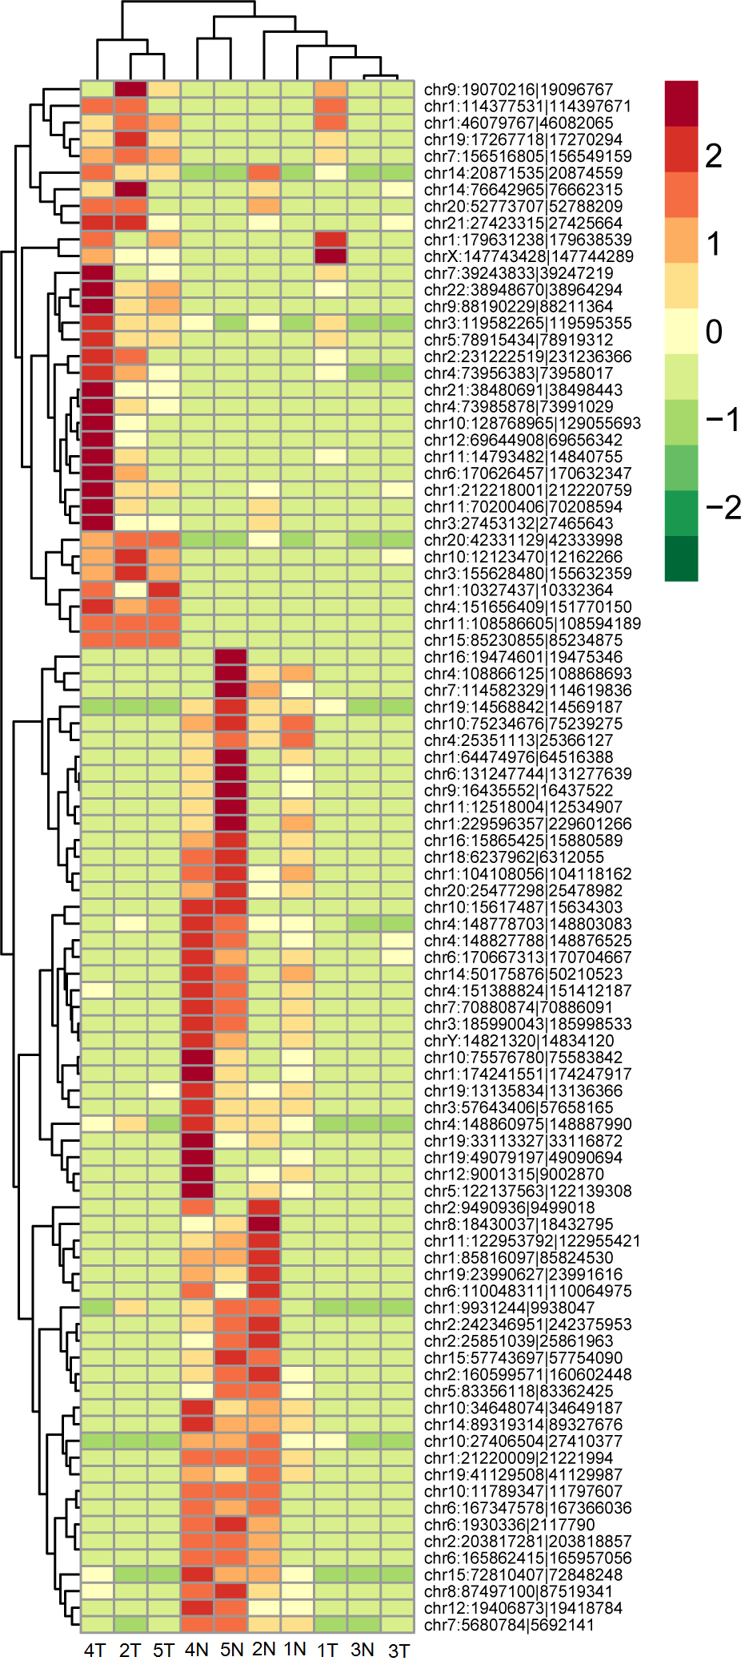
Figure S1: Clustering analysis showed expression distribution of circRNAs across different samples.
Note: The names of the circRNA are mainly their locations on chromosomes.
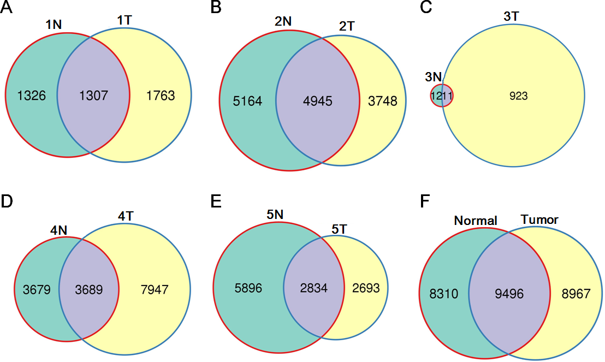
Figure S2: Venn's distributions of expressed circRNAs between paired normal and tumor samples.
A-E. Expressed circRNAs between paired normal and tumor samples; F. expressed circRNAs between all the pooled normal and tumor samples. The third samples were removed from the further analysis because fewer circRNAs were detected.

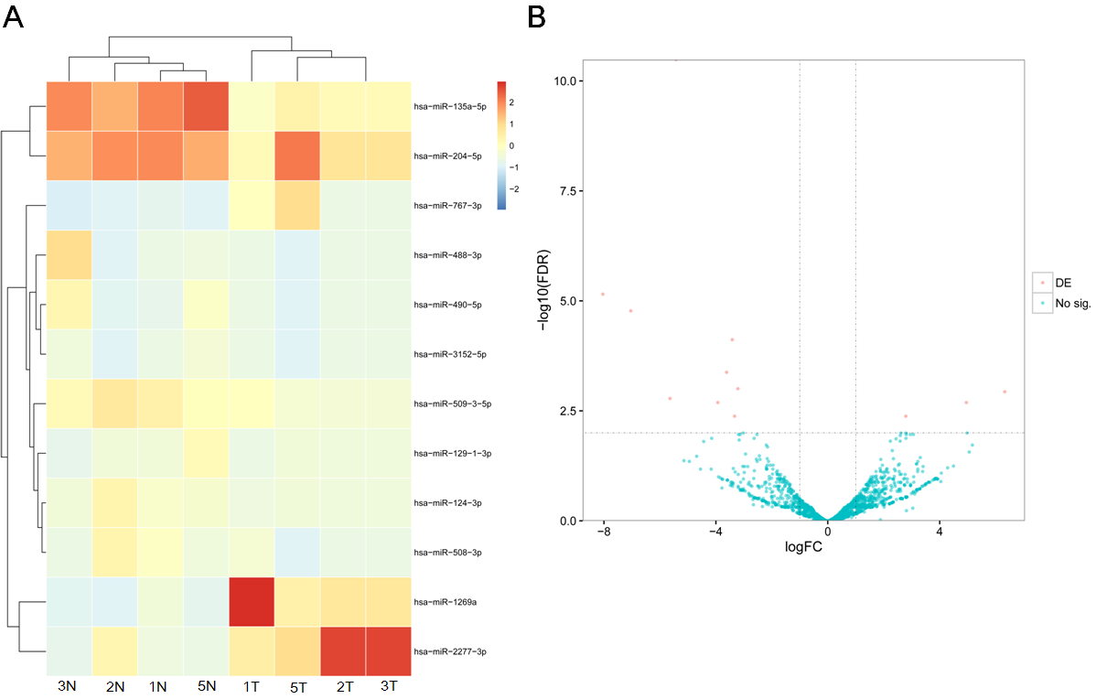
Figure S3: Clustering analysis and volcano distribution of miRNAs.
A. Clustering analysis of some miRNAs across different samples; B. volcano distribution of miRNAs.
Note: miRNAs in a specific sample (No. 4) were not involved in the relevant analysis because of outlier with other samples.

Table S1: Patients characteristics of 5 male patients with esophageal squamous cancer.
Age | Virus infection | History of smoking and drinking | Pathological condition | Lymph gland
67 | no | Smoking for 30 years | Moderate differentiation | Reactive hyperplasia of lymph node
60 | no | no | Medium-high differentiation | No metastasis
67 | no | Intermittently, small amount of alcohol and smoking | Poor differentiation | Reactive proliferation
63 | no | Intermittently, small amount of alcohol and smoking | Moderate or poor differentiation | Cancerometastasis
64 | no | no | Moderate differentiation | Cancerometastasis

Table S2: Selected deregulated circRNAs and their interacted deregulated miRNAs.
circRNA:miRNA | Deregulation pattern of circRNA:miRNA
circ-AGTPBP1:miR-490-3p | Up:Down
circ-ANKRD17:miR-490-3p | Up:Down
circ-ANKRD17:miR-3118# | Up:Down
circ-ANKRD17:miR-124-3p | Up:Down
circ-ARIH1:miR-26a-5p# | Down:Down
circ-FAM120B:miR-133a-3p# | Up:Down
circ-FAM120B:miR-133b# | Up:Down
circ-GMPS:miR-217# | Up:Down
circ-GMPS:miR-490-3p | Up:Down
circ-LRBA:miR-3118# | Down:Down
circ-PAPD4:miR-124-3p | Up:Down
circ-SEC11A:miR-216b-5p# | Up:Down
circ-SP140L:miR-520c-3p# | Up:Up
circ-SP140L:miR-520d-3p# | Up:Up
circ-SP140L:miR-373-3p | Up:Up
circ-SP140L:miR-216b-5p# | Up:Down
circ-SP140L:miR-124-3p | Up:Down
circ-SP140L:miR-302d-3p# | Up:Down
circ-SP140L:miR-302b-3p# | Up:Down
Note: the miRNA-circRNA pairs are obtained based on deregulated circRNAs.
# shows the miRNA is found biological difference (log₂FC > 2 or log₂FC < -2) but no significant difference is detected (FDR > 0.05).

