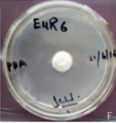
Figure S1: Colonies of EuR-6 grown on Hagem minimal medium and purified on PDA media plates, isolated from Euphorbia indica L. EuR represents that the starin was isolated from the Euphorbia indica L. root.

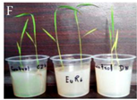
Figure S2: Screening bioassay of EuR-6 (100μl) isolated from Euphorbia indica L. on rice seedlings at 2 leaves stage grown in 0.8% water-agar medium for 2 weeks at 25ºC. Reading taken after 1 week of culture filtrate application. Czapek control (right), distilled water control (left) and endophyte cultural filtrate (middle).

