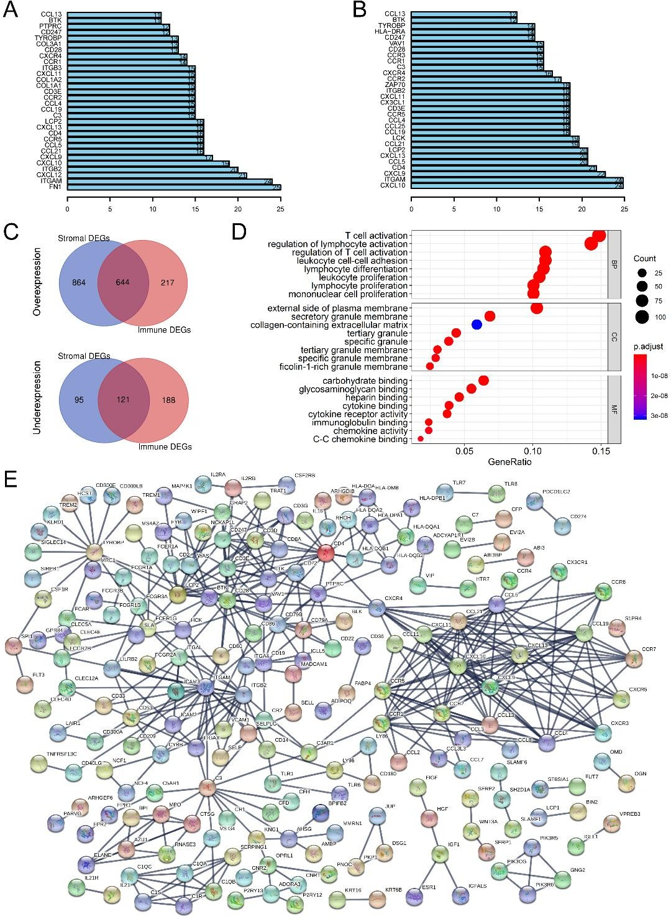
722
723 Supplementary Figure 1. Function analysis of stromal DEGs, immune DEGs and
724 common DEGs in STAD.
725 The top 30 remarkable nodes in PPI network of stromal and immune DEGs (A-B). 726 Venn diagram was used to identify the common DEGs shared by stromal and immune 727 signature (C). The GO enrichment (D) and the PPI network (E) of the common DEGs. 728

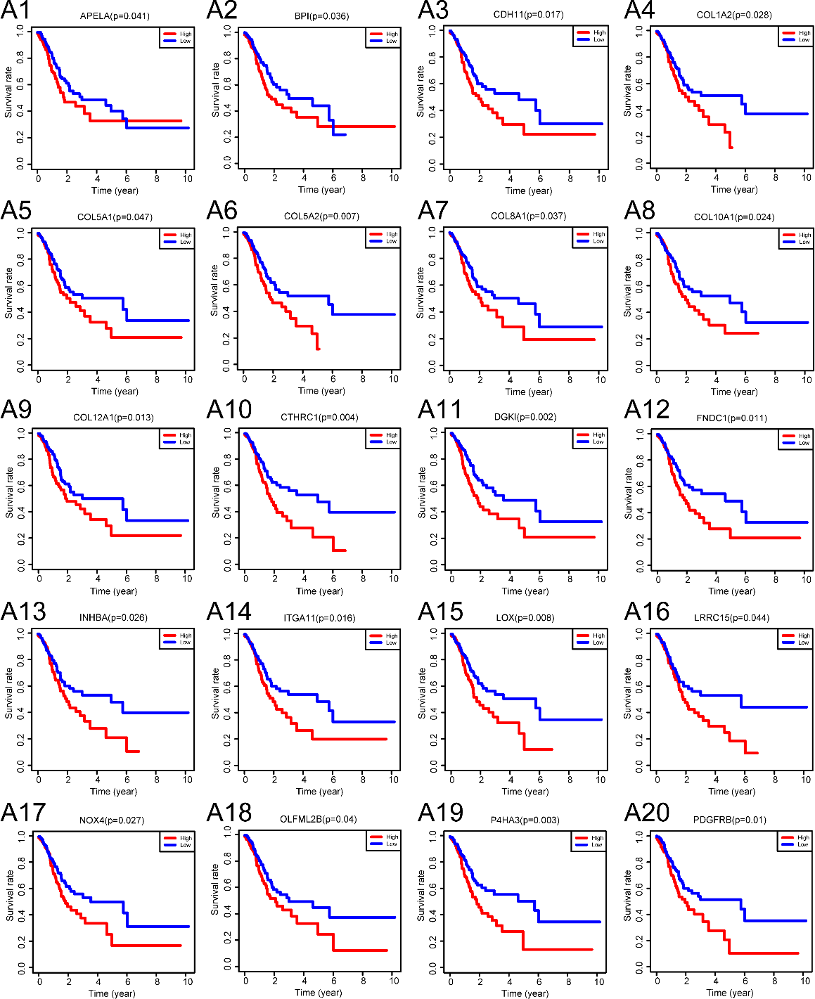

729

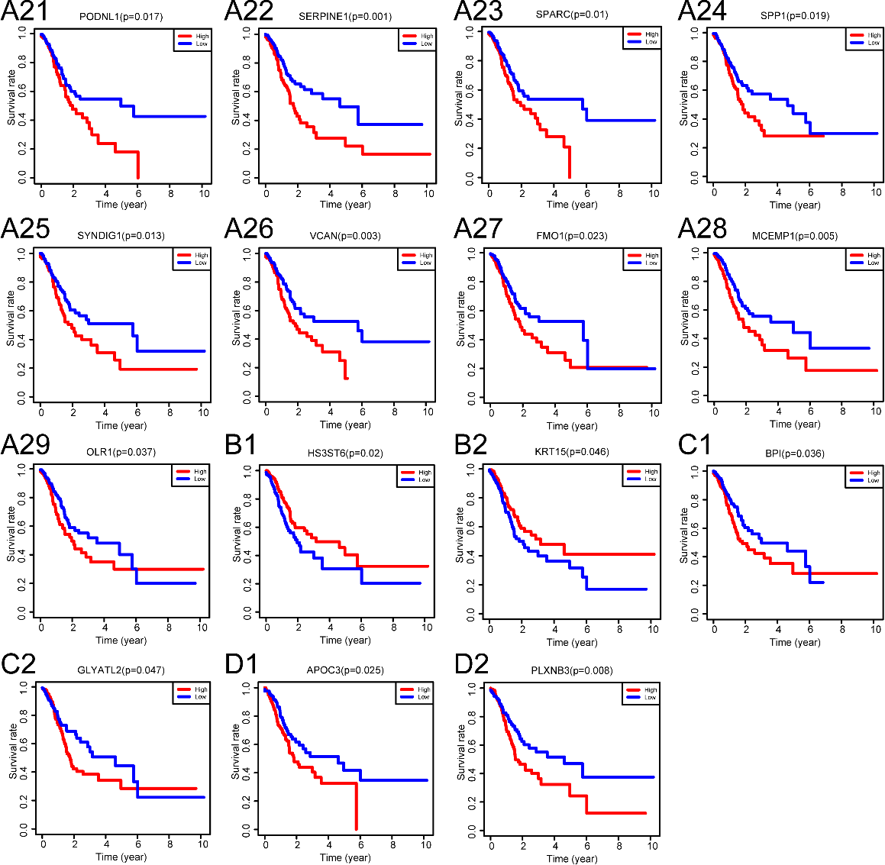
730
731 Supplementary Figure 2. Prognostic genes associated with stromal and immune
732 signature in STAD from TCGA database.
733 There were 29 prognostic genes over expressed in both STAD and stromal signature 734 (A1-A29), and two prognostic genes under expressed in both (2B1-B2). Five 735 prognostic genes were over expressed in both STAD and immune signature (2B1-B2, 736 D1-D2) and four were under expressed in both (2A27-A29, C1-C2).
737

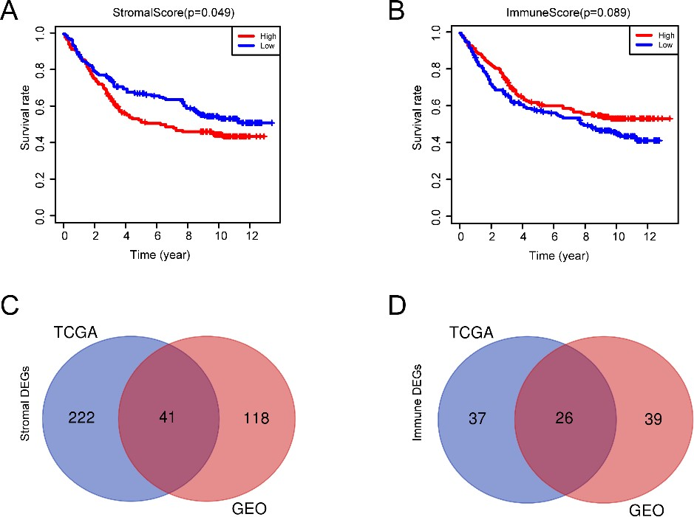
738
739 Supplementary Figure 3. Validation of prognostic genes of stromal/immune DEGs
740 for STAD in GEO database.
741 Relationship between stromal/immune scores obtained by ESTIMATE algorithm and 742 overall survival (A-B). Prognostic genes of stromal/immune DEGs for STAD from 743 TCGA and GEO cohorts and the shared genes (C-D).
744
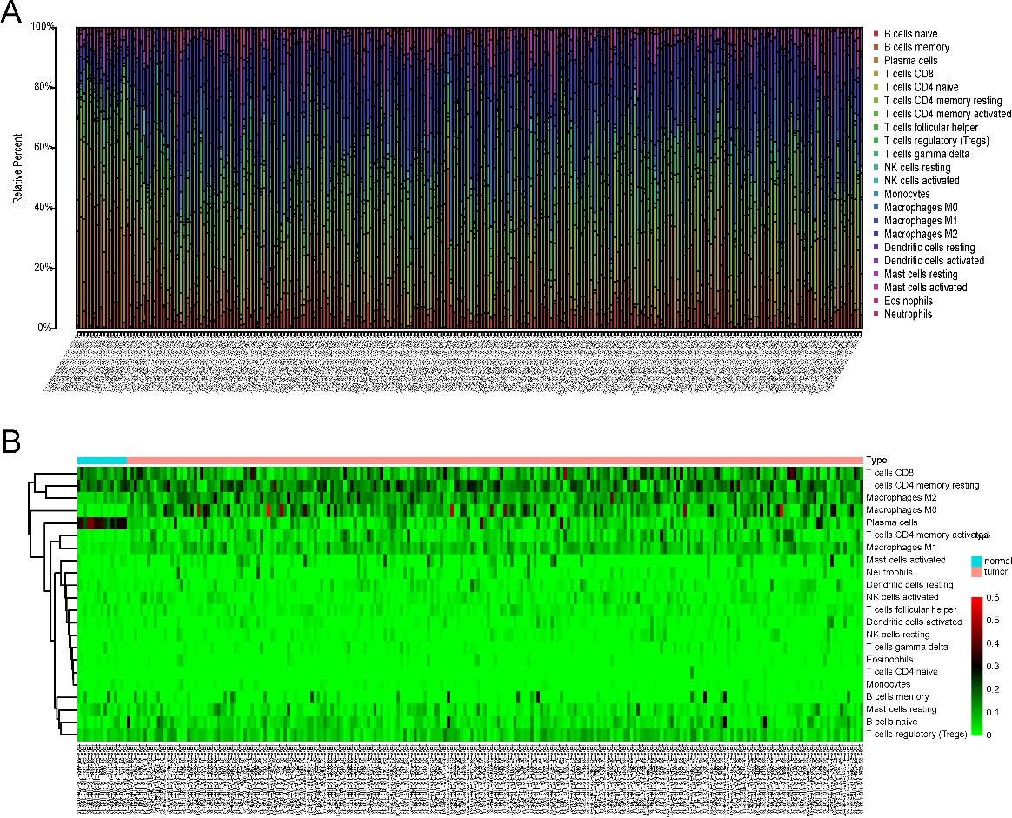
745
746 Supplementary Figure 4. The bar plot (A) and heat map (B) of 22 infiltrating
747 immune cells in STAD and controls estimated by CIBERSORT algorithm.

