Table S1. Population characteristics with unweighted and weighted estimates
 | % Unweighted [95% CI] |  | % Weighted [95% CI]
Gender
Female | 6.1 [4.9 - 7.5] |  | 5.7 [4.3 - 7.4]
Male | 93.7 [92.3 - 95.0] |  | 94.1 [92.3 - 95.5]
Transgender | 0.2 [0.06 - 0.7] |  | 0.2 [0 - 0.7]
Marital status
Single | 34.9 [32.4 - 37.5] |  | 34.4 [31.2 - 37.4]
Legally married | 33.4 [31.0 - 36.0] |  | 34.4 [31.3 - 37.7]
Living in couple | 3.2 [2.4 - 4.4] |  | 2.5 [1.5 - 3.3]
Divorced/Separated | 27.2 [24.9 - 29.7] |  | 27.7 [25 - 30.8]
Widowed | 1.2 [0.7 - 2.0] |  | 1.2 [0.5 - 1.8]
Years of injection
<5 | 28.7 [26.4 - 31.2] |  | 29.4 [26.4 - 32.2]
5 to <10 | 25.8 [23.5 - 28.2] |  | 26.7 [24 - 29.7]
10 to <15 | 21.4 [19.3 - 23.7] |  | 19.8 [17.5 - 22.3]
≥ 15 | 24.0 [21.8 - 26.4] |  | 24 [21.2 - 26.9]
HIV
HIV positive serology | 29.8 [27.4 - 32.3] |  | 29.4 [26.4 - 32.8]
HCV
HCV positive serology | 70.4 [67.9 - 72.8] |  | 70.5 [67.7 - 73.4]

Note. Respondent-driven sampling (RDS), combines "snowball sampling" (getting individuals to refer those they know, these individuals in turn refer those they know and so on) with a mathematical model that weights the sample to compensate for the fact that the sample was collected in a non-random way”. In our study, unweighted and weighted estimates shown in table S1 were very similar. We therefore conducted analyses considering the sample as representative of the population of interest and without accounting for the design effect (i.e. without weighting).

Reduction of the dimension of the dataset by Multiple Correspondance analysis – Selection of the number of axes to retain in analysis

Table S2. Inertia and Chi-square decomposition

Singular value | Principal Inertia | Chi-2 | % | Cumulative % | Loss of inertia | Benzecri adjusted  inertia |  | 2 4 6 8 10
 |  |  |  |  |  | % | Cum % | ----+----+----+----+---
0,371 | 0,137 | 2854,9 | 6,90 | 6,90 | 4,39 | 13,73 | 13,73 | *****************
0,363 | 0,132 | 2735,8 | 6,61 | 13,5 | 22,18 | 13,03 | 26,76 | *****************
0,329 | 0,108 | 2241,1 | 5,41 | 18,92 | 6,71 | 10,18 | 36,94 | **************
0,318 | 0,101 | 2099,5 | 5,07 | 23,99 | 4,54 | 9,37 | 46,31 | *************
0,311 | 0,096 | 2007,3 | 4,85 | 28,84 | 13,05 | 8,86 | 55,16 | ************
0,292 | 0,085 | 1776 | 4,29 | 33,13 | 5,15 | 7,57 | 62,73 | ***********
0,285 | 0,081 | 1691 | 4,08 | 37,21 | 6,25 | 7,10 | 69,83 | **********
0,277 | 0,076 | 1589 | 3,84 | 41,05 | 4,63 | 6,54 | 76,38 | **********
0,270 | 0,073 | 1518,4 | 3,67 | 44,72 | 1,94 | 6,16 | 82,54 | *********
0,268 | 0,071 | 1488,5 | 3,60 | 48,31 | 3,15 | 6,00 | 88,54 | *********
0,264 | 0,069 | 1446,8 | 3,49 | 51,81 | 1,16 | 5,78 | 94,32 | *********
0,262 | 0,068 | 1428 | 3,45 | 55,26 |  | 5,68 | 100,00 | *********
0,258 | 0,066 | 1380,7 | 3,34 | 58,59 |  |  |  | ********
0,256 | 0,065 | 1360,6 | 3,29 | 61,88 |  |  |  | ********
0,254 | 0,064 | 1341,5 | 3,24 | 65,12 |  |  |  | ********
0,252 | 0,063 | 1324,3 | 3,20 | 68,32 |  |  |  | ********
0,251 | 0,063 | 1306,1 | 3,15 | 71,47 |  |  |  | ********

Note. The number of axes was determined by a marked reduction of the inertia if the cumulative percent of inertia reached is large enough
Hierarchical cluster analysis (HCA)
Figure S1. Graphical determination of the optimal number of classes/profiles using pseudo T² criteria

Pseudo T²
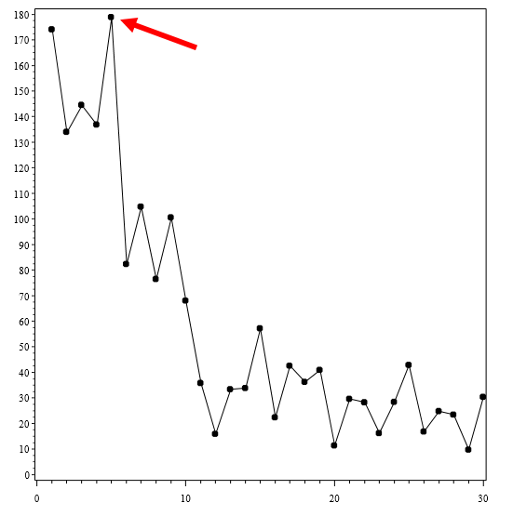
Number of classes
Note. The number of classes is determined by a slope discontinuity. Other criteria were used, such as the R-squared, semi-partial R-squared, and cubic classification. They were consistent in identifying 5 classes.

Figure S2. Graphical representation of the 5 subgroups/profiles by projection on the first 4 axes

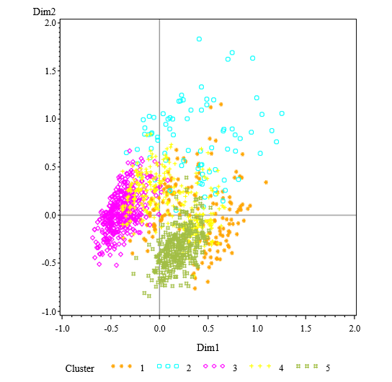 | 