Sequence and structural characterization of toll-like receptor 6 from human and related species
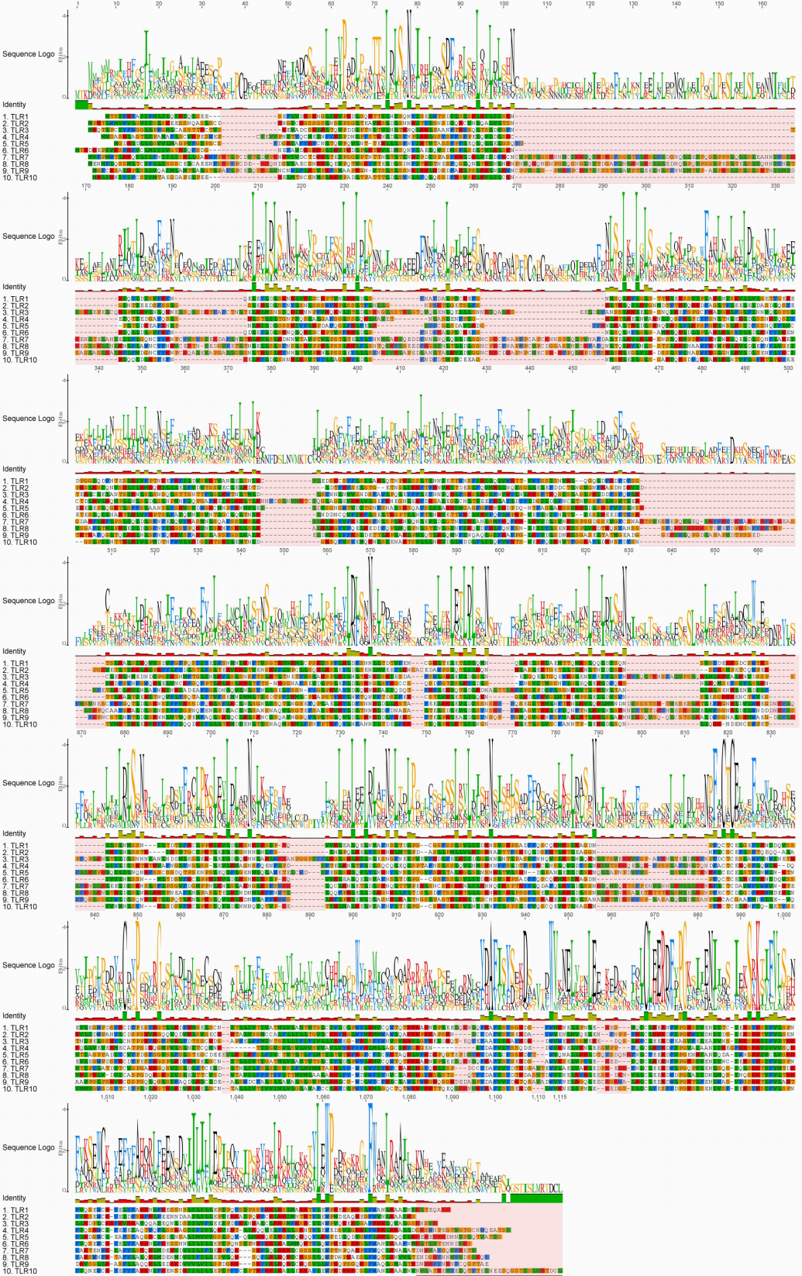
Fig S1: Sequence logo of human TLRs. In logo, the conserved sequences are represented by large single letter codes of amino acids at specific positions. The sequences which are missing from other TLRs are highlighted by pink rectangles

