Supplemental Material
Labeling stem cells with a new hybrid bismuth/carbon nanotube contrast agent for X-ray imaging and tracking
Mayra Hernández-Riveraª, Stephen Y. Choª, Sakineh E. Moghaddamª, Benjamin Y. Cheong^{b}, Maria da Graça Cabreira-Hansen^{b,c}, James T. Willerson^{b,c}, Emerson C. Perin^{b,c}, and Lon J. Wilsonª*
ªDepartment of Chemistry MS-60, Rice University, P.O. Box 1892, Houston, TX, 77251
^{b}CHI St. Luke’s Health - Baylor St. Luke’s Medical Center, 6720 Bertner Ave., MC 2-270 Houston, TX 77030
^{c}Texas Heart Institute, 6770 Bertner Ave C350, Houston, TX 77030
*Corresponding author:
Lon J. Wilson
durango@rice.edu
Department of Chemistry MS-60, Rice University, P.O. Box 1892, Houston, TX, 77251

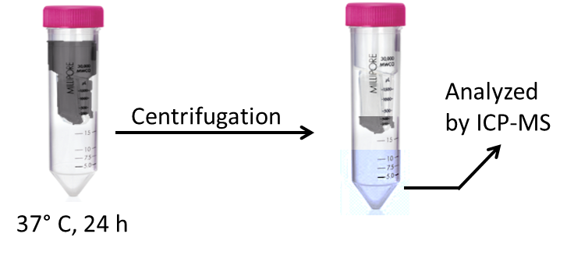
Figure S1: Representation of the filtration-challenge process performed in the cell labeling solution (Bi₄C@US-tubes suspended in Pluronic®).

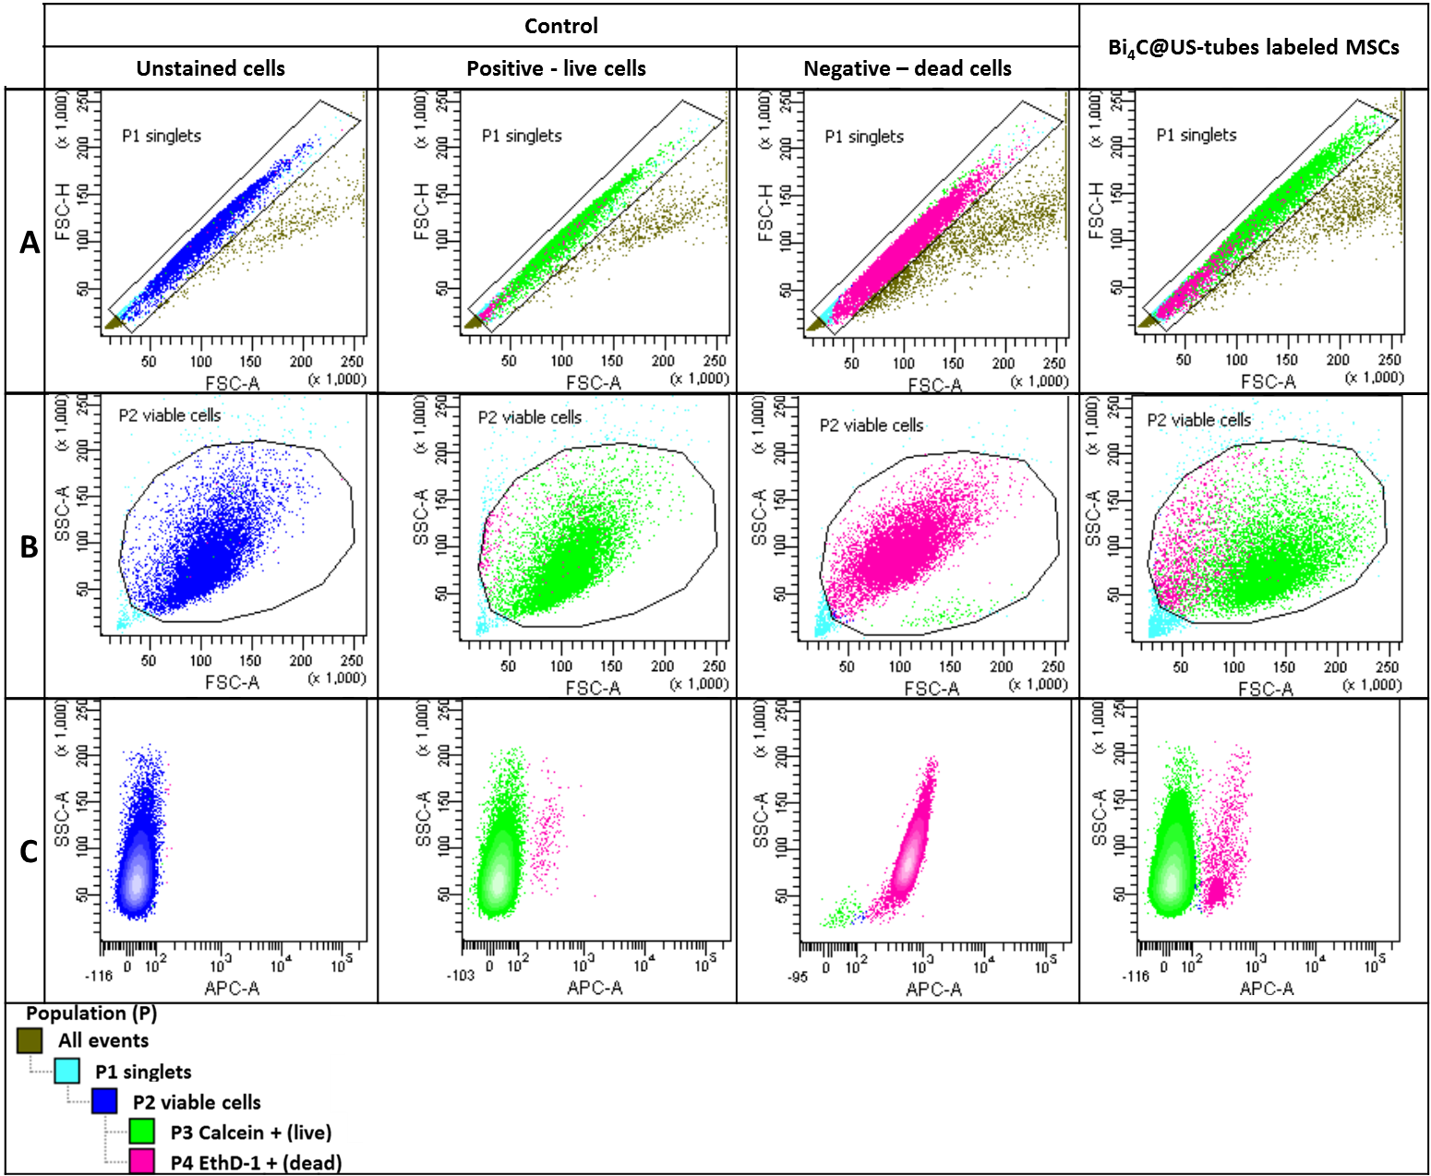

Figure S2: Data obtained by fluorescence-activated cell sorting (FACS) of unlabeled cells with not dyes (unstained MSCs), positive control cells (unlabeled live MSCs), negative control cells (unlabeled dead MSCs), and Bi₄@US-tubes-labeled MSCs (300 µM Bi³⁺). Representation of the gating for the FACS data, meaning, the selection of the regions of interest that determines which population is being analyzed. Since samples contain just one type of cell (MSC), the gating is excluding non-vial cells (debris) or big agglomerates of cells, thus the analyzed cells are viable, single cells. (A) Gating of the single cells, (B) gating for the viable cells, and (C) diagram of the side-scattered light (SSC) and Allophycocyanin (ACP-A) of the viable cells population.

Suspension | Zeta Potential (mV)
Pluronic® 0.17% (w/v)* | -19.3 ± 3.4
Full length SWCNTs* | -27.0 ± 1.7
US-tubes* | -53.8 ± 1.8
Gadonanotubes* | -44.3 ± 0.4
Bi₄C@US-tubes | -21.6 ± 2.3

Table S1: Z-potential values for Pluronic® alone, SWCNTs, US-tubes, Gadonanotubes and Bi₄@US-tubes. *Values previously reported in Ref. 1 below.

Reference

1. Phounsavath S. RF heating of ultra-short single-walled carbon nanotubes and gadonanotubes for non-invasive cancer hyperthermia. Ph.D. Dissertation, Rice University (2014).

