Supplementary Material
A
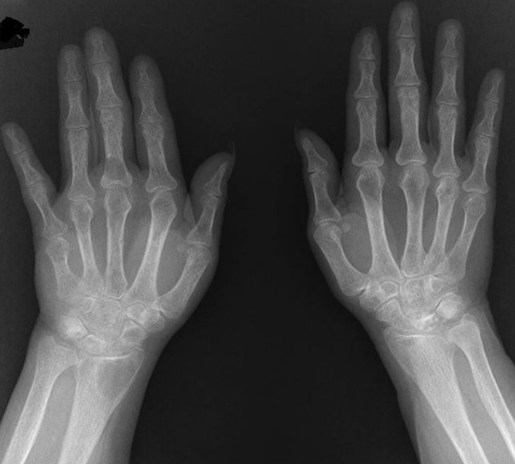

B
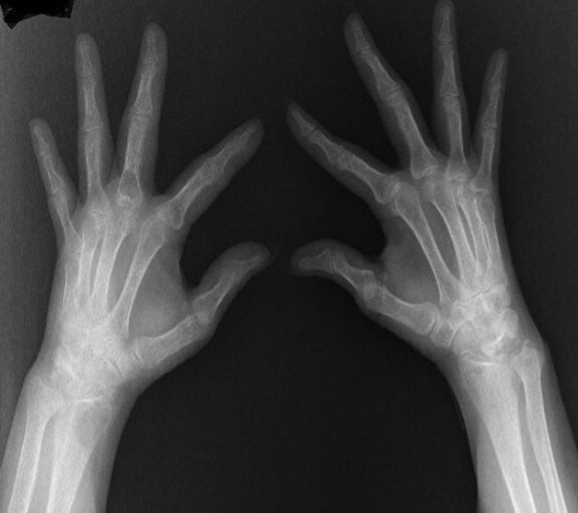

C
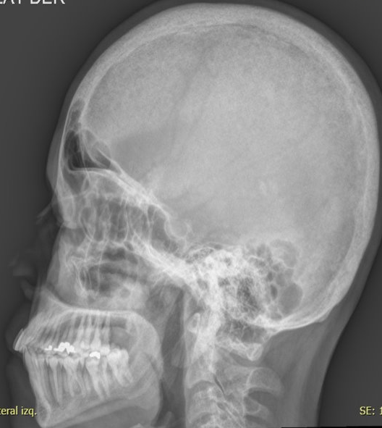

D
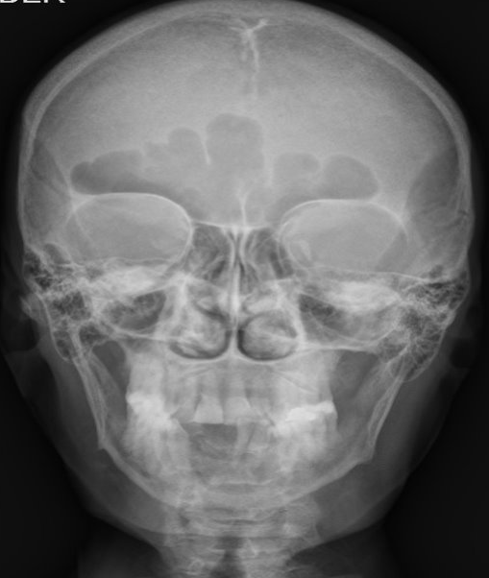

Supplementary figure 1. A, B Lytic lesion which involves lunate, hamate, and distal pole of the scaphoid bone bilaterally. Lytic lesion in distal radius. Generalized demineralization with thickening of trabecular pattern. Moth-eaten pattern (subperiosteal resorption) in metacarpal and phalanxes. Furthermore, cortical is irregular with small lytic images in the distal portion of the visible phalanxes. C, D Skull with salt and pepper lesions, a fine speckled pattern, and loss of the internal/external cortical definition.

Case reports from 2009-2020 (n =24) | Findings
Gender | ♀70%
Age | Mean 52 years (24-78)
Side | Left 45% Right 35% Middle 20%
Clinical presentation | Palpable nodule 45%  Bone pain 33%  Brown tumor 12.5%  Nephrolitiasis 12.5%  Constipation 25%  Asymptomatic 12.5%.
Metabolic profile | Mean Ca 13.8 mg/dl Mean PTH 1109 ng/L
Tumor weight (g) | Mean 47.24 g

Post-operative complications | Symptomatic hypocalcemia (32%)  Hungry bone syndrome (25%): especially with weight ≥15g

Supplementary Table 1. Characteristics of case reports with giant parathyroid adenomas.

