Table S1
93 compounds from WPX and their corresponding predicted OB, DL, Caco-2 scores and structures. 88 compounds that meet the parameters which OB ≥ 30%, DL ≥ 0.18, Caco-2 ≥0 were preserved as active compounds. 5 compounds which not meet the criterion but have been validated with various pharmaceutical activities were also reserved as the active components.
No. | Mol ID | Molecule name | OB | DL | Caco-2 | Structure | Herb
1 | MOL000006 | Luteolin | 36.16 | 0.25 | 0.19 | 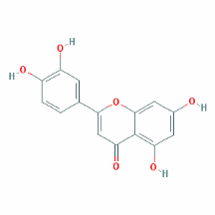 | PR，RS
2 | MOL000020 | 12-senecioyl-2E,8E,10E-atractylentriol | 62.40 | 0.22 | 0.01 | 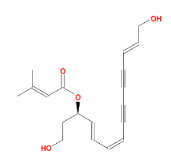 | AMK
3 | MOL000021 | 14-acetyl-12-senecioyl-2E,8E,10E-atractylentriol | 60.31 | 0.31 | 0.33 | 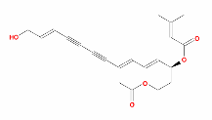 | AMK
4 | MOL000022 | 14-acetyl-12-senecioyl-2E,8Z,10E-atractylentriol | 63.37 | 0.30 | 0.42 | 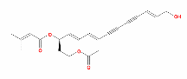 | AMK
5 | MOL000028 | α-Amyrin | 39.51 | 0.76 | 1.42 | 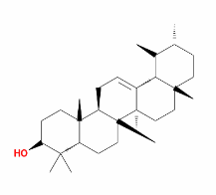 | AMK
6 | MOL000033 | (3S,8S,9S,10R,13R,14S,17R)-10,13-dimethyl-17-[(2R,5S)-5-propan-2-yloctan-2-yl]-2,3,4,7,8,9,11,12,14,15,16,17-dodecahydro-1H-cyclopenta[a]phenanthren-3-ol | 36.23 | 0.78 | 1.45 | 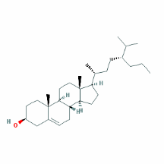 | HMM，AMK
7 | MOL000043 | AtractylenolideⅠ | 37.37 | 0.15 | 1.30 | 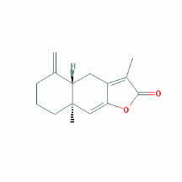 | AMK
8 | MOL000049 | 3β-acetoxyatractylone | 54.07 | 0.22 | 1.13 | 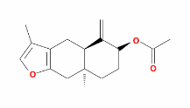 | AMK
9 | MOL000072 | 8β-ethoxy atractylenolide Ⅲ | 35.95 | 0.21 | 1.08 | 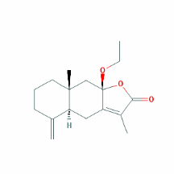 | AMK
10 | MOL000098 | Quercetin | 46.43 | 0.28 | 0.05 | 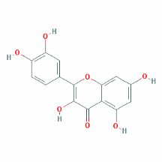 | HMM，HDH
11 | MOL000211 | Mairin | 55.38 | 0.78 | 0.73 | 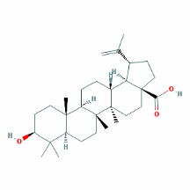 | HMM
12 | MOL000239 | Jaranol | 50.83 | 0.29 | 0.61 | 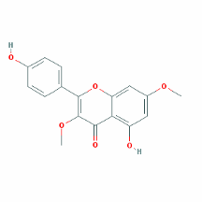 | HMM
13 | MOL000263 | Oleanolic acid | 29.02 | 0.76 | 0.59 | 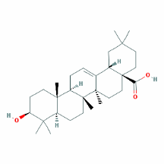 | RS，HDH
14 | MOL000296 | Hederagenin | 36.91 | 0.75 | 1.32 | 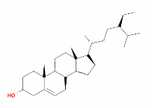 | HMM，CR
15 | MOL000354 | Isorhamnetin | 49.60 | 0.31 | 0.31 | 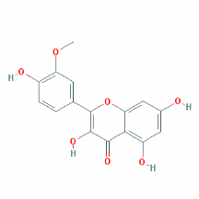 | HMM
16 | MOL000358 | Beta-sitosterol | 36.91 | 0.75 | 1.32 | 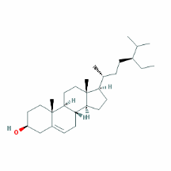 | PR，HDH
17 | MOL000371 | 3,9-di-O-methylnissolin | 53.74 | 0.48 | 1.18 | 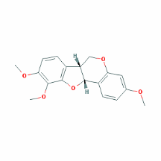 | HMM
18 | MOL000378 | 7-O-methylisomucronulatol | 74.69 | 0.30 | 1.08 | 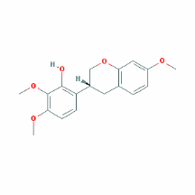 | HMM
19 | MOL000380 | (6aR,11aR)-9,10-dimethoxy-6a,11a-dihydro-6H-benzofurano[3,2-c]chromen-3-ol | 64.26 | 0.42 | 0.93 | 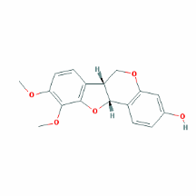 | HMM
20 | MOL000387 | Bifendate | 31.10 | 0.67 | 0.15 | 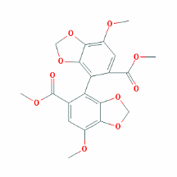 | HMM
21 | MOL000392 | Formononetin | 69.67 | 0.21 | 0.78 | 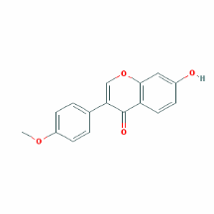 | HMM
22 | MOL000398 | Isoflavanone | 109.99 | 0.30 | 0.53 | 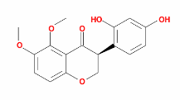 | HMM
23 | MOL000409 | Astragaloside IV | 17.74 | 0.15 | (2.22) | 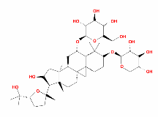 | HMM
24 | MOL000417 | Calycosin | 47.75 | 0.24 | 0.52 | 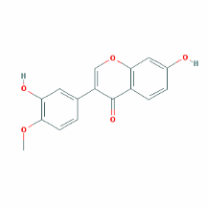 | HMM
25 | MOL000422 | kaempferol | 41.88 | 0.24 | 0.26 | 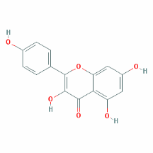 | HMM
26 | MOL000438 | (3R)-3-(2-hydroxy-3,4-dimethoxyphenyl)chroman-7-ol | 67.67 | 0.26 | 0.96 | 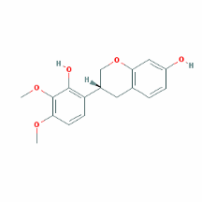 | HMM
27 | MOL000442 | 1,7-Dihydroxy-3,9-dimethoxy pterocarpene | 39.05 | 0.48 | 0.89 | 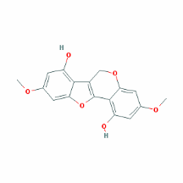 | HMM
28 | MOL000449 | Stigmasterol | 43.83 | 0.76 | 1.44 | 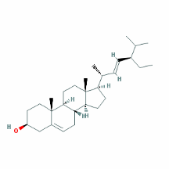 | HDH
29 | MOL000902 | Curcumol | 103.55 | 0.13 | 1.12 | 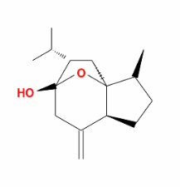 | CR
30 | MOL000906 | Wenjine | 47.93 | 0.27 | 0.30 | 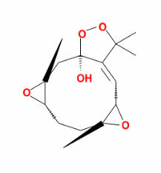 | CR
31 | MOL000940 | Bisdemethoxycurcumin | 77.38 | 0.26 | 0.49 | 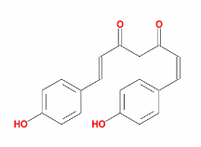 | CR
32 | MOL001506 | Supraene | 33.55 | 0.42 | 2.08 | 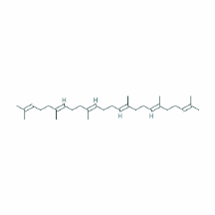 | PR
33 | MOL001601 | 1,2,5,6-tetrahydrotanshinone | 38.75 | 0.36 | 0.96 | 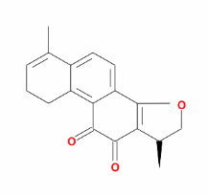 | RS
34 | MOL001646 | 2,3-dimethoxy-6-methyanthraquinone | 34.86 | 0.26 | 0.75 | 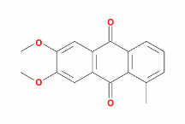 | HDH
35 | MOL001659 | Poriferasterol | 43.83 | 0.76 | 1.44 | 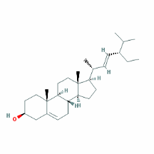 | RS，HDH
36 | MOL001663 | (4aS,6aR,6aS,6bR,8aR,10R,12aR,14bS)-10-hydroxy-2,2,6a,6b,9,9,12a-heptamethyl-1,3,4,5,6,6a,7,8,8a,10,11,12,13,14b-tetradecahydropicene-4a-carboxylic acid | 32.03 | 0.76 | 0.61 | 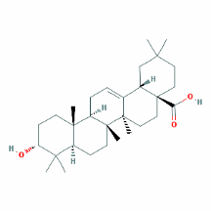 | HDH
37 | MOL001670 | 2-methoxy-3-methyl-9,10-anthraquinone | 37.83 | 0.21 | 0.73 | 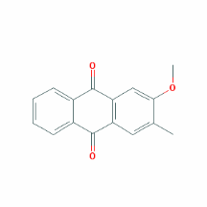 | HDH
38 | MOL001689 | Acacetin | 34.97 | 0.24 | 0.67 | 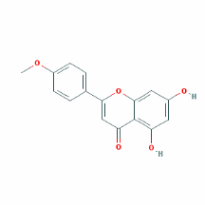 | PR
39 | MOL001771 | Poriferast-5-en-3beta-ol | 36.91 | 0.75 | 1.45 | 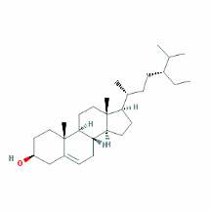 | RS
40 | MOL001942 | Isoimperatorin | 45.46 | 0.23 | 0.97 | 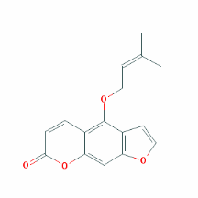 | RS
41 | MOL002222 | Sugiol | 36.11 | 0.28 | 1.14 | 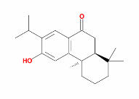 | RS
42 | MOL002464 | 1-Monolinolein | 37.18 | 0.30 | 0.32 | 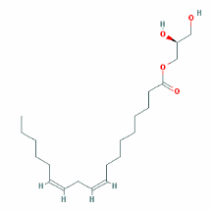 | PR
43 | MOL002651 | Dehydrotanshinone II A | 43.76 | 0.40 | 1.02 | 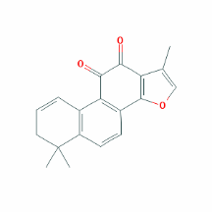 | RS
44 | MOL006554 | Taraxerol | 38.40 | 0.77 | 1.37 | 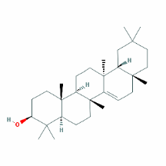 | PR
45 | MOL006756 | Schottenol | 37.42 | 0.75 | 1.33 | 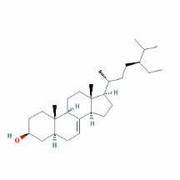 | PR
46 | MOL006824 | α-amyrin | 39.51 | 0.76 | 1.37 | 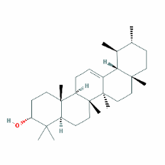 | RS
47 | MOL007036 | 5,6-dihydroxy-7-isopropyl-1,1-dimethyl-2,3-dihydrophenanthren-4-one | 33.77 | 0.29 | 1.19 | 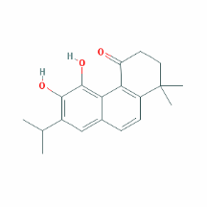 | RS
48 | MOL007041 | 2-isopropyl-8-methylphenanthrene-3,4-dione | 40.86 | 0.23 | 1.23 | 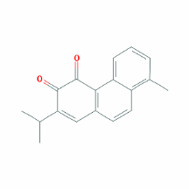 | RS
49 | MOL007045 | 3α-hydroxytanshinoneⅡA | 44.93 | 0.44 | 0.53 | 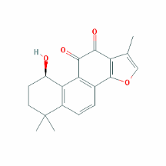 | RS
50 | MOL007048 | (E)-3-[2-(3,4-dihydroxyphenyl)-7-hydroxy-benzofuran-4-yl]acrylic acid | 48.24 | 0.31 | 0.18 | 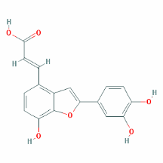 | RS
51 | MOL007049 | 4-methylenemiltirone | 34.35 | 0.23 | 1.25 | 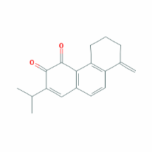 | RS
52 | MOL007050 | 2-(4-hydroxy-3-methoxyphenyl)-5-(3-hydroxypropyl)-7-methoxy-3-benzofurancarboxaldehyde | 62.78 | 0.40 | 0.35 | 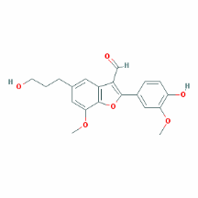 | RS
53 | MOL007058 | Formyltanshinone | 73.44 | 0.42 | 0.54 | 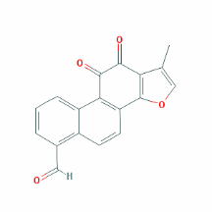 | RS
54 | MOL007059 | 3-beta-Hydroxymethyllenetanshiquinone | 32.16 | 0.41 | 0.38 | 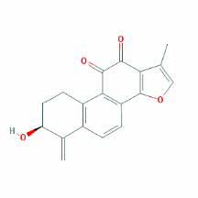 | RS
55 | MOL007061 | Methylenetanshinquinone | 37.07 | 0.36 | 1.03 | 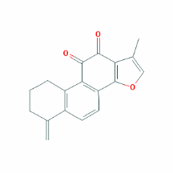 | RS
56 | MOL007064 | Przewalskin B | 110.32 | 0.44 | 0.34 | 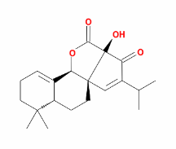 | RS
57 | MOL007068 | Przewaquinone B | 62.24 | 0.41 | 0.39 | 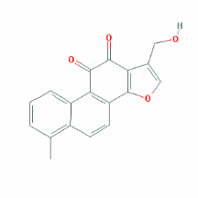 | RS
58 | MOL007069 | Przewaquinone C | 55.74 | 0.40 | 0.42 | 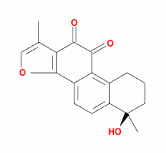 | RS
59 | MOL007077 | Sclareol | 43.67 | 0.21 | 0.84 | 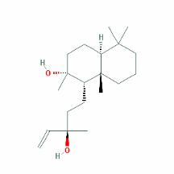 | RS
60 | MOL007079 | Tanshinaldehyde | 52.47 | 0.45 | 0.57 | 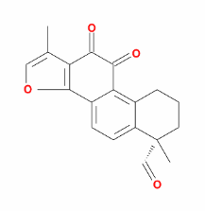 | RS
61 | MOL007081 | Danshenol B | 57.95 | 0.56 | 0.53 | 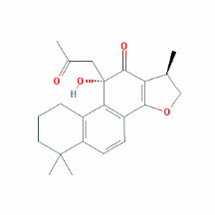 | RS
62 | MOL007082 | Danshenol A | 56.97 | 0.52 | 0.33 | 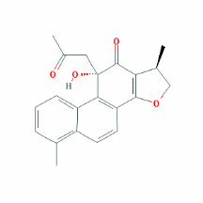 | RS
63 | MOL007085 | Salvilenone | 30.38 | 0.38 | 1.46 | 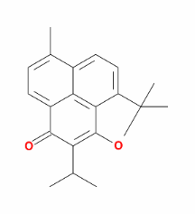 | RS
64 | MOL007088 | Cryptotanshinone | 52.34 | 0.40 | 0.95 | 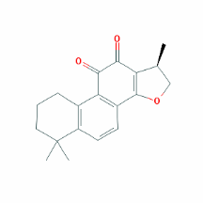 | RS
65 | MOL007093 | Dan-shexinkum d | 38.88 | 0.55 | 0.67 | 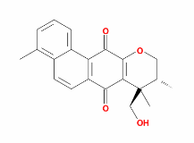 | RS
66 | MOL007094 | Danshenspiroketallactone | 50.43 | 0.31 | 0.88 | 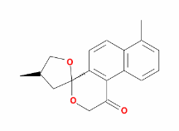 | RS
67 | MOL007098 | Deoxyneocryptotanshinone | 49.40 | 0.29 | 0.85 | 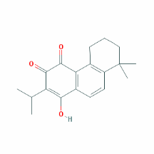 | RS
68 | MOL007100 | Dihydrotanshinlactone | 38.68 | 0.32 | 1.26 | 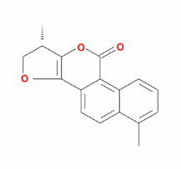 | RS
69 | MOL007101 | DihydrotanshinoneⅠ | 45.04 | 0.36 | 0.95 | 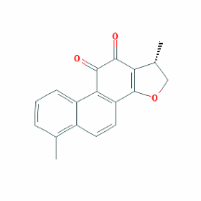 | RS
70 | MOL007105 | Epidanshenspiroketallactone | 68.27 | 0.31 | 0.90 | 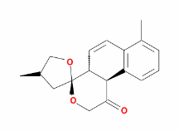 | RS
71 | MOL007107 | C09092 | 36.07 | 0.25 | 1.63 | 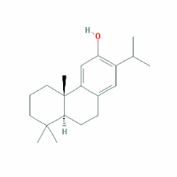 | RS
72 | MOL007108 | Isocryptotanshi-none | 54.98 | 0.39 | 0.93 | 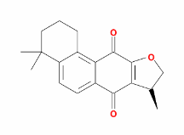 | RS
73 | MOL007111 | Isotanshinone II | 49.92 | 0.40 | 1.03 | 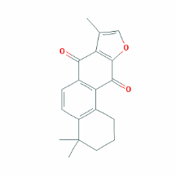 | RS
74 | MOL007115 | Manool | 45.04 | 0.20 | 1.28 | 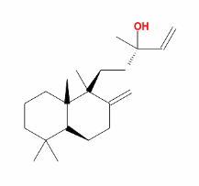 | RS
75 | MOL007118 | Microstegiol | 39.61 | 0.28 | 1.05 | 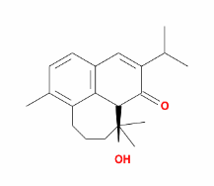 | RS
76 | MOL007119 | Miltionone Ⅰ | 49.68 | 0.32 | 0.35 | 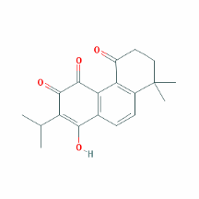 | RS
77 | MOL007120 | Miltionone Ⅱ | 71.03 | 0.44 | 0.62 | 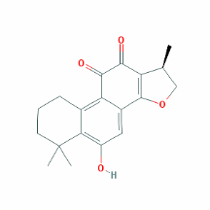 | RS
78 | MOL007121 | Miltipolone | 36.56 | 0.37 | 0.50 | 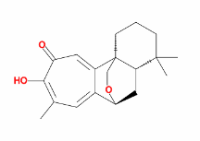 | RS
79 | MOL007122 | Miltirone | 38.76 | 0.25 | 1.23 | 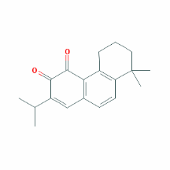 | RS
80 | MOL007123 | Miltirone Ⅱ | 44.95 | 0.24 | 0.04 | 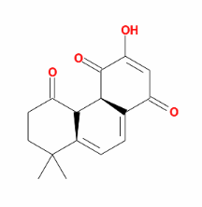 | RS
81 | MOL007124 | Neocryptotanshinone Ⅱ | 39.46 | 0.23 | 0.76 | 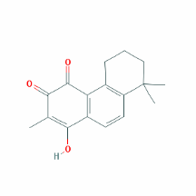 | RS
82 | MOL007125 | Neocryptotanshinone | 52.49 | 0.32 | 0.35 | 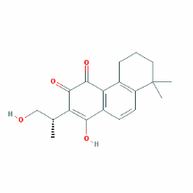 | RS
83 | MOL007127 | 1-methyl-8,9-dihydro-7H-naphtho[5,6-g]benzofuran-6,10,11-trione | 34.72 | 0.37 | 0.50 | 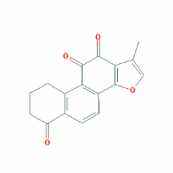 | RS
84 | MOL007130 | Prolithospermic acid | 64.37 | 0.31 | 0.10 | 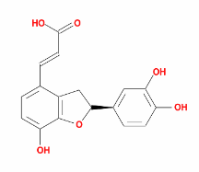 | RS
85 | MOL007134 | Danshensu | 36.91 | 0.06 | -0.27 | 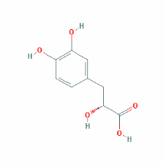 | RS
86 | MOL007143 | Salvilenone Ⅰ | 32.43 | 0.23 | 1.13 | 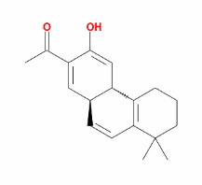 | RS
87 | MOL007145 | Salviolone | 31.72 | 0.24 | 1.04 | 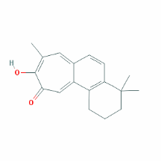 | RS
88 | MOL007149 | NSC 122421 | 34.49 | 0.28 | 1.08 | 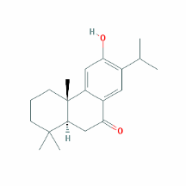 | RS
89 | MOL007150 | (6S)-6-hydroxy-1-methyl-6-methylol-8,9-dihydro-7H-naphtho[8,7-g]benzofuran-10,11-quinone | 75.39 | 0.46 | 0.03 | 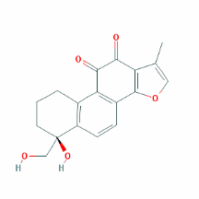 | RS
90 | MOL007151 | Tanshindiol B | 42.67 | 0.45 | 0.05 | 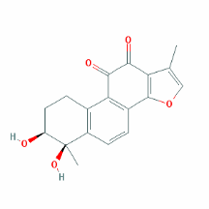 | RS
91 | MOL007154 | Tanshinone Ⅱa | 49.89 | 0.40 | 1.05 | 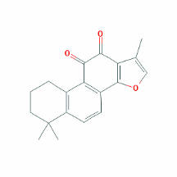 | RS
92 | MOL007155 | (6S)-6-(hydroxymethyl)-1,6-dimethyl-8,9-dihydro-7H-naphtho[8,7-g]benzofuran-10,11-dione | 65.26 | 0.45 | 0.44 | 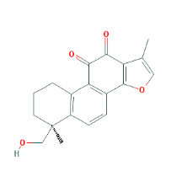 | RS
93 | MOL007156 | Tanshinone Ⅵ | 45.64 | 0.30 | 0.48 | 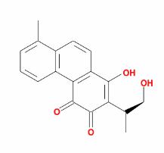 | RS

Table S2
The information of GPL-related targets. By combining the compound targets of WPX and the disease related targets, 146 overlapping ones were selected as the key targets in the treatment of GPL.
ID | UniProt | Protein names | Gene names | Organism
T01 | Q9UNQ0 | ATP-binding cassette sub-family G member 2 | ABCG2 | Homo sapiens
T02 | P15309 | Prostatic acid phosphatase | ACPP | Homo sapiens
T03 | P00326 | Alcohol dehydrogenase 1C | ADH1C | Homo sapiens
T04 | P35869 | Aryl hydrocarbon receptor | AHR | Homo sapiens
T05 | P15121 | Aldose reductase | AKR1B1 | Homo sapiens
T06 | O60218 | Aldo-keto reductase family 1 member B10 | AKR1B10 | Homo sapiens
T07 | P31749 | RAC-alpha serine/threonine-protein kinase | AKT1 | Homo sapiens
T08 | P18054 | Arachidonate 12-lipoxygenase, 12S-type | ALOX12 | Homo sapiens
T09 | P09917 | Arachidonate 5-lipoxygenase | ALOX5 | Homo sapiens
T10 | P10275 | Androgen receptor | AR | Homo sapiens
T11 | Q07812 | Apoptosis regulator BAX | BAX | Homo sapiens
T12 | P10415 | Apoptosis regulator Bcl-2 | BCL2 | Homo sapiens
T13 | Q07817 | Bcl-2-like protein 1 | BCL2L1 | Homo sapiens
T14 | O15392 | Baculoviral IAP repeat-containing protein 5 | BIRC5 | Homo sapiens
T15 | P42574 | Caspase-3 | CASP3 | Homo sapiens
T16 | Q14790 | Caspase-8 | CASP8 | Homo sapiens
T17 | P55211 | Caspase-9 | CASP9 | Homo sapiens
T18 | Q03135 | Caveolin-1 | CAV1 | Homo sapiens
T19 | P13500 | C-C motif chemokine 2 | CCL2 | Homo sapiens
T20 | P20248 | Cyclin-A2 | CCNA2 | Homo sapiens
T21 | P14635 | G2/mitotic-specific cyclin-B1 | CCNB1 | Homo sapiens
T22 | P24385 | G1/S-specific cyclin-D1 | CCND1 | Homo sapiens
T23 | P06493 | Cell division control protein 2 homolog | CDK1 | Homo sapiens
T24 | P24941 | Cell division protein kinase 2 | CDK2 | Homo sapiens
T25 | P11802 | Cell division protein kinase 4 | CDK4 | Homo sapiens
T26 | P38936 | Cyclin-dependent kinase inhibitor 1 | CDKN1A | Homo sapiens
T27 | P42771 | Cyclin-dependent kinase inhibitor 2A, isoforms 1/2/3 | CDKN2A | Homo sapiens
T28 | O14757 | Serine/threonine-protein kinase Chk1 | CHEK1 | Homo sapiens
T29 | O96017 | Serine/threonine-protein kinase Chk2 | CHEK2 | Homo sapiens
T30 | O14493 | Claudin-4 | CLDN4 | Homo sapiens
T31 | P02452 | Collagen alpha-1(I) chain | COL1A1 | Homo sapiens
T32 | P02741 | C-reactive protein | CRP | Homo sapiens
T33 | P07339 | Cathepsin D | CTSD | Homo sapiens
T34 | P10145 | Interleukin-8 | CXCL8 | Homo sapiens
T35 | P11511 | Cytochrome P450 19A1 | CYP19A1 | Homo sapiens
T36 | P04798 | Cytochrome P450 1A1 | CYP1A1 | Homo sapiens
T37 | P05177 | Cytochrome P450 1A2 | CYP1A2 | Homo sapiens
T38 | Q16678 | Cytochrome P450 1B1 | CYP1B1 | Homo sapiens
T39 | P08684 | Cytochrome P450 3A4 | CYP3A4 | Homo sapiens
T40 | P27487 | Dipeptidyl peptidase IV | DPP4 | Homo sapiens
T41 | Q01094 | Transcription factor E2F2 | E2F1 | Homo sapiens
T42 | P01133 | Pro-epidermal growth factor | EGF | Homo sapiens
T43 | P00533 | Epidermal growth factor receptor | EGFR | Homo sapiens
T44 | P19419 | ETS domain-containing protein Elk-1 | ELK1 | Homo sapiens
T45 | P04626 | Receptor tyrosine-protein kinase erbB-2 | ERBB2 | Homo sapiens
T46 | P21860 | Receptor tyrosine-protein kinase erbB-3 | ERBB3 | Homo sapiens
T47 | P03372 | Estrogen receptor | ESR1 | Homo sapiens
T48 | Q92731 | Estrogen receptor beta | ESR2 | Homo sapiens
T49 | P13726 | Tissue factor | F3 | Homo sapiens
T50 | P48023 | Tumor necrosis factor ligand superfamily member 6 | FASLG | Homo sapiens
T51 | P49327 | Fatty acid synthase | FASN | Homo sapiens
T52 | P05230 | Fibroblast growth factor 1 | FGF1 | Homo sapiens
T53 | P09038 | Fibroblast growth factor 2 | FGF2 | Homo sapiens
T54 | P17948 | Vascular endothelial growth factor receptor 1 | FLT1 | Homo sapiens
T55 | P35916 | Vascular endothelial growth factor receptor 3 | FLT4 | Homo sapiens
T56 | P01100 | Proto-oncogene c-Fos | FOS | Homo sapiens
T57 | P17302 | Gap junction alpha-1 protein | GJA1 | Homo sapiens
T58 | P49841 | Glycogen synthase kinase-3 beta | GSK3B | Homo sapiens
T59 | P09488 | Glutathione S-transferase Mu 1 | GSTM1 | Homo sapiens
T60 | P09211 | Glutathione S-transferase P | GSTP1 | Homo sapiens
T61 | P14210 | Hepatocyte growth factor receptor | HGF | Homo sapiens
T62 | Q16665 | Hypoxia-inducible factor 1-alpha | HIF1A | Homo sapiens
T63 | P52789 | Hexokinase-2 | HK2 | Homo sapiens
T64 | P04035 | 3-hydroxy-3-methylglutaryl-coenzyme A reductase | HMGCR | Homo sapiens
T65 | P09601 | Heme oxygenase 1 | HMOX1 | Homo sapiens
T66 | Q9Y251 | Heparanase 8 kDa subunit | HPSE | Homo sapiens
T67 | P07900 | Heat shock protein HSP 90 | HSP90AA1 | Homo sapiens
T68 | P11021 | 78 kDa glucose-regulated protein | HSPA5 | Homo sapiens
T69 | P04792 | Heat shock protein beta-1 | HSPB1 | Homo sapiens
T70 | P05362 | Intercellular adhesion molecule 1 | ICAM1 | Homo sapiens
T71 | P01579 | Interferon gamma | IFNG | Homo sapiens
T72 | P01344 | Insulin-like growth factor II | IGF2 | Homo sapiens
T73 | P17936 | Insulin-like growth factor-binding protein 3 | IGFBP3 | Homo sapiens
T74 | O14920 | Inhibitor of nuclear factor kappa-B kinase subunit beta | IKBKB | Homo sapiens
T75 | P22301 | Interleukin-10 | IL10 | Homo sapiens
T76 | P01584 | Interleukin-1 beta | IL1B | Homo sapiens
T77 | P60568 | Interleukin-2 | IL2 | Homo sapiens
T78 | P05112 | Interleukin-4 | IL4 | Homo sapiens
T79 | P05231 | Interleukin-6 | IL6 | Homo sapiens
T80 | P06213 | Insulin receptor | INSR | Homo sapiens
T81 | P10914 | Interferon regulatory factor 1 | IRF1 | Homo sapiens
T82 | P05412 | Transcription factor AP-1 | JUN | Homo sapiens
T83 | Q12809 | Potassium voltage-gated channel subfamily H member 2 | KCNH2 | Homo sapiens
T84 | P35968 | Vascular endothelial growth factor receptor 2 | KDR | Homo sapiens
T85 | P09960 | Leukotriene A-4 hydrolase | LTA4H | Homo sapiens
T86 | P28482 | Mitogen-activated protein kinase 1 | MAPK1 | Homo sapiens
T87 | Q16539 | Mitogen-activated protein kinase 14 | MAPK14 | Homo sapiens
T88 | P45983 | Mitogen-activated protein kinase 8 | MAPK8 | Homo sapiens
T89 | Q07820 | Induced myeloid leukemia cell differentiation protein Mcl-1 | MCL1 | Homo sapiens
T90 | Q00987 | E3 ubiquitin-protein ligase Mdm2 | MDM2 | Homo sapiens
T91 | O43451 | Maltase-glucoamylase, intestinal | MGAM | Homo sapiens
T92 | P03956 | Interstitial collagenase | MMP1 | Homo sapiens
T93 | P08253 | 72 kDa type IV collagenase | MMP2 | Homo sapiens
T94 | P08254 | Stromelysin-1 | MMP3 | Homo sapiens
T95 | P14780 | Matrix metalloproteinase-9 | MMP9 | Homo sapiens
T96 | P05164 | Myeloperoxidase | MPO | Homo sapiens
T97 | P01106 | Myc proto-oncogene protein | MYC | Homo sapiens
T98 | P21359 | Neurofibromin | NF1 | Homo sapiens
T99 | Q16236 | Nuclear factor erythroid 2-related factor 2 | NFE2L2 | Homo sapiens
T100 | Q99801 | Homeobox protein Nkx-3.1 | NKX3-1 | Homo sapiens
T101 | P35228 | Nitric oxide synthase, inducible | NOS2 | Homo sapiens
T102 | P15559 | NAD(P)H dehydrogenase [quinone] 1 | NQO1 | Homo sapiens
T103 | O75469 | Nuclear receptor subfamily 1 group I member 2 | NR1I2 | Homo sapiens
T104 | P11926 | Ornithine decarboxylase | ODC1 | Homo sapiens
T105 | P09874 | Poly [ADP-ribose] polymerase 1 | PARP1 | Homo sapiens
T106 | P12004 | Proliferating cell nuclear antigen | PCNA | Homo sapiens
T107 | P06401 | Progesterone receptor | PGR | Homo sapiens
T108 | P48736 | Phosphatidylinositol-4,5-bisphosphate 3-kinase catalytic subunit, gamma isoform | PIK3CG | Homo sapiens
T109 | P11309 | Proto-oncogene serine/threonine-protein kinase Pim-1 | PIM1 | Homo sapiens
T110 | P00749 | Urokinase-type plasminogen activator | PLAU | Homo sapiens
T111 | Q07869 | Peroxisome proliferator-activated receptor alpha | PPARA | Homo sapiens
T112 | Q03181 | Peroxisome proliferator-activated receptor delta | PPARD | Homo sapiens
T113 | P37231 | Peroxisome proliferator-activated receptor gamma | PPARG | Homo sapiens
T114 | P05771 | Protein kinase C beta type | PRKCB | Homo sapiens
T115 | P07477 | Trypsin-1 | PRSS1 | Homo sapiens
T116 | P60484 | Phosphatidylinositol-3,4,5-trisphosphate 3-phosphatase and dual-specificity protein phosphatase PTEN | PTEN | Homo sapiens
T117 | P43115 | Prostaglandin E2 receptor EP3 subtype | PTGER3 | Homo sapiens
T118 | P23219 | Prostaglandin G/H synthase 1 | PTGS1 | Homo sapiens
T119 | P35354 | Prostaglandin G/H synthase 2 | PTGS2 | Homo sapiens
T120 | P04049 | RAF proto-oncogene serine/threonine-protein kinase | RAF1 | Homo sapiens
T121 | Q9NS23 | Ras association domain-containing protein 1 | RASSF1 | Homo sapiens
T122 | P06400 | Retinoblastoma-associated protein | RB1 | Homo sapiens
T123 | Q04206 | Transcription factor p65 | RELA | Homo sapiens
T124 | Q13950 | Runt-related transcription factor 2 | RUNX2 | Homo sapiens
T125 | P19793 | Retinoic acid receptor RXR-alpha | RXRA | Homo sapiens
T126 | P28702 | Retinoic acid receptor RXR-beta | RXRB | Homo sapiens
T127 | P05121 | Plasminogen activator inhibitor 1 | SERPINE1 | Homo sapiens
T128 | Q96EB6 | NAD-dependent deacetylase sirtuin-1 | SIRT1 | Homo sapiens
T129 | P03973 | Antileukoproteinase | SLPI | Homo sapiens
T130 | P00441 | Superoxide dismutase [Cu-Zn] | SOD1 | Homo sapiens
T131 | P10451 | Osteopontin | SPP1 | Homo sapiens
T132 | P12931 | Proto-oncogene tyrosine-protein kinase Src | SRC | Homo sapiens
T133 | P42224 | Signal transducer and activator of transcription 1-alpha/beta | STAT1 | Homo sapiens
T134 | P40763 | Signal transducer and activator of transcription 3 | STAT3 | Homo sapiens
T135 | P01137 | Transforming growth factor beta-1 | TGFB1 | Homo sapiens
T136 | P07204 | Thrombomodulin | THBD | Homo sapiens
T137 | P01033 | Metalloproteinase inhibitor 1 | TIMP1 | Homo sapiens
T138 | Q9NR96 | Toll-like receptor 9 | TLR9 | Homo sapiens
T139 | P01375 | Tumor necrosis factor | TNF | Homo sapiens
T140 | P11387 | DNA topoisomerase 1 | TOP1 | Homo sapiens
T141 | P11388 | DNA topoisomerase 2-alpha | TOP2A | Homo sapiens
T142 | P04637 | Cellular tumor antigen p53 | TP53 | Homo sapiens
T143 | P15692 | Vascular endothelial growth factor A | VEGFA | Homo sapiens
T144 | P47989 | Xanthine dehydrogenase/oxidase | XDH | Homo sapiens
T145 | P98170 | Baculoviral IAP repeat-containing protein 4 | XIAP | Homo sapiens
T146 | P07947 | Tyrosine-protein kinase Yes | YES1 | Homo sapiens

Table S3
The GO terms of therapy target genes and their corresponding Count, PValue, FDR. Through the GO enrichment of the key targets, 26 top GO terms were obtained which indicate that large numbers of targets involved in the process of tumorigenesis.
GO ID | Term | Count | PValue | FDR
GO:0045944 | positive regulation of transcription from RNA polymerase II promoter | 48 | 4.35E-23 | 7.66E-20
GO:0043066 | negative regulation of apoptotic process | 39 | 5.03E-27 | 8.86E-24
GO:0045893 | positive regulation of transcription, DNA-templated | 39 | 4.54E-25 | 7.99E-22
GO:0008284 | positive regulation of cell proliferation | 35 | 2.99E-22 | 5.27E-19
GO:0007165 | signal transduction | 31 | 4.88E-08 | 8.58E-05
GO:0042493 | response to drug | 30 | 3.01E-22 | 5.30E-19
GO:0010628 | positive regulation of gene expression | 27 | 1.96E-20 | 3.46E-17
GO:0006915 | apoptotic process | 26 | 1.70E-11 | 2.99E-08
GO:0000122 | negative regulation of transcription from RNA polymerase II promoter | 23 | 2.39E-07 | 4.21E-04
GO:0007568 | aging | 20 | 2.28E-16 | 3.89E-13
GO:0043065 | positive regulation of apoptotic process | 20 | 1.28E-11 | 2.25E-08
GO:0008285 | negative regulation of cell proliferation | 20 | 1.44E-09 | 2.53E-06
GO:0045892 | negative regulation of transcription, DNA-templated | 20 | 6.02E-08 | 1.06E-04
GO:0001525 | angiogenesis | 19 | 7.81E-13 | 1.37E-09
GO:0006954 | inflammatory response | 19 | 4.72E-09 | 8.31E-06
GO:0071456 | cellular response to hypoxia | 18 | 5.33E-18 | 9.37E-15
GO:0045766 | positive regulation of angiogenesis | 18 | 1.29E-16 | 2.00E-13
GO:0008283 | cell proliferation | 18 | 1.81E-08 | 3.19E-05
GO:0006468 | protein phosphorylation | 17 | 2.10E-06 | 0.003686
GO:0001934 | positive regulation of protein phosphorylation | 16 | 2.71E-13 | 4.77E-10
GO:0001666 | response to hypoxia | 16 | 2.33E-11 | 4.09E-08
GO:0000165 | MAPK cascade | 16 | 8.27E-09 | 1.45E-05
GO:0032355 | response to estradiol | 15 | 4.10E-14 | 7.21E-11
GO:0071222 | cellular response to lipopolysaccharide | 15 | 8.95E-13 | 1.58E-09
GO:0070374 | positive regulation of ERK1 and ERK2 cascade | 15 | 3.52E-10 | 6.19E-07
GO:0006974 | cellular response to DNA damage stimulus | 15 | 3.38E-09 | 5.95E-06

Table S4
The KEGG Pathways of therapy target genes and their corresponding Count, PValue and FDR. Through the KEGG enrichment of the key targets, 21 remarkably enriched pathways which involved in cell proliferation, apoptosis and inflammation were obtained.
Term | Pathways | Count | Pvalue | FDR
hsa05200 | Pathways in cancer | 58 | 5.71E-36 | 7.20E-33
hsa04151 | PI3K-Akt signaling pathway | 37 | 3.03E-17 | 3.82E-14
hsa04010 | MAPK signaling pathway | 24 | 7.32E-10 | 9.24E-07
hsa04014 | Ras signaling pathway | 23 | 4.16E-10 | 5.25E-07
hsa04068 | FoxO signaling pathway | 22 | 9.91E-14 | 1.25E-10
hsa04066 | HIF-1 signaling pathway | 21 | 1.99E-15 | 2.52E-12
hsa04668 | TNF signaling pathway | 19 | 1.60E-12 | 2.02E-09
hsa04115 | p53 signaling pathway | 18 | 6.05E-15 | 7.56E-12
hsa04110 | Cell cycle | 18 | 2.38E-10 | 3.00E-07
hsa05202 | Transcriptional misregulation in cancer | 18 | 2.72E-08 | 3.43E-05
hsa04060 | Cytokine-cytokine receptor interaction | 18 | 2.52E-06 | 0.003174625
hsa04620 | Toll-like receptor signaling pathway | 17 | 1.91E-10 | 2.41E-07
hsa04015 | Rap1 signaling pathway | 17 | 3.43E-06 | 0.004325218
hsa04012 | ErbB signaling pathway | 16 | 1.04E-10 | 1.31E-07
hsa04660 | T cell receptor signaling pathway | 16 | 1.23E-09 | 1.55E-06
hsa04210 | Apoptosis | 14 | 1.50E-10 | 1.89E-07
hsa04915 | Estrogen signaling pathway | 13 | 4.83E-07 | 6.09E-04
hsa04621 | NOD-like receptor signaling pathway | 12 | 7.07E-09 | 8.92E-06
hsa04370 | VEGF signaling pathway | 12 | 2.23E-08 | 2.82E-05
hsa05230 | Central carbon metabolism in cancer | 11 | 4.11E-07 | 5.19E-04
hsa04064 | NF-kappa B signaling pathway | 11 | 7.37E-06 | 0.009296675

