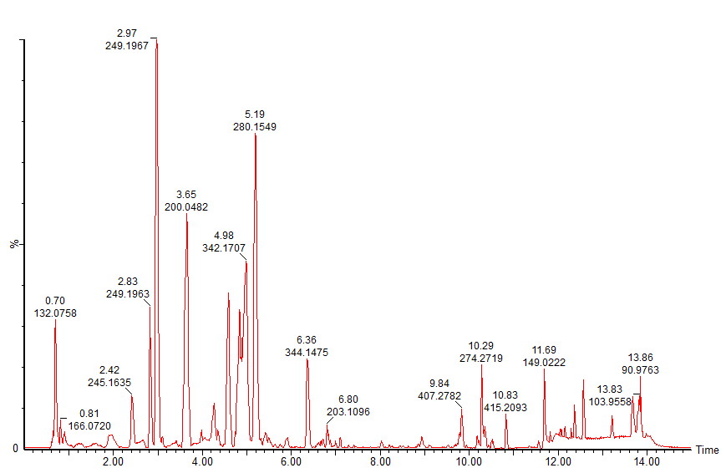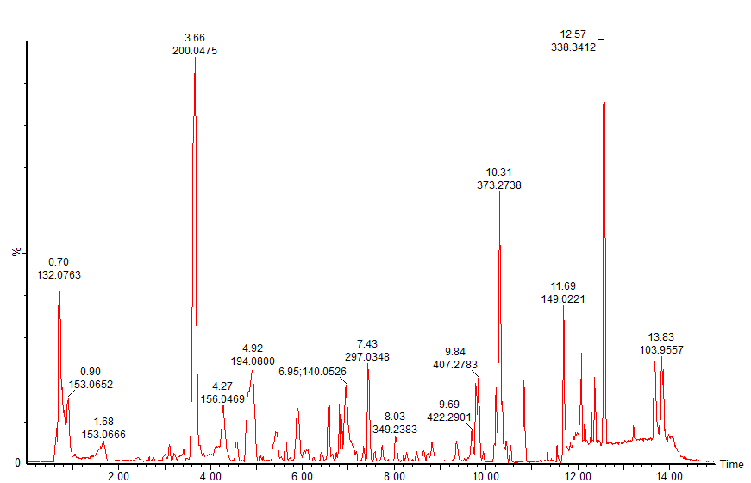

+ESIB

+ESIA

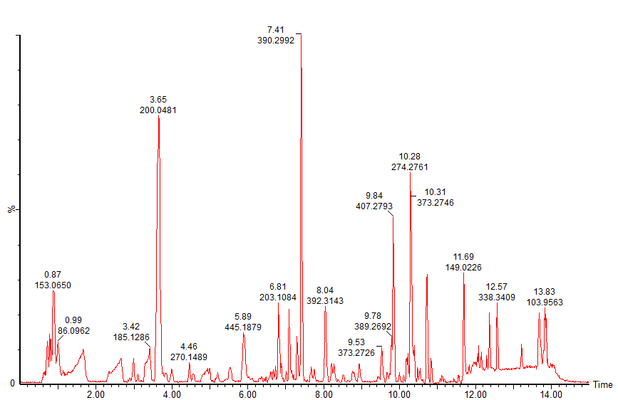

+ESIC

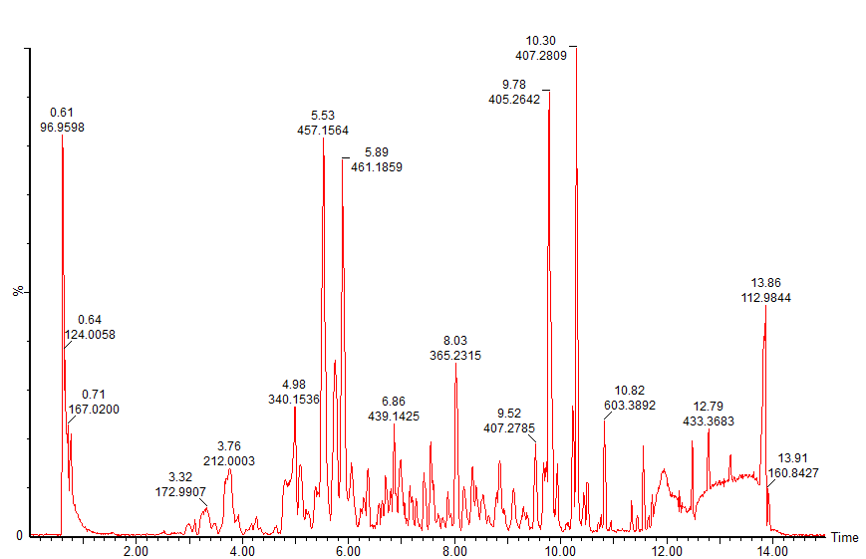

-ESIB

-ESIA

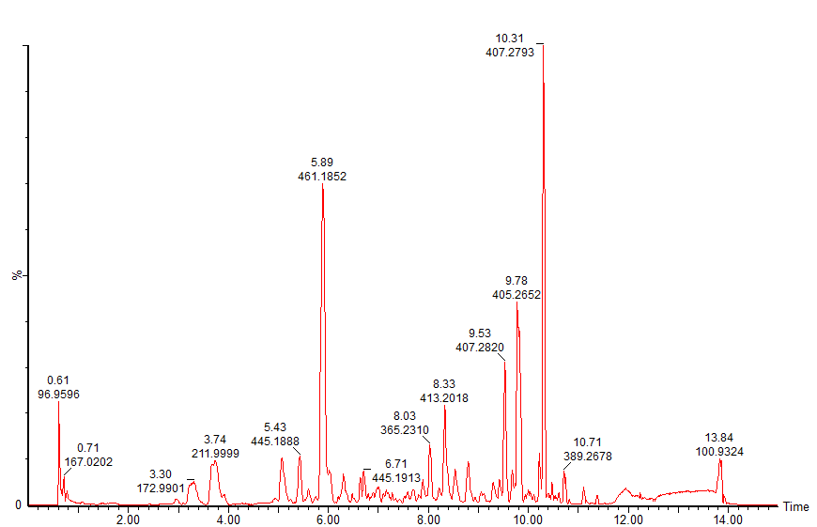

-ESIC

FigS1 ESI (+) and ESI (-) BPI chromatogram profile of metabolites in rat urine (A,B,C) by UPLC-Q-TOF/MS

(Normal:A; Vehicle: B;CRME:C)

|  |  |  |  |  |  |  |  |  |  |
| --- | --- | --- | --- | --- | --- | --- | --- | --- | --- |
| **NO.**  Tab.S1 Identities of differential metabolites between model and normal rats in urine | **Compound ID** | **ion mode** | **Rt**  **min** | **m/z** | **VIP value** | **Formula** | **Description** | **[KEGG](https://cn.bing.com/dict/search?q=KEGG&FORM=BDVSP6&mkt=zh-cn) [metabolic](https://cn.bing.com/dict/search?q=metabolic&FORM=BDVSP6&mkt=zh-cn) [pathways](https://cn.bing.com/dict/search?q=pathways&FORM=BDVSP6&mkt=zh-cn)** | **Trend** |
| 1 | HMDB01131 | - | 13.03 | 151.9964 | 1.0301 | C4H5NO4 | Iminoaspartic acid | [Aspartic](https://cn.bing.com/dict/search?q=aspartic&FORM=BDVSP6&mkt=zh-cn) [acid](https://cn.bing.com/dict/search?q=acid&FORM=BDVSP6&mkt=zh-cn) [metabolism](https://cn.bing.com/dict/search?q=metabolism&FORM=BDVSP6&mkt=zh-cn) | ↑ |
| 2 | HMDB04072 | - | 5.58 | 165.0555 | 1.3066 | C8H8O | 4-Hydroxystyrene | Tyrosine [metabolism](https://cn.bing.com/dict/search?q=metabolism&FORM=BDVSP6&mkt=zh-cn) | ↓ |
| 3 | HMDB02434 | - | 2.79 | 109.0294 | 3.07623 | C6H6O2 | 11-Hydroquinone | Tyrosine [metabolism](https://cn.bing.com/dict/search?q=metabolism&FORM=BDVSP6&mkt=zh-cn) | ↓ |
| 4 | HMDB06115 | - | 8.76 | 257.0818 | 1.1435 | C7H6O | Benzaldehyde | Tyrosine [metabolism](https://cn.bing.com/dict/search?q=metabolism&FORM=BDVSP6&mkt=zh-cn) | ↑ |
| 5 | HMDB00866 | - | 5.43 | 224.0959 | 12.5017 | C11H13NO4 | N-Acetyl-L-tyrosine | Tyrosine [metabolism](https://cn.bing.com/dict/search?q=metabolism&FORM=BDVSP6&mkt=zh-cn) | ↑ |
| 6 | HMDB02285 | - | 4.95 | 160.0403 | 1.60283 | C9H7NO2 | 2-Indolecarboxylic acid | [Tryptophan](https://cn.bing.com/dict/search?q=tryptophan&FORM=BDVSP6&mkt=zh-cn) [metabolism](https://cn.bing.com/dict/search?q=metabolism&FORM=BDVSP6&mkt=zh-cn) | ↓ |
| 7 | HMDB01896 | - | 6.78 | 427.1842 | 1.0155 | C11H13NO2 | 5-Methoxytryptophol | [Tryptophan](https://cn.bing.com/dict/search?q=tryptophan&FORM=BDVSP6&mkt=zh-cn) [metabolism](https://cn.bing.com/dict/search?q=metabolism&FORM=BDVSP6&mkt=zh-cn) | ↑ |
| 8 | HMDB00466 | - | 6.64 | 130.0662 | 1.4332 | C9H9N | 3-Methylindole | [Tryptophan](https://cn.bing.com/dict/search?q=tryptophan&FORM=BDVSP6&mkt=zh-cn) [metabolism](https://cn.bing.com/dict/search?q=metabolism&FORM=BDVSP6&mkt=zh-cn) | ↓ |
| 9 | HMDB00620 | - | 0.73 | 175.0247 | 1.0466 | C5H6O4 | Glutaconic acid | [Taurine](https://cn.bing.com/dict/search?q=Taurine&FORM=BDVSP6&mkt=zh-cn) [and](https://cn.bing.com/dict/search?q=and&FORM=BDVSP6&mkt=zh-cn) [hypotaurine](https://cn.bing.com/dict/search?q=hypotaurine&FORM=BDVSP6&mkt=zh-cn) [metabolism](https://cn.bing.com/dict/search?q=metabolism&FORM=BDVSP6&mkt=zh-cn) | ↓ |
| 10 | HMDB00208 | - | 0.71 | 191.0217 | 3.1493 | C5H6O5 | Oxoglutaric acid | [Taurine](https://cn.bing.com/dict/search?q=Taurine&FORM=BDVSP6&mkt=zh-cn) [and](https://cn.bing.com/dict/search?q=and&FORM=BDVSP6&mkt=zh-cn) [hypotaurine](https://cn.bing.com/dict/search?q=hypotaurine&FORM=BDVSP6&mkt=zh-cn) [metabolism](https://cn.bing.com/dict/search?q=metabolism&FORM=BDVSP6&mkt=zh-cn) | ↓ |
| 11 | HMDB06224 | - | 5.94 | 429.1970 | 2.8946 | C24H32O8 | 17-beta-Estradiol-3-glucuronide | Pentose and glucuronate interconversions | ↑ |
| 12 | HMDB02577 | - | 8.39 | 583.3171 | 2.4378 | C30H48O11 | Cholic acid glucuronide | Pentose and glucuronate interconversions | ↓ |
| 13 | HMDB00015 | - | 10.43 | 345.2080 | 5.6690 | C21H30O4 | Cortexolon | [Steroid](https://cn.bing.com/dict/search?q=steroid&FORM=BDVSP6&mkt=zh-cn) [metabolism](https://cn.bing.com/dict/search?q=metabolism&FORM=BDVSP6&mkt=zh-cn) | ↓ |
| 14 | HMDB01569 | - | 12.79 | 433.3698 | 3.2947 | C27H48O | 5b-Cholestanol | [Cholesterol](https://cn.bing.com/dict/search?q=cholesterol&FORM=BDVSP6&mkt=zh-cn) [metabolism](https://cn.bing.com/dict/search?q=metabolism&FORM=BDVSP6&mkt=zh-cn) | ↑ |
| 15 | HMDB01457 | - | 12.62 | 419.3532 | 1.11754 | C27H48O3 | 5-b-Cholestane-3a,7a,12a-triol | [Cholesterol](https://cn.bing.com/dict/search?q=cholesterol&FORM=BDVSP6&mkt=zh-cn) [metabolism](https://cn.bing.com/dict/search?q=metabolism&FORM=BDVSP6&mkt=zh-cn) | ↑ |
| 16 | HMDB00494 | - | 13.19 | 461.4011 | 2.04602 | C29H52O | Stigmastanol | [Cholesterol](https://cn.bing.com/dict/search?q=cholesterol&FORM=BDVSP6&mkt=zh-cn) [metabolism](https://cn.bing.com/dict/search?q=metabolism&FORM=BDVSP6&mkt=zh-cn) | ↑ |
| 17 | HMDB02421 | - | 8.06 | 487.2381 | 1.5031 | C24H40O8S | 7-Sulfocholic acid | [Cholesterol](https://cn.bing.com/dict/search?q=cholesterol&FORM=BDVSP6&mkt=zh-cn) [metabolism](https://cn.bing.com/dict/search?q=metabolism&FORM=BDVSP6&mkt=zh-cn) | ↓ |
| 18 | HMDB60044 | - | 8.83 | 401.2332 | 2.9863 | C23H32O3 | 14-HDoHE | [Fatty](https://cn.bing.com/dict/search?q=fatty&FORM=BDVSP6&mkt=zh-cn) [acid](https://cn.bing.com/dict/search?q=acid&FORM=BDVSP6&mkt=zh-cn) [metabolism](https://cn.bing.com/dict/search?q=metabolism&FORM=BDVSP6&mkt=zh-cn) | ↓ |
| 19 | HMDB02522 | - | 10.25 | 471.2437 | 2.2808 | C24H40O7S | Chenodeoxycholic acid sulfate | [Fatty](https://cn.bing.com/dict/search?q=fatty&FORM=BDVSP6&mkt=zh-cn) [acid](https://cn.bing.com/dict/search?q=acid&FORM=BDVSP6&mkt=zh-cn) [metabolism](https://cn.bing.com/dict/search?q=metabolism&FORM=BDVSP6&mkt=zh-cn) | ↓ |
| 20 | HMDB60094 | - | 7.61 | 329.1754 | 1.3813 | C20H28O5 | 12,20-Dioxo-leukotriene B4 | [Arachidonic](https://cn.bing.com/dict/search?q=arachidonic&FORM=BDVSP6&mkt=zh-cn) [acid](https://cn.bing.com/dict/search?q=acid&FORM=BDVSP6&mkt=zh-cn) | ↓ |
| 21 | HMDB01337 | - | 8.73 | 363.2175 | 2.9078 | C20H30O3 | Leukotriene A4 | [Arachidonic](https://cn.bing.com/dict/search?q=arachidonic&FORM=BDVSP6&mkt=zh-cn) [acid](https://cn.bing.com/dict/search?q=acid&FORM=BDVSP6&mkt=zh-cn) | ↓ |
| 22 | HMDB00851 | - | 8.12 | 427.1801 | 1.2233 | C18H28N4O8 | Pyridinoline | [Bone](https://cn.bing.com/dict/search?q=Bone&FORM=BDVSP6&mkt=zh-cn) [metabolism](https://cn.bing.com/dict/search?q=Metabolism&FORM=BDVSP6&mkt=zh-cn) | ↓ |
| 1 | HMDB00123 | + | 4.91 | 76.0400 | 3.7449 | C2H5NO2 | Glycine | [Glycine](https://cn.bing.com/dict/search?q=glycine&FORM=BDVSP6&mkt=zh-cn) [metabolism](https://cn.bing.com/dict/search?q=metabolism&FORM=BDVSP6&mkt=zh-cn) | ↓ |
| 2 | HMDB00821 | + | 4.91 | 194.0827 | 4.4962 | C10H11NO3 | Phenylacetylglycin | [Glycine](https://cn.bing.com/dict/search?q=glycine&FORM=BDVSP6&mkt=zh-cn) [metabolism](https://cn.bing.com/dict/search?q=metabolism&FORM=BDVSP6&mkt=zh-cn) | ↓ |
| 3 | HMDB00064 | + | 0.71 | 114.0672 | 1.0883 | C4H9N3O2 | Creatine | [Glycine](https://cn.bing.com/dict/search?q=glycine&FORM=BDVSP6&mkt=zh-cn) [metabolism](https://cn.bing.com/dict/search?q=metabolism&FORM=BDVSP6&mkt=zh-cn) | ↓ |
| 4 | HMDB00715 | + | 3.85 | 190.0504 | 1.3240 | C10H7NO3 | Kynurenic acid | [Tryptophan](https://cn.bing.com/dict/search?q=tryptophan&FORM=BDVSP6&mkt=zh-cn) [metabolism](https://cn.bing.com/dict/search?q=metabolism&FORM=BDVSP6&mkt=zh-cn) | ↓ |
| 5 | HMDB05785 | + | 5.08 | 130.0653 | 1.6852 | C9H9NO | Indole-3-carbinol | [Tryptophan](https://cn.bing.com/dict/search?q=tryptophan&FORM=BDVSP6&mkt=zh-cn) [metabolism](https://cn.bing.com/dict/search?q=metabolism&FORM=BDVSP6&mkt=zh-cn) | ↓ |
| 6 | HMDB01190 | + | 6.96 | 160.0759 | 1.2447 | C10H9NO | Indoleacetaldehyde | [Tryptophan](https://cn.bing.com/dict/search?q=tryptophan&FORM=BDVSP6&mkt=zh-cn) [metabolism](https://cn.bing.com/dict/search?q=metabolism&FORM=BDVSP6&mkt=zh-cn) | ↑ |
| 7 | HMDB04094 | + | 3.66 | 156.0408 | 3.1630 | C 8H7NO | Indoxyl | [Tryptophan](https://cn.bing.com/dict/search?q=tryptophan&FORM=BDVSP6&mkt=zh-cn) [metabolism](https://cn.bing.com/dict/search?q=metabolism&FORM=BDVSP6&mkt=zh-cn) | ↓ |
| 8 | HMDB00158 | + | 5.45 | 164.0711 | 1.2379 | C9H11NO3 | 1. Tyrosin | Tyrosine [metabolism](https://cn.bing.com/dict/search?q=metabolism&FORM=BDVSP6&mkt=zh-cn) | ↓ |
| 9 | HMDB00306 | + | 2.66 | 120.0811 | 1.2206 | C8H11NO | Tyramine | Tyrosine [metabolism](https://cn.bing.com/dict/search?q=metabolism&FORM=BDVSP6&mkt=zh-cn) | ↑ |
| 10 | HMDB00714 | + | 4.32 | 180.0670 | 3.6622 | C9H9NO3 | Hippuric acid | [Phenylalanine](https://cn.bing.com/dict/search?q=Phenylalanine&FORM=BDVSP6&mkt=zh-cn) [metabolism](https://cn.bing.com/dict/search?q=metabolism&FORM=BDVSP6&mkt=zh-cn) | ↓ |
| 11 | HMDB01870 | + | 4.32 | 105.0350 | 6.5706 | C7H6O2 | Benzoic acid | [Phenylalanine](https://cn.bing.com/dict/search?q=Phenylalanine&FORM=BDVSP6&mkt=zh-cn) [metabolism](https://cn.bing.com/dict/search?q=metabolism&FORM=BDVSP6&mkt=zh-cn) | ↓ |
| 12 | HMDB00159 | + | 2.66 | 166.0864 | 1.1666 | C9H11NO2 | 1. Phenylalanine | [Phenylalanine](https://cn.bing.com/dict/search?q=Phenylalanine&FORM=BDVSP6&mkt=zh-cn) [metabolism](https://cn.bing.com/dict/search?q=metabolism&FORM=BDVSP6&mkt=zh-cn) | ↑ |
| 13 | HMDB01943 | + | 3.76 | 148.1128 | 1.1480 | C10H15NO | Pseudoephedrine | [Phenylalanine](https://cn.bing.com/dict/search?q=Phenylalanine&FORM=BDVSP6&mkt=zh-cn) [metabolism](https://cn.bing.com/dict/search?q=metabolism&FORM=BDVSP6&mkt=zh-cn) | ↑ |
| 14 | HMDB00434 | + | 5.20 | 197.0830 | 1.8136 | C10H12O4 | Homoveratric acid | [Phenylalanine](https://cn.bing.com/dict/search?q=Phenylalanine&FORM=BDVSP6&mkt=zh-cn) [metabolism](https://cn.bing.com/dict/search?q=metabolism&FORM=BDVSP6&mkt=zh-cn) | ↑ |
| 15 | HMDB00182 | + | 0.61 | 147.1129 | 1.2911 | C6H14N2O2 | 1. Lysine | [Lysine](https://cn.bing.com/dict/search?q=Lysine&FORM=BDVSP6&mkt=zh-cn) [metabolism](https://cn.bing.com/dict/search?q=metabolism&FORM=BDVSP6&mkt=zh-cn) | ↑ |
| 16 | HMDB00070 | + | 0.72 | 130.0866 | 4.7519 | C6H11NO2 | Pipecolic acid | [Lysine](https://cn.bing.com/dict/search?q=Lysine&FORM=BDVSP6&mkt=zh-cn) [metabolism](https://cn.bing.com/dict/search?q=metabolism&FORM=BDVSP6&mkt=zh-cn) | ↓ |
| 17 | HMDB00679 | + | 0.71 | 212.1037 | 2.7624 | C7H15N3O3 | Homocitrulline | Citrulline metabolism | ↓ |
| 18 | HMDB00214 | + | 4.08 | 265.1897 | 2.8639 | C5H12N2O2 | Ornithi | [Arginine](https://cn.bing.com/dict/search?q=Arginine&FORM=BDVSP6&mkt=zh-cn) [and](https://cn.bing.com/dict/search?q=and&FORM=BDVSP6&mkt=zh-cn) [Proline](https://cn.bing.com/dict/search?q=Proline&FORM=BDVSP6&mkt=zh-cn) [metabolism](https://cn.bing.com/dict/search?q=metabolism&FORM=BDVSP6&mkt=zh-cn) | ↑ |
| 19 | HMDB00177 | + | 0.62 | 156.0769 | 1.0575 | C6H9N3O2 | 1. Histidine | [Histidine](https://cn.bing.com/dict/search?q=histidine&FORM=BDVSP6&mkt=zh-cn) [metabolism](https://cn.bing.com/dict/search?q=metabolism&FORM=BDVSP6&mkt=zh-cn) | ↑ |
| 20 | HMDB00696 | + | 4.39 | 172.0430 | 1.1712 | C5H11NO2S | 1. Methionine | [Glutathione](https://cn.bing.com/dict/search?q=glutathione&FORM=BDVSP6&mkt=zh-cn) [metabolism](https://cn.bing.com/dict/search?q=metabolism&FORM=BDVSP6&mkt=zh-cn) | ↓ |
| 21 | HMDB00283 | + | 0.90 | 151.0621 | 2.2789 | C5H10O5 | D-Ribose | Pentose phosphate pathway | ↑ |
| 22 | HMDB02056 | + | 11.69 | 205.0868 | 2.26043 | C12H14O4 | Monoisobutyl phthalic acid | Energy [metabolism](https://cn.bing.com/dict/search?q=metabolism&FORM=BDVSP6&mkt=zh-cn) | ↑ |
| 23 | HMDB00630 | + | 3.58 | 112.0508 | 1.2318 | C4H5N3O | Cytosine | [Pyrimidine](https://cn.bing.com/dict/search?q=pyrimidine&FORM=BDVSP6&mkt=zh-cn) [metabolism](https://cn.bing.com/dict/search?q=metabolism&FORM=BDVSP6&mkt=zh-cn) | ↑ |
| 24 | HMDB00079 | + | 0.81 | 111.0539 | 1.1038 | C5H8N2O2 | Dihydrothymine | [Pyrimidine](https://cn.bing.com/dict/search?q=pyrimidine&FORM=BDVSP6&mkt=zh-cn) [metabolism](https://cn.bing.com/dict/search?q=metabolism&FORM=BDVSP6&mkt=zh-cn) | ↑ |
| 25 | HMDB02369 | + | 4.05 | 283.2015 | 3.5816 | C20H28O2 | 1. cis-Retinoic acid | [Retinol](https://cn.bing.com/dict/search?q=retinol&FORM=BDVSP6&mkt=zh-cn) [metabolism](https://cn.bing.com/dict/search?q=metabolism&FORM=BDVSP6&mkt=zh-cn) [Vitamin](https://cn.bing.com/dict/search?q=vitamin&FORM=BDVSP6&mkt=zh-cn) [metabolism](https://cn.bing.com/dict/search?q=metabolism&FORM=BDVSP6&mkt=zh-cn) | ↑ |
| 26 | HMDB01518 | + | 11.68 | 301.1428 | 3.05208 | C16H22O4 | alpha-CEHC | [Vitamin](https://cn.bing.com/dict/search?q=vitamin&FORM=BDVSP6&mkt=zh-cn) [metabolism](https://cn.bing.com/dict/search?q=metabolism&FORM=BDVSP6&mkt=zh-cn) | ↑ |
| 27 | HMDB03152 | + | 0.69 | 137.0713 | 1.2103 | C7H8N2O | N-Methylnicotinamid | [Vitamin](https://cn.bing.com/dict/search?q=vitamin&FORM=BDVSP6&mkt=zh-cn) [metabolism](https://cn.bing.com/dict/search?q=metabolism&FORM=BDVSP6&mkt=zh-cn) | ↑ |
| 28 | HMDB06707 | + | 10.31 | 817.5973 | 3.6611 | C54H82O4 | Coenzyme Q9 | [Vitamin](https://cn.bing.com/dict/search?q=vitamin&FORM=BDVSP6&mkt=zh-cn) [metabolism](https://cn.bing.com/dict/search?q=metabolism&FORM=BDVSP6&mkt=zh-cn) | ↑ |
| 29 | HMDB04194 | + | 0.90 | 153.0662 | 2.9325 | C7H8N2O2 | N1-Methyl-4-pyridone  -3-carboxamide | [Vitamin](https://cn.bing.com/dict/search?q=vitamin&FORM=BDVSP6&mkt=zh-cn) [metabolism](https://cn.bing.com/dict/search?q=metabolism&FORM=BDVSP6&mkt=zh-cn) | ↓ |
| 30 | HMDB02226 | + | 9.67 | 355.2642 | 1.0801 | C22H36O2 | Adrenic acid | Hormone monoamine neurotransmitter metabolism | ↓ |
| 31 | HMDB02362 | + | 11.93 | 101.0712 | 3.66737 | C4H10N2O2 | 2,4-Diaminobutyric acid | Amino acid neurotransmitter metabolism | ↑ |
| 32 | HMDB00391 | + | 8.21 | 407.2805 | 2.6227 | C24H38O5 | 7-ketodeoxycholic acid | Bile acid metabolism | ↓ |
| 33 | HMDB00460 | + | 12.37 | 413.2715 | 2.5729 | C24H38O4 | 7-Hydroxy-3-oxocholanoic acid | Bile acid metabolism | ↑ |
| 34 | HMDB01408 | + | 6.99 | 386.1248 | 1.0108 | C13H24NO10P | Phosphatidylserine | [Glycerol](https://cn.bing.com/dict/search?q=Glycerol&FORM=BDVSP6&mkt=zh-cn) [phosphate](https://cn.bing.com/dict/search?q=phosphate&FORM=BDVSP6&mkt=zh-cn) [metabolism](https://cn.bing.com/dict/search?q=metabolism&FORM=BDVSP6&mkt=zh-cn) | ↑ |

Note: ↑↓represents the trend of biomarkers in the model group was higher or lower than that in the blank group. HMDB (the human metabolome database) is human metabolism Group database, column to 00391, for example, on behalf of this compound in the HMDB number.