Supplementary Materials

Table S1. Biological processes of the genes targeted by the compounds.
Pathway ID | Pathway Description | Observed Gene Count | False Discovery Rate | Matching Proteins in Network (Labels)
GO.0009812 | flavonoid metabolic process | 13 | 2.97E-21 | SULT1A1,SULT1A3,SULT1A4,SULT1B1,UGT1A1,UGT1A10,  UGT1A3,UGT1A4,UGT1A6,UGT1A7,UGT1A8,UGT1A9,UGT2B15
GO.1904224 | negative regulation of glucuronosyltransferase activity | 8 | 4.83E-17 | UGT1A1,UGT1A10,UGT1A3,UGT1A4,  UGT1A6,UGT1A7,UGT1A8,UGT1A9
GO.2001030 | negative regulation of cellular glucuronidation | 8 | 4.83E-17 | UGT1A1,UGT1A10,UGT1A3,UGT1A4,  UGT1A6,UGT1A7,UGT1A8,UGT1A9
GO.0052697 | xenobiotic glucuronidation | 8 | 2.89E-16 | UGT1A1,UGT1A10,UGT1A3,UGT1A4,  UGT1A6,UGT1A7,UGT1A8,UGT1A9
GO.0006805 | xenobiotic metabolic process | 15 | 1.98E-14 | CYP51A1,SULT1A1,SULT1A2,SULT1A3,SULT1A4,SULT1B1,UGT1A1,  UGT1A10,UGT1A3,UGT1A4,UGT1A6,  UGT1A7,UGT1A8,UGT1A9,UGT2B15
GO.0009813 | flavonoid biosynthetic process | 9 | 1.98E-14 | UGT1A1,UGT1A10,UGT1A3,UGT1A4,UGT1A6,  UGT1A7,UGT1A8,UGT1A9,UGT2B15
GO.0052696 | flavonoid glucuronidation | 9 | 1.98E-14 | UGT1A1,UGT1A10,UGT1A3,UGT1A4,UGT1A6,  UGT1A7,UGT1A8,UGT1A9,UGT2B15
GO.0071466 | cellular response to xenobiotic stimulus | 15 | 2.56E-14 | CYP51A1,SULT1A1,SULT1A2,SULT1A3,SULT1A4,SULT1B1,UGT1A1,UGT1A10,  UGT1A3,UGT1A4,UGT1A6,UGT1A7,UGT1A8,UGT1A9,UGT2B15
GO.0045922 | negative regulation of fatty acid metabolic process | 8 | 1.91E-11 | UGT1A1,UGT1A10,UGT1A3,UGT1A4,  UGT1A6,UGT1A7,UGT1A8,UGT1A9
GO.0051552 | flavone metabolic process | 5 | 2.12E-09 | UGT1A1,UGT1A10,UGT1A7,UGT1A8,UGT1A9
GO.0019217 | regulation of fatty acid metabolic process | 9 | 7.52E-09 | CPT1A,UGT1A1,UGT1A10,UGT1A3,UGT1A4,  UGT1A6,UGT1A7,UGT1A8,UGT1A9
GO.0002755 | MyD88-dependent toll-like receptor signaling pathway | 8 | 2.19E-07 | IRAK2,IRAK4,MYD88,TIRAP,TLR4,TLR5,TLR6,TRAF6
GO.0034142 | toll-like receptor 4 signaling pathway | 8 | 9.14E-07 | IRAK2,IRAK4,MYD88,TIRAP,TLR3,TLR4,TLR6,TRAF6
GO.0051923 | sulfation | 5 | 1.11E-06 | SULT1A1,SULT1A2,SULT1A3,SULT1A4,SULT1B1
GO.0042573 | retinoic acid metabolic process | 5 | 1.5E-06 | UGT1A1,UGT1A3,UGT1A7,UGT1A8,UGT1A9
GO.0005996 | monosaccharide metabolic process | 10 | 1.7E-06 | CPT1A,UGT1A1,UGT1A10,UGT1A3,UGT1A4,UGT1A6,  UGT1A7,UGT1A8,UGT1A9,UGT2B15
GO.0038123 | toll-like receptor TLR1:TLR2 signaling pathway | 7 | 2.31E-06 | IRAK2,IRAK4,MYD88,TIRAP,TLR4,TLR6,TRAF6
GO.0038124 | toll-like receptor TLR6:TLR2 signaling pathway | 7 | 2.31E-06 | IRAK2,IRAK4,MYD88,TIRAP,TLR4,TLR6,TRAF6
GO.0050427 | 3 -phosphoadenosine 5 -phosphosulfate metabolic process | 5 | 2.32E-06 | SULT1A1,SULT1A2,SULT1A3,SULT1A4,SULT1B1
GO.0034134 | toll-like receptor 2 signaling pathway | 7 | 2.54E-06 | IRAK2,IRAK4,MYD88,TIRAP,TLR4,TLR6,TRAF6
GO.0002224 | toll-like receptor signaling pathway | 8 | 3.15E-06 | IRAK2,IRAK4,MYD88,TIRAP,TLR3,TLR4,TLR5,TRAF6
GO.0042440 | pigment metabolic process | 6 | 1.43E-05 | UGT1A1,UGT1A10,UGT1A4,UGT1A7,UGT1A8,UGT1A9
GO.0032755 | positive regulation of interleukin-6 production | 6 | 2.06E-05 | MYD88,TIRAP,TLR3,TLR4,TLR6,TRAF6
GO.0008202 | steroid metabolic process | 9 | 2.78E-05 | CYP51A1,SULT1A1,SULT1A2,SULT1A3,SULT1A4,  SULT1B1,UGT1A1,UGT1A8,UGT2B15
GO.0043436 | oxoacid metabolic process | 15 | 5.73E-05 | CPT1A,SULT1A1,SULT1A2,SULT1A3,SULT1A4,SULT1B1,UGT1A1,UGT1A10,  UGT1A3,UGT1A4,UGT1A6,UGT1A7,UGT1A8,UGT1A9,UGT2B15
GO.0070887 | cellular response to chemical stimulus | 23 | 8.18E-05 | CPT1A,CYP51A1,IL1R1,IRAK2,IRAK4,MYD88,SULT1A1,SULT1A2,SULT1A3,SULT1A4,SULT1B1,TIRAP,TLR4,  TLR5,UGT1A1,UGT1A10,UGT1A3,UGT1A4,UGT1A6,UGT1A7,UGT1A8,UGT1A9,UGT2B15
GO.0034754 | cellular hormone metabolic process | 6 | 0.000129 | SULT1A1,UGT1A1,UGT1A3,UGT1A7,UGT1A8,UGT1A9
GO.0042445 | hormone metabolic process | 7 | 0.000217 | SULT1A1,SULT1B1,UGT1A1,UGT1A3,UGT1A7,UGT1A8,UGT1A9
GO.0045410 | positive regulation of interleukin-6 biosynthetic process | 3 | 0.000383 | TIRAP,TLR6,TRAF6
GO.0007249 | I-kappaB kinase/NF-kappaB signaling | 5 | 0.000393 | IRAK2,TIRAP,TLR3,TLR4,TRAF6
GO.0043123 | positive regulation of I-kappaB kinase/NF-kappaB signaling | 7 | 0.000601 | IRAK4,MYD88,TIRAP,TLR3,TLR4,TLR6,TRAF6
GO.0034146 | toll-like receptor 5 signaling pathway | 5 | 0.000712 | IRAK2,IRAK4,MYD88,TLR5,TRAF6
GO.0034166 | toll-like receptor 10 signaling pathway | 5 | 0.000712 | IRAK2,IRAK4,MYD88,TLR5,TRAF6
GO.0032735 | positive regulation of interleukin-12 production | 4 | 0.000718 | TIRAP,TLR3,TLR4,TRAF6
GO.0032787 | monocarboxylic acid metabolic process | 10 | 0.000718 | CPT1A,UGT1A1,UGT1A10,UGT1A3,UGT1A4,  UGT1A6,UGT1A7,UGT1A8,UGT1A9,UGT2B15
GO.0051338 | regulation of transferase activity | 13 | 0.00101 | IRAK2,TLR3,TLR4,TLR6,TRAF6,UGT1A1,UGT1A10,UGT1A3,  UGT1A4,UGT1A6,UGT1A7,UGT1A8,UGT1A9
GO.0018958 | phenol-containing compound metabolic process | 5 | 0.00137 | SULT1A1,SULT1A2,SULT1A3,SULT1A4,SULT1B1
GO.0071219 | cellular response to molecule of bacterial origin | 6 | 0.00137 | IRAK2,TIRAP,TLR4,TLR5,TLR6,TRAF6
GO.0070498 | interleukin-1-mediated signaling pathway | 3 | 0.00186 | IL1R1,IRAK2,TRAF6
GO.0032757 | positive regulation of interleukin-8 production | 4 | 0.00191 | TIRAP,TLR3,TLR4,TLR5
GO.0006584 | catecholamine metabolic process | 4 | 0.00228 | SULT1A1,SULT1A2,SULT1A3,SULT1A4
GO.0009617 | response to bacterium | 9 | 0.00327 | IRAK2,MYD88,TIRAP,TLR3,TLR4,TLR5,TLR6,TRAF6,UGT1A1
GO.0042088 | T-helper 1 type immune response | 3 | 0.00328 | TLR4,TLR6,TRAF6
GO.0034123 | positive regulation of toll-like receptor signaling pathway | 3 | 0.00536 | TIRAP,TLR3,TLR5
GO.0046330 | positive regulation of JNK cascade | 5 | 0.00586 | TIRAP,TLR3,TLR4,TLR6,TRAF6
GO.0007250 | activation of NF-kappaB-inducing kinase activity | 3 | 0.00605 | TLR3,TLR6,TRAF6
GO.0002237 | response to molecule of bacterial origin | 7 | 0.0071 | IRAK2,TIRAP,TLR4,TLR5,TLR6,TRAF6,UGT1A1
GO.0042742 | defense response to bacterium | 6 | 0.0071 | MYD88,TIRAP,TLR3,TLR4,TLR5,TLR6
GO.0010033 | response to organic substance | 20 | 0.00749 | CPT1A,IL1R1,IRAK2,IRAK4,MYD88,SULT1A3,SULT1A4,TIRAP,TLR3,TLR4,TLR5,TLR6,  UGT1A10,UGT1A3,UGT1A4,UGT1A6,UGT1A7,UGT1A8,UGT1A9,UGT2B15
GO.0071310 | cellular response to organic substance | 17 | 0.00749 | CPT1A,IL1R1,IRAK2,IRAK4,MYD88,SULT1A3,SULT1A4,TLR4,TLR5,UGT1A10,  UGT1A3,UGT1A4,UGT1A6,UGT1A7,UGT1A8,UGT1A9,UGT2B15
GO.0051092 | positive regulation of NF-kappaB transcription factor activity | 5 | 0.00973 | IRAK2,TIRAP,TLR3,TLR4,TRAF6
GO.0006954 | inflammatory response | 8 | 0.0109 | IRAK2,MYD88,TIRAP,TLR3,TLR4,TLR5,TLR6,UGT1A1
GO.0042221 | response to chemical | 25 | 0.0131 | CPT1A,CYP51A1,IL1R1,IRAK2,IRAK4,MYD88,SULT1A1,SULT1A2,SULT1A3,SULT1A4,SULT1B1,TIRAP,TLR3,  TLR4,TLR5,TLR6,UGT1A1,UGT1A10,UGT1A3,UGT1A4,UGT1A6,UGT1A7,UGT1A8,UGT1A9,UGT2B15
GO.0034162 | toll-like receptor 9 signaling pathway | 4 | 0.0153 | IRAK2,IRAK4,MYD88,TRAF6
GO.0071260 | cellular response to mechanical stimulus | 4 | 0.0153 | MYD88,TLR3,TLR4,TLR5
GO.0002730 | regulation of dendritic cell cytokine production | 2 | 0.0159 | TLR3,TLR4
GO.0071221 | cellular response to bacterial lipopeptide | 2 | 0.0159 | TIRAP,TLR6
GO.0006629 | lipid metabolic process | 12 | 0.0173 | CYP51A1,SULT1A1,SULT1A2,SULT1A3,SULT1A4,SULT1B1,  UGT1A1,UGT1A3,UGT1A7,UGT1A8,UGT1A9,UGT2B15
GO.0038061 | NIK/NF-kappaB signaling | 3 | 0.0182 | TLR3,TLR6,TRAF6
GO.0035666 | TRIF-dependent toll-like receptor signaling pathway | 4 | 0.0186 | IRAK2,TLR3,TLR4,TRAF6
GO.0034138 | toll-like receptor 3 signaling pathway | 4 | 0.0223 | IRAK2,TLR3,TLR4,TRAF6
GO.0042167 | heme catabolic process | 2 | 0.0286 | UGT1A1,UGT1A4
GO.0045084 | positive regulation of interleukin-12 biosynthetic process | 2 | 0.0286 | TLR4,TRAF6
GO.0045359 | positive regulation of interferon-beta biosynthetic process | 2 | 0.0286 | TLR3,TLR4
GO.0032496 | response to lipopolysaccharide | 6 | 0.0342 | IRAK2,TIRAP,TLR4,TLR5,TRAF6,UGT1A1
GO.0009804 | coumarin metabolic process | 2 | 0.0362 | UGT1A7,UGT1A8
GO.0032667 | regulation of interleukin-23 production | 2 | 0.0362 | MYD88,TLR4
GO.0032648 | regulation of interferon-beta production | 3 | 0.0413 | TIRAP,TLR3,TLR4
GO.0032870 | cellular response to hormone stimulus | 8 | 0.0413 | UGT1A10,UGT1A3,UGT1A4,UGT1A6,  UGT1A7,UGT1A8,UGT1A9,UGT2B15
GO.0032722 | positive regulation of chemokine production | 3 | 0.0427 | TIRAP,TLR3,TLR4
GO.0071223 | cellular response to lipoteichoic acid | 2 | 0.0427 | TIRAP,TLR4
GO.0017144 | drug metabolic process | 3 | 0.0482 | UGT1A1,UGT1A7,UGT1A8

Table S2. Molecular functions of the genes interacting with the compounds.

Pathway ID | Pathway Description | Gene Count | False Discovery Rate | Matching Proteins in Network (Labels)
GO.0015020 | glucuronosyltransferase activity | 9 | 8.7E-12 | UGT1A1,UGT1A10,UGT1A3,UGT1A4,  UGT1A6,UGT1A7,UGT1A8,UGT1A9,UGT2B15
GO.0004062 | aryl sulfotransferase activity | 5 | 5.37E-09 | SULT1A1,SULT1A2,SULT1A3,SULT1A4,SULT1B1
GO.0001972 | retinoic acid binding | 5 | 2.69E-06 | UGT1A1,UGT1A3,UGT1A7,UGT1A8,UGT1A9
GO.0046982 | protein heterodimerization activity | 10 | 3.03E-06 | IRAK2,TIRAP,UGT1A1,UGT1A10,UGT1A3,  UGT1A4,UGT1A6,UGT1A7,UGT1A8,UGT1A9
GO.0042802 | identical protein binding | 13 | 0.00421 | IRAK2,MYD88,TIRAP,TLR3,TRAF6,UGT1A1,UGT1A10,  UGT1A3,UGT1A4,UGT1A6,UGT1A7,UGT1A8,UGT1A9
GO.0042803 | protein homodimerization activity | 10 | 0.00421 | IRAK2,TIRAP,UGT1A1,UGT1A10,UGT1A3,  UGT1A4,UGT1A6,UGT1A7,UGT1A8,UGT1A9
GO.0008146 | sulfotransferase activity | 4 | 0.00564 | SULT1A1,SULT1A2,SULT1A3,SULT1A4
GO.0047894 | flavonol 3-sulfotransferase activity | 2 | 0.0104 | SULT1A1,SULT1A2
GO.0005080 | protein kinase C binding | 3 | 0.0447 | TIRAP,UGT1A10,UGT1A7

Table S3. Protein–protein interaction (PPI) status of 10 proteins with co-expression.
Node1 | Node2 | Neighborhood on Chromosome | Gene Fusion | Phylogenetic Cooccurrence | Homology | Coexpression | Experimentally Determined Interaction | Database Annotated | Automated Textmining | Combined Score
IL1R1 | IRAK2 | 0 | 0 | 0 | 0 | 0 | 0.384 | 0.900 | 0.669 | 0.977
IL1R1 | TLR3 | 0 | 0 | 0 | 0 | 0 | 0 | 0 | 0.734 | 0.734
IL1R1 | TLR4 | 0 | 0 | 0 | 0 | 0.083 | 0 | 0 | 0.798 | 0.807
IL1R1 | TIRAP | 0 | 0 | 0 | 0 | 0 | 0 | 0 | 0.671 | 0.671
IL1R1 | TLR6 | 0 | 0 | 0 | 0 | 0 | 0 | 0 | 0.705 | 0.705
IL1R1 | TLR5 | 0 | 0 | 0 | 0 | 0.061 | 0 | 0 | 0.709 | 0.715
IL1R1 | TRAF6 | 0 | 0 | 0 | 0 | 0 | 0.993 | 0.900 | 0.774 | 0.999
IL1R1 | MYD88 | 0 | 0 | 0 | 0 | 0.061 | 0.993 | 0.900 | 0.915 | 0.999
IL1R1 | IRAK4 | 0 | 0 | 0 | 0 | 0.061 | 0.993 | 0.900 | 0.749 | 0.999
IRAK2 | TLR5 | 0 | 0 | 0 | 0 | 0 | 0.177 | 0 | 0.566 | 0.627
IRAK2 | TLR6 | 0 | 0 | 0 | 0 | 0.065 | 0.177 | 0 | 0.562 | 0.633
IRAK2 | TLR3 | 0 | 0 | 0 | 0 | 0 | 0.467 | 0 | 0.595 | 0.775
IRAK2 | TLR4 | 0 | 0 | 0 | 0 | 0.057 | 0.467 | 0.900 | 0.654 | 0.980
IRAK2 | TIRAP | 0 | 0 | 0 | 0 | 0 | 0.501 | 0.900 | 0.651 | 0.981
IRAK2 | TRAF6 | 0 | 0 | 0 | 0 | 0.059 | 0.472 | 0.900 | 0.783 | 0.987
IRAK2 | IRAK4 | 0 | 0 | 0 | 0.691 | 0 | 0.958 | 0.900 | 0.905 | 0.996
IRAK2 | MYD88 | 0 | 0 | 0 | 0 | 0 | 0.882 | 0.900 | 0.940 | 0.999
IRAK4 | TLR3 | 0 | 0 | 0 | 0 | 0.062 | 0.177 | 0 | 0.771 | 0.808
IRAK4 | TLR4 | 0 | 0 | 0 | 0 | 0.059 | 0.435 | 0.900 | 0.741 | 0.984
IRAK4 | TIRAP | 0 | 0 | 0 | 0 | 0 | 0.807 | 0.900 | 0.764 | 0.995
IRAK4 | TLR6 | 0 | 0 | 0 | 0 | 0.086 | 0.177 | 0 | 0.674 | 0.733
IRAK4 | TLR5 | 0 | 0 | 0 | 0 | 0 | 0.177 | 0 | 0.675 | 0.721
IRAK4 | TRAF6 | 0 | 0 | 0 | 0 | 0.059 | 0.765 | 0.900 | 0.901 | 0.997
IRAK4 | MYD88 | 0 | 0 | 0 | 0 | 0.061 | 0.922 | 0.900 | 0.982 | 0.999
MYD88 | TLR3 | 0 | 0 | 0 | 0 | 0.061 | 0.544 | 0.900 | 0.948 | 0.997
MYD88 | TLR4 | 0 | 0 | 0 | 0.580 | 0.065 | 0.902 | 0.900 | 0.962 | 0.994
MYD88 | TIRAP | 0 | 0 | 0 | 0.610 | 0 | 0.463 | 0.900 | 0.943 | 0.964
MYD88 | TLR6 | 0 | 0 | 0 | 0 | 0.070 | 0.297 | 0.900 | 0.888 | 0.991
MYD88 | TLR5 | 0 | 0 | 0 | 0 | 0.061 | 0.544 | 0.800 | 0.879 | 0.988
MYD88 | TRAF6 | 0 | 0 | 0 | 0 | 0.061 | 0.876 | 0.900 | 0.945 | 0.999
TIRAP | TLR3 | 0 | 0 | 0 | 0 | 0 | 0.064 | 0 | 0.750 | 0.756
TIRAP | TLR4 | 0 | 0 | 0 | 0 | 0 | 0.448 | 0.900 | 0.882 | 0.992
TIRAP | TLR5 | 0 | 0 | 0 | 0 | 0.061 | 0.064 | 0 | 0.708 | 0.720
TIRAP | TLR6 | 0 | 0 | 0 | 0 | 0 | 0.064 | 0 | 0.718 | 0.725
TIRAP | TRAF6 | 0 | 0 | 0 | 0 | 0 | 0.379 | 0.900 | 0.812 | 0.987
TLR3 | TLR4 | 0 | 0 | 0 | 0.592 | 0.061 | 0 | 0 | 0.912 | 0.409
TLR3 | TRAF6 | 0 | 0 | 0 | 0 | 0 | 0.993 | 0.900 | 0.755 | 0.999
TLR4 | TLR5 | 0 | 0 | 0 | 0.594 | 0.062 | 0.379 | 0.800 | 0.894 | 0.919
TLR4 | TLR6 | 0 | 0 | 0 | 0.589 | 0.133 | 0.313 | 0.900 | 0.878 | 0.958
TLR4 | TRAF6 | 0 | 0 | 0 | 0 | 0.062 | 0.902 | 0.900 | 0.808 | 0.998
TLR5 | TRAF6 | 0 | 0 | 0 | 0 | 0 | 0.079 | 0 | 0.712 | 0.723
TLR6 | TRAF6 | 0 | 0 | 0 | 0 | 0 | 0.079 | 0.900 | 0.712 | 0.971

Table S4. Molecular interactions with the best ligand efficiencies for compounds binding with IL1R1 (PDB: 1ITB).
Ligands | Hydrogen Bond Interactions |  | Hydrophobic Bond Interactions
 | Amino Acid Residue | Distance (Å) | Amino Acid Residue | Distance (Å)
3-Furaldehyde | LYS-93 | 4.78 | GLU-252 | 4.51
4(1H)-Pyrimidinone,_6-hydroxy- | GLU-252 | 5.29 | - | -
 | ASP-251 | 4.23 | - | -
 | LYS-93 | 4.83 | - | -
 | GLU-259 | 2.59 | - | -
Catechol | ASP-251 | 4.73 | - | -
 | LYS-93 | 5.23, 4.39 | - | -
 | GLU-259 | 4.02 | - | -
 | PRO-2 | 4.35 | - | -
Hydroquinone | ASP-251 | 4.42 | - | -
 | LYS-93 | 4.73 | - | -
Phenol | PRO-2 | 4.44 | - | -
 | LYS-93 | 4.44 | - | -
Sulcatone | LYS-93 | 4.84 | - | -
 | GLU-259 | 3.62 | - | -
Aspirin | ASP-254 | 3.76 | GLU-252 | 4.59
 | LEU-257 | 6.37 | GLY-258 | 4.12, 4.74
 | LYS-93 | 4.54

Table S5. Molecular interactions with the best ligand efficiencies for compounds binding with IRAK4 (PDB: 6EGA).
Ligands | Hydrogen Bond Interactions |  | Hydrophobic Bond Interactions
 | Amino Acid Residue | Distance (Å) | Amino Acid Residue | Distance (Å)
3-Furaldehyde | MET-265 | 4.00 | VAL-263 | 5.08
 | - | - | VAL-246 | 4.34
 | - | - | ALA-211 | 5.34
 | - | - | LEU-318 | 6.31
4-Methyl-1,5-Heptadiene | - | - | ALA-211 | 4.31, 4.68
 | - | - | VAL-200 | 4.77
 | - | - | TYR-262 | 4.31, 4.81, 5.01
 | - | - | LEU-318 | 5.91
 | - | - | MET-265 | 5.11
 | - | - | VAL-246 | 5.40, 5.24
Catechol | LYS-213 | 4.59 | TYR-262 | 4.91
 | ASP-329 | 4.02, 3.48 | - | -
Methylcyclohexane | - | - | PHE-330 | 5.68, 6.22
 | - | - | TYR-262 | 4.14
 | - | - | LEU-318 | 5.93
 | - | - | ALA-211 | 4.95
 | - | - | LYS-213 | 6.63
p-Vinylguaiacol | ASP-329 | 4.05, 4.06 | TYR-262 | 4.13, 4.27
 | LYS-213 | 4.60 | MET-265 | 5.49
 | - | - | LEU-318 | 6.11
 | - | - | VAL-246 | 4.60, 5.69
 | - | - | ALA-211 | 5.02
Phenol | ASP-329 | 3.49 | VAL-246 | 5.55
 | - | - | TYR-262 | 4.90
Aspirin | ASP-329 | 4.24 | ALA-211 | 5.78
 | - | - | VAL-246 | 5.20
 | - | - | PHE-330 | 5.80
 | - | - | TYR-262 | 3.84

Table S6. Molecular interactions with the best ligand efficiencies for compounds binding with MYD88 (4EO7).
Ligands | Hydrogen Bond Interactions |  | Hydrophobic Bond Interactions
 | Amino Acid Residue | Distance (Å) | Amino Acid Residue | Distance (Å)
Coniferol | ASP-156 | 3.06 | VAL-155 | 3.62, 3.64
 | - | - | MET-157 | 4.33
2-(2-Hydroxy-2-phenylethyl)-3,5,6-trimethylpyrazine | TRP-205 | 5.45 | ARG-188 | 4.59
 | ASP-156 | 3.84 | CYS-203 | 5.72
 | - | - | LEU-189 | 6.03
 | - | - | PRO-158 | 4.35
 | - | - | VAL-155 | 6.17, 4.26
(Z,E)-Farnesol | ASP-156 | 3.16 | TRP-205 | 5.81, 6.85
 | - | - | MET-157 | 5.01
 | - | - | CYS-203 | 4.15
 | - | - | VAL-155 | 5.48
4-Methyl-1,5-Heptadiene | - | - | MET-157 | 4.07, 4.15
 | - | - | TRP-205 | 6.87
Hydroquinone | MET-157 | 3.95 | MET-157 | 4.36
 | - | - | ASP-156 | 3.51
trans-13-Docosenamide | ARG-160 | 5.21 | MET-157 | 4.11
 | GLU-159 | 4.36 | - | -
Aspirin | GLY-154 | 3.71 | - | -

Table S7. Molecular interactions with the best ligand efficiencies for compounds binding with TIRAP (PDB: 4FZ5).
Ligands | Hydrogen Bond Interactions |  | Hydrophobic Bond Interactions
 | Amino Acid Residue | Distance (Å) | Amino Acid Residue | Distance (Å)
3-Furaldehyde | LEU-107 | 5.08 | LYS-210 | 4.44
 | VAL-88 | 4.21 | - | -
4-Ethylresorcinol | SER-110 | 3.87 | LYS-210 | 4.24, 4.72
 | GLY-109 | 4.49 | - | -
 | TYR-106 | 3.71, 4.89 | - | -
Catechol | LEU-107 | 4.87 | LEU-107 | 5.06
 | ASP-87 | 4.29 | VAL-213 | 6.30
 | - | - | VAL-88 | 6.55
Methylcyclohexane | - | - | VAL-213 | 4.40
 | - | - | LEU-217 | 4.94
 | - | - | LEU-107 | 5.13
Hydroquinone | TYR-106 | 4.57 | LYS-210 | 4.86
Phenol | LEU-107 | 4.61 | LEU-107 | 4.90
 | - | - | VAL-88 | 7.09
 | - | - | LEU-217 | 7.05
 | - | - | VAL-213 | 5.77
 | - | - | LYS-210 | 4.68
Aspirin | LYS-210 | 4.51 | - | -
 | LEU-107 | 5.10 | - | -

Table S8. Molecular interactions with the best ligand efficiencies for compounds binding with TLR4 (PDB: 3FXI).
Ligands | Hydrogen Bond Interactions |  | Hydrophobic Bond Interactions
 | Amino Acid Residue | Distance (Å) | Amino Acid Residue | Distance (Å)
Coniferol | LYS-125 | 5.26 | TYR-131 | 6.95
 | GLU-439 | 4.18 | VAL-82 | 6.10
 | ARG-90 | 4.87 | PHE-126 | 5.42
 | - | - | SER-441 | 3.87
4-Methyl-1,5-Heptadiene | - | - | TYR-131 | 5.67
 | - | - | VAL-82 | 5.07
 | - | - | ILE-124 | 5.68
 | - | - | PHE-126 | 5.42
 | - | - | LEU-87 | 6.08
Catechol | SER-441 | 3.06 | SER-441 | 4.27, 3.38
 | LYS-126 | 5.35 | VAL-82 | 6.44
Hydroquinone | LYS-125 | 5.29 | SER-441 | 3.83
 | - | - | PHE-126 | 5.46
 | - | - | VAL-82 | 6.17
Phenol | SER-441 | 3.12 | VAL-82 | 5.13
 | - | - | SER-441 | 4.10
 | - | - | PHE-126 | 5.88
Sulcatone | SER-441 | 3.36 | ILE-124 | 5.18
 | - | - | ILE-80 | 4.99
 | - | - | PHE-126 | 5.61
 | - | - | LEU-87 | 5.61
Aspirin | ARG-90 | 4.71 | ARG-90 | 4.80
 | GLU-439 | 3.67 | - | -

Table S9. Molecular interactions with the best ligand efficiencies for compounds binding with TRAF6 (PDB: 3HCT).
Ligands | Hydrogen Bond Interactions |  | Hydrophobic Bond Interactions
 | Amino Acid Residue | Distance (Å) | Amino Acid Residue | Distance (Å)
Coniferol | ARG-6 | 3.53 | LYS-96 | 7.04, 4.55
2-(2-Hydroxy-2-phenylethyl)-3,5,6-trimethylpyrazine | GLN-54 | 3.90 | ARG-6 | 3.84, 5.00
 | ARG-6 | 3.84 | PRO-5 | 4.54
 | - | - | ACE-53 | 4.09
 | - | - | PRO-63 | 7.05
 | - | - | ARG-7 | 6.53
3-Furaldehyde | LYS-96 | 4.72 | ARG-7 | 4.04, 4.04
 | GLN-54 | 5.03 | PRO-63 | 4.72
 | - | - | ILE-73 | 4.41
Coumaran | - | - | LYS-96 | 5.80, 4.67
 | - | - | PRO-63 | 5.78, 5.73
 | - | - | TYR-62 | 6/06
 | - | - | MET-64 | 5.98
 | - | - | GLU-61 | 5.07
Phenol | LYS-96 | 5.22 | PRO-63 | 6.68
Sulcatone | CYS-93 | 4.08 | ARG-7 | 5.40
 | LYS-96 | 4.32 | ARG-6 | 4.57
 | ILE-72 | 4.57 | - | -
 | MET-64 | 5.22 | - | -
 | PRO-63 | 5.29 | - | -
Aspirin | LYS-96 | 6.20 | PRO-63 | 6.97
 | GLN-54 | 4.77, 3.93 | - | -
 | ARG-7 | 5.63 | - | -
 | ARG-6 | 4.57 | - | -

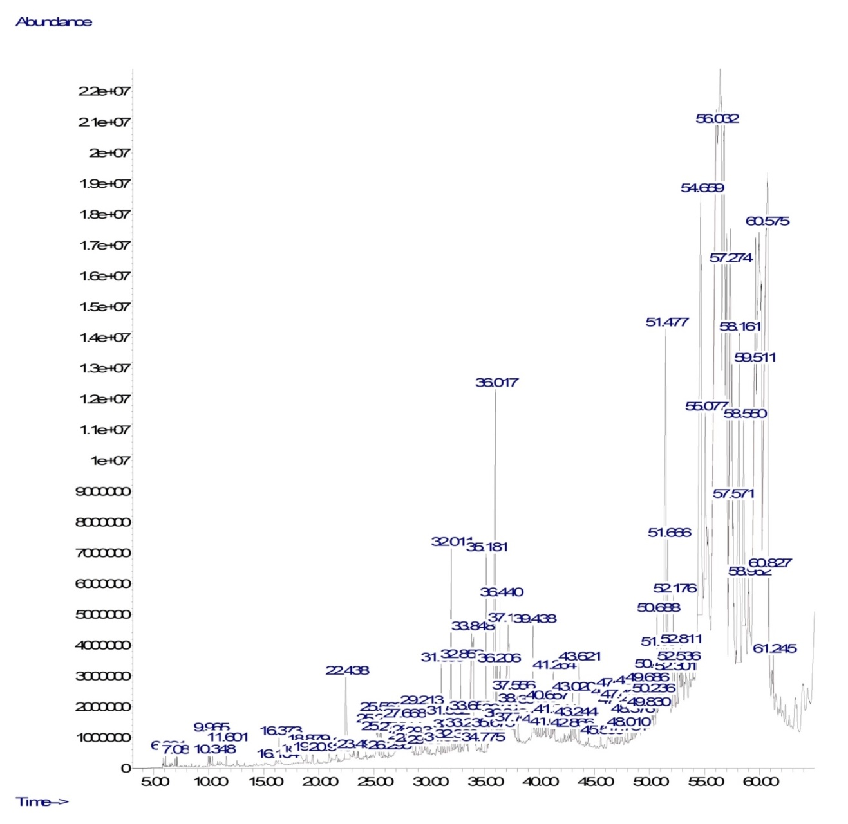

Figure S1. GC-MS chromatograph of the methanolic extract of Argyreia capitiformis stem.
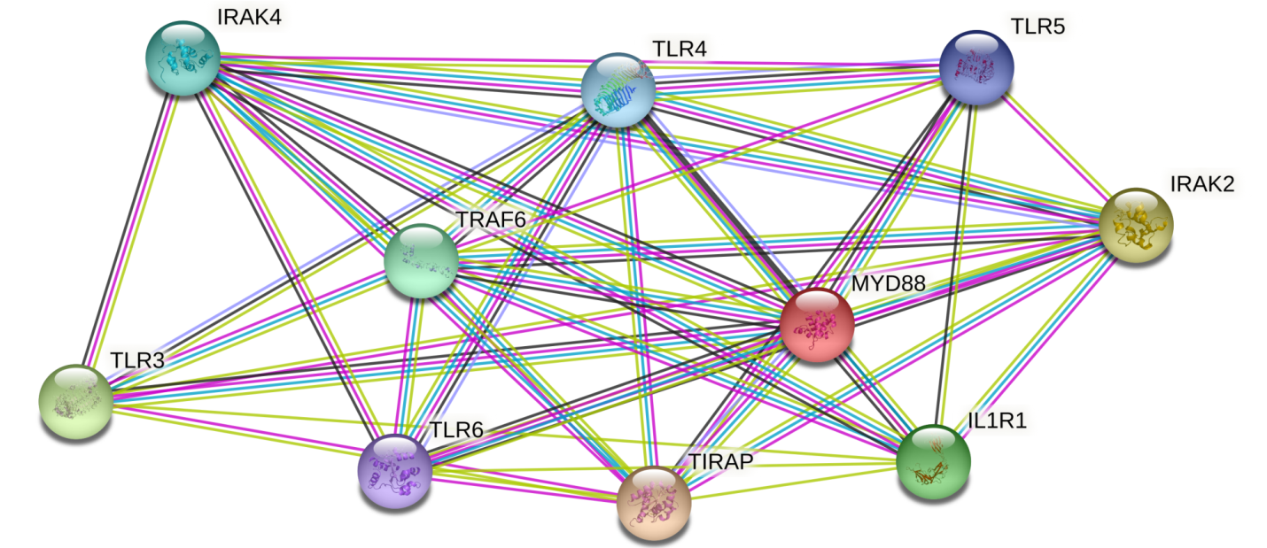

Figure S2. Protein-protein interaction (PPI) network of 10 proteins.
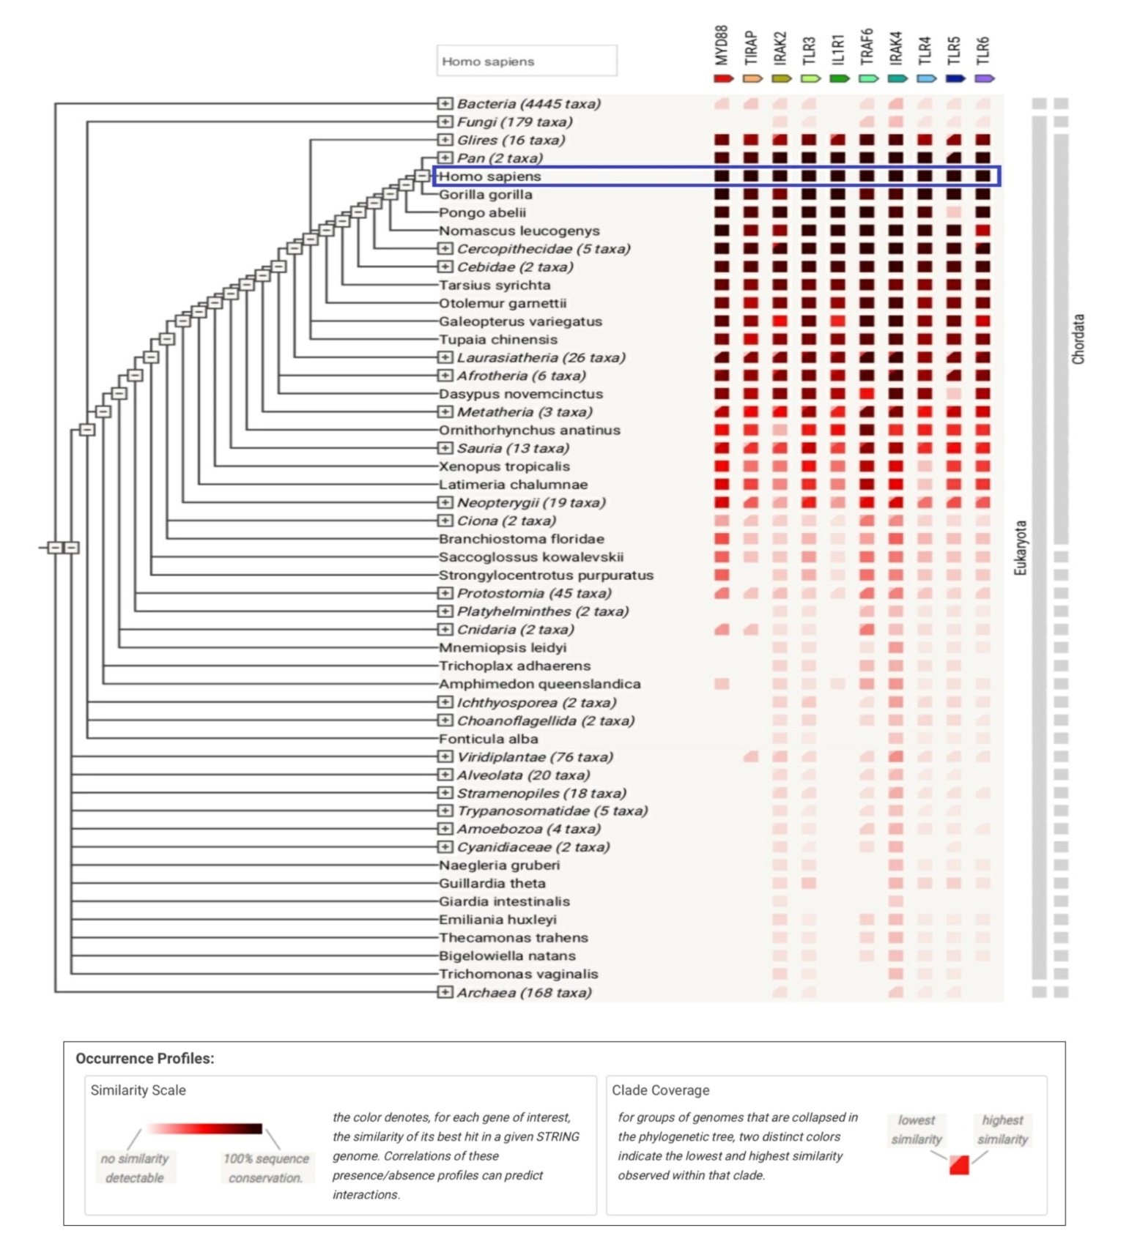
Figure S3. Gene co-occurrence of 10 proteins for Homo sapiens.

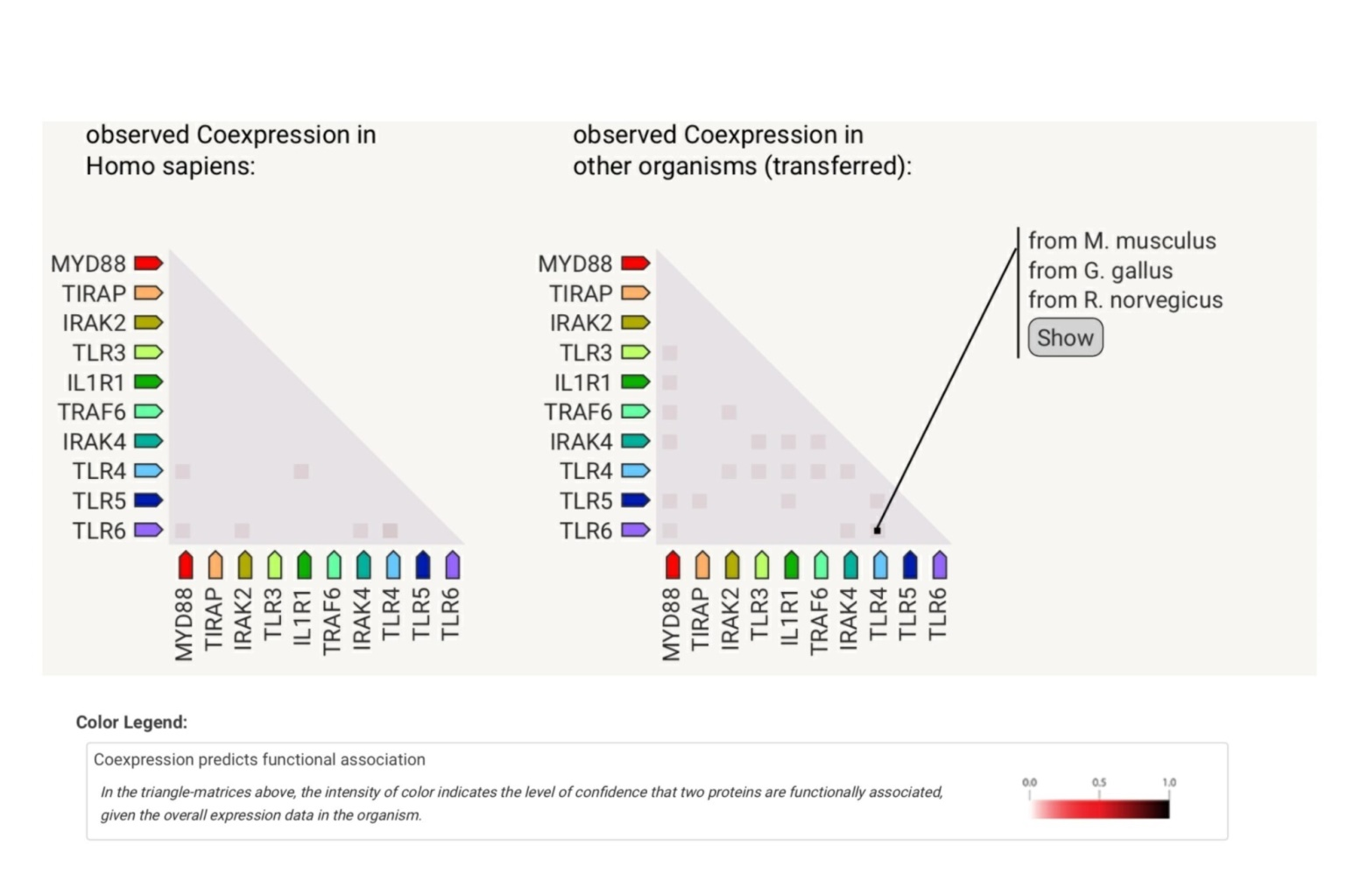
Figure S4. Gene coexpression of 10 proteins in PPI network.

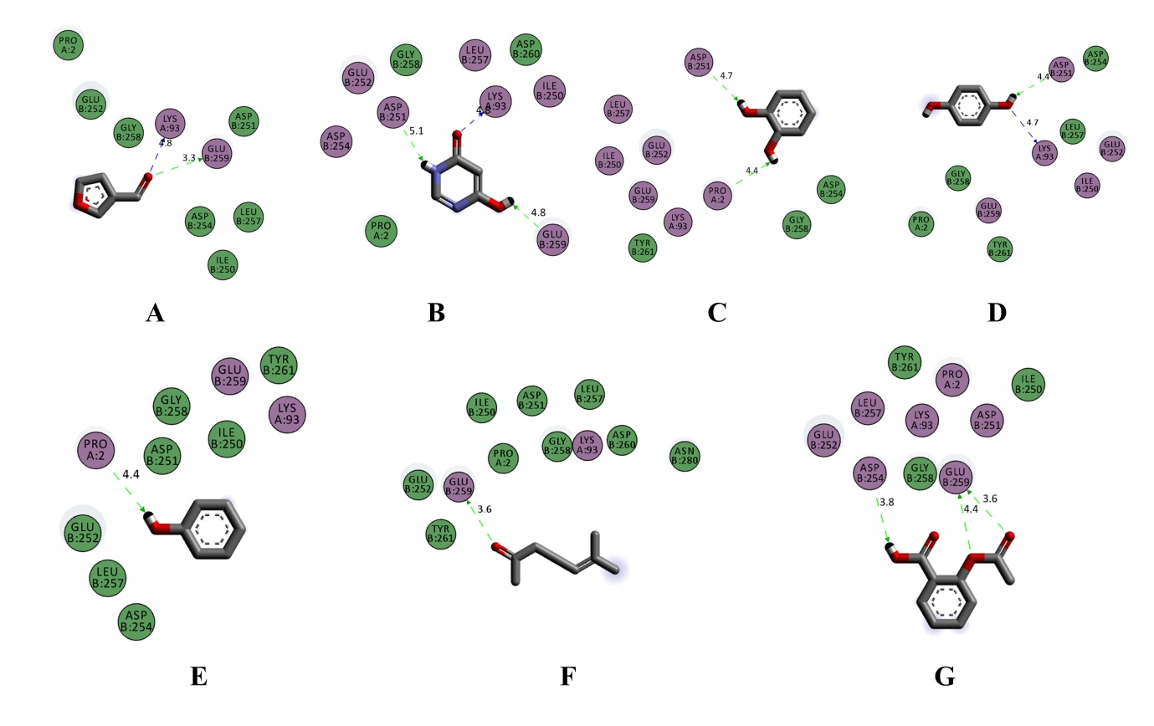
Figure S5. Two-dimensional representations of the best ligand efficiencies for compounds binding with IL1R1 (PDB: 1ITB). 3-furaldehyde (A), 4(1H)-pyrimidinone, 6-hydroxy- (B), catechol (C), hydroquinone (D), phenol (E), sulcatone (F), and aspirin (G) are shown.

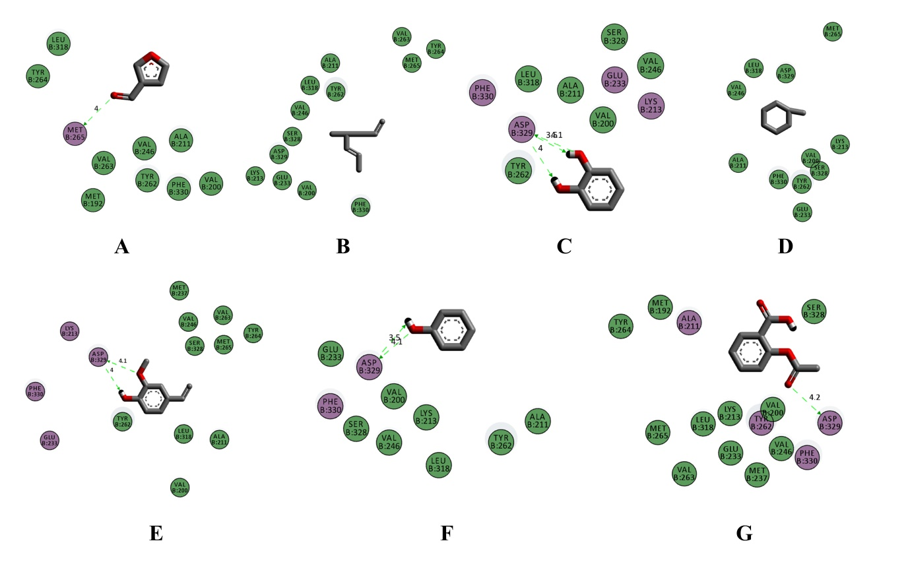
Figure S6. Two-dimensional representations of the best ligand efficiencies for compounds binding to IRAK4 (PDB: 6EGA). 3-furaldehyde (A), 4-methyl-1,5-heptadiene (B), catechol (C), methylcyclohexane (D), p-vinylguaiacol (E), phenol (F), and aspirin (G) are shown.
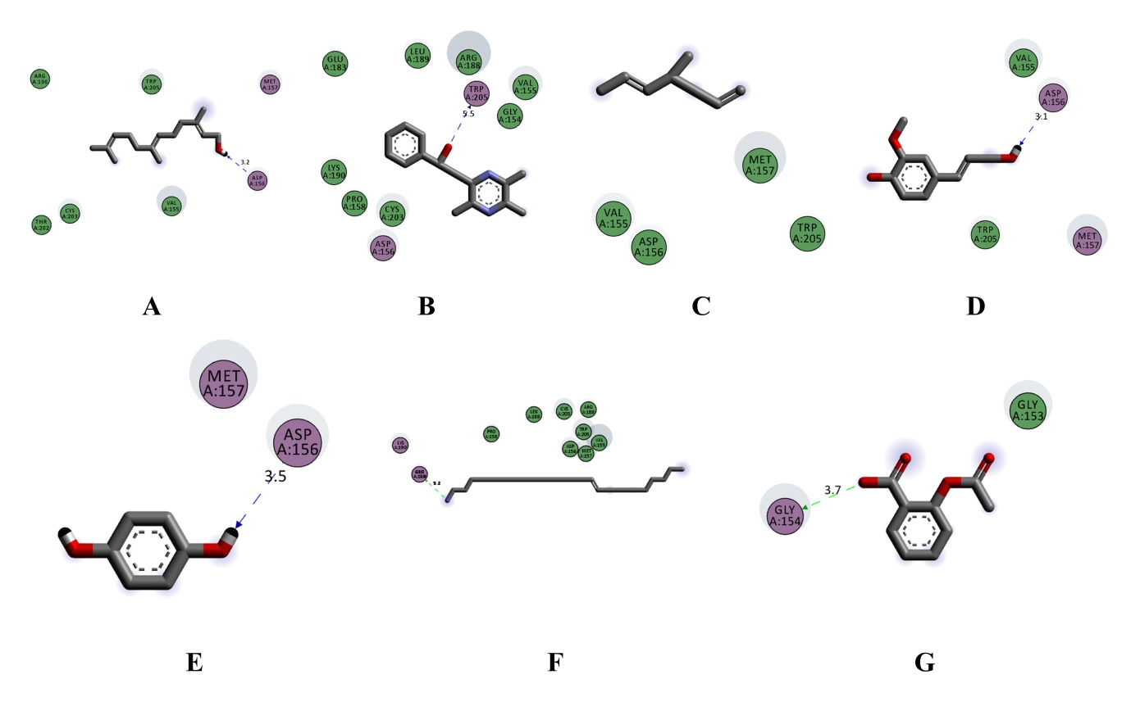
Figure S7. Two-dimensional representations of best the ligand efficiencies for compounds binding to MYD88 (4EO7). (Z,E)-farnesol (A), 2-(2-hydroxy-2-phenylethyl)-3,5,6-trimethylpyrazine (B), 4-methyl-1,5-heptadiene (C), coniferol (D), hydroquinone (E), trans-13-docosenamide (F), and aspirin (G) are shown.

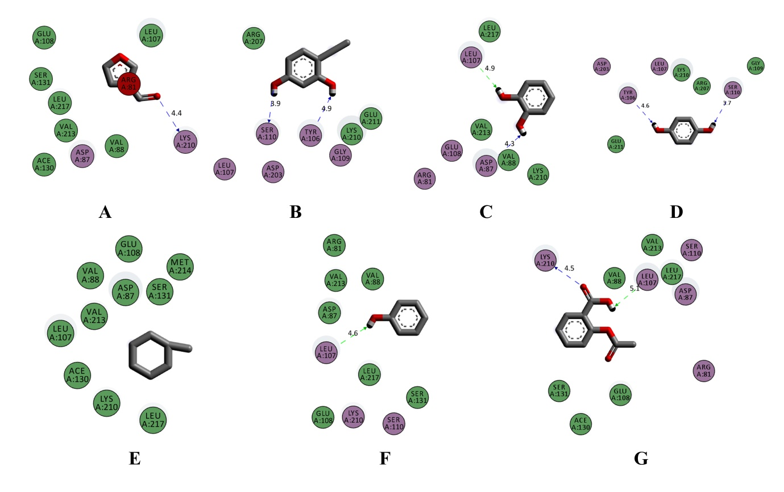
Figure S8. Two-dimensional representations of the best ligand efficiencies for compounds binding to TIRAP (PDB: 4FZ5). 3-furaldehyde (A), 4-ethylresorcinol (B), catechol (C), hydroquinone (D), methylcyclohexane (E), phenol (F), and aspirin (G) are shown.

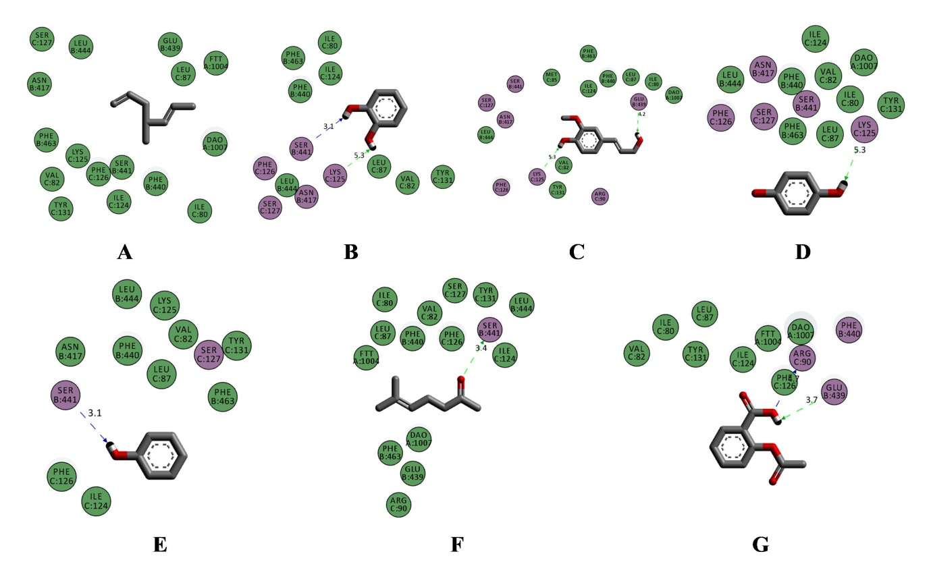
Figure S9. Two-dimensional representations of best ligand efficiencies for compounds against TLR4 (PDB: 3FXI). 4-methyl-1,5-heptadiene (A), catechol (B), coniferol (C), hydroquinone (D), phenol (E), sulcatone (F), and aspirin (G) are shown.

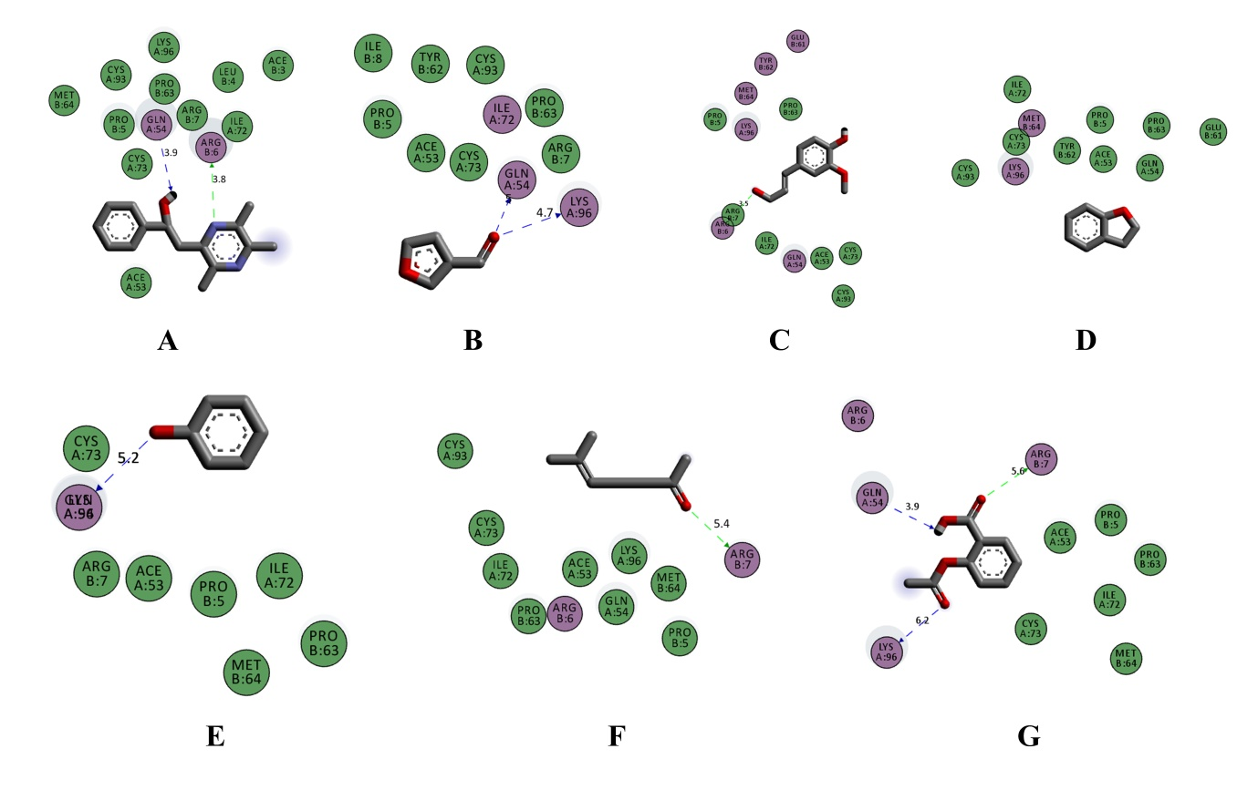
Figure S10. Two-dimensional representations of the best ligand efficiencies for compounds against TRAF6 (PDB: 3HCT). 2-(2-Hydroxy-2-phenylethyl)-3,5,6-trimethylpyrazine (A), 3-furaldehyde (B), coniferol (C), coumaran (D), phenol (E), sulcatone (F), and aspirin (G) are shown.

