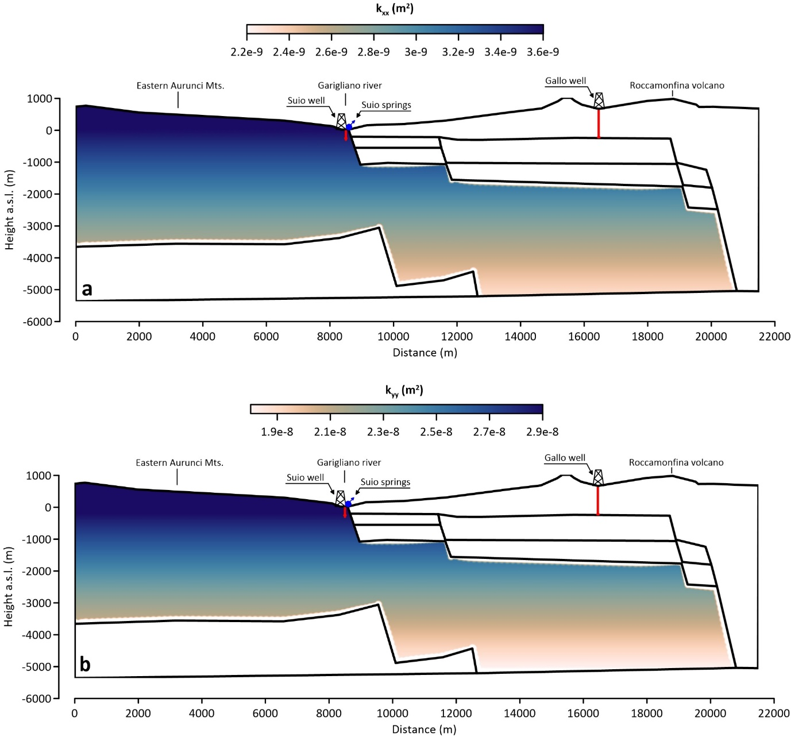
Figure S1: Assumed permeability distribution inside the CC complex. The other complexes have an isotropic permeability of 1x10⁻¹² m². a) Horizontal permeability (κ_{xx}); b) vertical permeability (κ_{yy}).

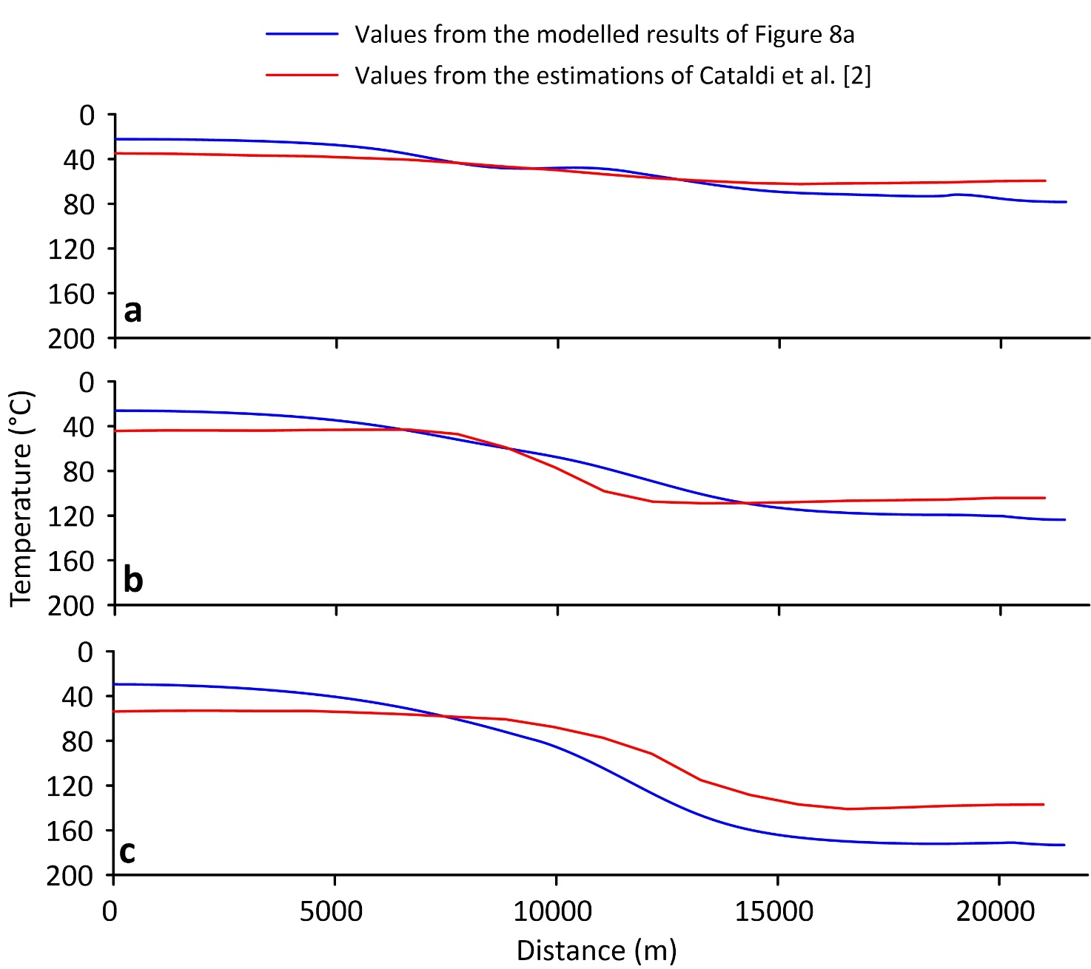
Figure S2: Comparison between the modelled temperatures of Figure 8a and the values estimated at 1000 (a), 2000 (b) and 3000 (c) meters below the sea level by Cataldi et al. [2] (available at: https://unmig.mise.gov.it/index.php/it/dati/altre-attivita/risorse-geotermiche)

