Supplementary information for “Compaction of hyaloclastite from the active geothermal system at Krafla volcano, Iceland”

G. H. Eggertsson¹, J. E. Kendrick¹, J. Weaver¹, P. A. Wallace¹, J. E. P. Utley¹, J. D. Bedford¹, M. J. Allen¹, S. H. Markússon², R. H. Worden¹, D. R. Faulkner¹ and Y. Lavallée¹

¹Department of Earth, Ocean and Ecological Sciences, University of Liverpool, 4 Brownlow Street, Liverpool, United Kingdom, L69 3GP.
²Landsvirkjun, Háaleitisbraut 68, 103 Reykjavík, Iceland.

Supplementary Figures
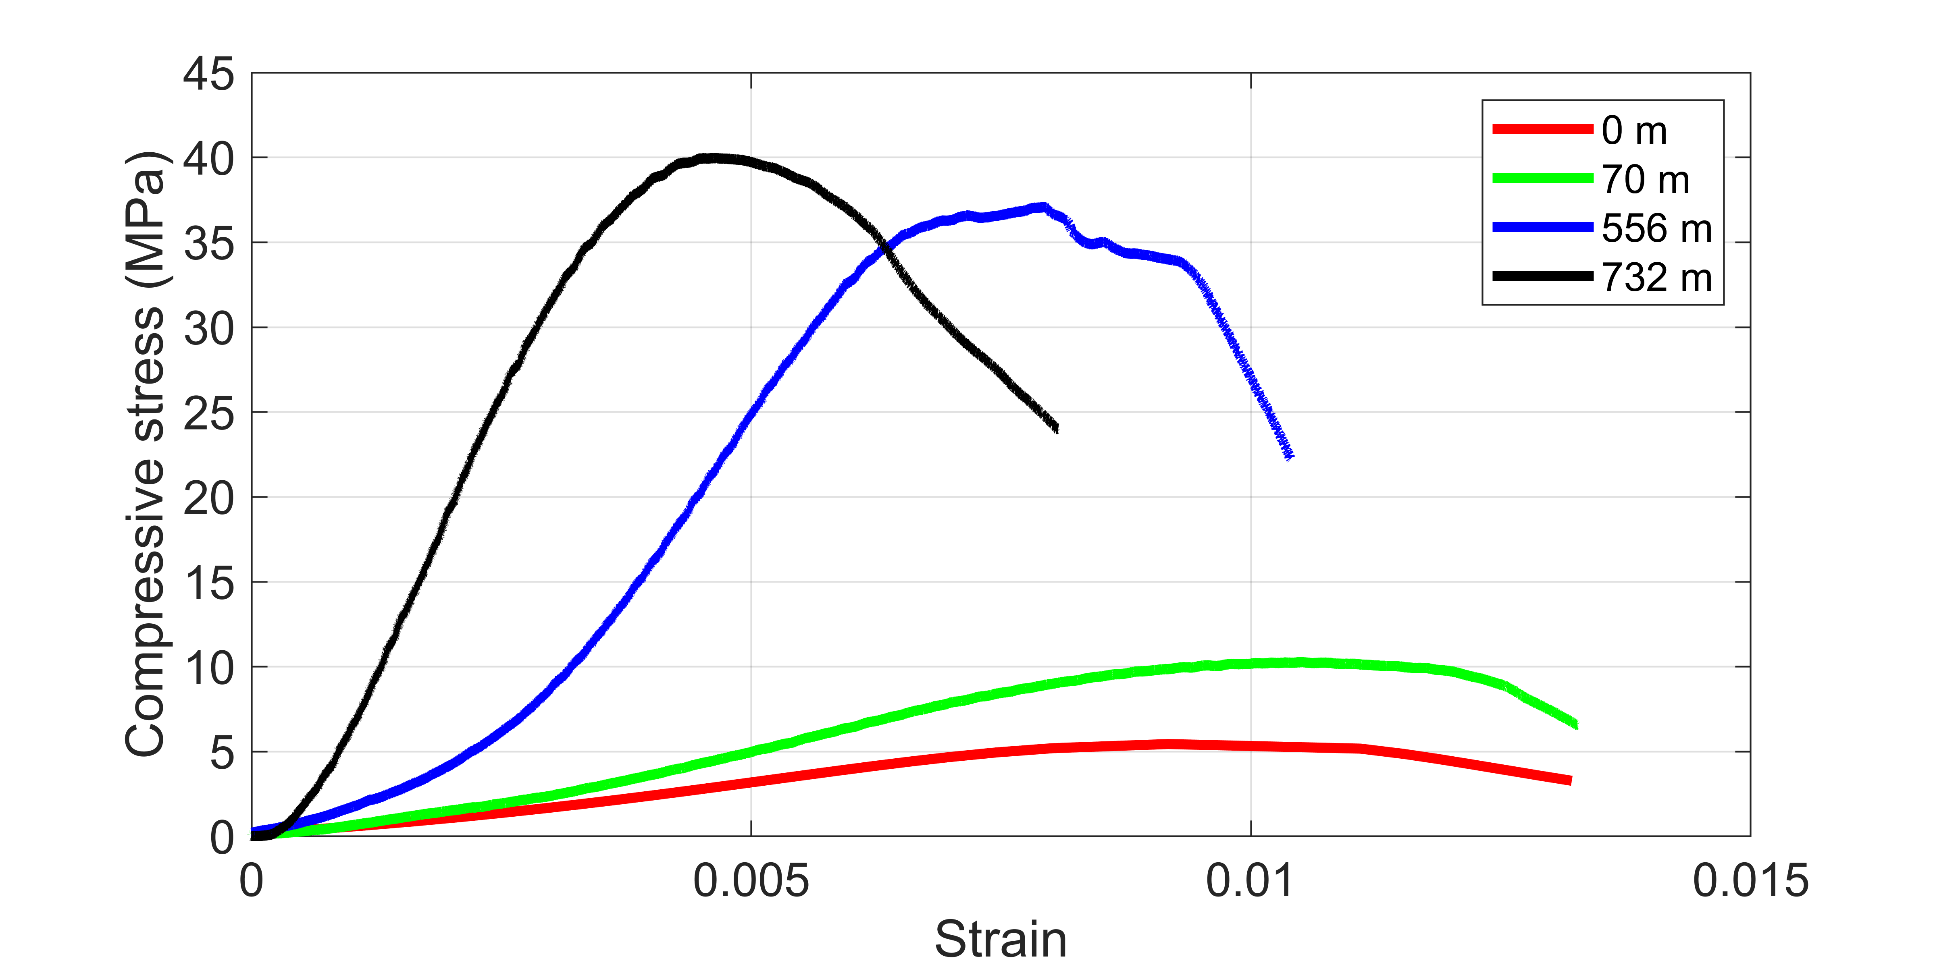

Figure S1. The UCS data showing the stress-strain loading paths for each of the samples tested within the uniaxial press, where the sample is loaded until a stress drop of >10 % is observed. Strength increases with increasing sampling depth within the reservoir, and the slope of the stress strain curves is steeper with increasing sampling depth, corresponding to a lower porosity.
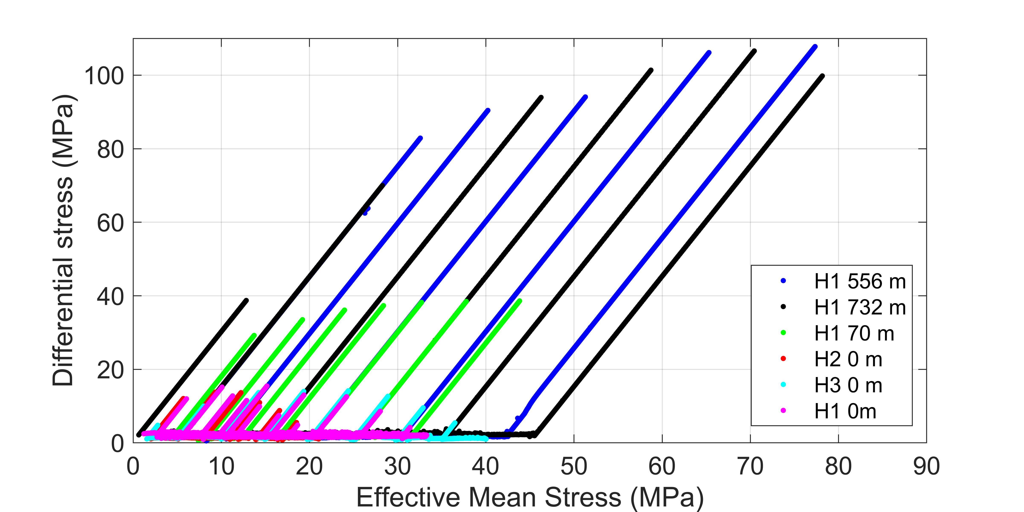

Figure S2. The raw loading data for each sample, showing the loading paths for each of the samples tested within the triaxial apparatus. The samples are loaded to the target confining pressure and then axially stressed until they exhibit their elastic limit (P*) before removing the axial load, reducing the effective mean stress again. However, if the sample is loaded past P* (the surface samples) then the effective mean stress is reduced slightly before the axial load is increased on the sample.

