Supplementary material
A versatile SERS sensor for multiple determination of Polycyclic Aromatic Hydrocarbons and its application potential in analysis of fried foods
Shi Wang ¹, Jie Cheng ^{1,} *, Caiqin Han ², and Jianchun Xie ³
¹ Institute of Quality Standards and Testing Technologies for Agro-products, Chinese Academy of Agricultural Sciences, Beijing, 100081, China
² Jiangsu Key Laboratory of Advanced Laser Materials and Devices, School of Physics and Electronic Engineering, Jiangsu Normal University, Xuzhou, 221116, China
³ Beijing Advanced Innovation Center for Food Nutrition and Human Health, Beijing Technology & Business University (BTBU), Beijing 100048, Beijing

Correspondence should be addressed to Jie Cheng; chengjie@caas.cn;
ORCID: 0000-0003-0773-0244
Table of contents
Fig. S1 SERS spectra of 16 PAHs (C = 100 ng·mL⁻¹) in the presence of ro-GO/AuNP (red lines) and AuNPs (green lines) substrates.
Table S1. Band assignments for experimental SERS of NAP
Table S2. Band assignments for experimental SERS of PYR
Table S3. Band assignments for experimental SERS of ACE
Table S4. Band assignments for experimental SERS of ACEY
Table S5. Band assignments for experimental SERS of ANTH
Table S6. Band assignments for experimental SERS of CHR
Table S7. Band assignments for experimental SERS of FLU
Table S8. Band assignments for experimental SERS of PHE
Table S9. Band assignments for experimental SERS of BaP
Table S10. Band assignments for experimental SERS of FLUA
Table S11. Band assignments for experimental SERS of BaA
Table S12. Band assignments for experimental SERS of DiB
Table S13. Band assignments for experimental SERS of BbF
Table S14. Band assignments for experimental SERS of BkF
Table S15. Band assignments for experimental SERS of BghiP
Table S16. Band assignments for experimental SERS of Ind
Table S17. The LOD and quantitative calculation model of 16 PAHs
References

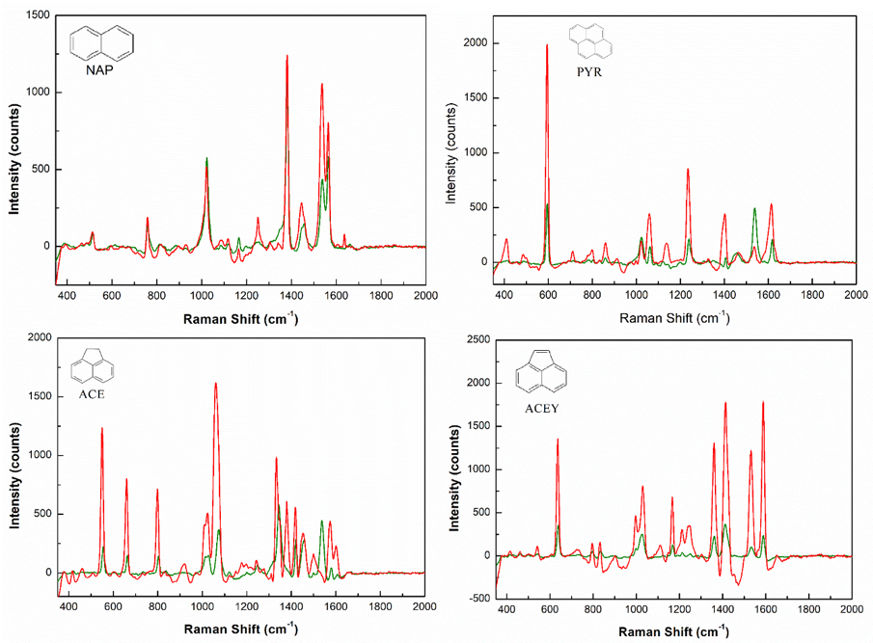
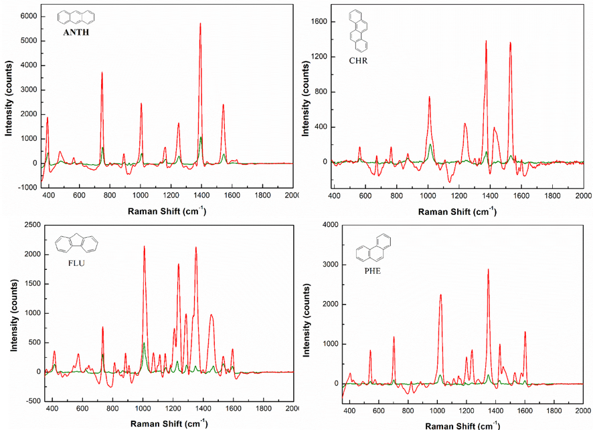
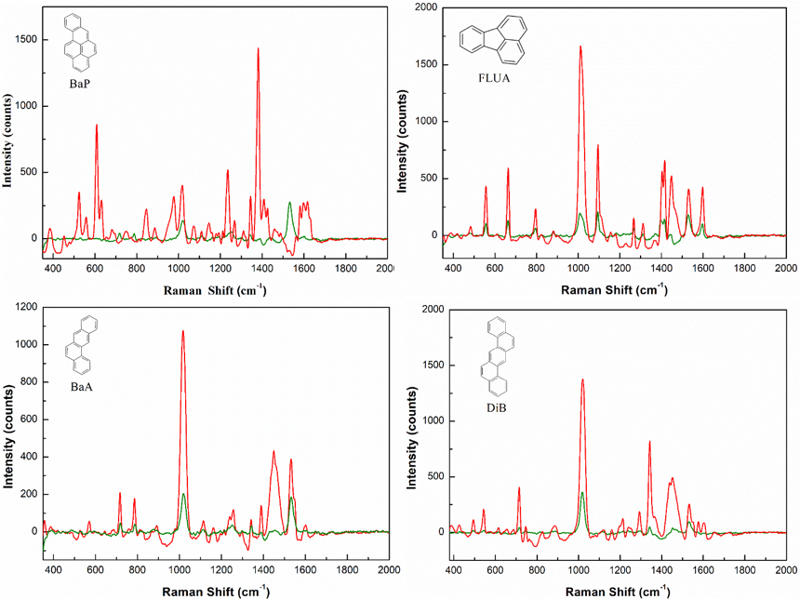
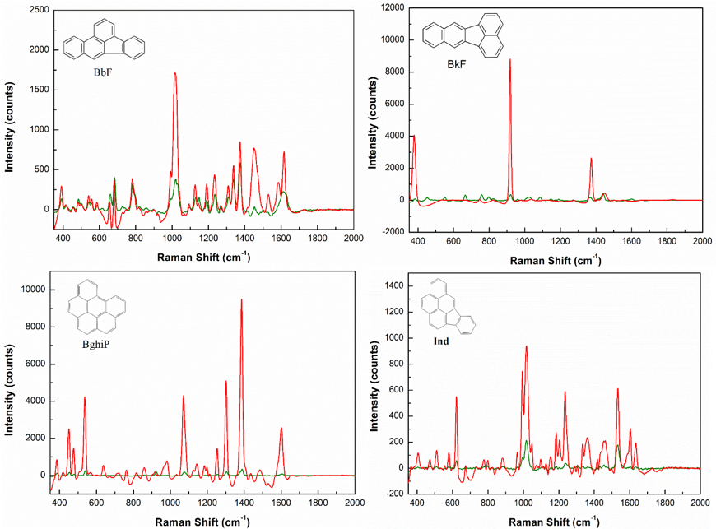
Fig. S1 SERS spectra of 16 PAHs (C = 100 ng·mL⁻¹) in the presence of ro-GO/AuNP (red lines) and AuNPs (green lines) substrates.

Table S1. Band assignments for experimental SERS of NAP
Experimental  SERS | SERS Ref.¹ | Vibrational modes
512 | 502 | α_{C-C-C}
760 | 754 | γ_{C-H}
1018 | 1015 | ν_{C-C}
1165 | - | β_{C-H}τ_{C-C-C-H}
1382 | 1378 | ν_{C-C}
1564 | 1561 | ν_{C-C}

Table S2. Band assignments for experimental SERS of PYR
Experimental  SERS | SERS Ref. ¹ | Vibrational modes
409 | 405 | ν_{C-C-C-C}
 | 453 | ν_{C-C-C-C}
486 | 495 | ν_{C-C-C-C}
594 | 592 | ν_{C-C-C-C}
715
799
859
1059 | 1055 | δ_{C-H}
1138 | 1135 | δ_{C-H}
1234 | 1241 | ν_{C-C}δ_{C-H}
1400 | 1398 | ν_{C-C}τ_{C-C-C-H}
1535
1612 | 1610 | ν_{C-C}

Table S3. Band assignments for experimental SERS of ACE
Experimental  SERS | SERS Ref. ¹ | Vibrational modes
416 | 415 | ν_{C-C-C-C}
461 | - | δ_{C-H}
510 | - | ν_{C-C-C-C}
550 | 543 | ν_{C-C-C-C}
 | 639 | τ_{C-C-C-H}
660
798 | 800 | ν_{C-C-C-C}
836 | 833 | δ_{C-H}
 | 1002 | ν_{C-C}δ_{C-H}
 | 1035 | ν_{C-C}δ_{C-H}
1177 | - | δ_{C-H}
1198 | 1215 | ν_{C-C}δ_{C-H}
1243 | 1265 ² | ν_{C-C}δ_{C-H}
 | 1366 | ν_{C-C}δ_{C-H}
1418 | 1420 | ν_{C-C}δ_{C-H}
1454 | 1461 ² | ν_{C-C}δ_{C-H}
1600 | 1593 | ν_{C-C}δ_{C-H}

Table S4. Band assignments for experimental SERS of ACEY
Experimental  SERS | SERS Ref. ¹ | Vibrational modes
 | 377 | δ_{C-H}
412 | 414 | ν_{C-C-C-C}
537 | 549 | ν_{C-C-C-C}
634 | 659 | τ_{C-C-C-H}
796 | 800 | ν_{C-C-C-C}ν_{C-C}
832
 | 921 | δ_{C-H}
1000 | 1011 | ν_{C-C}δ_{C-H}
1030 | 1026 | ν_{C-C}δ_{C-H}
 | 1074 | ν_{C-C}δ_{C-H}
1165
1213 | 1207 | ν_{C-C}δ_{C-H}
1247 | 1245 | ν_{C-C}δ_{C-H}
1366 | 1350 | ν_{C-C}δ_{C-H}
 | 1380 | ν_{C-C}δ_{C-H}
1409 | 1420 | ν_{C-C}δ_{C-H}
 | 1460 | ν_{C-C}δ_{C-H}
1531 | 1539 | ν_{C-C}δ_{C-H}
1591 | 1602 | ν_{C-C}δ_{C-H}

Table S5. Band assignments for experimental SERS of ANTH
Experimental  SERS | SERS Ref. ¹ | Vibrational modes
393 | 392 | ν_{C-C-C-C}
749 | 753 | ν_{C-C}
893 | 891 ² | τ_{C-C-C-H}
1008 | 1008 | ν_{C-C}
1252 | 1252 | τ_{C-C-C-H}
1393 | 1395 | ν_{C-C}τ_{C-C-C-H}
1541 | 1545 | ν_{C-C}

Table S6. Band assignments for experimental SERS of CHR
Experimental  SERS | SERS Ref. ¹ | Vibrational modes
378 | 381 | δ_{C-H}
562 | 568 | ν_{C-C-C-C}
668
 | 678 | ν_{C-C-C-C}τ_{C-C-C-H}
763 | 768 | ν_{C-C-C-C}
 | 877 | ν_{C-C-C-C}ν_{C-C}
1012 | 1016 | ν_{C-C-C-C}τ_{C-C-C-H}
 | 1040 | ν_{C-C}δ_{C-H}
1238 | 1245 | ν_{C-C}δ_{C-H}
 | 1334 | ν_{C-C}δ_{C-H}
1376 | 1377 | ν_{C-C}δ_{C-H}
1427 | 1428 | ν_{C-C}δ_{C-H}
1531
 | 1568 | ν_{C-C}δ_{C-H}
 | 1605 | ν_{C-C}δ_{C-H}

Table S7. Band assignments for experimental SERS of FLU
Experimental  SERS | SERS Ref. ¹ | Vibrational modes
415 | 416 | ν_{C-C-C-C}
735 | 734 | ν_{C-C-C-C}ν_{C-C}
811 | 806 ² | C-H out-of plane bending, C-H wagging
887 | 890 ² | C-H out-of-plane bending, C-H twisting
1009 | 1008 | ν_{C-C}δ_{C-H}
1070 | 1054 ² | ν_{C-C}δ_{C-H}
1107 | 1108 ² | --
1150 | 1153 | δ_{C-H}
1207 | 1210 ² | ν_{C-C}δ_{C-H}
1238 | 1236 | ν_{C-C}δ_{C-H}
1287 | 1299 | ν_{C-C}δ_{C-H}
1354 | 1354 | ν_{C-C}δ_{C-H}
1455 | 1469 | ν_{C-C}δ_{C-H}
1531 | 1545 ² | --
 | 1568 | ν_{C-C}δ_{C-H}
1595 | 1601 | ν_{C-C}δ_{C-H}

Table S8. Band assignments for experimental SERS of PHE
Experimental  SERS | SERS Ref. ¹ | Vibrational modes
402 | 405 | ν_{C-C-C-C}
540 | 545 | ν_{C-C-C-C}
704 | 711 | ν_{C-C-C-C}
824 | 826 | ν_{C-C-C-C}
1021
 | 1032 | ν_{C-C}δ_{C-H}
 | 1165 | ν_{C-C}δ_{C-H}
1200 | 1207 | τ_{C-C-C-H}δ_{C-H}
1237 | 1244 | ν_{C-C}δ_{C-H}
1351 | 1352 | ν_{C-C}δ_{C-H}
1428 | 1431 | ν_{C-C}δ_{C-H}
1533
1606 | 1610 | ν_{C-C}δ_{C-H}

Table S9. Band assignments for experimental SERS of BaP
Experimental  SERS | SERS Ref. ¹ | Vibrational modes
 | 334 | δ_{C-C}δ_{C-H}
385 | 381 | δ_{C-C}δ_{C-H}
455 | 452 | τ_{C-C}γ_{C-H}
528
555 | 558 | δ_{C-C} δ_{C-H}
608 | 613 | δ_{C-C}δ_{C-H}
632 | 636 | τ_{C-C}δ_{C-C}δ_{C-H}
842 | 847 | ν_{C-C}ν_{C-H}
979 | 985 | δ_{C-H}ν_{C-C}
1016 | 1016 | δ_{C-H}ν_{C-C}
 | 1196 | δ_{C-H}
 | 1216 | δ_{C-H}
1238 | 1238 | δ_{C-H}τ_{C-C-C-H}
1268 | 1270 | δ_{C-H}
 | 1321 | δ_{C-H}v_{C-C}ν_{C-C-C-C}
1348 | 1350 | δ_{C-H}v_{C-C}τ_{C-C-C-C}
1378 | 1382 | v_{C-C-C}
1406 | 1407 | δ_{C-H}v_{C-C}
1424 | 1425 | δ_{C-H}v_{C-C}
 | 1572 | δ_{C-H}v_{C-C}
 | 1617 | δ_{C-H}v_{C-C}
 | - | δ_{C-H}v_{C-C}

Table S10. Band assignments for experimental SERS of FLUA
Experimental  SERS | SERS Ref. ¹ | Vibrational modes
 | 352 | ν_{C-C-C-C}
 | 451 | ν_{C-C-C-C}
482 | 484 | ν_{C-C-C-C}ν_{C-C}
556 | 563 | ν_{C-C-C-C}
662 | 672 | ν_{C-C-C-C}ν_{C-C}
796 | 802 | ν_{C-C-C-C}ν_{C-C}
1006 | 1012 | ν_{C-C}δ_{C-H}
1098 | 1100 | ν_{C-C}δ_{C-H}
 | 1158 | ν_{C-C}δ_{C-H}
1268 | 1280 | ν_{C-C}δ_{C-H}
1311
 | - | τ_{C-C-C-H}ν_{C-C}δ_{C-H}
 | 1419 | ν_{C-C}δ_{C-H}
1448 | 1448 | ν_{C-C}δ_{C-H}
1537 | 1544 | ν_{C-C}δ_{C-H}
1601 | 1601 | ν_{C-C}δ_{C-H}

Table S11. Band assignments for experimental SERS of BaA
Experimental  SERS | SERS Ref. ¹ | Vibrational modes
 | 306 | δ_{C-C}
360 | 358 | δ_{C-C}
528
568 | 574 | τ_{C-C}
717 | 722 | ν_{C-C}δ_{C-C}
784 | 792 | -
887
1019 | 1012 | τ_{C-H}
 | 1035 | δ_{C-H}
1116
1162 | 1166 | δ_{C-H}
1259 | 1262 | δ_{C-H}
1344 | 1345 | δ_{C-C}δ_{C-H}
1388 | 1393 | δ_{C-H}
1448 | 1432 | δ_{C-C}δ_{C-H}
1531
 | 1554 | ν_{C-C}δ_{C-H}
1598 | 1610 | ν_{C-C}δ_{C-H}

Table S12. Band assignments for experimental SERS of DiB
Experimental  SERS | SERS Ref. ¹ | Vibrational modes
 | 330 | δ_{C-H}
495 | 496 | ν_{C-C-C-C}
544 | 547 | δ_{C-H}
616 | 619 | ν_{C-C-C-C}
714
745 | 752 | δ_{C-H}
 | 931 | ν_{C-C-C-C}δ_{C-H}
1015
 | 1035 | ν_{C-C-C-C}δ_{C-H}
1159 | 1164 | ν_{C-C}δ_{C-H}
1214 | 1217 | ν_{C-C}δ_{C-H}
 | 1260 | ν_{C-C}δ_{C-H}
1293 | 1298 | ν_{C-C}δ_{C-H}
1342 | 1346 | ν_{C-C}δ_{C-H}
 | 1380 | ν_{C-C}δ_{C-H}
1436 | 1435 | δ_{C-H}
 | 1496 | ν_{C-C}δ_{C-H}
1531
 | 1559 | ν_{C-C}
1574 | 1582 | ν_{C-C}δ_{C-H}
1604 | 1608 | ν_{C-C}δ_{C-H}

Table S13. Band assignments for experimental SERS of BbF
Experimental  SERS | SERS Ref. ¹ | Vibrational modes
 | 334 | ν_{C-C-C-C}
390 | 392 | ν_{C-C-C-C}
 | 486 | ν_{C-C-C-C}
 | 592 | ν_{C-C-C-C}
 | 660 | ν_{C-C-C-C}
684 | 688 | ν_{C-C-C-C}
778 | 790 | ν_{C-C-C-C}
 | 901 | δ_{C-H}
1015 | 996 | τ_{C-C-C-H}
 | 1032 | ν_{C-C}
 | 1096 | ν_{C-C}δ_{C-H}
1128
1192 | 1194 | ν_{C-C}δ_{C-H}
1235 | 1238 | τ_{C-C-C-H}δ_{C-H}
 | 1276 | ν_{C-C}δ_{C-H}
 | 1314 | ν_{C-C}δ_{C-H}
 | 1337 | ν_{C-C}δ_{C-H}
1376 | 1380 | ν_{C-C}δ_{C-H}
 | 1418 | ν_{C-C}δ_{C-H}
1455 | 1455 | ν_{C-C}δ_{C-H}
1533 | 1526 | τ_{C-C-C-H}δ_{C-H}ν_{C-C}
 | 1593 | ν_{C-C}δ_{C-H}
1613 | 1620 | ν_{C-C}δ_{C-H}

Table S14. Band assignments for experimental SERS of BkF
Experimental  SERS | SERS Ref. ¹ | Vibrational modes
 | 452 | ν_{C-C-C-C}τ_{C-C-C-H}
 | 492 | ν_{C-C-C-C}
 | 552 | ν_{C-C-C-C}
 | 601 | δ_{C-H}
 | 669 | ν_{C-C-C-C}
 | 761 | δ_{C-H}
 | 800 | ν_{C-C-C-C}
 | 817 | ν_{C-C-C-C}δ_{C-H}
 | 895 | τ_{C-C-C-H}δ_{C-H}
920 | 924 | δ_{C-H}
 | 1024 | ν_{C-C}δ_{C-H}
 | 1031 | ν_{C-C}δ_{C-H}
 | 1092 | ν_{C-C}δ_{C-H}
 | 1132 | ν_{C-C}δ_{C-H}
 | 1153 | ν_{C-C}δ_{C-H}
 | 1194 | ν_{C-C}δ_{C-H}
 | 1275 | ν_{C-C}δ_{C-H}
 | 1342 | ν_{C-C}δ_{C-H}
1375 | 1366 | ν_{C-C}δ_{C-H}
 | 1401 | ν_{C-C}δ_{C-H}
1441 | 1442 | ν_{C-C}δ_{C-H}
 | 1495 | ν_{C-C}δ_{C-H}

Table S15. Band assignments for experimental SERS of BghiP
Experimental  SERS | SERS Ref. ¹ | Vibrational modes
 | 366 | ν_{C-C-C-C}
382 | 387 | ν_{C-C-C-C}
420 | 416 | ν_{C-C}δ_{C-H}
452 | 452 | τ_{C-C-C-H}
478 | 479 | ν_{C-C-C-C}
539 | 538 | τ_{C-C-C-H}
637
 | 712 | ν_{C-C}δ_{C-H}
761
860 | 848 | ν_{C-C}δ_{C-H}
979 | 985 | τ_{C-C-C-H}
1071 | 1083 | τ_{C-C-C-H}
1141 | 1146 | δ_{C-H}
 | 1202 | τ_{C-C-C-H}δ_{C-H}
1255 | 1255 | τ_{C-C-C-H}δ_{C-H}
1305 | 1305 | ν_{C-C}δ_{C-H}
1368
 | 1385 | ν_{C-C}δ_{C-H}
1432 | 1436 | τ_{C-C-C-H}δ_{C-H}
1599 | 1594 | ν_{C-C}

Table S16. Band assignments for experimental SERS of Ind
Experimental  SERS | SERS Ref. ¹ | Vibrational modes
 | 319 | ν_{C-C-C-C}
 | 365 | ν_{C-C-C-C}
407 | 407 | ν_{C-C-C-C}
473 | 473 | ν_{C-C-C-C}
514
579
623 | 626 | ν_{C-C-C-C}
673 | 680 | ν_{C-C-C-C}
780 | 785 | ν_{C-C}τ_{C-C-C-H}
799
883
 | 971 | ν_{C-C}τ_{C-C-C-H}
 | 1001 | τ_{C-C-C-H}
1017
 | 1052 | ν_{C-C}τ_{C-C-C-H}
 | 1103 | ν_{C-C}δ_{C-H}
 | 1153 | ν_{C-C}δ_{C-H}
1183 | 1187 | δ_{C-H}
 | 1209 | ν_{C-C}δ_{C-H}
1233 | 1242 | τ_{C-C-C-H}δ_{C-H}
 | 1295 | ν_{C-C}δ_{C-H}
 | 1311 | ν_{C-C}δ_{C-H}
 | 1337 | ν_{C-C}τ_{C-C-C-H}
 | 1380 | ν_{C-C}δ_{C-H}
 | 1428 | ν_{C-C}δ_{C-H}
 | 1477 | ν_{C-C}δ_{C-H}
1533 | 1538 | ν_{C-C}
1599 | 1587 | ν_{C-C}
 | 1606 | ν_{C-C}
1637 | 1645 | ν_{C-C}

Table S17. The LOD and quantitative calculation model of 16 PAHs
Compound | Fitting regression | R² | LOD  (ng·mL⁻¹)
NAP | C = -0.5767* I₁₀₁₈+3.1339* I₁₅₆₄-748.577 | 0.9989 | 0.5
PYR | C = 0.06147* I₁₂₃₄+0.1143* I₁₄₀₀+0.4411 | 0.9997 | 0.2
ACE | C = 0.1334* I₅₅₀+0.0824* I₆₆₀+0.6486 | 0.9997 | 1.0
ACEY | C = 0.8293* I₁₂₁₃+0.2180* I₁₄₀₉-323.123 | 0.9987 | 0.8
ANTH | C = 0.09212* I₁₃₉₃+0.4323* I₁₅₄₈+4.2894 | 0.9994 | 0.5
CHR | C = 0.1326* I₁₀₁₂+1.8781* I₁₄₂₇-1.7821 | 0.9990 | 0.8
FLU | C = 0.3760* I₇₃₅+0.2381* I₁₃₅₄-0.2421 | 0.9995 | 0.2
PHE | C = 0.05268* I₇₀₄+0.9253* I₁₃₅₁+0.4854 | 0.9989 | 0.5
BaP | C = 0.4817* I₁₂₃₈+0.4301* I₁₃₇₈+1.4213 | 0.9990 | 0.5
FLUA | C = 0.2643* I₇₉₆+0.0983* I₁₄₄₈+2.3629 | 0.9894 | 1.0
BaA | C = 0.5675* I₇₁₇+0.2733* I₁₅₃₁+0.2690 | 0.9995 | 0.8
DiB | C = -0.02649* I₇₁₄+2.3462* I₁₃₄₂+13.3556 | 0.9990 | 0.5
BbF | C = 0.3292* I₆₈₄+0.3645* I₁₁₉₂+0.2662 | 0.9901 | 1.0
BkF | C = 0.3292* I₁₃₇₅ +0.6803 | 0.9889 | 2.0
BghiP | C = 1.0382* I₄₅₂+0.4619* I₁₃₀₅+0.3305 | 0.9994 | 0.2
Ind | C = 0.3534* I₆₂₃+0.5347* I₁₅₃₃₋0.15375 | 0.9995 | 0.5

References
- J. J. Du, J. W. Xu, Z. L. Sun, and C. Y. Jing, “Au nanoparticles grafted on Fe₃O₄ as effective SERS substrates for label-free detection of the 16 EPA priority polycyclic aromatic hydrocarbons,” Analytical Chimica Acta, vol. 915, pp. 81-89, 2016.
- J. Chen, Y. W. Huang, and Y. P. Zhao, “Characterization of polycyclic aromatic hydrocarbons using Raman and surface-enhanced Raman spectroscopy,” Journal of Raman Spectroscopy, vol. 46, pp. 64-69, 2015.

