Table S1 Sample characteristics [(mean (SD) or n (percentage)] in boys over survey year from 2004 to 2015
 | 2004 (n=196) | 2006 (n=304) | 2009 (n=296) | 2011 (n=278) | 2015 (n=107) | Time trend (p)
Participants’ personal characteristics
Age(years) | 9.11 (1.50) | 9.86 (2.03) | 10.23 (1.92) | 9.95 (2.11) | 11.85 (0.83) | <0.001
BMI z score | -0.07 (0.83) | -0.03 (0.89) | -0.04 (0.99) | 0.06 (1.13) | 0.17 (1.18) | 0.443
Waist circumference | 58.62 (6.71) | 59.57 (8.63) | 62.39 (10.86) | 61.68 (11.21) | 65.69 (13.66) | <0.001
Physical exercise frequency per week
<3 | 82 (48.2) | 58 (27.9) | 62 (27.6) | 57 (29.8) | 41 (43.6) | <0.001
3-7 | 70 (41.2) | 83 (39.9) | 108 (48.0) | 89 (46.6) | 33 (35.1)
≥8 | 18 (10.6) | 67 (32.2) | 55 (24.4) | 45 (23.6) | 20 (21.3)
Screen time per day
<1h | 61 (32.8) | 78 (26.7) | 65 (22.6) | 65 (24.3) | 24 (23.8) | 0.080
1-2h | 73 (39.2) | 99 (33.9) | 108 (37.6) | 106 (39.6) | 32 (31.7)
≥3h | 52 (28.0) | 115 (39.4) | 114 (39.7) | 97 (36.2) | 45 (44.6)
Family and community information
Parents hypertension history
No | 182 (97.8) | 272 (97.5) | 262 (96.0) | 230 (93.9) | 81 (90.0) | 0.009
Yes | 4 (2.2) | 7 (2.5) | 11 (4.0) | 15 (96.1) | 9 (10.0)
Per capital house income
Tertiles 1 | 79 (40.9) | 125 (42.1) | 65 (22.4) | 60 (22.0) | 22 (21.0) | <0.001
Tertiles 2 | 75 (38.9) | 112 (37.7) | 113 (39.0) | 93 (34.1) | 20 (19.0)
Tertiles 3 | 39 (20.2) | 60 (20.2) | 112 (38.6) | 120 (44.0) | 63 (60.0)
Urbanization index
Tertiles 1 | 62 (31.6) | 115 (37.8) | 115 (38.9) | 110 (39.6) | 41 (38.3) | 0.545
Tertiles 2 | 75 (38.3) | 96 (31.6) | 95 (32.1) | 95 (34.2) | 41 (38.3)
Tertiles 3 | 59 (30.1) | 93 (30.6) | 86 (29.1) | 73 (26.3) | 25 (23.4)
Region
Central | 52 (26.5) | 74 (24.3) | 72 (24.3) | 67 (24.1) | 27 (25.2) | 0.002
Eastcost | 36 (18.4) | 57 (18.8) | 58 (19.6) | 56 (20.1) | 29 (27.1)
Northeastern | 50 (25.5) | 65 (21.4) | 46 (15.5) | 33 (11.9) | 10 (9.3)
Western | 58 (29.6) | 108 (35.5) | 120 (40.5) | 122 (43.9) | 41 (38.3)
Sleep duration and blood pressure
Sleep duration (hours) | 9.33 (0.94) | 9.13 (0.87) | 9.07 (0.97) | 9.10 (0.90) | 8.49 (0.83) | <0.001
Sleep duration (hours)
<9 | 36 (18.4) | 71 (23.4) | 80 (27.0) | 76 (27.3) | 64 (59.8) | <0.001
≥9 | 160 (81.6) | 233 (76.6) | 216 (73.0) | 202 (72.7) | 43 (40.2)
SBP (mmHg) | 94.57 (12.57) | 93.92 (11.23) | 98.20 (13.14) | 97.20 (12.10) | 103.11 (13.45) | <0.001
DBP (mmHg) | 62.72 (9.65) | 62.32 (8.08) | 65.70 (8.94) | 63.94 (9.23) | 66.54 (10.15) | <0.001
Elevated BP
No | 165 (84.2) | 275 (90.5) | 242 (81.8) | 235 (84.5) | 86 (80.4) | 0.022
Yes | 31 (15.8) | 29 (9.5) | 54 (18.2) | 43 (15.5) | 21 (19.6)
BMI: body mass index; SBP: systolic blood pressure; DBP: diastolic blood pressure; BP: blood pressure

Table S2 Sample characteristics [(mean (SD) or n (percentage)) in girls over survey year from 2004 to 2015
 | 2004 (n=178) | 2006 (n=252) | 2009 (n=234) | 2011 (n=244) | 2015 (n=102) | Time trend (p)
Participants’ personal characteristics
Age(years) | 8.98 (1.45) | 9.98 (1.86) | 9.98 (1.88) | 9.71 (2.03) | 11.78 (0.82) | <0.001
BMI z score | -0.10 (0.81) | -0.01 (0.97) | -0.05 (0.92) | 0.03 (1.05) | 0.23 (1.31) | 0.345
Waist circumference | 56.06 (6.88) | 57.14 (7.25) | 58.42 (8.40) | 59.52 (11.13) | 65.15 (10.92) | <0.001
Physical exercise frequency per week (times)
<3 | 74 (46.5) | 50 (29.9) | 41 (24.0) | 53 (28.3) | 34 (40.5) | <0.001
3-7 | 66 (41.5) | 75 (44.9) | 76 (44.4) | 94 (50.3) | 39 (46.1)
≥8 | 19 (11.9) | 42 (25.1) | 54 (31.6) | 40 (21.4) | 11 (13.1)
Screen time per day (hours)
<1 | 62 (39.2) | 77 (33.2) | 60 (26.0) | 56 (23.7) | 31 (33.7) | 0.001
1-2 | 61 (38.6) | 88 (37.9) | 88 (38.1) | 96 (40.7) | 22 (23.9)
≥3 | 35 (22.2) | 67 (28.9) | 83 (35.9) | 84 (35.6) | 39 (42.4)
Family and community information
Parents high BP history
No | 160 (97.0) | 227 (97.4) | 197 (93.8) | 195 (95.1) | 80 (94.1) | 0.310
Yes | 5 (3.0) | 6 (2.6) | 13 (6.2) | 10 (4.9) | 5 (5.9)
Per capital house income (yuan)
Tertiles 1 | 86 (48.6) | 109 (44.1) | 82 (35.5) | 65 (27.2) | 20 (19.6) | <0.001
Tertiles 2 | 56 (31.6) | 95 (38.5) | 79 (34.2) | 74 (31.0) | 23 (22.5)
Tertiles 3 | 35 (19.8) | 43 (17.4) | 70 (30.3) | 100 (41.8) | 59 (57.8)
Urbanization index
Tertiles 1 | 60 (33.7) | 88 (34.9) | 86 (36.8) | 87 (35.7) | 43 (42.2) | 0.790
Tertiles 2 | 63 (35.4) | 90 (35.7) | 80 (34.2) | 74 (30.3) | 30 (29.4)
Tertiles 3 | 55 (30.9) | 74 (29.4) | 68 (29.1) | 83 (34.0) | 29 (28.4)
Region
Central | 38 (21.3) | 57 (22.6) | 62 (26.5) | 61 (25.0) | 15 (14.7) | <0.001
Eastcost | 25 (14.0) | 38 (15.1) | 40 (17.1) | 50 (20.5) | 30 (29.4)
Northeastern | 48 (27.0) | 55 (21.8) | 27 (11.5) | 19 (7.8) | 8 (7.8)
Western | 67 (37.6) | 102 (40.5） | 105 (44.9) | 114 (46.7) | 49 (48.0)
Sleep duration and blood pressure
Sleep duration | 9.28 (0.91) | 9.13 (0.93) | 9.20 (0.93) | 9.16 (0.89) | 8.68 (1.03) | <0.001
Sleep duration
<9h | 35 (19.7) | 65 (25.8) | 55 (23.5) | 52 (21.3) | 53 (52.0) | <0.001
≥9h | 143 (80.3) | 187 (74.2) | 179 (76.5) | 192 (78.7) | 49 (48.0)
SBP (mmHg) | 92.28 (12.10) | 93.65 (12.95) | 96.61 (12.63) | 95.54 (11.11) | 101.32 (11.60) | <0.001
DBP (mmHg) | 60.76 (9.60) | 61.71 (8.94) | 64.90 (9.46) | 62.19 (8.56) | 65.73 (8.33) | <0.001
Elevated BP
No | 157 (88.2) | 228 (90.5) | 193 (82.5) | 221 (90.6) | 91 (89.2) | 0.041
Yes | 21 (11.8) | 24 (9.5) | 41 (17.5) | 23 (9.4) | 11 (10.8)
BMI: body mass index; SBP: systolic blood pressure; DBP: diastolic blood pressure; BP: blood pressure

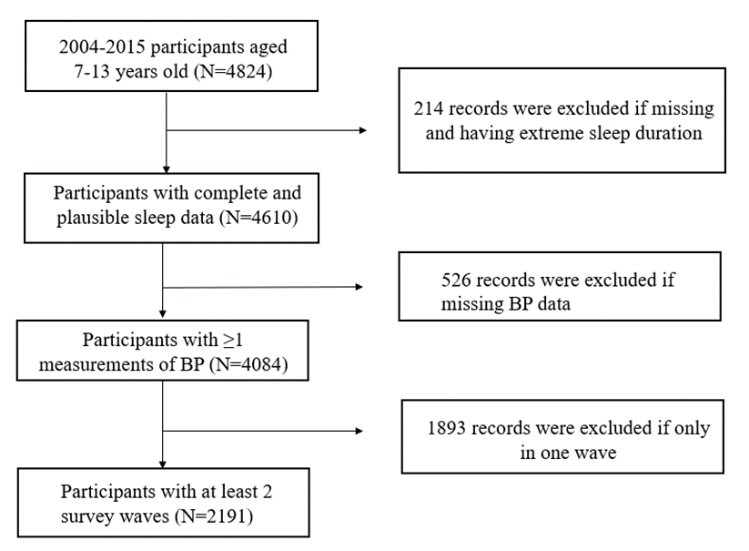
Figure S1 Sampling flowchart and participants enrollment

Table S3 The association of sleep duration with BP in 2004-2015.

 | SBP | P for interaction | DBP | P for interaction | Elevated BP | P for interaction
 | β (95%CI) |  | β (95%CI) |  | OR (95%CI)
Crude
continuous | -2.052(-2.619, -1.485) |  | -1.159(-1.561, -0.757) |  | 0.814 (0.708, 0.935)
<9h | 3.757 (2.582, 4.931) |  | 1.964 (1.088, 2.840) |  | 1.396 (1.066, 1.829)
≥9h | Reference |  | Reference |  | Reference
Adjusted model¹
continuous | -0.801(-1.416, -0.185) |  | -0.388 (-0.823, 0.046) |  | 0.823 (0.704, 0.962)
<9h | 1.098 (-0.165, 2.362) |  | 0.405 (-0.515, 1.324) |  | 1.361 (1.007, 1.841)
≥9h | Reference |  | Reference |  | Reference
Adjusted model²
continuous | -0.678 (-1.457, 0.101) |  | -0.210 (-0.748, 0.327) |  | 0.891 (0.731, 1.086)
<9h | 1.458 (-0.015, 2.931) |  | 0.641 (-0.433, 1.714) |  | 1.200 (0.837, 1.722)
≥9h | Reference |  | Reference |  | Reference
Interaction term
Gender |  | 0.746 |  | 0.011 |  | 0.375
BMI z score |  | 0.828 |  | 0.654 |  | 0.328
WC |  | 0.290 |  | 0.905 |  | 0.808
Physical activities |  | 0.058 |  | 0.454 |  | 0.568
OR, odds ratios; CI, confidence interval
Model 1 adjusted for age, gender and parents hypertension history
Model 2 additionally adjusted for survey time, waist circumference, BMI z score, urbanization, per capita household income, region, frequency of physical activities per week, screen time per day.

Table S4 The association of sleep duration with SBP, DBP, and elevated BP stratified by gender in 2004-2011.
 | SBP | DBP | Elevated BP
 | β (95%CI) | β (95%CI) | OR (95%CI)
Boy | N=976
Crude model
Continuous | -1.698 (-2.565, -0.831) ** | -0.595 (-1.198, 0.008) | 0.845 (0.702, 1.016)
<9h | 2.415 (0.683, 4.147) ** | 0.447 (-0.842, 1.736) | 1.182 (0.803, 1.738)
≥9h | Reference | Reference | Reference
Adjusted model¹
Continuous | -0.701 (-1.639, 0.237) | 0.119 (-0.510, 0.748) | 0.843 (0.682, 1.041)
<9h | 0.571 (-1.280, 2.423) | -0.780 (-2.067, 0.507) | 1.181 (0.771, 1.808)
≥9h | Reference | Reference | Reference
Adjusted model²
Continuous | -0.650 (-1.830, 0.530) | 0.554 (-0.236, 1.344) | 0.940 (0.724, 1.221)
<9h | 0.350 (-1.868, 2.567) | -1.367 (-2.859, 0.124) | 1.007 (0.595, 1.705)
≥9h | Reference | Reference | Reference
Girl | n=815
Crude model
Continuous | -2.016 (-2.933, -1.098) *** | -1.857 (-2.505, -1.210) *** | 0.676 (0.523, 0.874) **
<9h | 3.745 (1.663, 5.828) *** | 3.317 (1.732, 4.901) *** | 1.994 (1.234, 3.223) **
≥9h | Reference | Reference | Reference
Adjusted model¹
Continuous | -1.226 (-2.162, -0.291) ** | -1.562 (-2.241, -0.883) *** | 0.675 (0.507, 0.898) **
<9h | 1.832 (-0.292, 3.956) | 2.543 (0.909, 4.177) ** | 2.017 (1.199, 3.394) **
≥9h | Reference | Reference | Reference
Adjusted model²
Continuous | -0.831 (-1.970, 0.301) | -1.336 (-2.145, -0.527) ** | 0.727 (0.501, 1.055)
<9h | 1.694 (-0.725, 4.113) | 2.193 (0.425, 3.962) * | 1.909 (1.024, 3.556) *
≥9h | Reference | Reference | Reference
* P<0.05, ** P<0.01, * P<0.001.
OR, odds ratios; CI, confidence interval
Model 1 adjusted for age, parents’ hypertension history
Model 2 additionally adjusted for survey time, BMI z score, waist circumference, urbanization, per capita household income, region, frequency of physical activities per week, screen time per day.

