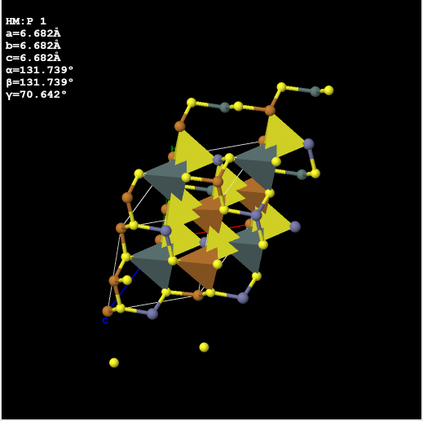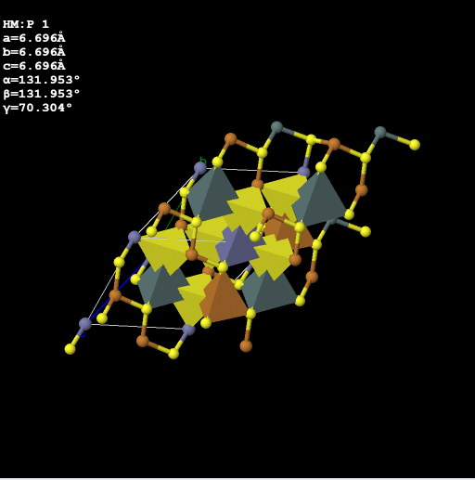
- (b)
Figure S1: Crystal structure of (a) stannite and (b) kesterite CZTS [1].

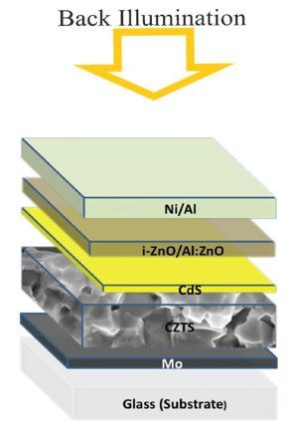
Figure S2: Typical device structure for CZTS solar cells (adapted from [2]).

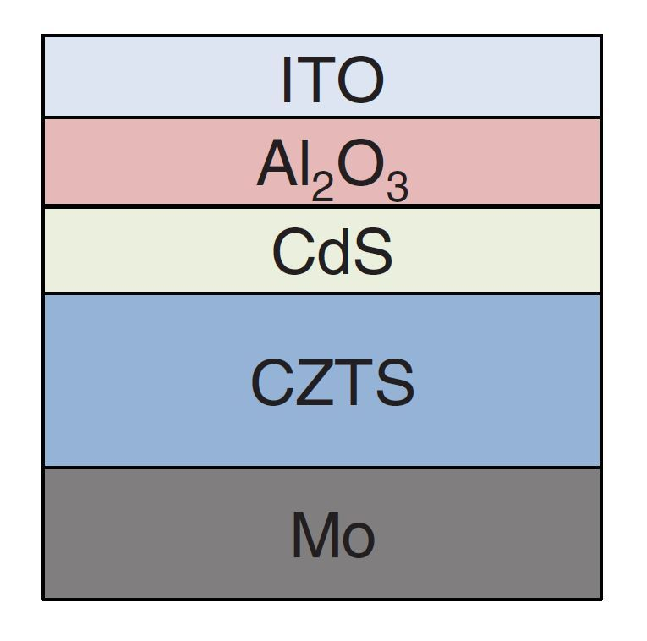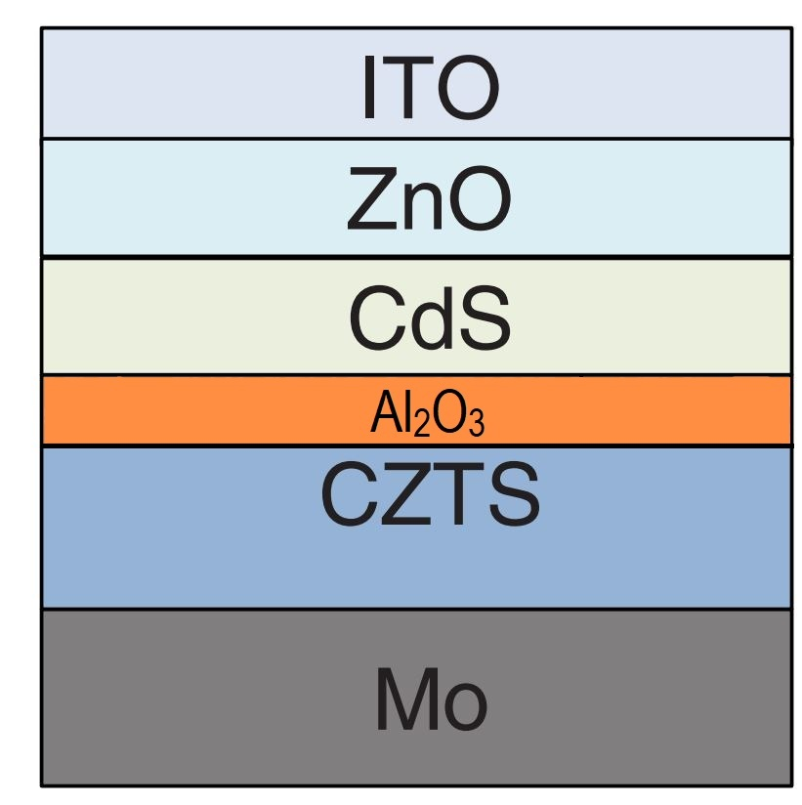
- (b)
Figure S3: Schematic of device structures with Al2O3 on the top of (a) Absorber layer (b) n-type CdS layer (adapted from [3]).

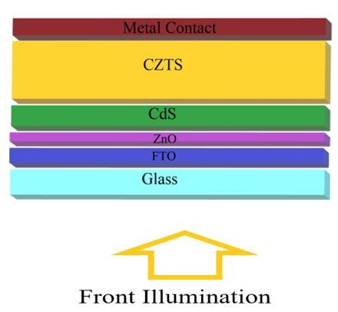
Figure S4: Schematic of CZTS device structures with FTO coated Substrate

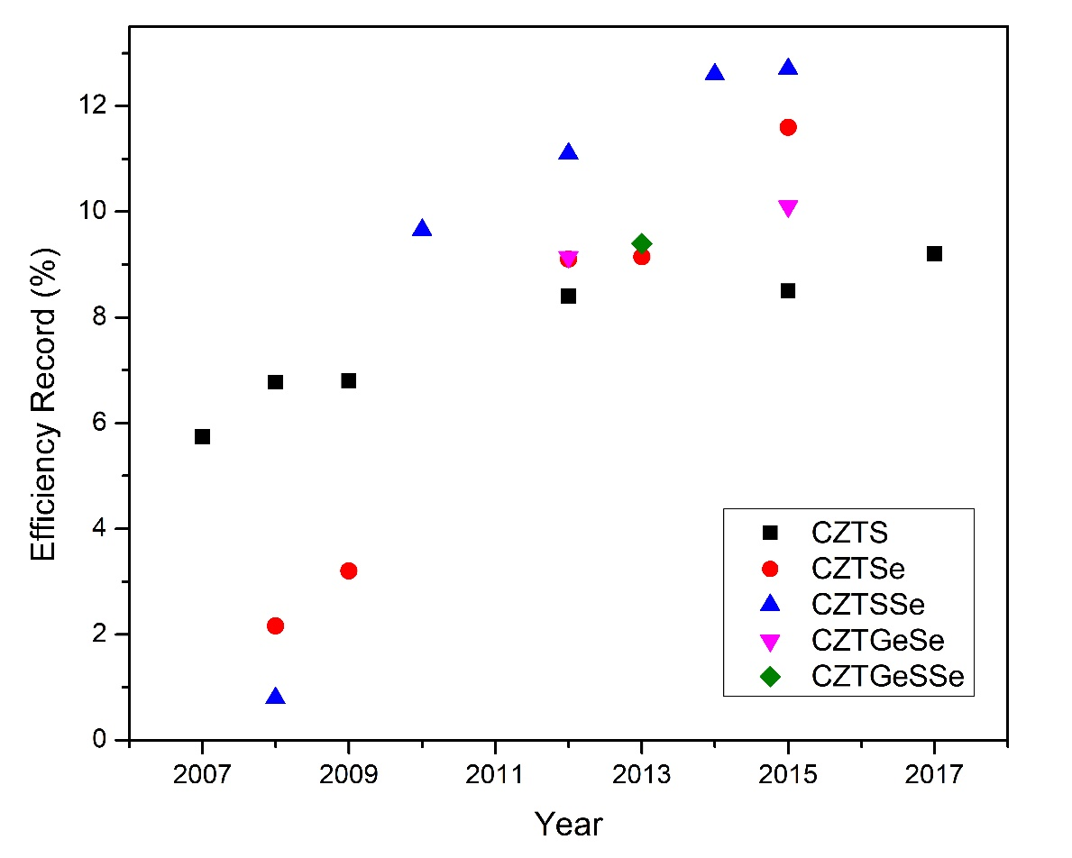
Figure S5: Improvement of conversion efficiency on CZTS-based thin-film solar cells ([4]–[23])
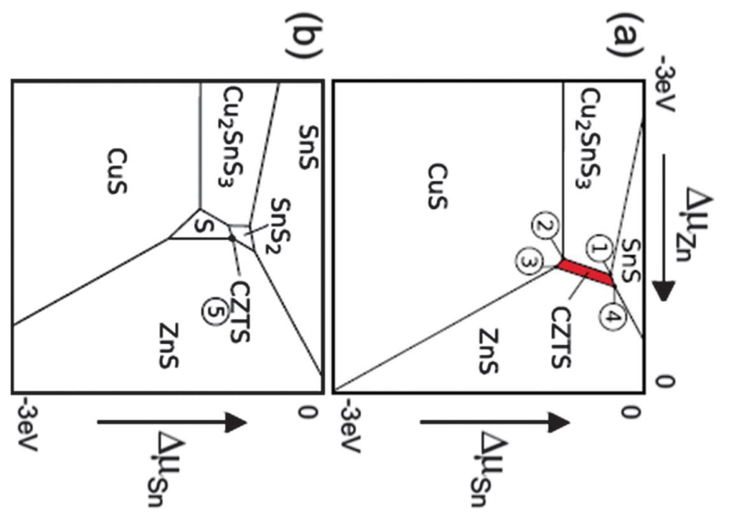
Figure S6: Chemical potential based stability diagram for tin and zinc under (a) copper-rich and (b) copper-poor conditions. Δµ is the chemical potential for the standard element. (adapted from [2]).
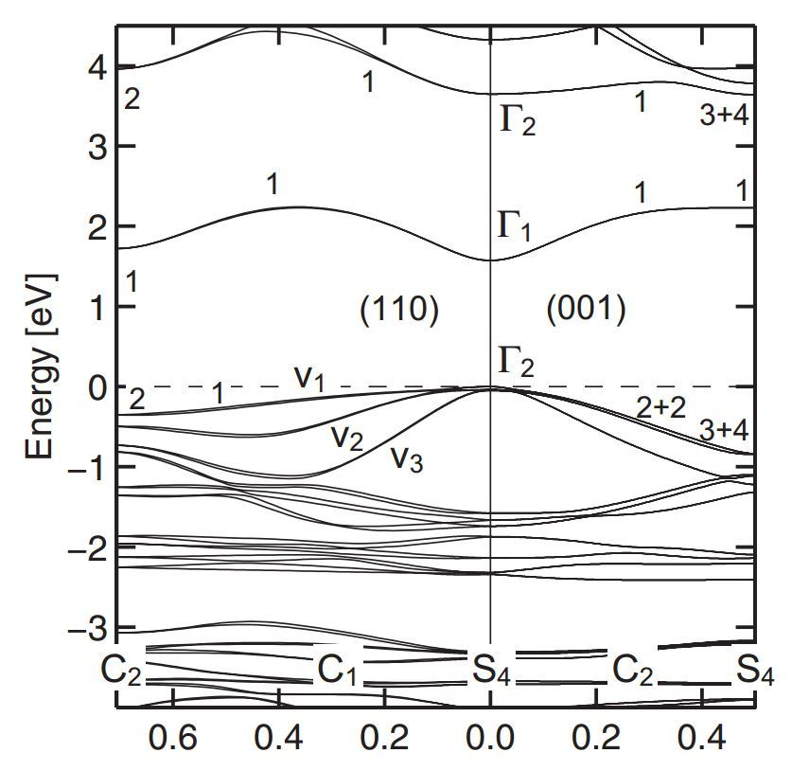
Figure S7: Electronic band structure of kesterite CZTS along with the two symmetry directions (110) and (001) (adapted from [24]).
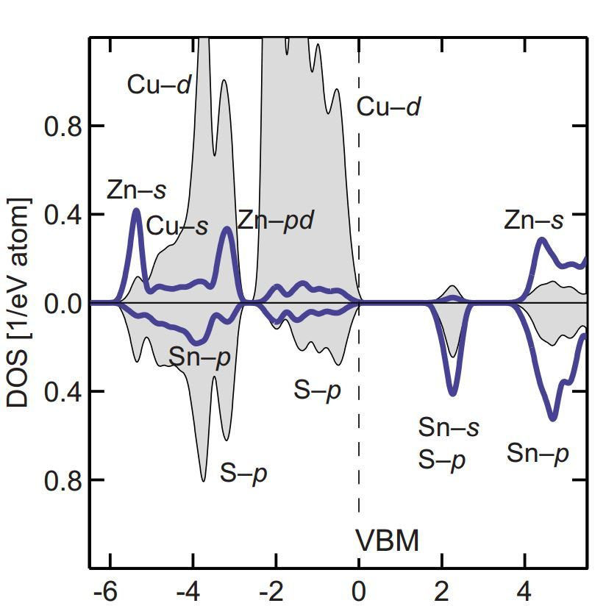
Figure S8: Atomic resolved DOS of CZTS, presented with a 0.1 eV Lorentzian broadening. The gray area in the upper panels represents the DOS of Cu atoms, and the thick blue line represents Zn atoms. In the lower panels, the gray area represents S, and the thick blue line represents Sn atoms (adapted from [25]).
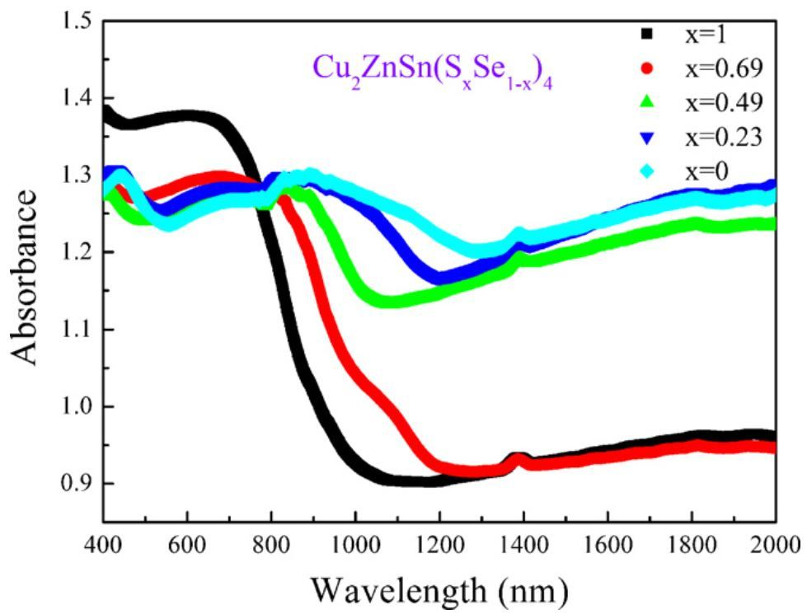
Figure S9: Absorption spectra of Cu₂ZnSn(S_{x}Se_{1−x})₄ powders (adapted from [26]).

References
[1] A. Jain and S. P. Ong, “A. Jain, SP Ong, G. Hautier, W. Chen, WD Richards, S. Dacek, S. Cholia, D. Gunter, D. Skinner, G. Ceder, and KA Persson, APL Mater. 1, 011002 (2013).,” APL Mater., vol. 1, p. 11002, 2013.
[2] M. Kumar, A. Dubey, N. Adhikari, S. Venkatesan, and Q. Qiao, “Strategic review of secondary phases, defects and defect-complexes in kesterite CZTS–Se solar cells,” Energy Environ. Sci., 2015, doi: 10.1039/C5EE02153G.
[3] Y. S. Lee et al., “Atomic Layer Deposited Aluminum Oxide for Interface Passivation of Cu2ZnSn(S,Se)4 Thin-Film Solar Cells,” Adv. Energy Mater., 2016, doi: 10.1002/aenm.201600198.
[4] G. S. Babu, Y. B. K. Kumar, P. U. Bhaskar, and V. S. Raja, “Growth and characterization of co-evaporated Cu2ZnSnSe4 thin films for photovoltaic applications,” J. Phys. D. Appl. Phys., vol. 41, no. 20, p. 205305, 2008.
[5] I. Repins et al., “Co-evaporated Cu2ZnSnSe4 films and devices,” Sol. Energy Mater. Sol. Cells, vol. 101, pp. 154–159, 2012.
[6] H. Katagiri and K. Jimbo, “Development of rare metal-free CZTS-based thin film solar cells,” in 2011 37th IEEE Photovoltaic Specialists Conference, 2011, pp. 3516–3521, doi: 10.1109/PVSC.2011.6186707.
[7] K. Sun et al., “Influence of sodium incorporation on kesterite Cu2ZnSnS4 solar cells fabricated on stainless steel substrates,” Sol. Energy Mater. Sol. Cells, vol. 157, pp. 565–571, 2016, doi: https://doi.org/10.1016/j.solmat.2016.07.036.
[8] H. Katagiri et al., “Enhanced conversion efficiencies of Cu2ZnSnS4-based thin film solar cells by using preferential etching technique,” Appl. Phys. Express, 2008, doi: 10.1143/APEX.1.041201.
[9] C. W. Hong, S. W. Shin, M. P. Suryawanshi, M. G. Gang, J. Heo, and J. H. Kim, “Chemically Deposited CdS Buffer/Kesterite Cu2ZnSnS4 Solar Cells: Relationship between CdS Thickness and Device Performance,” ACS Appl. Mater. Interfaces, vol. 9, no. 42, pp. 36733–36744, Oct. 2017, doi: 10.1021/acsami.7b09266.
[10] S. Bag, O. Gunawan, T. Gokmen, Y. Zhu, and D. B. Mitzi, “Hydrazine-processed Ge-substituted CZTSe solar cells,” Chem. Mater., 2012, doi: 10.1021/cm302881g.
[11] K. Jimbo et al., “Cu2ZnSnS4-type thin film solar cells using abundant materials,” Thin Solid Films, 2007, doi: 10.1016/j.tsf.2006.12.103.
[12] Q. Guo, H. W. Hillhouse, and R. Agrawal, “Synthesis of Cu2ZnSnS4 nanocrystal ink and its use for solar cells,” J. Am. Chem. Soc., vol. 131, no. 33, pp. 11672–11673, 2009.
[13] T. Ericson et al., “Zinc‐Tin‐Oxide Buffer Layer and Low Temperature Post Annealing Resulting in a 9.0% Efficient Cd‐Free Cu2ZnSnS4 Solar Cell,” Sol. RRL, vol. 1, no. 5, p. 1700001, 2017.
[14] C. J. Hages et al., “Improved performance of Ge-alloyed CZTGeSSe thin-film solar cells through control of elemental losses,” Prog. Photovoltaics Res. Appl., 2015, doi: 10.1002/pip.2442.
[15] N. Muhunthan, O. P. Singh, S. Singh, and V. N. Singh, “Growth of CZTS thin films by cosputtering of metal targets and sulfurization in H2S,” Int. J. Photoenergy, vol. 2013, 2013.
[16] T. K. Todorov et al., “Beyond 11% efficiency: characteristics of state‐of‐the‐art Cu2ZnSn (S, Se) 4 solar cells,” Adv. Energy Mater., vol. 3, no. 1, pp. 34–38, 2013.
[17] K. Sun et al., “Over 9% Efficient Kesterite Cu2ZnSnS4Solar Cell Fabricated by Using Zn1–xCdxS Buffer Layer,” Adv. Energy Mater., 2016, doi: 10.1002/aenm.201600046.
[18] T. K. Todorov, K. B. Reuter, and D. B. Mitzi, “High-efficiency solar cell with earth-abundant liquid-processed absorber,” Adv. Mater., 2010, doi: 10.1002/adma.200904155.
[19] G. Zoppi, I. Forbes, R. W. Miles, P. J. Dale, J. J. Scragg, and L. M. Peter, “Cu2ZnSnSe4 thin film solar cells produced by selenisation of magnetron sputtered precursors,” Prog. Photovoltaics Res. Appl., 2009, doi: 10.1002/pip.886.
[20] D. A. R. Barkhouse, R. Haight, N. Sakai, H. Hiroi, H. Sugimoto, and D. B. Mitzi, “Cd-free buffer layer materials on Cu2ZnSn(SxSe(1 - x]))4: Band alignments with ZnO, ZnS, and InS3,” Applied Physics Letters. 2012, doi: 10.1063/1.4714737.
[21] B. Shin, O. Gunawan, Y. Zhu, N. A. Bojarczuk, S. J. Chey, and S. Guha, “Thin film solar cell with 8.4% power conversion efficiency using an earth-abundant Cu2ZnSnS4 absorber,” Prog. Photovoltaics Res. Appl., 2013, doi: 10.1002/pip.1174.
[22] K. Ben Messaoud et al., “Synthesis and characterization of (Cd, Zn) S buffer layer for Cu2ZnSnSe4 solar cells,” J. Phys. D. Appl. Phys., vol. 50, no. 28, p. 285501, 2017.
[23] C. Platzer-Björkman et al., “Reduced interface recombination in Cu2ZnSnS4 solar cells with atomic layer deposition Zn1− x Sn x O y buffer layers,” Appl. Phys. Lett., vol. 107, no. 24, p. 243904, 2015.
[24] J. Tao et al., “7.1% efficient co-electroplated Cu2ZnSnS4thin film solar cells with sputtered CdS buffer layers,” Green Chem., 2016, doi: 10.1039/c5gc02057c.
[25] Y. S. Lee et al., “Cu2ZnSnSe4 thin-film solar cells by thermal co-evaporation with 11.6% efficiency and improved minority carrier diffusion length,” Adv. Energy Mater., 2015, doi: 10.1002/aenm.201401372.
[26] A. Khare, A. W. Wills, L. M. Ammerman, D. J. Norris, and E. S. Aydil, “Size control and quantum confinement in Cu2ZnSnS4nanocrystals,” Chem. Commun., 2011, doi: 10.1039/c1cc14687d.

