**Valorizing rice straw and its anaerobically digested residues for biochar to remove Pb(Ⅱ) from aqueous solution**

Jingyang Lia,b,c,d, Fei Shenc,d[1]*, Gang Yangc,d, Yanzong Zhangd, Shihuai Dengc,d, Jing Zhangc,d, Yongmei Zengc,d, Tao Luo a,b,, Zili Mei a,b,

a Biogas Institute of Ministry of Agriculture，Chengdu, Sichuan 610041, P. R. China;

b Key Laboratory of Development and Application of Rural Renewable Energy, Ministry of Agriculture, Chengdu, Sichuan 610041, P. R. China

c Institute of Ecological and Environmental Sciences, Sichuan Agricultural University, Chengdu, Sichuan 611130, P. R. China;

d Rural Environment Protection Engineering & Technology Center of Sichuan Province, Sichuan Agricultural University, Chengdu, Sichuan 611130, P. R. China;

**Supplementary Information**

${\text{q}}_{\text{e}}\text{=}\frac{{\text{Q}}_{\text{m}}{\text{K}}_{l}{\text{C}}_{\text{e}}}{\text{1+}{\text{K}}_{l}{\text{C}}_{\text{e}}}$ Eq. S1

${\text{q}}_{\text{e}}\text{=}{\text{K}}_{\text{f}}{ \text{C}}_{\text{e}}^{\text{n}}$ Eq. S2

where *qe* is the equilibrium phosphate adsorption capacity (mg g-1), *Qm* is the maximum capacity (mg g-1), *Kl* is the represent the Langmuir bonding tern related to interaction energies (L mg-1), *Ce* is the equilibrium concentration of phosphate (mg L-1), *n* is the Freundlich linearity constant, *Kf* represents the Freundlich affinity coefficient (mg(1-n) Ln g-1).

Eq. S3

where *Kl* is a fitted parameter of Langmuir model, *Co* is the highest initial phosphate concentration in solution (mg L-1).

Eq. S4

Eq. S5

Where *qe* and *qt* represent the amount of phosphate adsorbed at equilibrium and at time *t*, respectively (mg g-1), *t* is the contact time (h), *k1*and *k2* are adsorption rate constants of the first order (h-1) and second order (g mg-1 h-1) models, respectively.

$ΔG^{0}=-RTlnK_{e}$ Eq. S6

$K_{e}=\frac{q_{e}}{C_{e}}$ Eq. S7

$lnK_{e}=-\frac{ΔH^{0}}{RT}+\frac{ΔS^{0}}{R}$ Eq. S8

where *R* is gas constant (8.314 J mol-1 K), *T* is the absolute temperature (K), *qe* is lead concentration on RS-500 and DRS-500 at equilibrium (mg g-1), *Ce* is the remaining lead concentration in the solution at equilibrium (mg L-1), ΔG0 (kJ mol-1), ΔH0 (kJ mol-1) and ΔS0 (J mol-1 K-1) can be calculated from the slope and intercept of the plot of ΔG0 versus T.

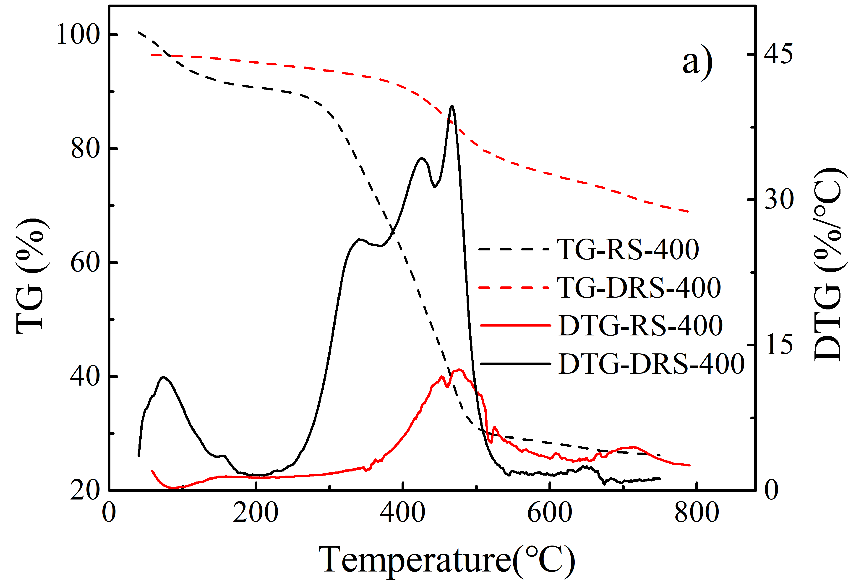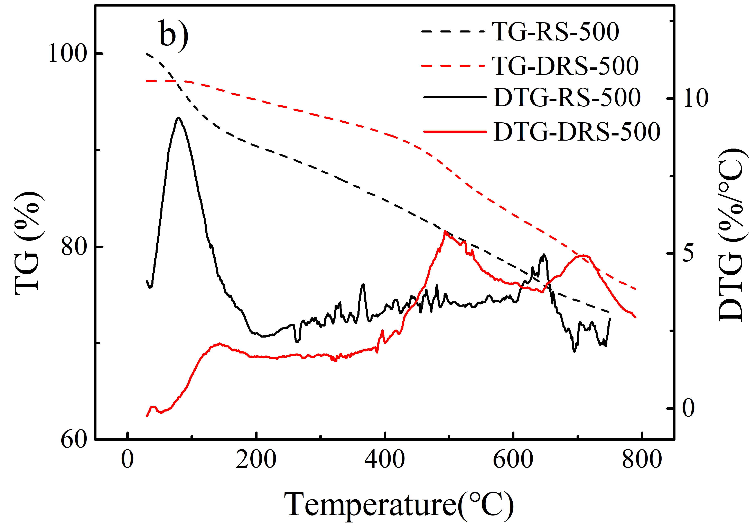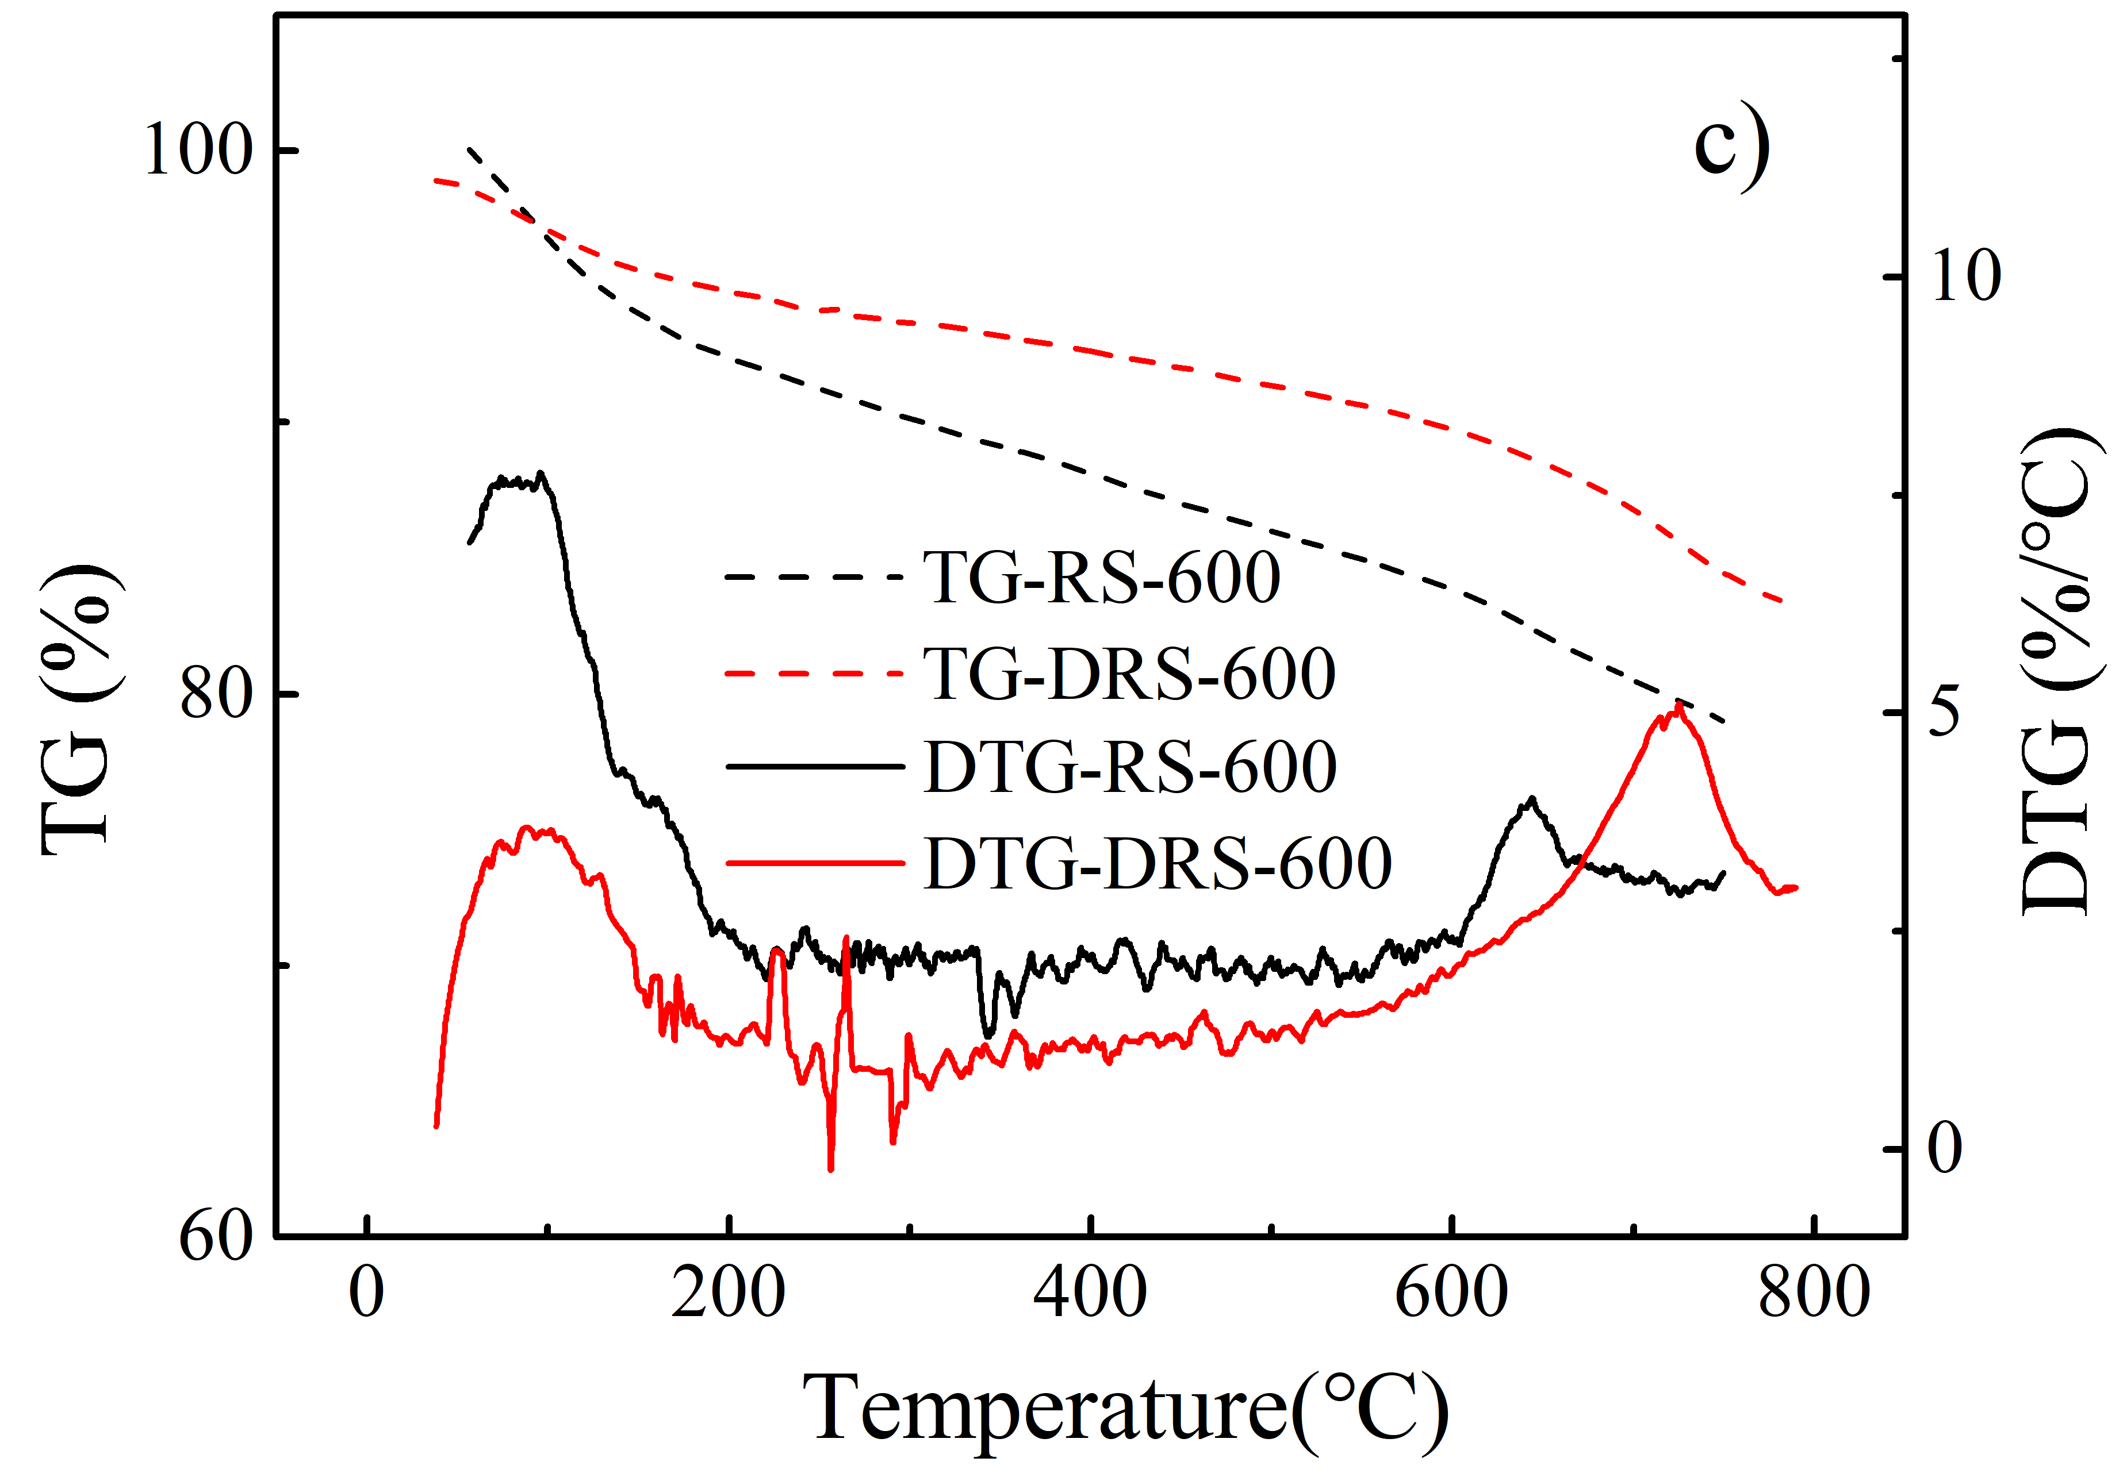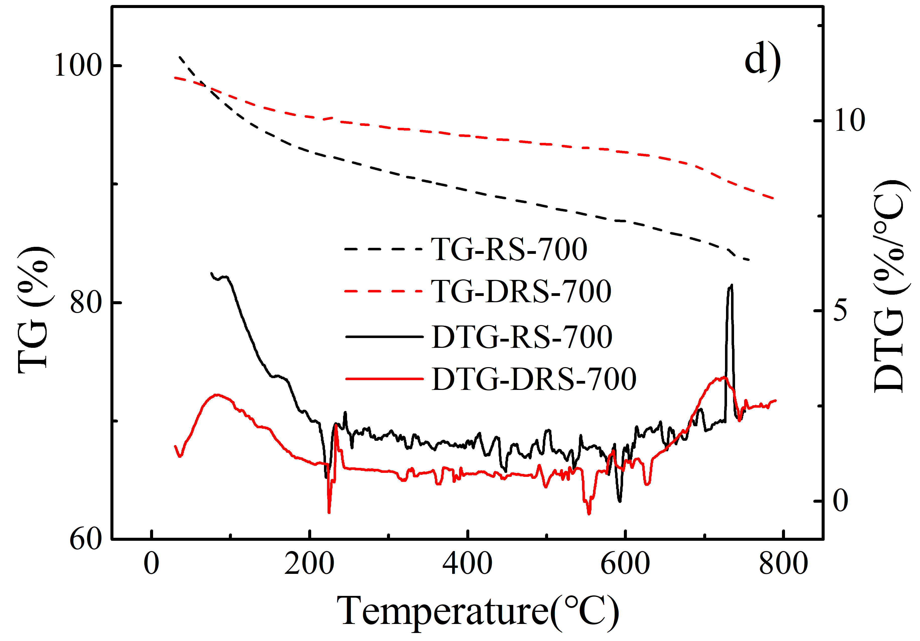

**Fig. S1** TG-DTG curves of biochars. a) RS-400 and DRS-400; b) RS-500 and DRS-500; c) RS-600 and DRS-600; d) RS-700 and DRS700

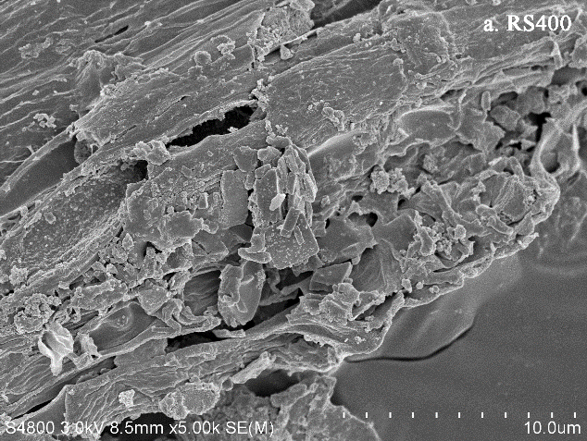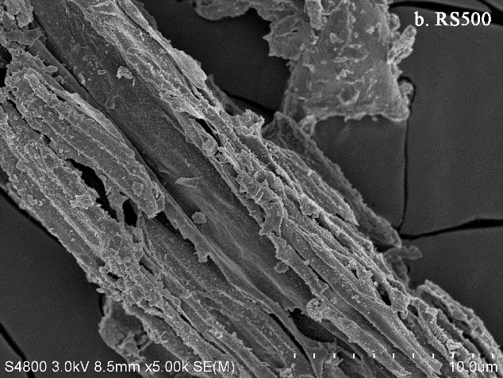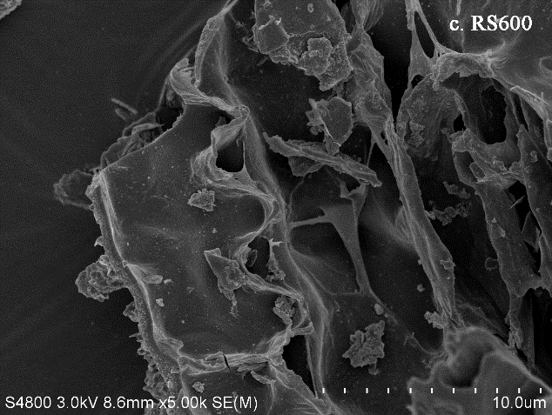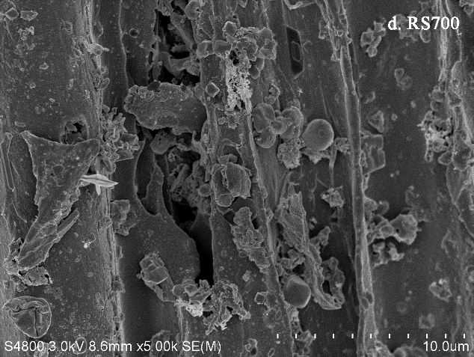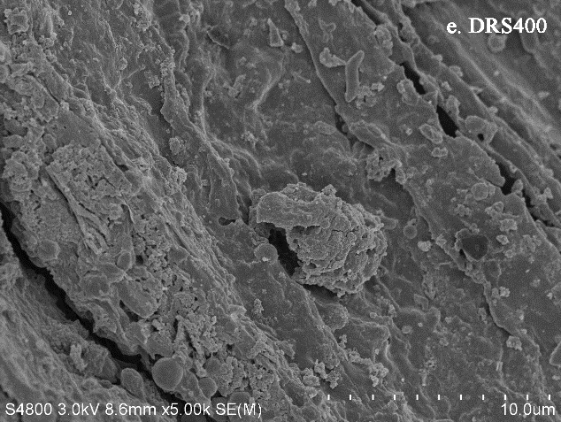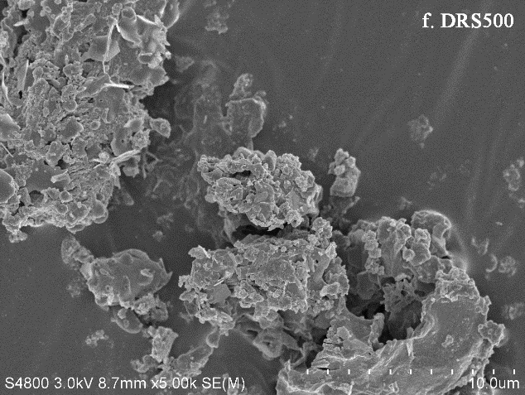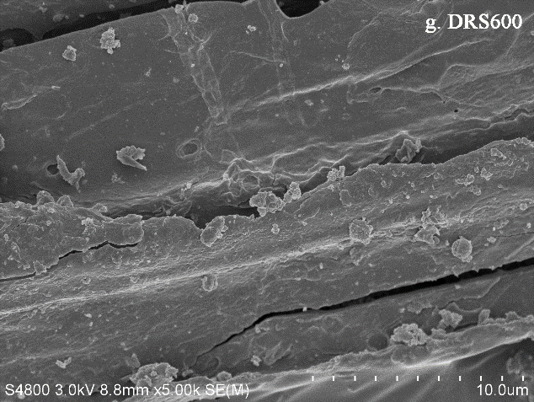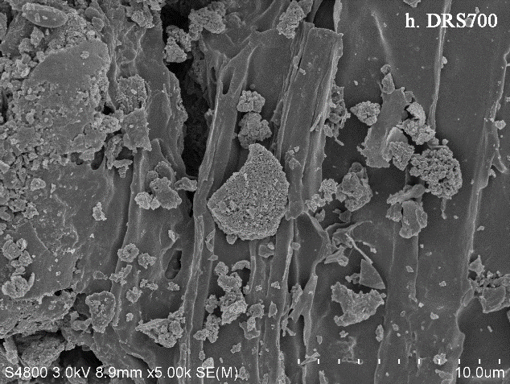

**Fig. S1** SEM for RSBCs and DRSBCs

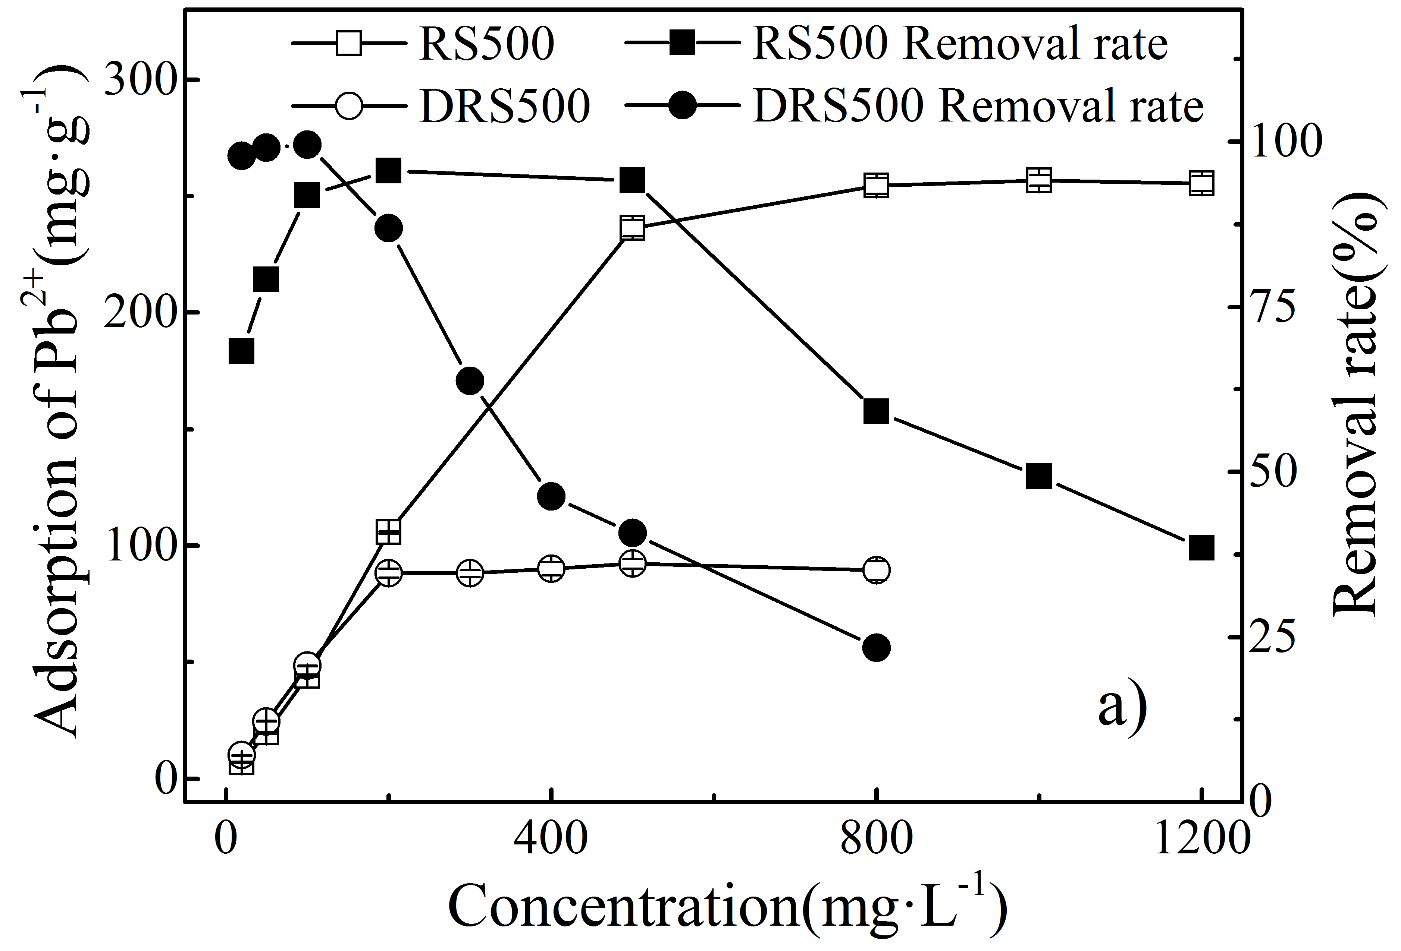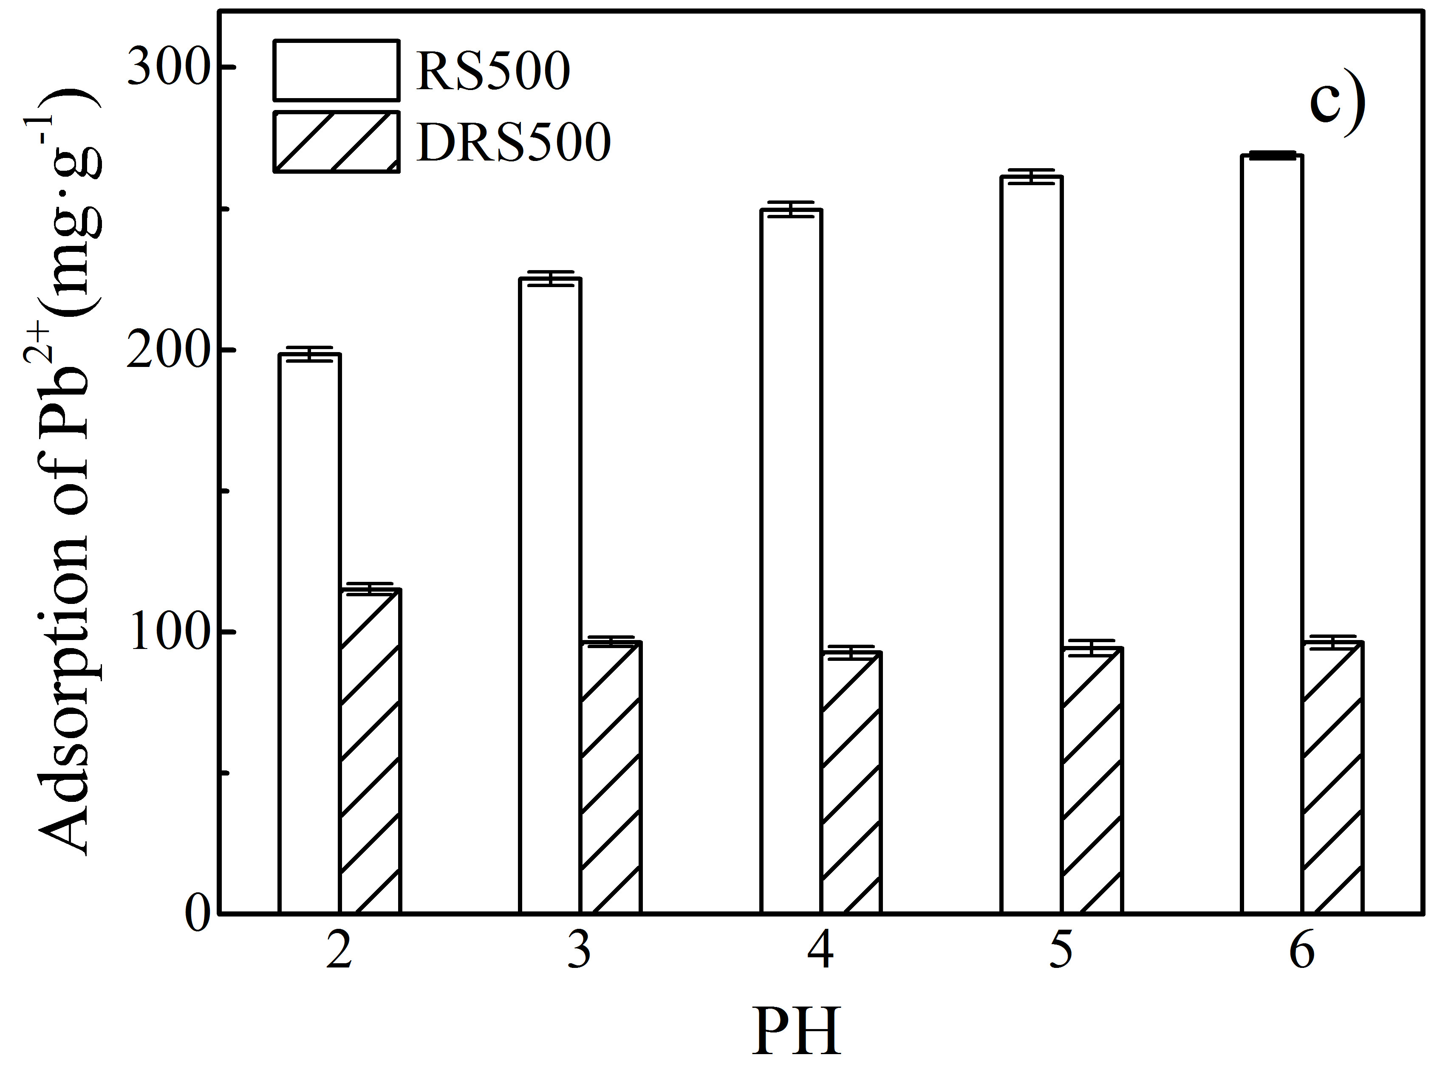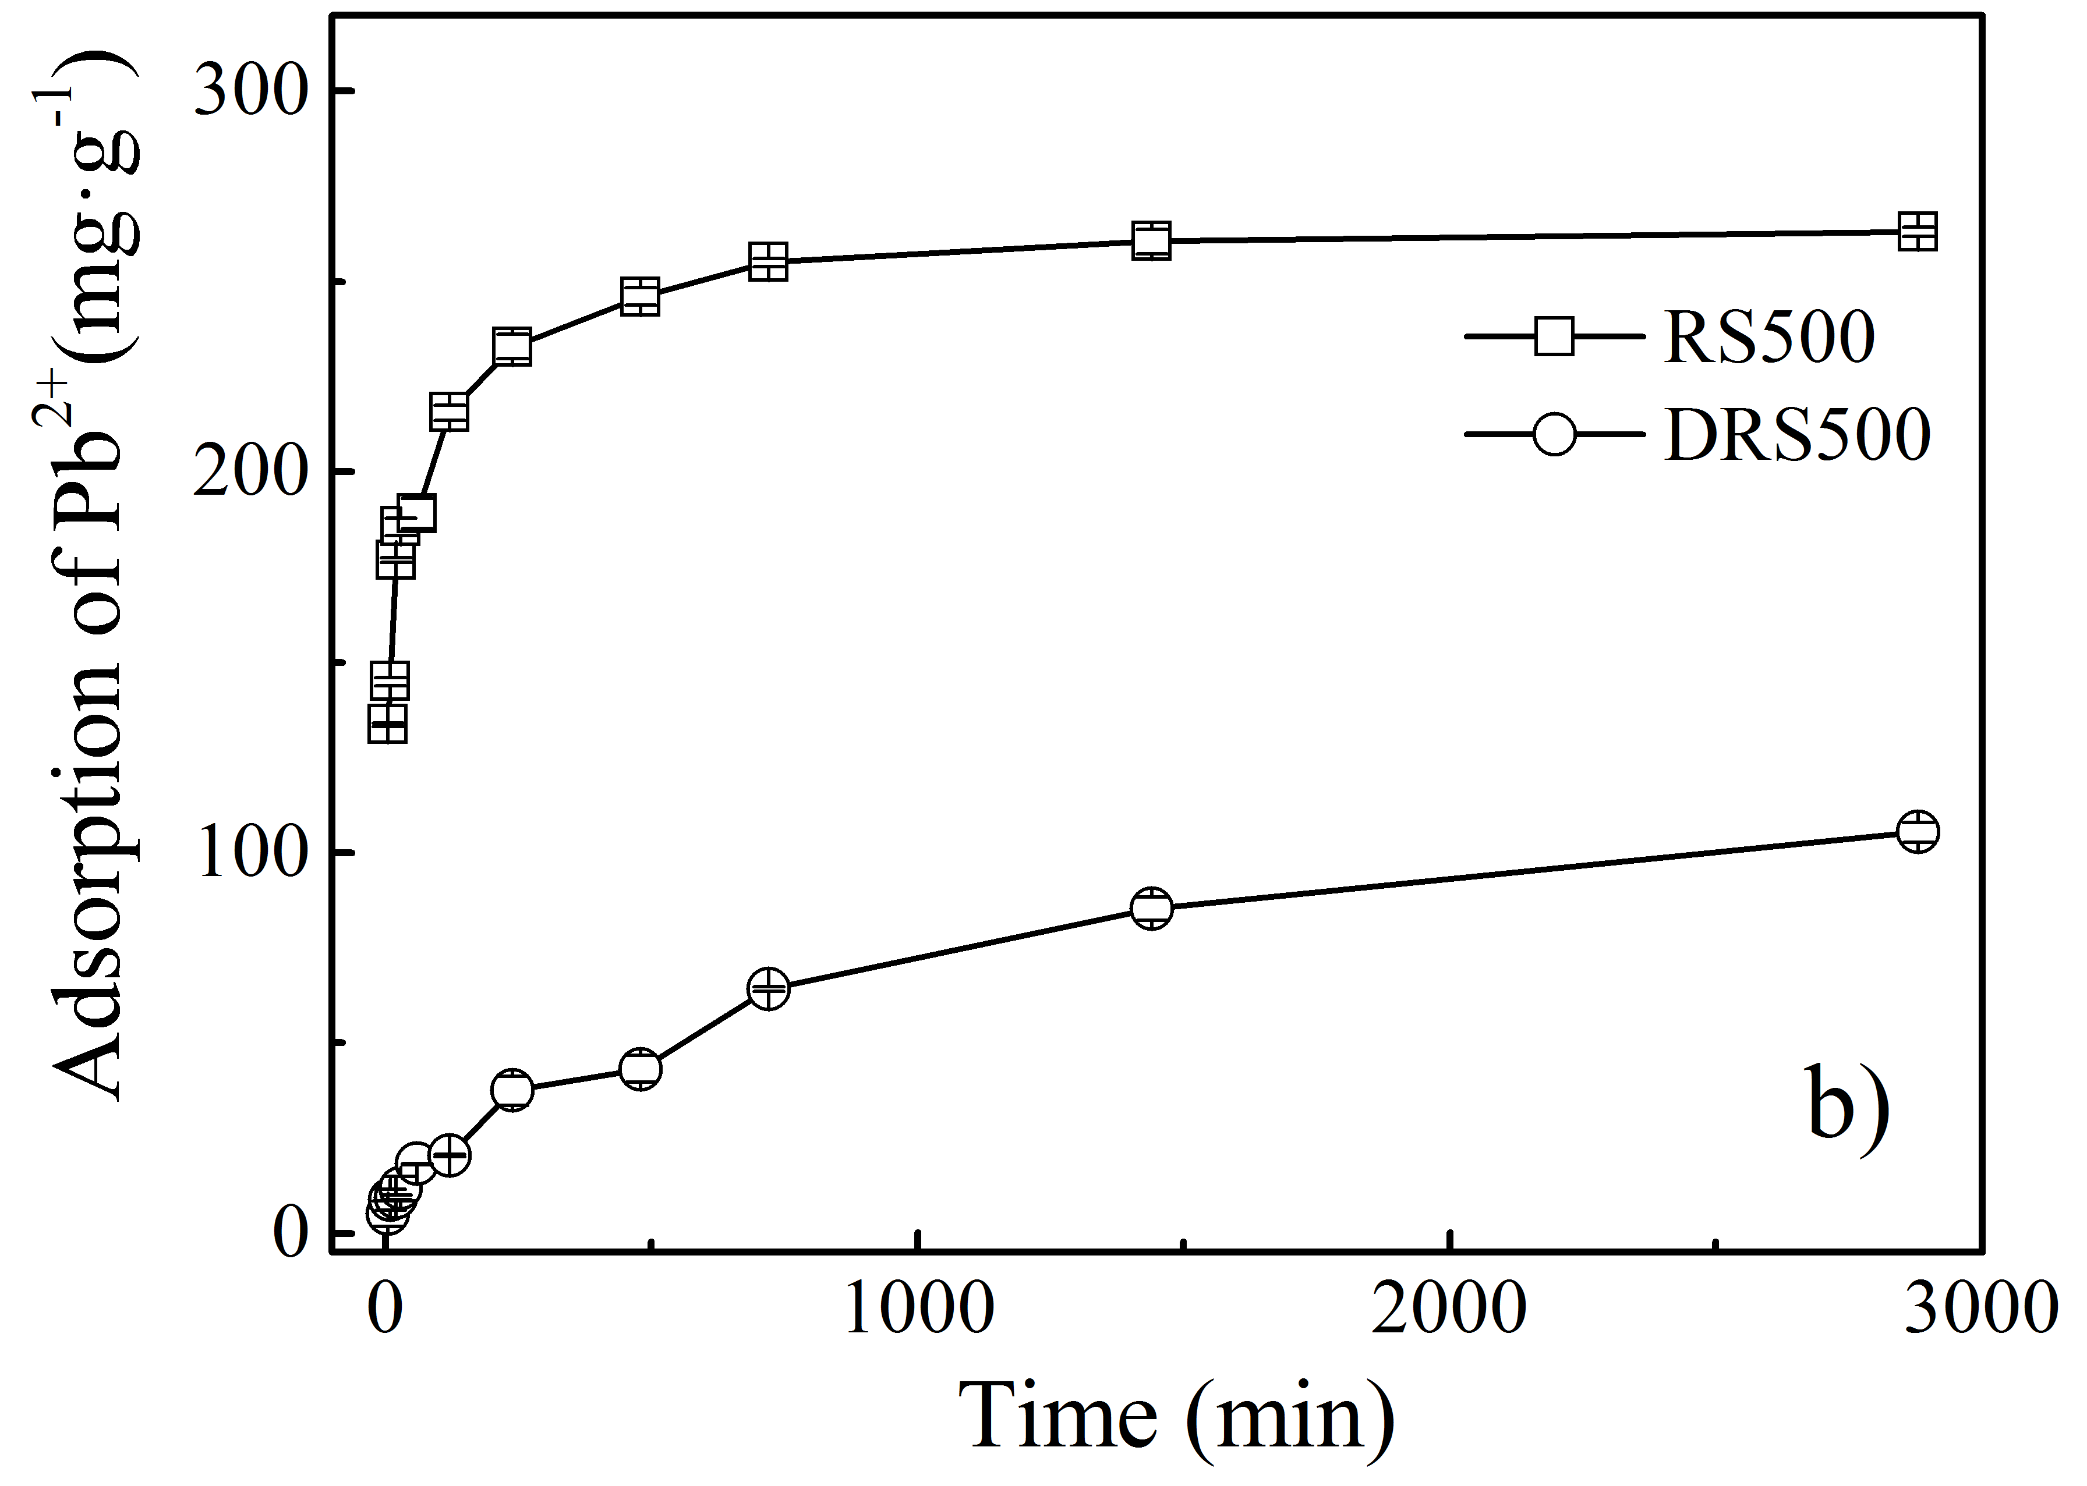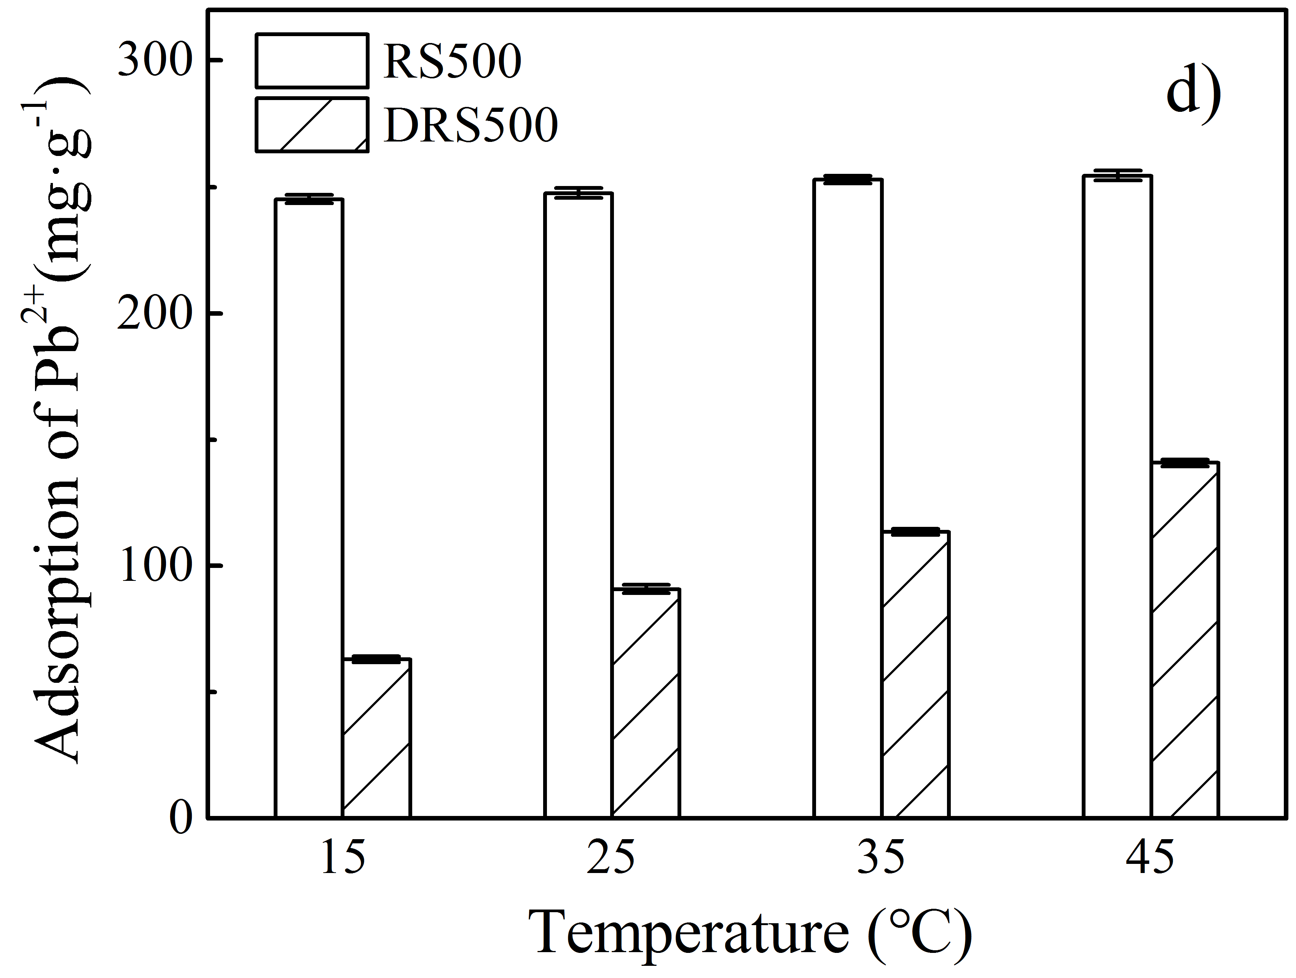

**Fig. S3** Influences of reaction conditions on lead adsorption by RS-500 and DRS-500.

a) concentration; b) time; c)pH; d) temperature

E:\实验\origin图片\Pb\PbIR.tif

**Fig. S4** FT-IR spectra for RS500-Pb and DRS500-Pb

**Table S1** Elemental analysis of biochars produced at different temperatures

|  |  |  |  |  |  |  |  |
| --- | --- | --- | --- | --- | --- | --- | --- |
| Biochar | C(%) | H(%) | O(%) | N(%) | H/C | O/C | C/N |
| RS | 39.34 | 5.22 | 39.58 | 0.42 | 0.13 | 1.01 | 93.24 |
| RS-400 | 41.14 | 3.14 | 21.94 | 1.92 | 0.076 | 0.53 | 21.45 |
| RS-500 | 43.18 | 1.83 | 18.85 | 1.12 | 0.042 | 0.44 | 38.46 |
| RS-600 | 44.08 | 1.27 | 12.66 | 0.91 | 0.029 | 0.29 | 48.32 |
| RS-700 | 43.76 | 0.58 | 12.08 | 1.42 | 0.013 | 0.28 | 30.73 |
| DRS | 30.80 | 4.13 | 19.04 | 2.27 | 0.13 | 0.62 | 13.59 |
| DRS-400 | 28.90 | 2.22 | 9.39 | 2.12 | 0.077 | 0.32 | 13.61 |
| DRS-500 | 24.56 | 1.19 | 8.12 | 1.95 | 0.049 | 0.33 | 12.61 |
| DRS-600 | 23.79 | 0.17 | 4.10 | 2.93 | 0.0071 | 0.17 | 8.11 |
| DRS-700 | 21.50 | 0.076 | 3.63 | 3.97 | 0.0035 | 0.17 | 5.42 |

**Table S2** Isotherm parameters of lead adsorption on RS-500 and DRS-500

|  |  |  |  |  |  |  |  |
| --- | --- | --- | --- | --- | --- | --- | --- |
| Biochar | Langmuir | | |  | Freundlich | | |
|  | Qm | KL | R2 |  | Kf | n | R2 |
|  | (mg·g-1) | (L·mg-1) | | (mg(1-n)Lng-1) | | |  |
| RS-500 | 276.26 | 0.039 | 0.83 |  | 42.16 | 3.47 | 0.67 |
| DRS-500 | 90.52 | 1.04 | 0.87 |  | 40.17 | 6.73 | 0.74 |

**Table S3** Kinetic parameters of lead adsorption on RS-500 and DRS-500

|  |  |  |  |  |  |  |  |
| --- | --- | --- | --- | --- | --- | --- | --- |
| Biochar | First order | | |  | Second order | | |
|  | qe | K1 | R2 |  | qe | K2 | R2 |
|  | (mg·g-1) | (h-1) |  |  | (mg·g-1) | (mg·g-1·h-1) | |
| RS-500 | 216.13 | 0.17 | 0.62 |  | 240.10 | 0.00088 | 0.87 |
| DRS-500 | 102.37 | 0.0014 | 0.95 |  | 124.84 | 0.000012 | 0.96 |

|  |  |  |  |  |  |  |
| --- | --- | --- | --- | --- | --- | --- |
| **Table S4** Thermodynamic parameters of lead adsorption on RS-500 and DRS-500 | | | | | | |
|  | ΔH0 | ΔS0 | ΔG0（kJ·mol-1） | | | |
|  | （kJ·mol-1） | （J·mol-1·K-1） | 288K | 298K | 308K | 318K |
| RS-500 | 0.244 | 5.904 | -1.456 | -1.515 | -1.574 | -1.633 |
| DRS-500 | 4.038 | 18.047 | -1.160 | -1.340 | -1.521 | -1.701 |

1. * Corresponding author; Address: 211 Huimin Road, Wenjiang District, Chengdu, Sichuan, 611130, P. R. China; Tel.(Fax): +86 28 86293087; E-mail: [fishensjtu@gmail.com](mailto:fishensjtu@gmail.com) or fishen@sicau.edu.cn.