Supporting Information

Investigation of the effects of different hydrophilic and hydrophobic comonomers on the volume phase transition temperatures and thermal properties of N-isopropylacrylamide based hydrogels

Ahmet Okudan*, Abdullah Altay

Selcuk University, Faculty of Science, Department of Chemistry, 42075, Konya, Turkey

S1. The NIPA/AA/NTBA hydrogel
S2. The NIPA/MMA/NTBA hydrogel
S3. The NIPA/MMA/AA hydrogel
S4. Dependence of swelling ratio on temperature in pure water for P(NIPA) hydrogel
S5. Dependence of swelling ratio on temperature in pure water for NIPA(50)/MMA(40)/AA(10), NIPA(50)/AA(40)/NTBA(10), NIPA(50)/MMA(10)/NTBA(40) hidrogels
S6. Dependence of swelling ratio on temperature in pure water for NIPA(50)/MMA(10)/AA(40), NIPA(50)/AA(40)/NTBA(10), NIPA(50)/MMA(10)/NTBA(40) hidrogels
S7. Dependence of swelling ratio on temperature in pure water for NIPA(60)/AA(20)/NTBA(20), NIPA(60)/MMA(20)/AA(20), NIPA(60)/MMA(20)/NTBA(20) hidrogels
S8. Dependence of swelling ratio on temperature in pure water for NIPA(60)/MMA(10)/AA(30), NIPA(60)/AA(30)/NTBA(10), NIPA(60)/MMA(10)/NTBA(30) hidrogels
S9. Dependence of swelling ratio on temperature in pure water for NIPA(60)/MMA(30)/AA(10), NIPA(60)/MMA(30)/NTBA(10), NIPA(60)/AA(10)/NTBA(30) hidrogels
S10. Dependence of swelling ratio on temperature in pure water NIPA(80)/AA(10)/NTBA(10), NIPA(80)/MMA(10)/AA(10), NIPA(80)/MMA(10)/NTBA(40) hidrogels
S11. Dependence of swelling ratio on temperature in pure water for NIPA(80)/MMA(5)/NTBA(15), NIPA(80)/MMA(5)/AA(15) hidrogels
S12. Dependence of swelling ratio on temperature in pure water for NIPA(80)/MMA(15)/AA(5), NIPA(80)/MMA(15)/NTBA(5) hidrogels
S13.Dependence of swelling ratio on temperature in pure water for
NIPA(80)/AA(5)/NTBA(15), NIPA(80)/AA(15)/NTBA(5) hidrogels
S.14. DSC thermogram of P(NIPA) hydrogel
S.15. DSC thermograms of a: (NIPAAm%80/MMA%15/NTBA%5),
b: (NIPAAm%80/NTBA%15/AA%5)P(NIPA) and
c: (NIPAAm%80/AA%5/NTBA%15) hydrogels
S.16. DSC thermograms of d: (NIPAAm%50/AA%40/MMA%10) and e: (NIPAAm%50/AA%40/NTBA%10) hydrogels
S.17. DTG thermograms of the (NIPA%80/MMA%15/NTBA%5) and b:(NIPA%80/MMA%15/AA%5) hydrogels. Scan was run at 10 oC/min under nitrogen atmosphere.
S.18. DTG thermograms of the b:(NIPA%80/MMA%15/AA%5) and c:(NIPA%80/AA%5/NTBA%15) hydrogels. Scan was run at 10 oC/min under nitrogen atmosphere.
S.19. DTG thermograms of the d:(NIPA%50AA%40/MMA%10/) and e:(NIPA%50/AA%40/NTBA%10) hydrogels. Scan was run at 10 oC/min under nitrogen atmosphere.

SCHEME S1: The NIPA/AA/NTBA hydrogel

SCHEME S2: The NIPA/MMA/NTBA hydrogel

SCHEME S3: The NIPA/MMA/AA hydrogel

FIGURE S4: Dependence of swelling ratio on temperature in pure water for P(NIPA) hydrogel.

FIGURE S5: Dependence of swelling ratio on temperature in pure water for NIPA(50)/MMA(40)/AA(10), NIPA(50)/AA(40)/NTBA(10), NIPA(50)/MMA(10)/NTBA(40) hidrogels

FIGURE S6: Dependence of swelling ratio on temperature in pure water for NIPA(50)/MMA(10)/AA(40), NIPA(50)/AA(40)/NTBA(10), NIPA(50)/MMA(10)/NTBA(40) hidrogels

FIGURE S7: Dependence of swelling ratio on temperature in pure water for NIPA(60)/AA(20)/NTBA(20), NIPA(60)/MMA(20)/AA(20), NIPA(60)/MMA(20)/NTBA(20) hidrogels

FIGURE S8: Dependence of swelling ratio on temperature in pure water for NIPA(60)/MMA(10)/AA(30), NIPA(60)/AA(30)/NTBA(10), NIPA(60)/MMA(10)/NTBA(30) hidrogels

FIGURE S9: Dependence of swelling ratio on temperature in pure water for NIPA(60)/MMA(30)/AA(10),NIPA(60)/MMA(30)/NTBA(10), NIPA(60)/AA(10)/NTBA(30) hidrogels

FIGURE S10: Dependence of swelling ratio on temperature in pure water forNIPA(80)/AA(10)/NTBA(10),NIPA(80)/MMA(10)/AA(10), NIPA(80)/MMA(10)/NTBA(40) hidrogels

FIGURE S11: Dependence of swelling ratio on temperature in pure water for NIPA(80)/MMA(5)/NTBA(15), NIPA(80)/MMA(5)/AA(15) hidrogels

FIGURE S12: Dependence of swelling ratio on temperature in pure water for NIPA(80)/MMA(15)/AA(5), NIPA(80)/MMA(15)/NTBA(5) hidrogels

FIGURE S13: Dependence of swelling ratio on temperature in pure water for NIPA(80)/AA(5)/NTBA(15),NIPA(80)/AA(15)/NTBA(5) hidrogels

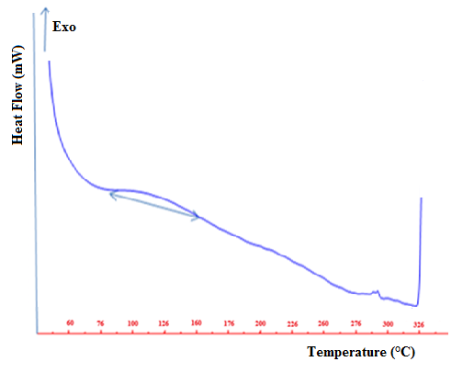
FIGURE S14: DSC thermogram of P(NIPA) hydrogel

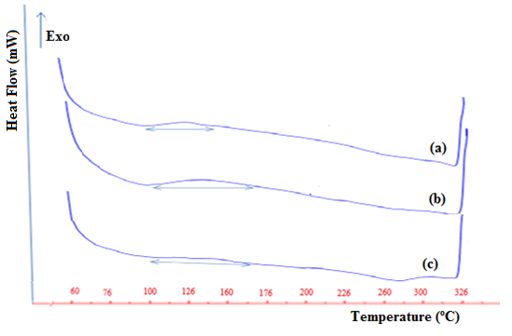
FIGURE S15: DSC thermograms of a: (NIPAAm%80/MMA%15/NTBA%5),
b: (NIPAAm%80/NTBA%15/AA%5)P(NIPA) and
c: (NIPAAm%80/AA%5/NTBA%15) hydrogels

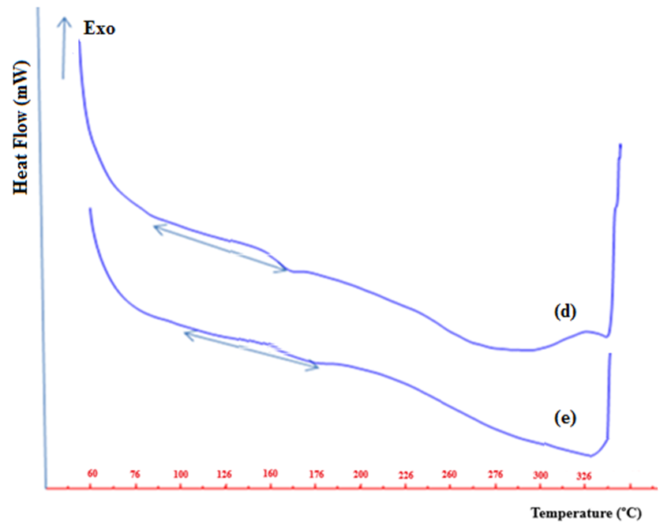

FIGURE S16: DSC thermograms of d: (NIPAAm%50/AA%40/MMA%10) and
e: (NIPAAm%50/AA%40/NTBA%10) hydrogels

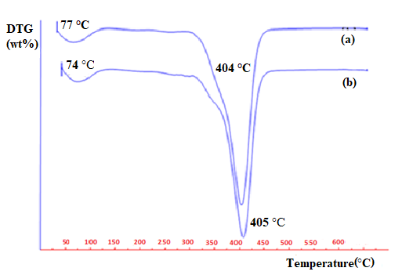
FIGURE S17: DTG thermograms of the (NIPA%80/MMA%15/NTBA%5) and b:(NIPA%80/MMA%15/AA%5) hydrogels. Scan was run at 10 oC/min under nitrogen atmosphere.

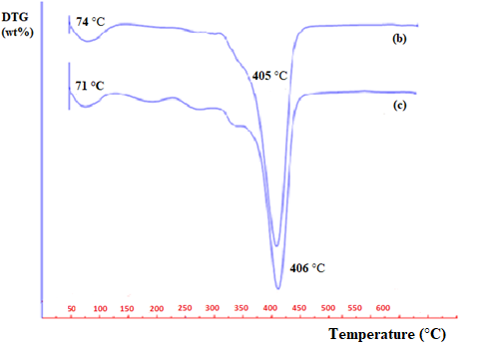
FIGURE S18: DTG thermograms of the b:(NIPA%80/MMA%15/AA%5) and c:(NIPA%80/AA%5/NTBA%15) hydrogels. Scan was run at 10 oC/min under nitrogen atmosphere.

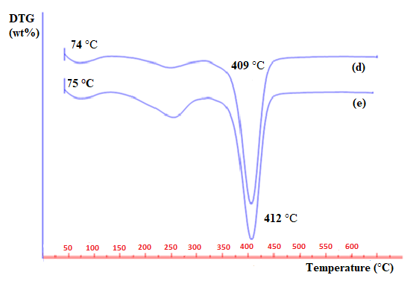
FIGURE S19: DTG thermograms of the d:(NIPA%50AA%40/MMA%10/) and e:(NIPA%50/AA%40/NTBA%10) hydrogels. Scan was run at 10 oC/min under nitrogen atmosphere.

