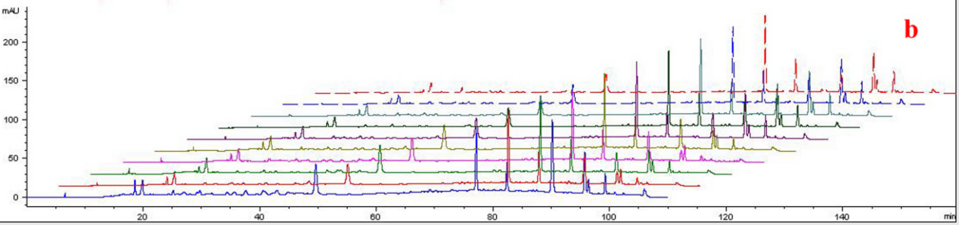
Feature graph of 10 batches specimens of saffron

