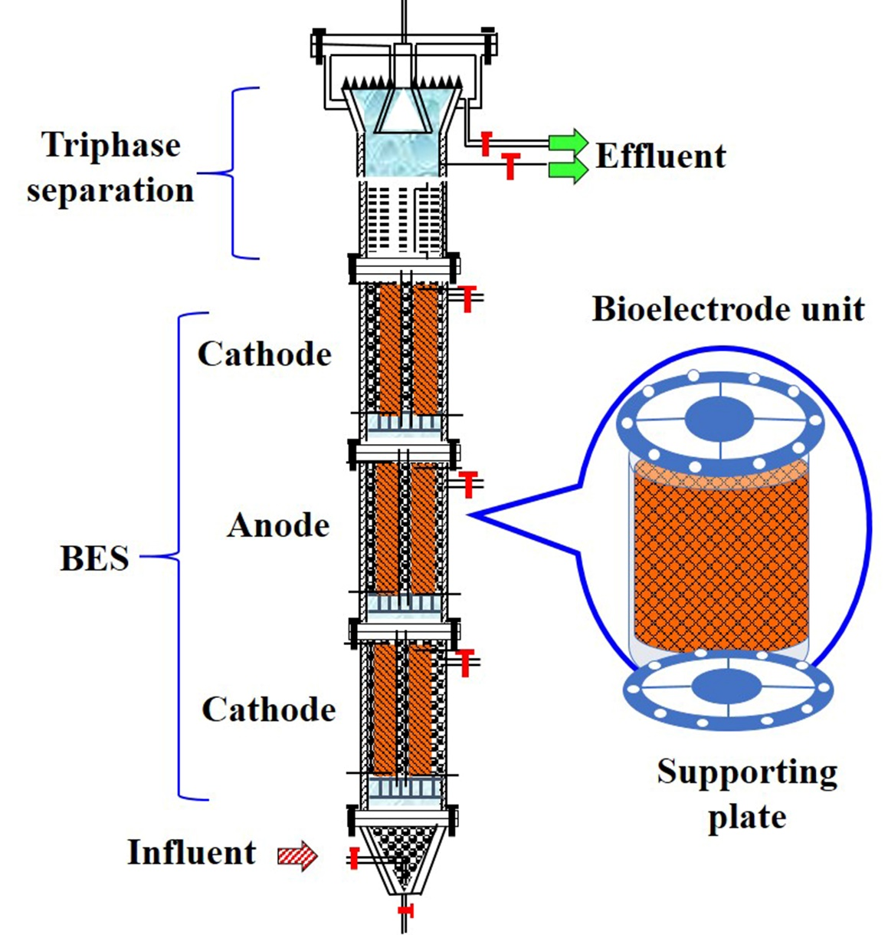

The membrane-less three-electrode (cathode-anode-cathode) upflow reactor for oilfield sewage micro-electrocatalytic deoxygenation. The reactor was assembled with an inner diameter of 5 cm and a height of 100 cm and an effective volume of 2 L. The anode was made of carbon brush electrode (carbon fiber, radius 2.5 cm, length 20 cm); cathode was made of nickel foam (Ni>99.8%)

