Supplementary information files

Tunable Synthesis of ultrathin BiOCl 2D nanosheets for Efficient Photocatalytic Degradation of Carbamazepine upon Visible-Light Irradiation
Shuo Xu^{1#*}, Xiaoya Gao^{2#}, Wenfeng Xu¹, Pengfei Jin¹, Yongmei Kuang¹
1.Department of Pharmaceutical Science, Beijing Hospital, National Center of Gerontology, Institute of Geriatric Medicine, Chinese Academy of Medical Sciences, Beijing Key Laboratory of Drug Clinical Risk and Personalized Medication Evaluation, Beijing 100730, P. R. China;
2.Faculty of Environmental Science and Engineering, Kunming University of Science and Technology, Kunming 650500, P. R. China

#These authors contributed equally to this work.
*Corresponding author. Email: victoria06251226@163.com

Fig. S1. The absorption spectra for the degradation of carbamazepine over ultrathin BiOCl.

Fig. S2. TPO spectra of the as-synthesized BiOCl samples.

Fig. S3. XRD patterns of the as-synthesized BiOCl samples
ultrathin BiOCl
ordinary BiOCl
Fig. S4. TEM images of the as-synthesized BiOCl samples

Fig. S5. The average thickness of ultrathin BiOCl samples characterized by AFM

Fig. S6. UV–vis diffuse reflection spectra of the as-synthesized BiOCl samples.

Fig. S7. Photocatalytic degradation CBZ over the as-synthesized BiOCl samples.in the presence of various radicals scavengers.

White precipitate means the formation of BiOCl. In fact, BiOCl could be formed in acidic conditions, which was also found by An [1] and Sarwan [2,3]. Wang demonstrated that Bi³⁺ could be completely transformated to BiOCl when the catalyst preparation reaction solution pH >1.7. The reactions for the formation of BiOCl are as follows [4].:
Bi(NO₃)₃+ 3NaCI=BiCl₃+ 3NaNO₃ (1 )
Bi³⁺ + Cl⁻+ 2H₂O =Bi(OH)₂Cl + 2H⁺ (2)
Bi(OH)₂Cl=BiOCl+H₂O (3)
Furthermore, Complete degradation of Carbamazepine was confirmed by TOC measurements. The TOC of the photocatalytic degradation was 10.5%, which was much higher than some other reported photocatalyst, such as BiPO₄ (5%) [5].and thermally activated persulfate (TAP) oxidation (5.7%)[6].
The effect of pH was tested in the degradation process (Carbamazepine solution pH was varied from 3, 5, 7 and 9). However, the carbamazepine solution pH of 1 was not tested for that BiOCl particles were hard to be removed from the reaction solution and interfered the measurement of CBZ.
As shown in Fig. S8, the initial pH had a significant impact on the photoefficiency of CBZ, and acidic condition was more favorable than neutral and alkaline conditions. These results were consistent with previous reports showing that low pH favored the photodegradation of CBZ [7].

Fig. S8. Effect of initial pH on CBZ degradation

If we add more NaOH pH 8, massive bubbles were formed in the preparation process of BiOCl. And the photocatalytic activity of formed BiOCl was tested. As shown in Fig. S9, the BiOCl (formed in the catalyst preparation reaction solution pH of 8) displayed a similar photocatalytic activity as that prepared in the pH of 2. To save reagents, the pH was adjusted to 2 by NaOH.

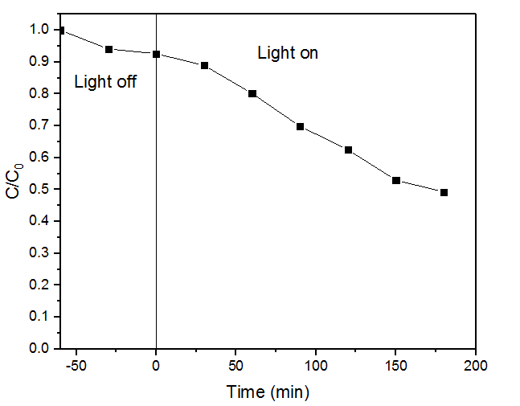
Fig. S9. Photocatalytic degradation CBZ over the BiOCl formed in the catalyst preparation reaction solution pH of 8.

References
[1] H. An, Y. Du, T. Wang, et al., “photocatalytic properties of B iO X (X = C I，B r，and I) ,” Rare metals, vol. 27, pp. 243-241, 2008.
[2] B.Sarwan, B. Pare, A.D. Acharya, et al., “Mineralization and toxicity reduction of textile dye neutral red in aqueous phase using BiOCl photocatalysis,” Journal of Photochemistry and Photobiology B: Biology, vol. 116,pp. 48–55, 2012.
[3] B. Sarwan, B. Pare, A.D. Acharya, “The effect of oxygen vacancies on the photocatalytic activity of BiOCl nanocrystals prepared by hydrolysis and UV light irradiation,” Materials Science in Semiconductor Processing, vol. 25, pp. 89–97, 2014.
[4] Y. Wang, W. Peng, L. Chai, et al., “ Study on preparation of sheet BiOCl powder by the method of bismuthnitrate transformation and hydrolysis,” Hunan Metallurgy,vol. 31, pp. 20-24 ,2003.
[5] J. Xu, L. Li, C.S. Guo, et al., “Photocatalytic degradation of carbamazepine by tailored BiPO₄: efficiency, intermediates and pathway,” Applied Catalysis B: Environmental,vol. 130–131, pp. 285–292, 2013.
[6] J. Deng, Y.S. Shao, N.Y. Gao, et al., “Thermally activated persulfate (TAP) oxidation of antiepileptic drug carbamazepine in water,” Chemical Engineering Journal,vol. 228, pp.765–771, 2013.
[7] X. Gao, X. Zhang, Y. Wang, et al., “Photocatalytic degradation of carbamazepine using hierarchical BiOCl microspheres: Some key operating parameters, degradation intermediates and reaction pathway,” Chemical Engineering Journal, vol. 273, pp. 156–165, 2015.

