PREPARATION OF CARBON-SUPPORTED TERNARY NANOCATALYST PALLADIUM-VANADIUM-COBALT FOR ALCOHOL ELECTROOXIDATION
Thanh Thien Co¹, Thi Thanh Thao Pham¹, Thi Kieu Chinh Pham¹, Thi Duyen Diep¹,
Le Thanh Nguyen Huynh¹, Viet Hai Le²
¹Faculty of Chemistry, VNUHCM-University of Science, Vietnam
²Faculty of Material Science and Technology, VNUHCM-University of Science, Vietnam
Contact: ctthien@hcmus.edu.vn
SUPPORTING INFORMATION

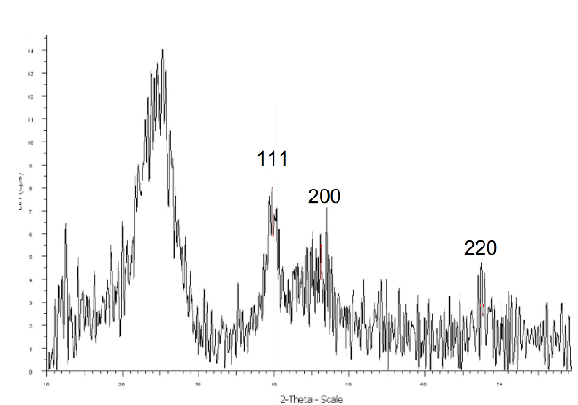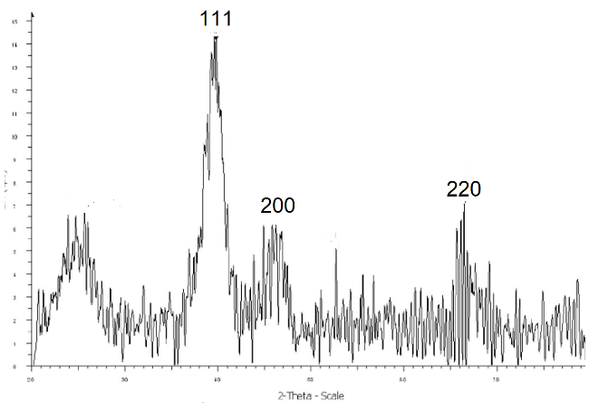
(b)
(a)
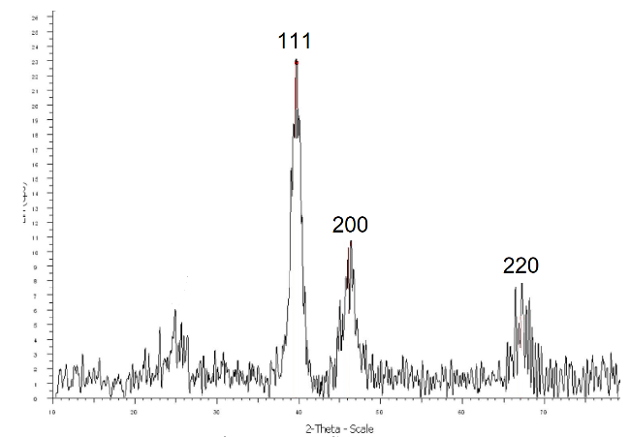
(c)
Figure S1 XRD patterns of nano catalyst (a) PdVCo-15EG; (b) PdVCo-20EG and
(c) PdVCo-15EG-20NaBH₄.

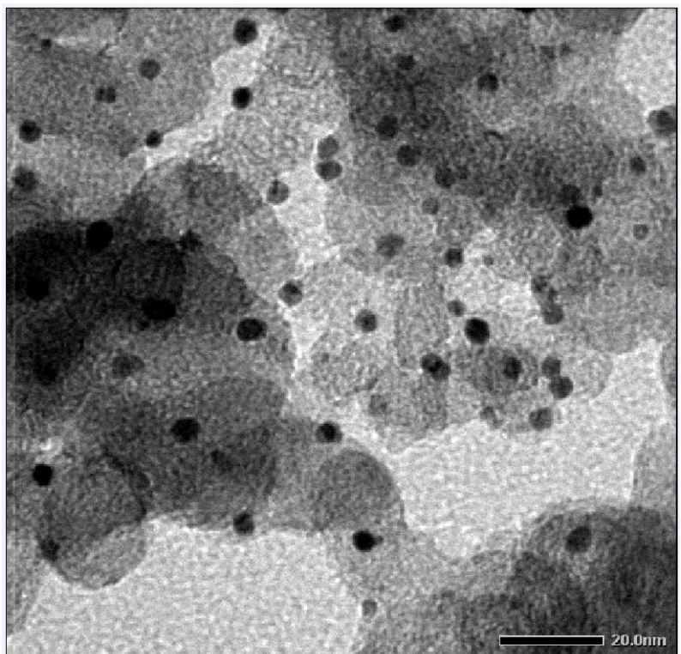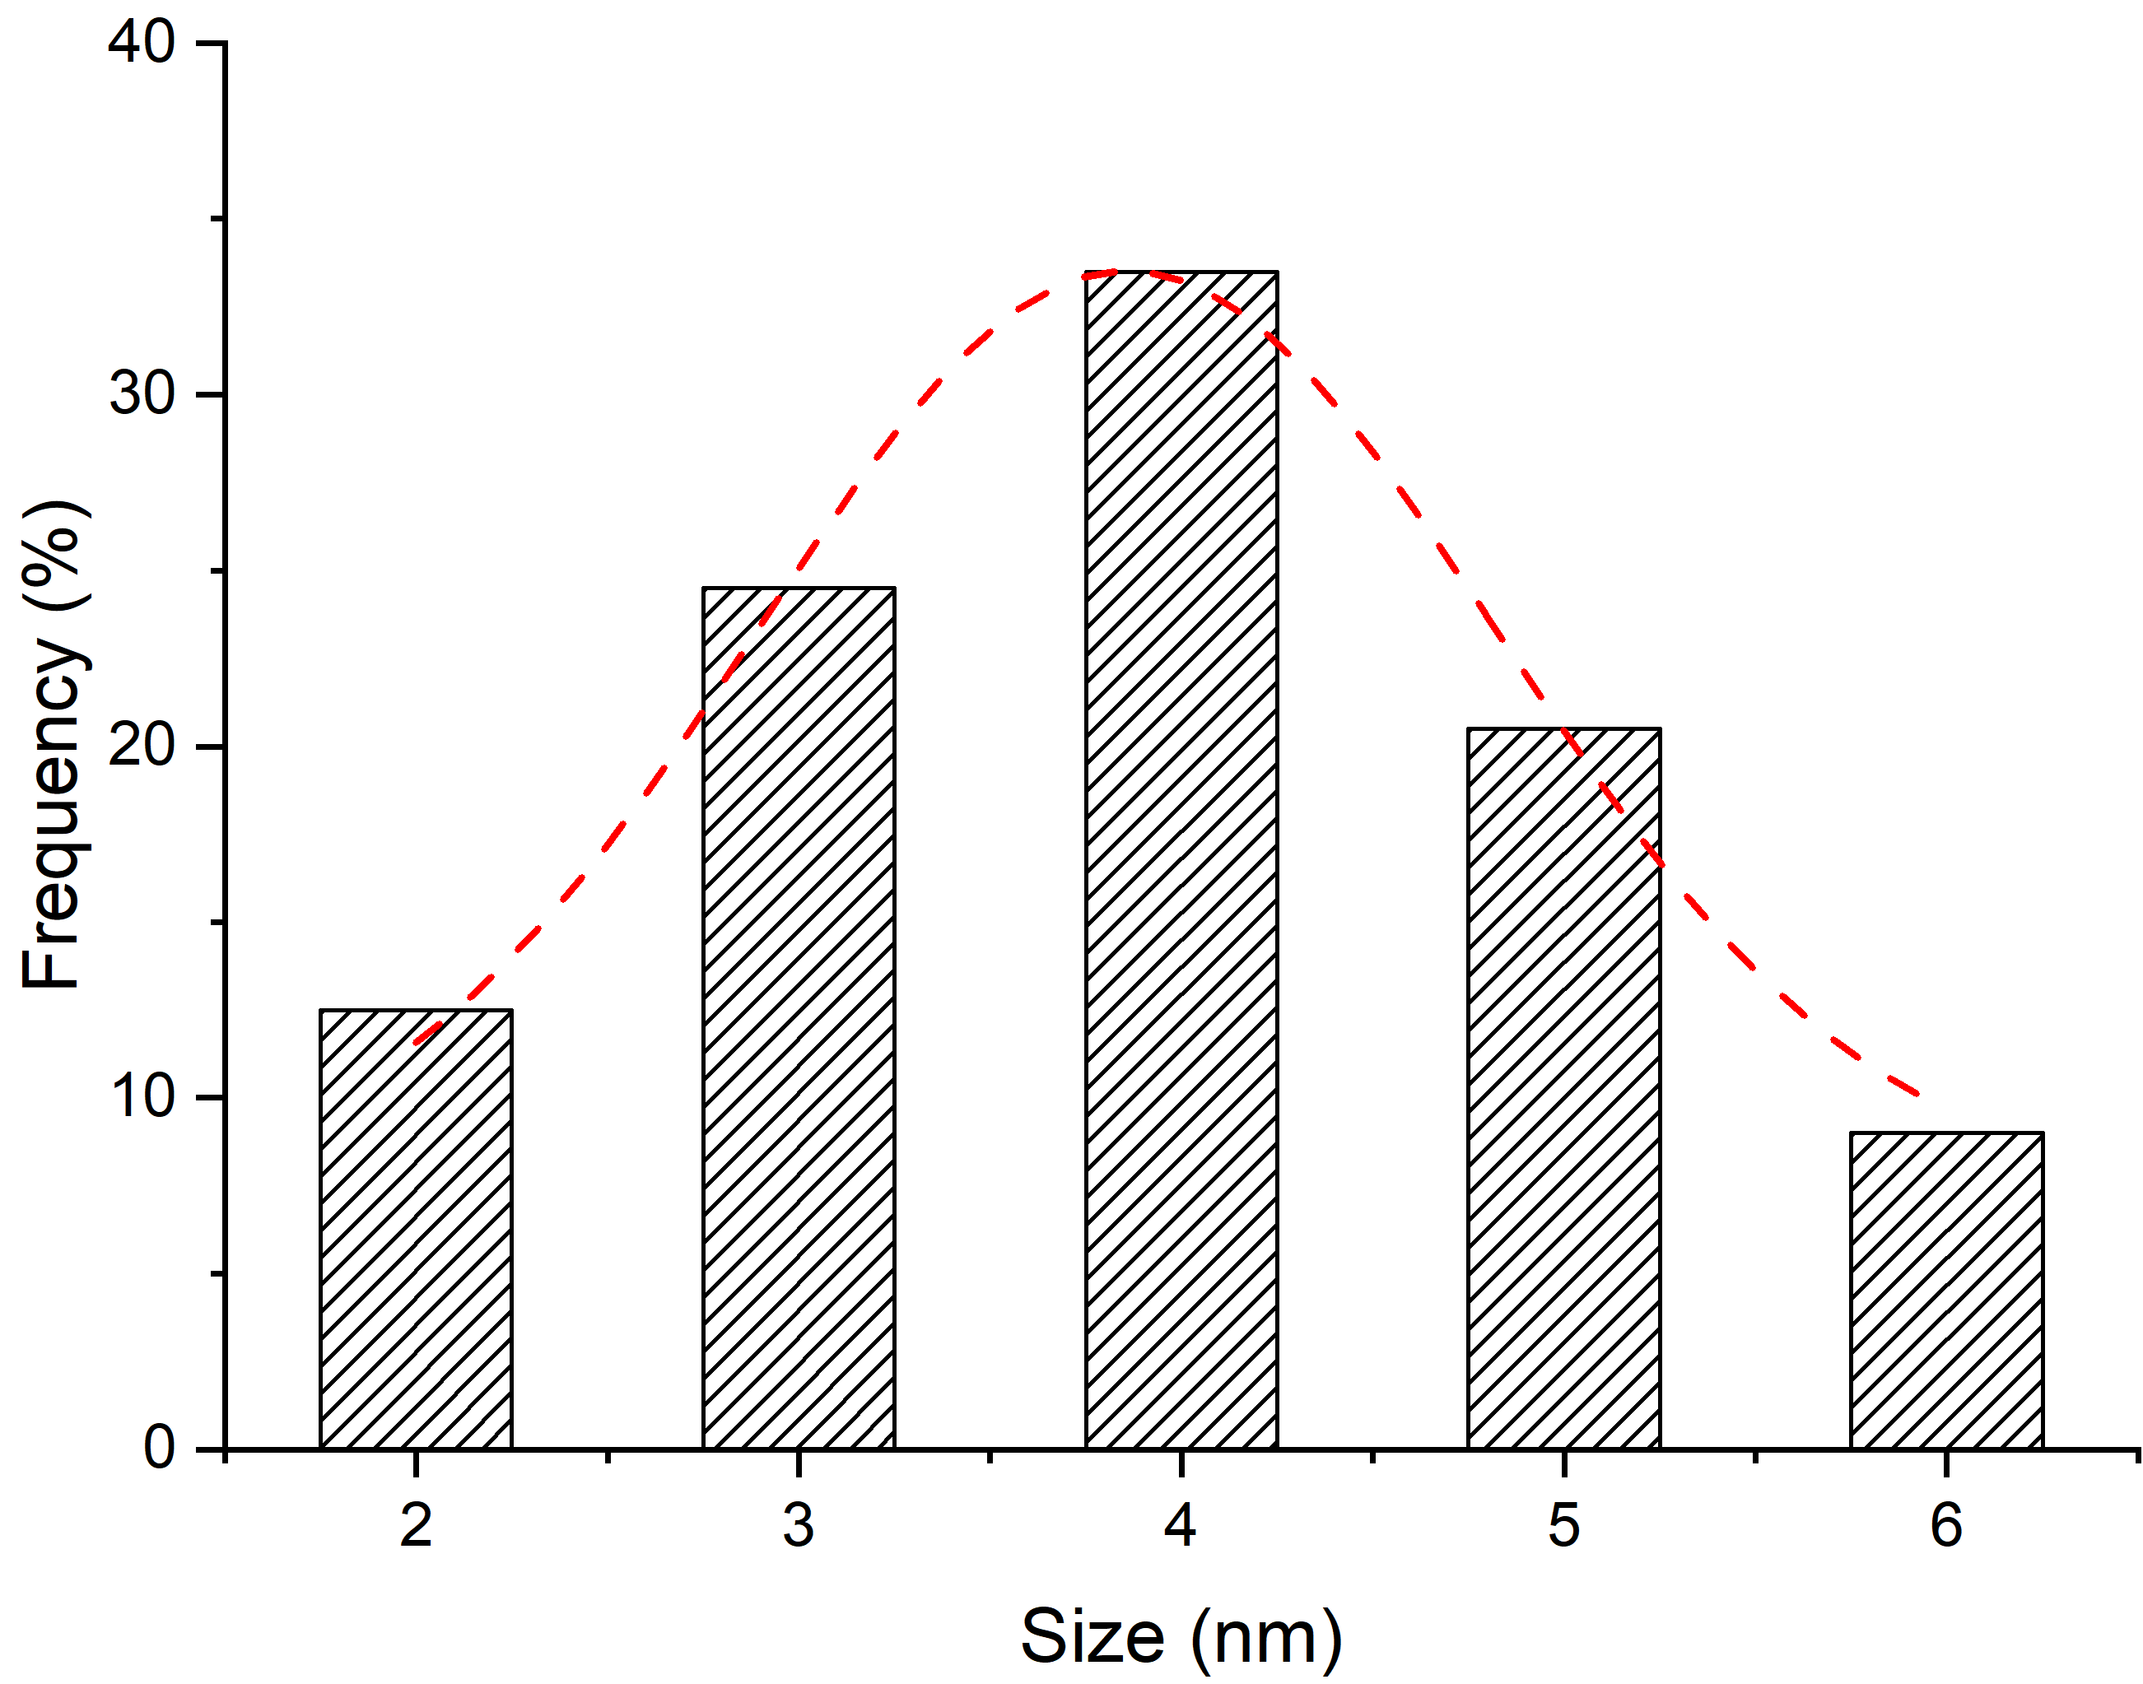
Figure S2 TEM and images and particle size distribution of sample Pd-20EG-20NaBH₄.

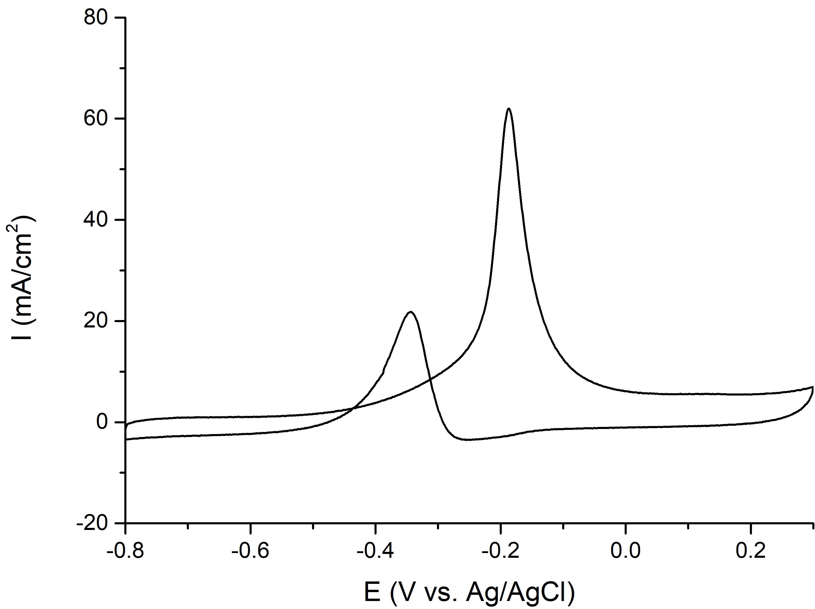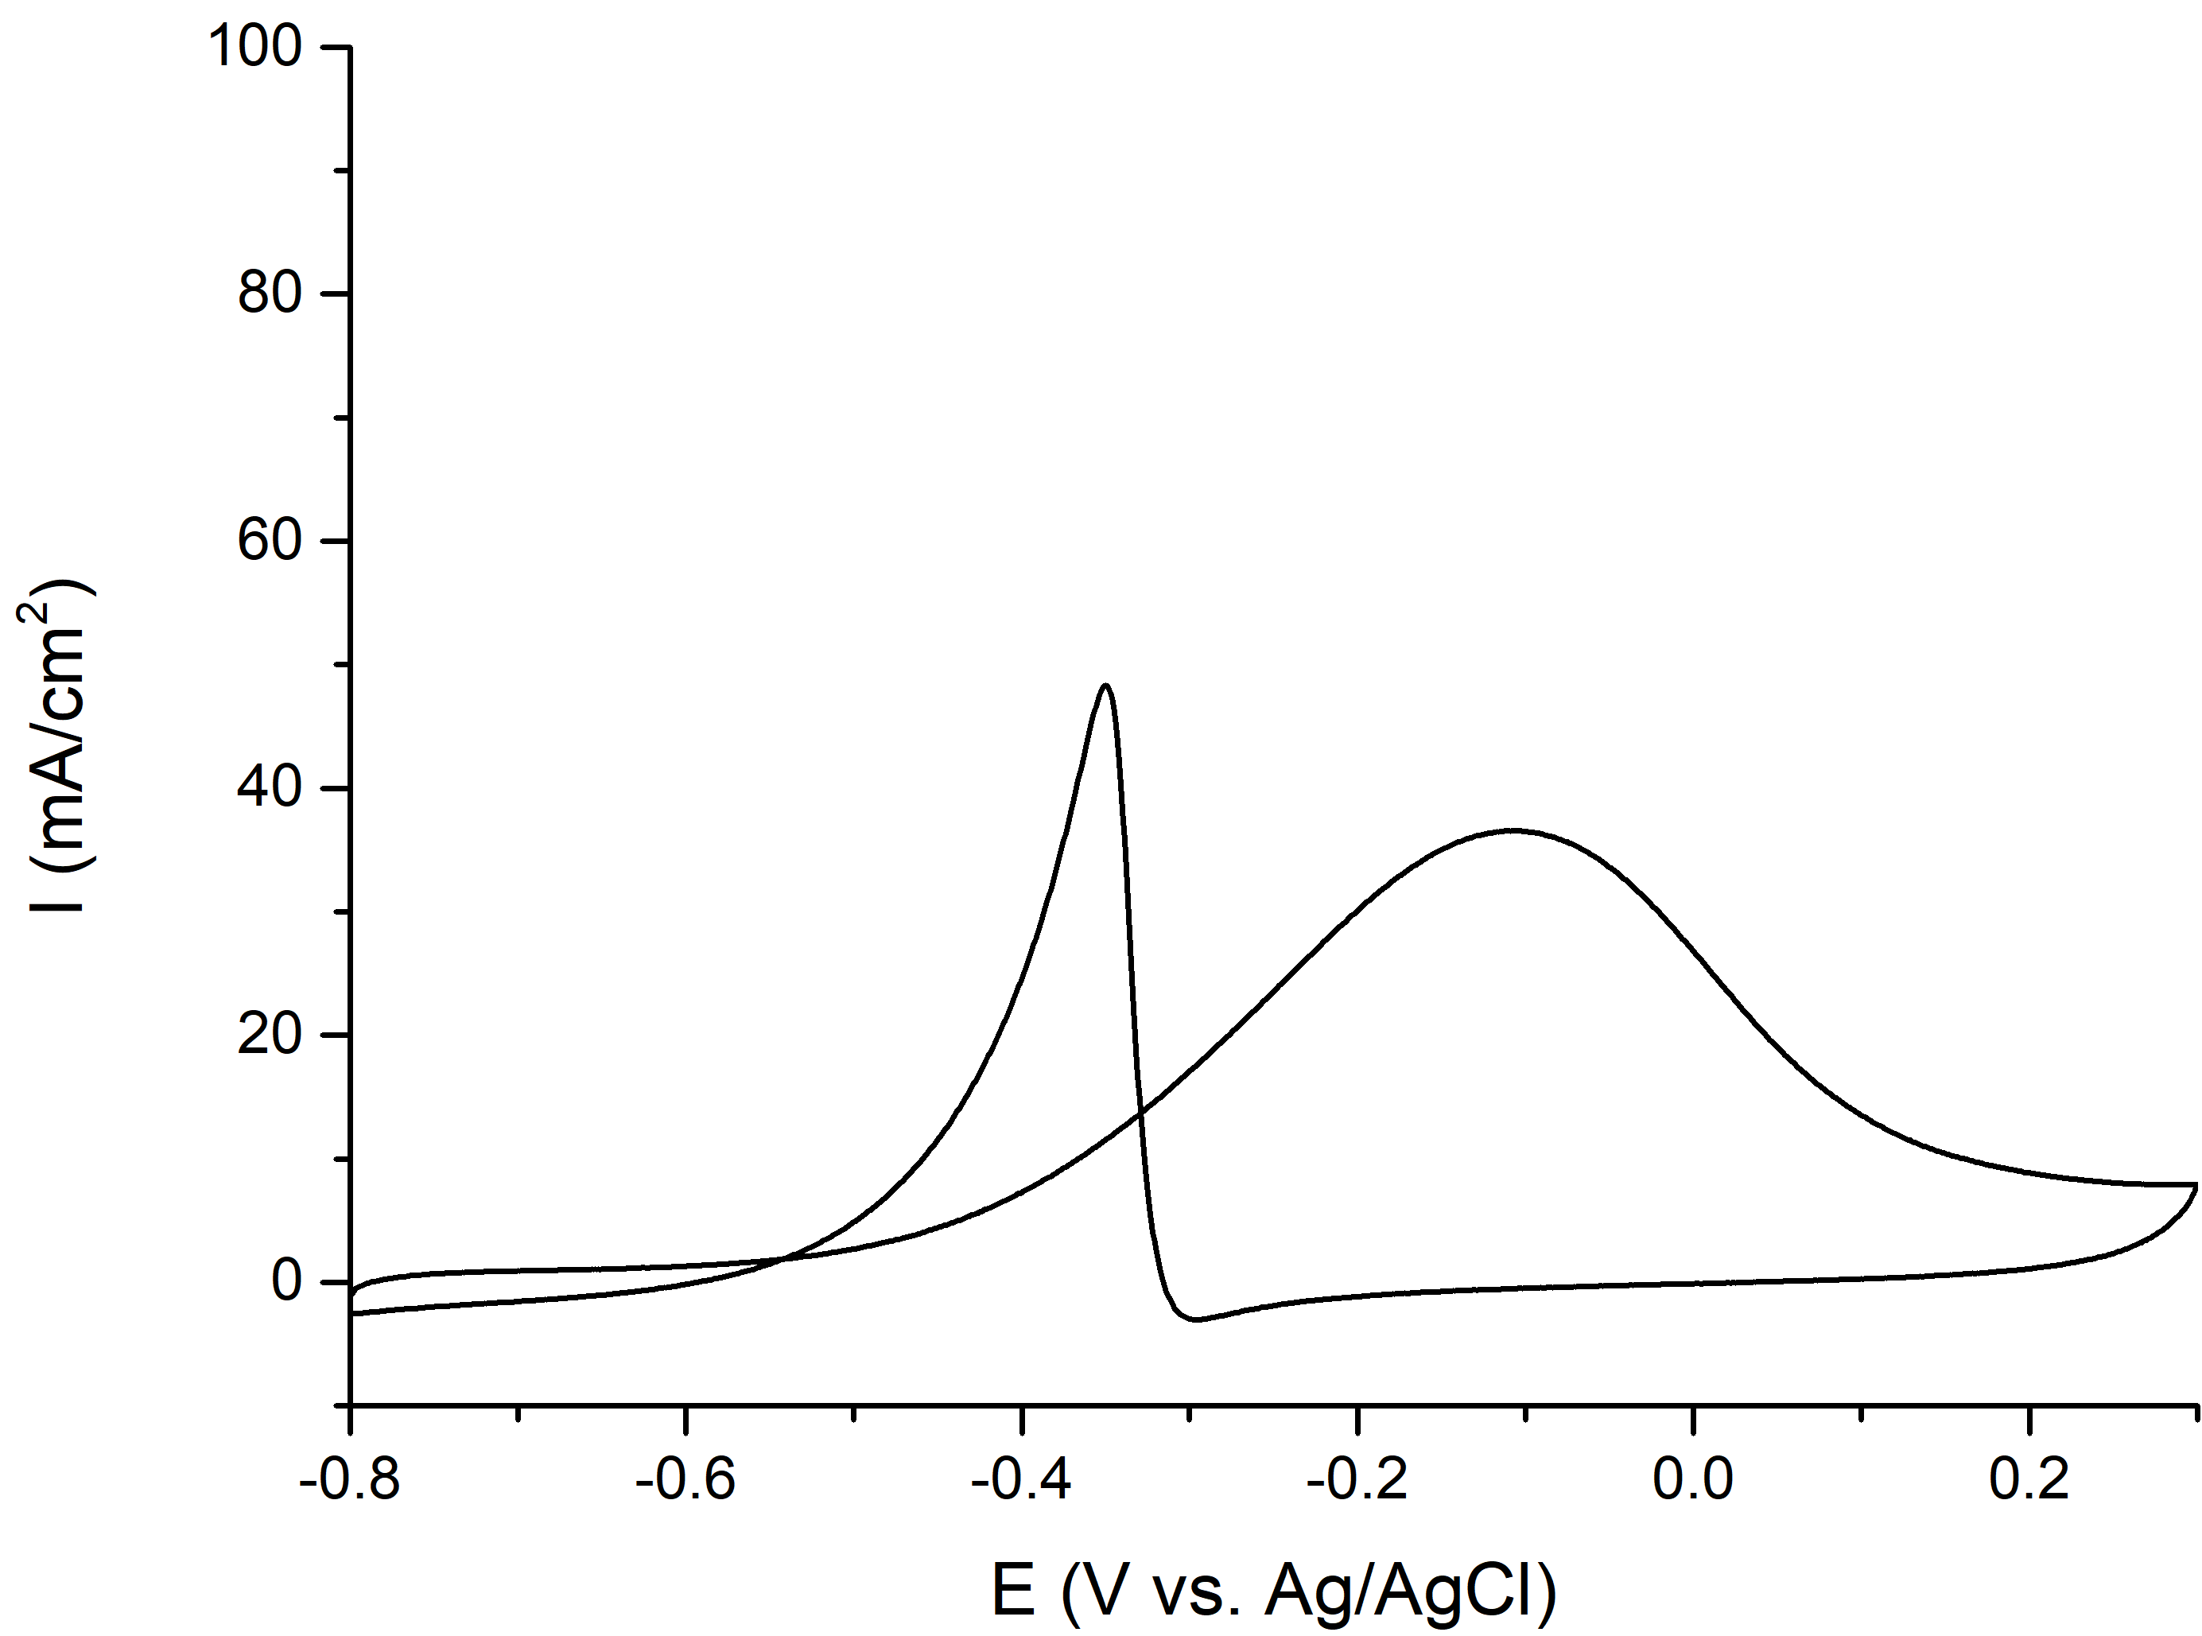
(b)
(a)
Figure S3 CVs of on nanocatalysts Pd-20EG-NaBH₄ in a solution of:
(a) 1 M KOH + 1 M CH₃OH (I_{f}/I_{b} = 2.60) and (b) 1 M KOH + 1 M C₂H₅OH (I_{f}/I_{b} = 0.63).

Table S1 Average crystallite size of nanocatalysts
 | Lattice parameter / Å | Crystallite size / nm
Pd-20EG-20NaBH₄ | 3.8971 | 4.69
PdVCo-15EG | 3.8867 | 6.95
PdVCo-20EG | 3.8814 | 5.62
PdVCo-15EG-20NaBH₄ | 3.8761 | 6.67
PdVCo-20EG-20NaBH₄ | 3.8618 | 5.66

Table S2 Onset potential (V vs. Ag/AgCl) of nanocatalysts in a solution of
1 M KOH + 1 M CH₃OH and 1 M KOH + 1 M C₂H₅OH
 | CH₃OH | C₂H₅OH
Pd-20EG-20NaBH₄ | -0.45 V | -0.50 V
PdVCo-15EG | -0.62 V | -0.54 V
PdVCo-20EG | -0.62 V | -0.54 V
PdVCo-15EG-20NaBH₄ | -0.61 V | -0.54 V
PdVCo-20EG-20NaBH₄ | -0.61 V | -0.54 V

