Occurrence of Pharmaceutical Residues and Antibiotic-Resistant Bacteria in Water and Sediments from Major Reservoirs (Owabi and Barekese Dams) in Ghana

Joseph Nana Gyesi¹, Bismark Anabila Nyaaba¹, Godfred Darko¹, Felix Charles Mills-Robertson³, Kodwo Miezah⁴, Nana Aboagye Acheampong⁵, Felicia Frimpong¹, Grace Gyimah¹, Bridget Quansah¹ and Lawrence Sheringham Borquaye^{1, 2*},

¹ Department of Chemistry, Kwame Nkrumah University of Science and Technology, Kumasi - Ghana
² Central Laboratory, Kwame Nkrumah University of Science and Technology, Kumasi - Ghana
³ Department of Biochemistry and Biotechnology, Kwame Nkrumah University of Science and Technology, Kumasi - Ghana
⁴ Department of Environmental Sciences, Kwame Nkrumah University of Science and Technology, Kumasi - Ghana

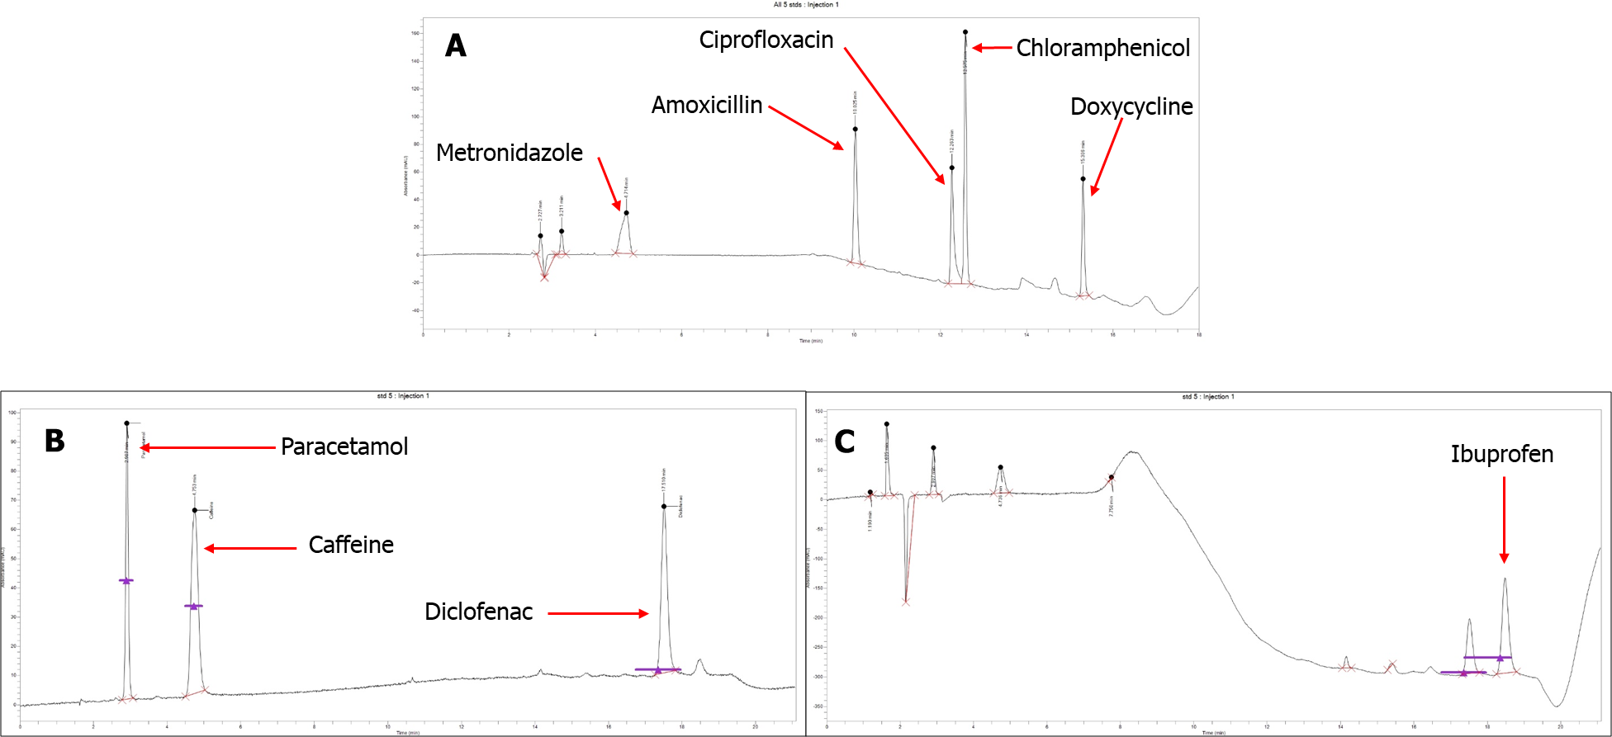
Fig. S1: HPLC chromatogram for analyte standards A: antibiotics at 215 nm; B: analgesics at 270 nm; C: analgesic at 220 nm. Peaks corresponding to specific analytes have been indicated.

Table S1: HPLC flow program for the analyses of antibiotics and analgesics

Analyte Type | Step | Step type | Step time (min) | Flow (mL/min) | % A | % B
Antibiotics* | 0 | Equilibration | 1.0 | 1.0 | 75.0 | 25.0
 | 1 | Run | 4.0 | 1.0 | 75.0 | 25.0
 | 2 | Run | 4.0 | 1.0 | 30.0 | 70.0
 | 3 | Run | 8.0 | 1.0 | 30.0 | 70.0
 | 4 | Run | 0.1 | 1.0 | 75.0 | 25.0
 | 5 | Run | 5.0 | 1.0 | 75.0 | 25.0
Analgesics# | 0 | Equilibration | 1.0 | 1.0 | 75.0 | 25.0
 | 1 | Run | 4.0 | 1.0 | 75.0 | 25.0
 | 2 | Run | 4.0 | 1.0 | 30.0 | 70.0
 | 3 | Run | 8.0 | 1.0 | 30.0 | 70.0
 | 4 | Run | 0.1 | 1.0 | 75.0 | 25.0
 | 5 | Run | 5.0 | 1.0 | 75.0 | 25.0
*For antibiotics, solvent A is 0.05% TFA and solvent B is methanol
#For analgesics, solvent A is 0.1% acetic acid and solvent B is methanol

Table S2: Quality parameters
Analyte Class | Analyte | % Recovery | LOD  (µg/L) | LOQ  (µg/L) | R2
Analgesics | Paracetamol | 97.02 | 0.058 | 0.193 | 0.998
 | Caffeine | 93.19 | 0.041 | 0.137 | 0.999
 | Diclofenac | 94.66 | 0.031 | 0.103 | 0.999
 | Ibuprofen | 91.58 | 0.116 | 0.386 | 0.998
Antibiotics | Amoxicillin | 94.26 | 0.084 | 0.280 | 0.982
 | Doxycycline | 91.04 | 0.105 | 0.350 | 0.997
 | Metronidazole | 85.51 | 0.061 | 0.203 | 0.998
 | Ciprofloxacin | 89.12 | 0.092 | 0.306 | 0.997
 | Chloramphenicol | 91.16 | 0.090 | 0.300 | 0.997
% R – percentage recovery LOD – limit of detection, LOQ – Limit of quantitation, R² values were obtained from the calibration curves.

Table S3: Frequency of disposal of prescription and non-prescription drugs
Type of medicine | %
 | daily | weekly | monthly | yearly | when necessary | never
Orthodox medicines | 1.0 | 10.0 | 6.0 | 3.0 | 58.0 | 22.0
Herbal medicines | 5.0 | 4.0 | 4.0 | 3.0 | 49.0 | 35.0

Table S4: Disposal methods and medication types often disposed
Item and options | Number of mentions
Methods of disposal (n = 100) Dustbin | 67
Incineration | 19
Flush down toilet/sink | 12
Return to pharmacy | 2
Prescription medicines disposed off  Pain medications | 42
Antimalarials | 55
Antibiotics | 64
Antihypertensives | 5
Heart medications | 7
Non-prescription medicines disposed of  Pain medications | 54
Antimalarials | 11
Antibiotics | 24
Herbal medicines | 43
Cough preparations | 7

Table S5: How important are health, transportation, education, environment, and jobs (n=100)
 | Frequencies
 | Extremely important | Very important | Moderately important | Slightly important | Not at all important
Health | 78 | 13 | 5 | 2 | 2
Transportation | 1 | 15 | 14 | 23 | 47
Education | 7 | 15 | 53 | 11 | 14
Environment | 9 | 16 | 14 | 48 | 13
Jobs | 11 | 43 | 10 | 14 | 22

Table S6: Respondent's willingness to better improve the environment

Statements | Strongly  agree | Agree  somewhat | Neither  Nor  disagree | Disagree  somewhat | Strongly  disagree
Taking my unused or expired medication to the pharmacy for disposal would be inconvenient? | 60 | 12 | 5 | 9 | 14
We should only spend money on environmental problems that affect human health, not on problems that only affect other species or ecosystems | 51 | 20 | 10 | 13 | 6
We should try to prevent all water pollution, even if we have no evidence that a pollutant will harm human or ecosystem health | 66 | 23 | 9 | 2 | 0
Pharmaceuticals affect the environment | 38 | 32 | 21 | 5 | 5
Return drugs to pharmacy | 60 | 12 | 5 | 9 | 14
Spend on only Environment & Human health | 51 | 20 | 10 | 13 | 6
Prevent all water pollution | 66 | 23 | 9 | 2 | 0
Human health against environment | 56 | 25 | 8 | 3 | 8
Pharmaceuticals affect the environment | 38 | 32 | 21 | 4 | 5

