Prophylactic mRNA vaccination against allergy confers long-term memory responses and persistent protection in mice

E. Hattinger, S. Scheiblhofer, E. Roesler, T. Thalhamer, J. Thalhamer & R. Weiss
Department of Molecular Biology, University of Salzburg, Salzburg, Austria
Correspondence: Richard Weiss, Department of Molecular Biology, University of Salzburg, Hellbrunnerstrasse 34, 5020 Salzburg, Austria; Tel +4366280445737; E-mail: Richard.Weiss@sbg.ac.at

Online Supplement

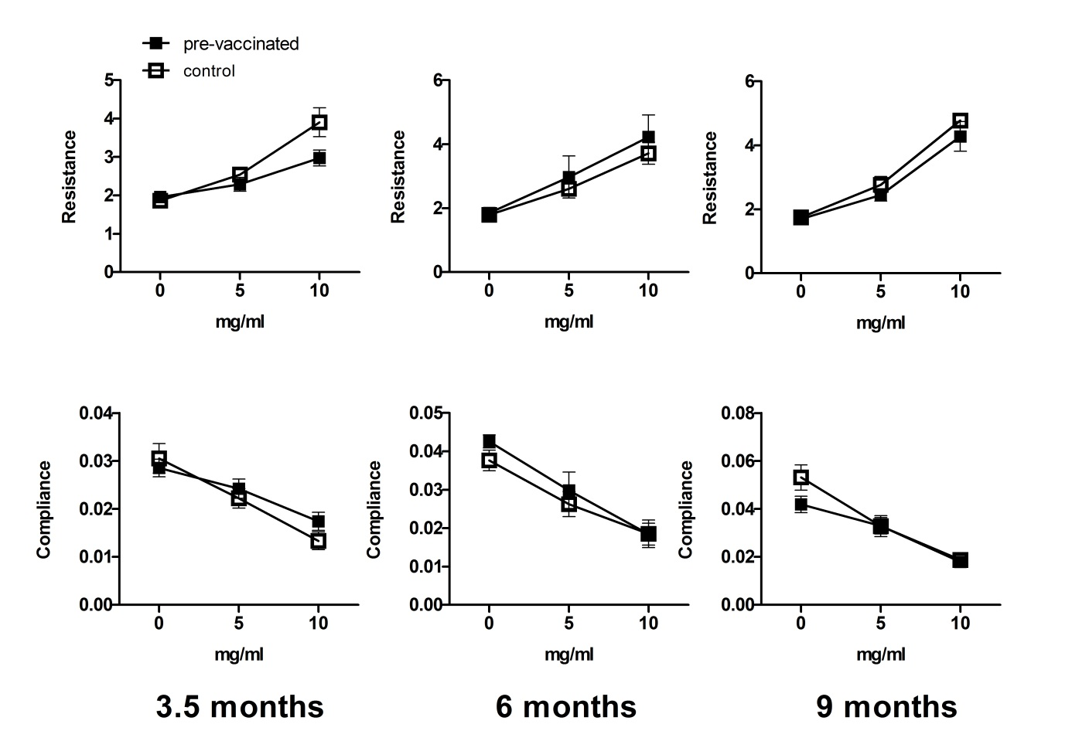
Supplementary Figure S1. Mice were vaccinated with mRNA, sensitized, and challenged once after the indicated time interval. Effects of pre-vaccination on lung function were tested by measuring lung resistance (top panels) and dynamic compliance (bottom panels) in response to increasing concentrations of methacholine. Data are shown as mean ± SEM (n = 5).

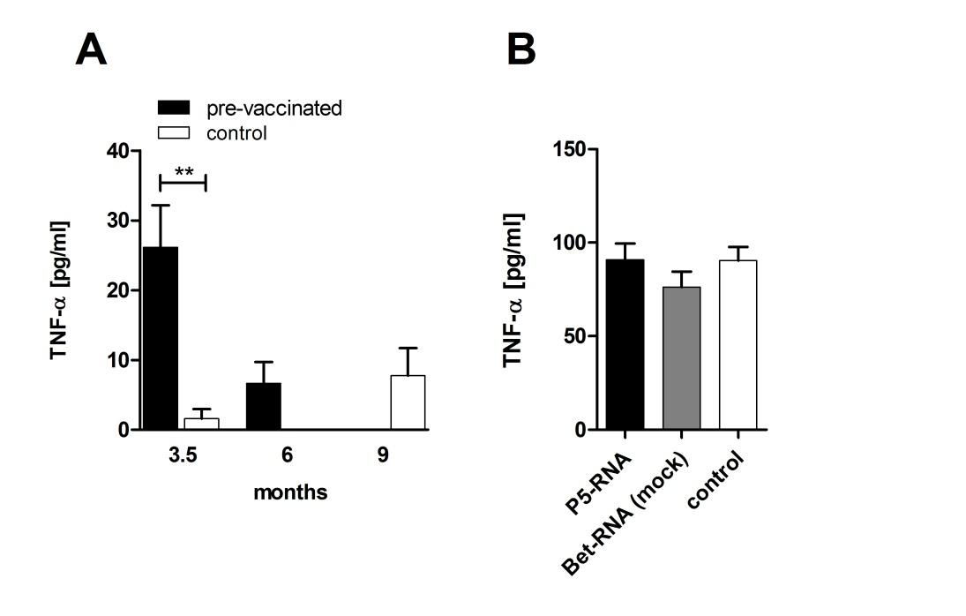
Supplementary Figure S2. TNF-α was determined in culture supernatants after in vitro restimulation of splenocytes with Phl p 5. Splenocytes were analyzed after sensitization in mice that had been vaccinated 3.5, 6, or 9 months earlier (A) or after 7 monthly aerosol challenges (B). Data are displayed as means ± SEM (n = 5). ** P < 0.01.

