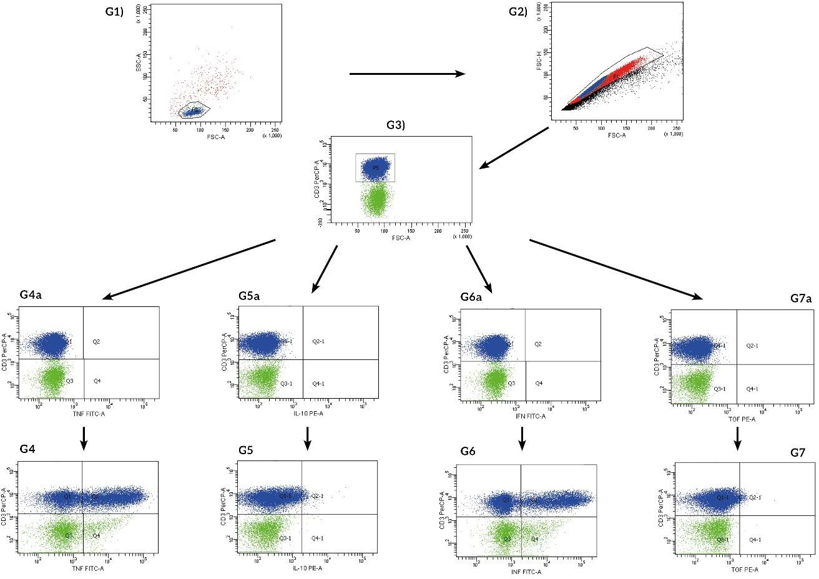

Supplementary data to figure 1: Lymphocytes after PMA stimulation. Gating strategy: lymphocytes were identified on FSC/SSC dot plot G1) as cells within 50-100 x 10³ on FSC and below 50 x 10³ on SSC. G2) doublets exclusion. G3) CD3 positive cells (T lymphocytes were identified as events with PreCP fluorescence above 10³ on logarithmic scale G4) TNF - α positive T lymphocytes were identified as CD3⁺ lymphocytes from G3 gate with fluorescence higher than fluorescence minus one from G4a. G5) IL-10 positive T lymphocytes were identified as CD3⁺ lymphocytes from G3 gate with fluorescence higher than fluorescence minus one from G5a. G6) INF – γ positive T lymphocytes were identified as CD3⁺ lymphocytes from G3 gate with fluorescence higher than fluorescence minus one from G6a. G7) TGF - β positive T lymphocytes were identified as CD3⁺ lymphocytes from G3 gate with fluorescence higher than fluorescence minus one from G7a. FMO controls are represented on G4a, G5a, G6a, Ga7, G8a dot plots.

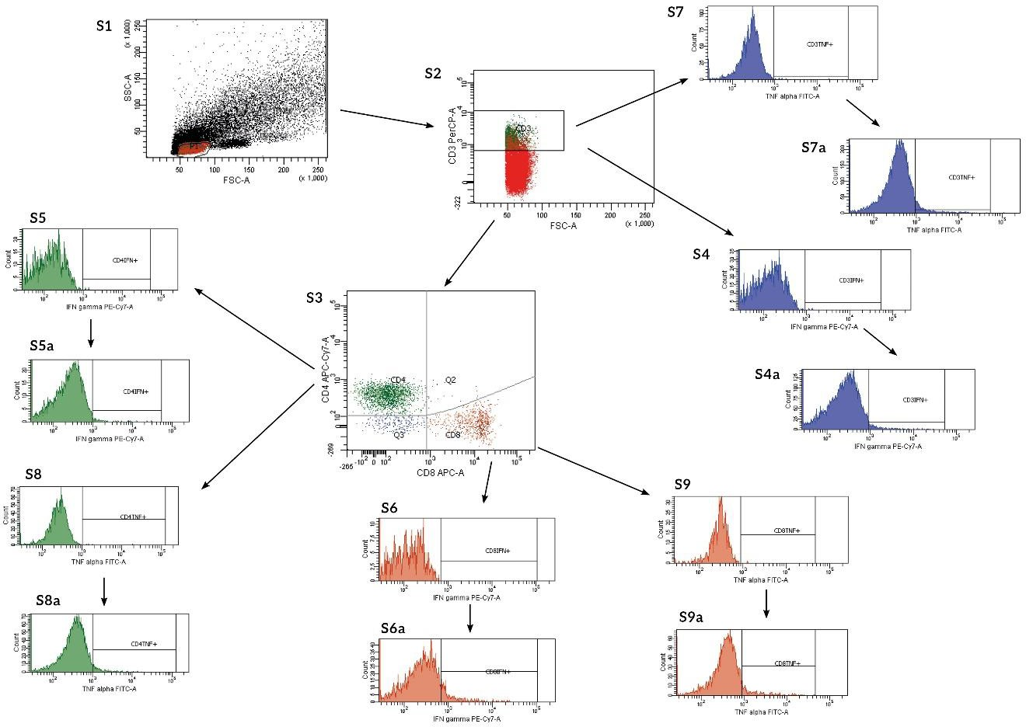

Supplementary data to figure 2: Lymphocytes after PHA stimulation. Gating strategy: lymphocytes were identified on FSC/SSC dot plot S1) as cells within 50-100 x 10³ on FSC and below 50 x 10³ on SSC,
S2) CD3 positive cells ( T lymphocytes were identified as events with PreCP fluorescence above 10³ on logarithmic scale S3) CD4 positive cells ( T helper lymphocytes were identified as events with APC- Cy7 fluorescence above 10² on logarithmic scale and CD8 positive cells (T cytotoxic lymphocytes were identified as events with APC fluorescence above 10³ on logarithmic scale. IFN – γ ^{pos} cells were identified as cells positive for PeCy7 above 10³ respectively from gate CD3 (S4a), CD4(S5a), CD8(S6a). TNF -α ^{pos} cells were identified as cells positive for PeCy7 above 10³ respectively from gate CD3(S7a), CD4(S8a), CD8(S9a). FMO controls are represented on S4, S5, S6, S7, S8 histograms.

