Supplementary Materials: Efficiency Improvement of a Capacitive Deionization (CDI) System by Modifying 3D SWCNT/RVC Electrodes Using Microwave Irradiated Graphene Oxide (mwGO) for Effective Desalination

Ali Aldalbahi¹*, Mostafizur Rahaman¹, Mohammed Almoiqli², Al Yahya Meriey¹, Govindasami Periyasami¹

¹Department of Chemistry, College of Science, King Saud University, Riyadh 11451, Saudi Arabia

²Nuclear Sciences Research Institute, King Abdulaziz City for Science and Technology, Riyadh 11442, Saudi Arabia

*Corresponding Author: aaldalbahi@ksu.edu.sa (Ali Aldalbahi)

S1. Functionalization of CNTs
The functionalization of SWCNT was carried out by refluxing into a round-bottom flask containing 20 mg of it in 40 mL of nitric acid (6M, HNO₃). The round-bottom was equipped with magnetic stirrer and immersed in an oil bath at 120 °C for 6 hrs. The refluxed mixture was then neutralized by washing with water, and subsequently with 10 mL of methanol and DMF, separately. Finally, it was dried in oven at 105 °C for 48 hrs. The acid treated SWCNT was designated as a-SWCNT.

S2. Synthesis of GO
GO was synthesized by modified Hummer’s method, whose outline was given by Marcano et al. [1]. In this typical method, graphite powder (1 g) was thoroughly mixed with conc H₂SO₄ (60 ml) for few mins. Then 3.5 g of KMnO₄ was added in small aliquots so as the temperature did not exceed 100 °C. The mixture was continuously stirred for 18 hrs and then hydrolysed by adding 300 to 500 ml distilled H₂O (ice bath condition) to form graphite oxide. Thereafter, 30% aqueous H₂O₂ (appx. 3 ml) was added drop wise into the mixture till its complete colour change. Finally, the vacuum filtrated mixture was washed with HCl solution, distilled H₂O, and C₂H₅OH. The slurried mass was dried under vacuum-oven overnight at 50 °C.

S3. Exfoliation and reduction of GO using microwave irradiation
Exfoliated and reduced GO (mwGO) were formed using a conventional microwave oven (1200 W). The GO powder was irradiated within the microwave oven for 10 s. After irradiation, the GO glowed red hot accompanied by fuming and sparking, leading to a remarkable volume expansion caused by the violent expulsion of the volatile materials present at the interlayer space of graphene intercalated compounds [2, 3].

S4. Dispersion of mwGO and a-SWCNT
A dispersion of 5 ml containing mwGO 0.1% w/v in DMF, a good solvent for GO dispersions because it can be coupled to an amphiphilic oligoester to produce amphiphilic graphene oxide that is dispersible [3, 4], was prepared using a homogenizer (Branson, Sonifier model S-450D), which was attached with a 13 mm step disruptor horn and a 3 mm tapered microtip. The sonicator was operated by setting the frequency at 20 kHz, amplitude at 25% (means power output 100 W), pulse on-off for two and one second, and placed on a water-ice bath for preventing overheating of dispersion. Furthermore, functionalised SWCNT 0.2% w/v was dispersed in DMF and optimised. The optimization was done by dispersing a-SWCNT 0.2% w/v in 15 ml DMF using the same sonicator and conditions.

S5. Preparation of a-SWCNT/mwGO composite coating solution
The preparation of a-SWCNT/mwGO composite material coated RVC electrode involves the steps as shown in Figure S1. The dispersion, containing a-SWCNT and mwGO solution were mixed via probe sonication for 30 minutes at 30% amplitude (1s on / 2s off pulse) and bath sonication for 30 minutes [5] and as optimised for the individual components. The a-SWCNT/mwGO composites were prepared using the weight ratios 90% a-SWCNT: 10% mwGO, 80% a-SWCNT: 20% mwGO and 70% a-SWCNT: 30% mwGO, which were the weight ratios optimised in our laboratory, one of which (90% a-SWCNT: 10% mwGO) afforded the highest specific capacitance for the composite material in an electrode and that also gave the highest capacity for electrosorption.
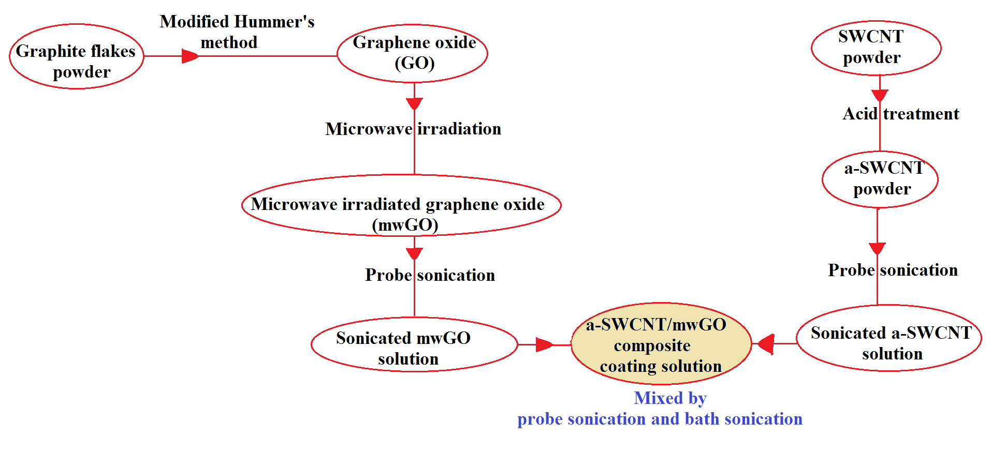
Figure S1. Scheme for the preparation process of composite a-SWCNT/mwGO coating solution.

S6. Pre-treatment of the RVC electrode
The best pores per inch (ppi) RVC electrode, used as a substrate for loading carbon material, was optimized (see section S7). It optimised one was 60 ppi RVC electrode because of its increased conductivity that readily allows the movement of electrical charge, and had comparatively higher capacitance and surface area. Therefore, this optimised electrode was chosen as a substrate for loading a-SWCNT/mwGO composite material to be used as an electrode in a CDI system. Definite sizes of electrodes (length 4 cm * width 1.8 cm * thickness 0.3 cm) (2.16 cm³) were taken by cutting from a block of RVC, and were soaked in 2M HNO₃ for 24 hrs for removing any impurity. The electrodes were washed several times with distilled water for the removal of acid. The effluent’s pH was checked regularly until it became neutral. The removal of organic impurity from the electrode was carried out by soaking in CH₃OH for 2 hrs. The electrode was then dried under N₂ flow and followed by heating in an oven overnight at 110°C. The dried electrodes were weighed properly through a suitable balance.

S7. Optimization of RVC electrodes coated with a-SWCNT
The general purpose of this work is the optimization of the reticulated vitreous carbon (RVC) electrodes of different porosities coated with a-SWCNT. RVC electrode has a free void volume between 90% and 97%. Thus, RVC electrodes have a low flow resistance. Figure S2 (a, b, and c) shows photo images of three RVC electrodes with porosities of 60, 45 and 30 ppi (nominal pores per inch). It is clear that the free void volume of the RVC electrodes increases with decreasing ppi grade. The average pore sizes of the RVC electrodes were calculated from SEM images by measuring the distance between green lines in Figure S2 (d, e, and f) and they were 350, 700 and 900 µm for 60, 45 and 30 ppi, respectively. RVC electrode properties are dependent on the ppi grade. If the amount of pores per inch (ppi) increases, the electrode area per unit electrode volume will increase as well. According to previous reported properties of RVC [6-8], which are good surface area, conductivity and good mechanical strength, it is envisaged that the RVC electrode that has the largest number of pores per inch would be the best electrode for use in a CDI system. Therefore, in order to confirm that the smaller pores electrode is the best electrode for loading of a-SWCNT for use in a CDI system, we investigated the influence of all electrode capacitances of RVC electrodes with different pore sizes coated with the same amount of a-SWCNT. All RVC electrodes had the same geometric volume (dimensions of 4.0cm*1.8cm*0.3cm) and the same amount of a-SWCNT was coated, around 6 mg. The effect of different pores per inch was investigated in aqueous solution. Figure S2 (g) shows the capacitances of all at the potential scan rate of 5 mV/s. It can be seen that the highest specific capacitance was 267.24 F/ g for a-SWCNT coated RVC electrode with 60 pores per inch, and the specific capacitance decreased with a decrease in the amount of pores per inch. This is because the RVC electrode with 60 ppi has higher surface area per volume of electrode. In conclusion, therefore, 60 ppi RVC electrodes were selected as substrates to load a-SWCNT for use as electrodes.
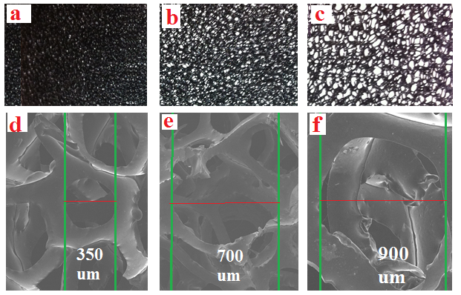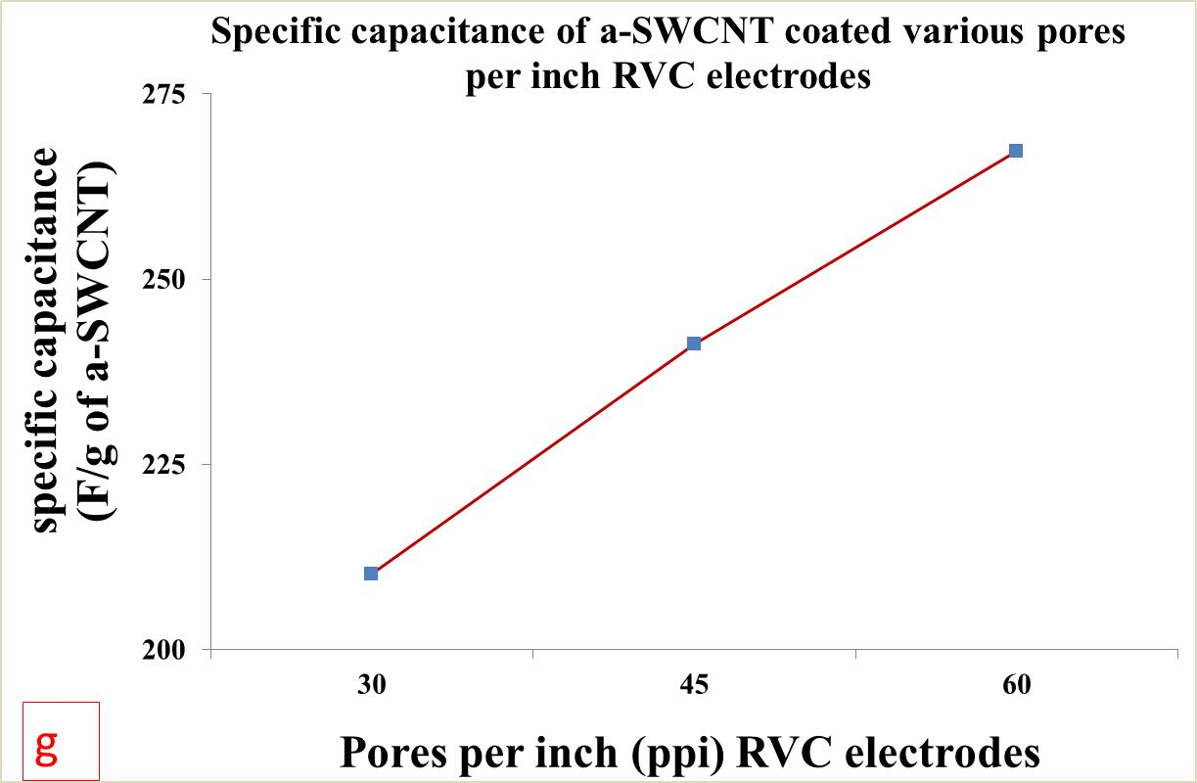
Figure S2. (a,b,c) Photo images and (d,e,f) SEM micrographs of 60, 45 and 30 ppi RVC samples, respectively. (g) The specific capacitance of a-SWCNT coated RVC electrodes of various porosities in 1 M NaCl solution calculated from cyclic voltammograms recorded in a voltage range between -0.2 to 1.0 V using a three-electrode system vs Ag/AgCl at 5mV/s scan rate.

S8. Preparation of a-SWCNT, mwGO, and a-SWCNT/mw GO composite dip coated RVC electrodes
All electrodes which are a-SWCNT, mwGO, or a-SWCNT/mwGO composites with RVC, were made by the dip coating method by slowly immersing into the composite solution. Figure S3 is schematically showing the dip-coating process of RVC in a composite solution of 9 CNT: 1 mw GO. The dip-coated substrates were initially placed in an oven for 2 hrs for drying at 100 °C and later on in a vacuum oven for 2 hrs at 50 °C for removing all organic solvents that remained in the micropore of the electrodes.
Table S1 presents the weights of material loaded on the RVC electrodes. It was calculated by taking the weight of electrode before and after its dip-coating. The 9 a-SWCNT/ mwGO composite material weights coated on RVC electrodes were 10, 30 and 50 mg, and all the other composite materials weights coated on RVC electrodes were 50 mg including a-SWCNT and mwGO material coated RVC electrodes. A maximum of 50 mg loading was used because our previous work [9, 10] showed that 50 mg was the highest amount of CNT material that can be loaded into the RVC electrode and it afforded the highest capacitance and electrosorption capacity in terms of geometric volume. The geometric volume of the electrodes were estimated by multiplying its length with its width and thickness (length * width * thickness). Initial investigations were done (Table S1 (a)) to determine which electrode material gave the best performance with maximum 50 mg loading. Subsequent experiments (Table S1 (b)) were performed on the best electrode to confirm that 50 mg loading indeed gave the best result.
In future discussions, these composite electrodes, depending on the ratio of a-SWCNT in the sample, will be identified as 9-CNT/mwGO/RVC (9 a-SWCNT: 1 mwGO coated RVC electrode), 8-CNT/mwGO/RVC (8 a-SWCNT: 2 mwGO coated RVC electrode), 7-CNT/mwGO/RVC (7 a-SWCNT: 3 mwGO coated RVC electrode), CNT /RVC (10 a-SWCNT: 0 mwGO coated RVC electrode), and mwGO/RVC (0 a-SWCNT: 10 mwGO coated RVC electrode).
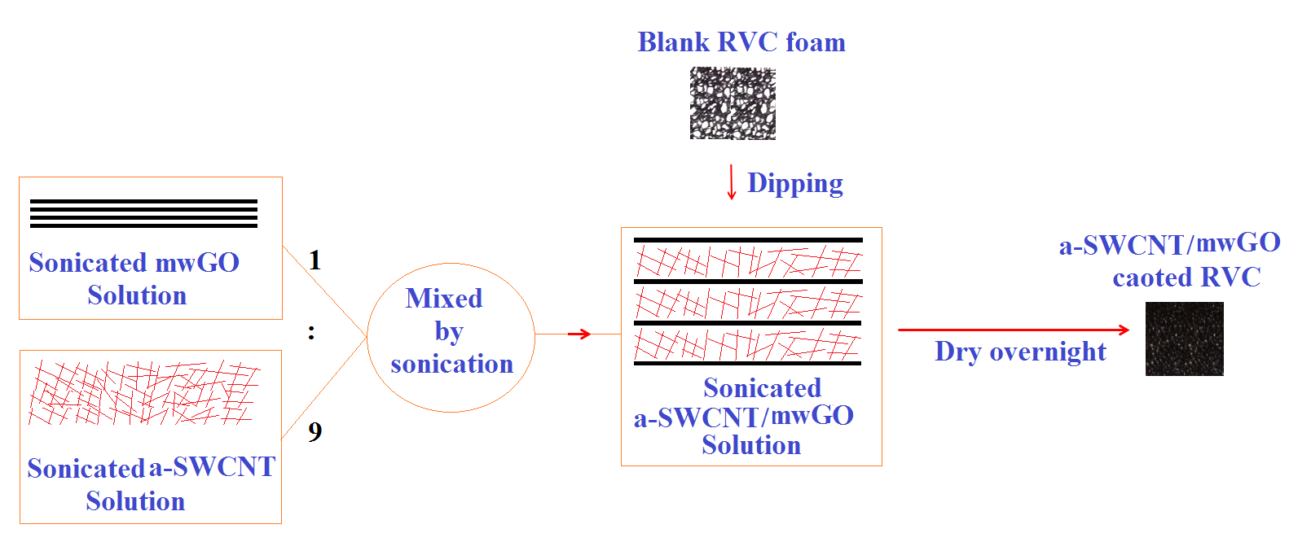
Figure S3. Schematic diagram of the preparation process of ratio 9:1 composite a-SWCNT/mw GO coated RVC electrode.
Table S1. Details of carbon materials coated on RVC (2.16 cm³) electrodes.
samples | Ratio in coating solution |  | Material weight (mg)
 | a-SWCNT | mw GO
(a)
CNT/RVC | 10 | 0 | 50
9-CNT/mwGO/RVC | 9 | 1 | 50
8-CNT/mwGO/RVC | 8 | 2 | 50
7-CNT/mwGO/RVC | 7 | 3 | 50
mwGO/RVC | 0 | 10 | 50
(b)
9-CNT/mwGO/RVC
1 | 9 | 1 | 10
2 | 9 | 1 | 30
3 | 9 | 1 | 50

S9. Measurement and Calculation of Ion Removal from NaCl Aqueous Solution

Measurement of Ion Removal from NaCl Solution
NaCl concentration was determined in our laboratory by measuring the electrical conductivity of NaCl solution. The calibration curve linearity is shown in Figure S4. Conductivity linearly increased as NaCl concentration increased. The equation from fitting a line starting from the origin (0,0) to the calibration curve is as follows;
Cond = 1.9067 * Conc (S1)
where, Cond and Conc are the conductivity (μS/cm) and concentration (mg/L) of NaCl solution, respectively. An example for calculation of the ion removal from NaCl solution has been shown in this supplementary information section.
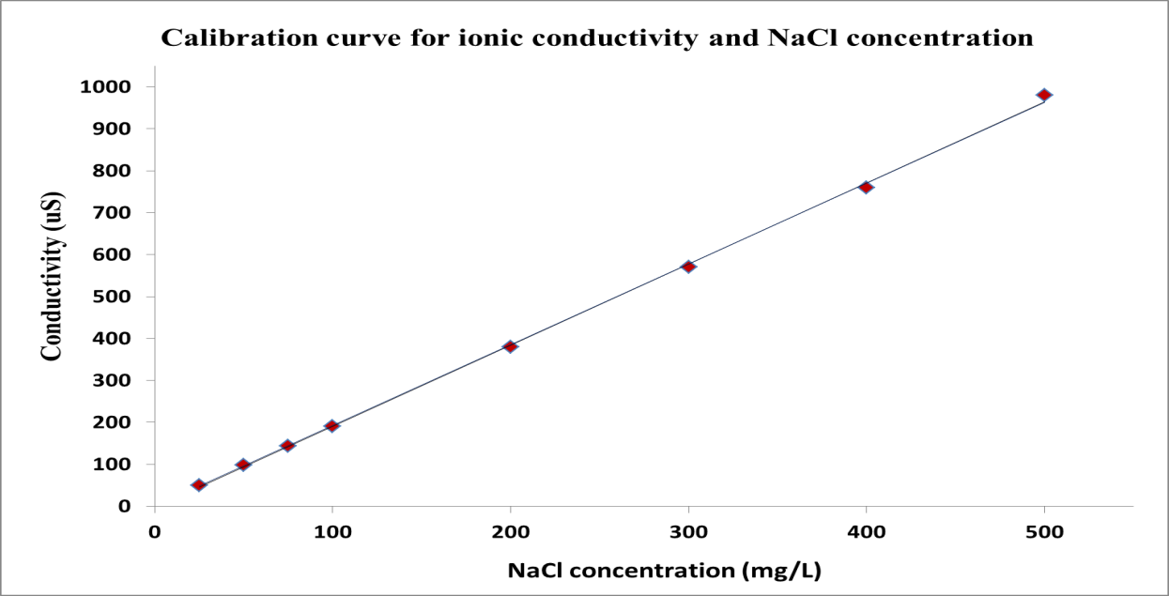
Figure S4. Calibration curve linearity for ionic conductivity vs NaCl concentration.
Calculation of Ion Removal from NaCl Solution
The conductivity of the solution is measured by the conductivity meter. If the initial NaCl solution conductivity is 143.00 μS/cm and after charging the electrode it became 138.59 μS/cm, then the ion removal from the solution can be calculated. As we know from equation S1 that;
Conductivity = 1.9067 * Concentration; and hence
Concentration = Conductivity/1.9067
Therefore, Initial concentration = (143.00)/1.9067= 75.00 mg/L and
Final concentration = (138.59)/1.9067= 72.69 mg/L.
Hence, the ion removal from the NaCl solution = Initial concentration – Final concentration = 2.31 mg/L.

S10. Construction of a Capacitive Deionization Cell and Desalination Experiments
Capacitive deionization experiments were carried out in a flow-through electrode system. Figure S5 shows the schematic of a CDI cell made in our laboratory. It was built on a Connex 350 3D printer, by Objet. The flow-through cell was produced using MED610 material printed over a period of three hours. This cell was rectangular shaped outside and the dimensions were 50 mm * 70 mm *28 mm in height, length and width, respectively (Figure S5a). Each side had one 4 mm diameter hole in the middle that served as inlet and outlet ports for re-circulating the fluid flow by pumping. When entering the cell, the solution was passed through a flow distributor chamber, which was 40 mm * 20 mm * 10 mm in height, length and width respectively, that had 45 (0.35 mm diameter) holes in the exit side that helped to direct flow onto the whole electrode surface (Figure S5b). A similar chamber was constructed for the outlet end. The cell was designed inside to fit a series of electrodes and separate between them. The dimensions of each location and each separating space were 50 mm * 22 mm* 5 mm and 50 mm * 20 mm * 5 mm in height, length and width, respectively. This flow-through cell can hold up to 5 electrodes at any one time.
The total volume of solution in this cell was 70 ml and the total amount of NaCl salt dissolved in our solution (75 mg/L = 143.00 µS/cm) was 5.25 mg. If the adsorption of the electrode (50 mg) saturate after the NaCl conductivity dropped from 143.00 to 138.59 µS/cm (3.31 mg/L), then the absolute amount of NaCl adsorbed by the electrode is 0.16 mg; resulting in electrosorption capacities of 2.77 mg/g.
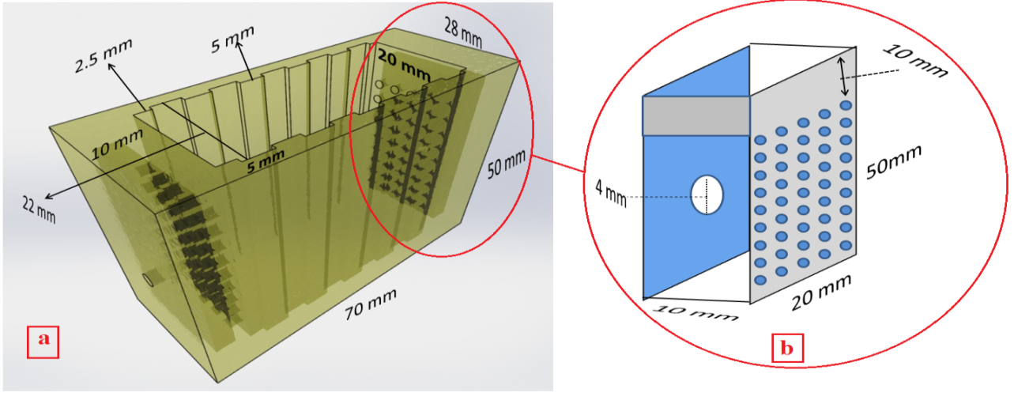
Figure ‎S5. Schematic of a flow-through cell (a) and cross-section of flow distributor chamber (b).

S11. Measurement of the Effect of Flow-rate and Voltage on Ions Removal Efficiency

In this system, the total volume of solution was 70 ml. The concentration and the electrical voltage were 75 mg/L NaCl solute ion and 1.5 V, respectively. The flow-rate was investigated to study the NaCl removal using the different electrodes in the CDI system. The distance between electrodes was 5 mm.
S12. Calculation of Electrosorption Capacity
The electrosorption capacity of the electrodes was calculated according to the following equations:
M _{mass} = [(C₀ – C_{f})* V] / m $(S2)$
M _{volume} = [(C₀ – C_{f})* V] / Z $(S3)$
M _{area} = [(C₀ – C_{f})* V] / A $(S4)$
Where M _{mass}, M _{volume} and M _{area} are the electrosorption capacity of the working electrode in term of mg/g, mg/cm³ and mg/cm² respectively. C₀ is the initial concentration of solution (mg/L), C_{f} is the final concentration of solution (mg/L) after adsorption, V is the volume of solution (L), m is the mass of materials (g), Z and A are volume of electrode and the geometric area, respectively.
S13. Pseudo-first-order Equation
The equation for pseudo-first-order is;
log ${(q}_{t}-q_{e}$) = log ${(q}_{e})$- $\frac{K_{1}t}{2.303}$ (S5)
Where, q_{t} and q_{e} are the amounts of NaCl adsorbed (mg/g) at time t and at equilibrium respectively, and $K_{1 }$is the rate constant of pseudo-first-order adsorption process (min⁻¹).
S14. Langmuir and Freundlich Isotherm
Langmuir (Eq. S6) and Freundlich isotherm (Eq. S7) are used to fit the experimental data for electrosorption of Na⁺ and Cl⁻¹ onto the electrode, respectively.
q= $\frac{q_{m}K_{L}C}{1+K_{L}C}$ (S6)
q= K_{F}$C^{1/n}$ (S7)
Where, C is the equilibrium concentration (mg/l), q is the amount of adsorbed NaCl in milligrams per gram of a-SWCNT, q_{m} is the maximum adsorption capacity corresponding to complete monolayer coverage (mg/g). K_{L} is the Langmuir constant related to binding energy, K_{F} is the Freundlich constant related to the adsorption capacity of adsorbent, and 1/n is the indication of the tendency of the adsorbate to be adsorbed. The value of 1/n is determined from the slope of the plot. It allows to understand the adsorption process. Generally, 1/n < 1. A variation in the slope between 0 and 1 is associated with a chemisorption process, which is more heterogeneous as the value gets closer to 0. At high pressure 1/n = 0, hence extent of adsorption becomes independent of pressure. At 1/n = 1, a linear plot is observed. When a slope (1/n) above 1 is observed, it is consistent with a cooperative adsorption.
References
1. D. C. Marcano, D. V. Kosynkin, J. M. Berlin, A. Sinitskii, Z. Sun, A. Slesarev, L. B. Alemany, W. Lu and J. M. Tour, "Improved Synthesis of Graphene Oxide," ACS Nano, vol. 4, no. 8, pp. 4806-4814, 2010.
2. B. Tryba, A. W. Morawski and M. Inagaki, "Preparation of exfoliated graphite by microwave irradiation," Carbon, vol. 43, no. 11, pp. 2417-2419, 2005.
3. E. H. L. Falcao, R. G. Blair, J. J. Mack, L. M. Viculis, C. W. Kwon, M. Bendikov, R. B. Kaner, B. S. Dunn and F. Wudl, "Microwave exfoliation of a graphite intercalation compound," Carbon, vol. 45, no. 6, pp. 1367-1369, 2007.
4. O. C. Compton and S. T. Nguyen, "Graphene Oxide, Highly Reduced Graphene Oxide, and Graphene: Versatile Building Blocks for Carbon-Based Materials," Small, vol. 6, no. 6, pp. 711-723, 2010.
5. D. Zhang, T. Yan, L. Shi, Z. Peng, X. Wen and J. Zhang, "Enhanced capacitive deionization performance of graphene/carbon nanotube composites," Journal of Materials Chemistry, vol. 22, no. 29, pp. 14696-14704, 2012.
6. G. Tondi, V. Fierro, A. Pizzi and A. Celzard, "Tannin-based carbon foams," Carbon, vol. 47, no. 6, pp. 1480-1492, 2009.
7. Jenkins and Wamura, "Polymeric carbons, carbon fibre, glass and char," Cambridge University Press, pp. 178, 1976.
8. J. M. Friedrich, "Reticulated vitreous carbon as an electrode material," Journal of Electroanalytical Chemistry and Interfacial Electrochemistry, vol. 561, no. 1, pp. 203-217, 2004.
9. A. Aldalbahi, M. Rahaman, M. Almoiqli, A. Hamedelniel and A. Alrehaili, "Single-Walled Carbon Nanotube (SWCNT) Loaded Porous Reticulated Vitreous Carbon (RVC) Electrodes Used in a Capacitive Deionization (CDI) Cell for Effective Desalination," Nanomaterials, vol. 8, no. 7, pp. 527, 2018.
10. A. Aldalbahi, M. Rahaman, M. Almoigli, A. Meriey and K. Alharbi, "Improvement in Electrode Performance of Novel SWCNT Loaded Three-Dimensional Porous RVC Composite Electrodes by Electrochemical Deposition Method," Nanomaterials, vol. 8, no. 1, pp. 19, 2018.

