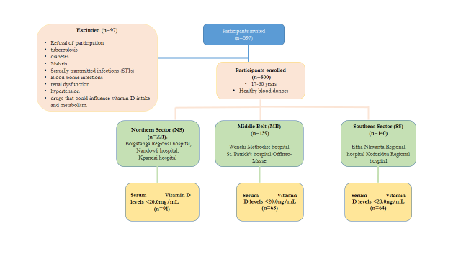

Figure S1. Flowchart of the protocol for the selection of subject

Table S1: Geographical study sites and their respective coordinates

Hospital | Region | Geographical Coordinates | Geographical area
Bolgatanga regional hospital | Upper East | 10.70ºN,0.98ºW | Northern Sector(NS)
Nandowli regional hospital | Upper West | 10.25ºN,2.15ºW | Northern Sector(NS)
Kpandai hospital | Northern | 9.54ºN,0.91ºW | Northern Sector(NS)
Wenchi-Methodist hospital | Brong-Ahafo | 6.79ºN,1.68ºW | Middle Belt (MB)
St. Patrick Hospital-Offinso Maase | Ashanti | 6.75oN,1.52ºW | Middle Belt (MB)
Koforidua regional hospital | Eastern | 6.24ºN,0.45ºW | Southern Sector (SS)
Effia-Nkwata regional hospital | western | 5.39ºN,2.15oW | Southern Sector (SS)

Site |  | N | n | J^{th} term
NS | Bolgatanga regional hospital | 300 | 71 | 4
 | Nandowli hospital | 300 | 71 | 4
 | Kpandai hospiatal | 500 | 80 | 6
MB | Wenchi Methodist hospital | 300 | 70 | 4
 | St. Patrick hospital | 500 | 69 | 7
SS | Effia Nkwanta regional hospital | 300 | 69 | 4
 | Koforidua reginal hospital | 300 | 70 | 4
Total |  |  | 500

Table S2: Sampling Technique Method

NS=Northern sector, MB=Middle belt, SS=Southern sector, N= number of participants who qualified for inclusion, n= number of selected participants, J^{th} term= the selection interval.

Table S3: Association between predisposing factors for Vitamin D deficiency and the stratified geographical areas.
Variables | NS  (n=221) | MB  (n=139) | SS  (n=140) | P-value
Knowledge on Vit D foods
Yes | 17(53.1%) | 3(9.4%) | 12(37.5%) | 0.926
No | 204(43.6%) | 136(29.1%) | 128(27.4%) | 0.926
Milk intake
Not taken | 27(39.7%) | 37(54.4%) | 4(5.9%) | <0.001
Daily | 15(48.4%) | 13(41.9%) | 3(9.7%) | 0.039
Weekly | 63(41.4%) | 17(11.2%) | 72(47.4%) | <0.001
Monthly | 118(46.6%) | 72(28.9%) | 61(24.5%) | 0.173
Salmon(Oily fish)
Not Taken | - | - | -
Daily | 83(44.9%) | 53(28.6%) | 49(26.5%) | 0.841
Weekly | 97(43.9%) | 63(28.5%) | 61(27.6%) | 0.287
Monthly | 41(43.6%) | 23(24.5%) | 30(31.9%) | 0.576
Fruit/vegetable intake
Not Taken | - | - | -
Daily | 24(48.0%) | 16(32.0%) | 10(20.0%) | 0.406
Weekly | 117(46.1%) | 68(26.8%) | 69(27.2%) | 0.694
Monthly | 80(40.8%) | 55(28.1%) | 61(31.1%) | 0.761
Interleukin 10
Normal (<10pg/mL) | 186(44.4%) | 117(27.9%) | 116(27.7%) | 0.938
High (≥10pg/mL) | 35(43.2%) | 22(27.2%) | 24(29.6%) | 0.938
Interferon Gamma
Normal (<8pg/mL) | 79(51.0%) | 44(28.4%) | 32(20.6%) | 0.350
High (≥8pg/mL) | 142(41.2%) | 95(27.5%) | 108(31.3%) | 0.350
P-value<0.05=statistically significant, NS=Northern Sector, MB=middle Belt, SS=Southern Sector, Vit D= Vitamin D.

Table S4: Binary logistic regression analysis predicting the odds ratio for socio-demographics with respect to vitamin D deficiency among study participants
Socio-demographics | Total(n=500) | Univariate  (95%CI) | P-value
Age group(years)
<20 | 84(16.8%) | 1
20-29 | 239(47.8%) | 1.3(0.8-2.2) | 0.250
30-39 | 121(24.2%) | 0.8(0.4-1.4) | 0.443
≥40 | 56(11.2%) | 0.9(0.5-1.8) | 0.779
Gender
Male | 362(72.4%) | 1
Female | 138(27.6%) | 0.9(0.6-1.3) | 0.523
Marital Status
Single | 309(61.8%)
Married | 180(36.0%) | 0.8(0.6-1.2) | 0.798
Divorced | 11(2.2%) | 0.4(0.1-1.7) | 0.438
Religious Status
Christians | 376(75.2%) | 1
Muslims | 97(19.4%) | 1.1(0.7-1.6) | 0.828
Traditionalists | 27(5.4%) | 1.2(0.6-2.7) | 0.609
Educational background
None | 69(13.8%) | 1
Basic | 76(15.2%) | 0.9(0.4-1.7) | 0.644
Secondary | 207(41.4%) | 1.4(0.8-2.4) | 0.266
Tertiary | 148(29.6) | 1.1(0.6-1.9) | 0.855
P-value<0.05=statistically significant

