**Supplementary Information**

**Photocatalytic BiFeO3 Nanoﬁbrous Mats for Effective Water Treatment**

Parmiss Mojir Shaibani*, K. Prashanthi, Amirreza Sohrabi• and Thomas Thundat

Department of Chemical and Materials Engineering, University of Alberta, Edmonton, AB, Canada, T6G 2V4

*Corresponding author email: [mojirsha@ualberta.ca](mailto:mojirsha@ualberta.ca)

Co-author emails:  [kovur@ualberta.ca](mailto:kovur@ualberta.ca), •[sohrabi@ualberta.ca](mailto:sohrabi@ualberta.ca), [thundat@ualberta.ca](mailto:thundat@ualberta.ca)

**Photocatalytic BiFeO3 nanogrids in water treatment mimicking the structure of conventional filters**

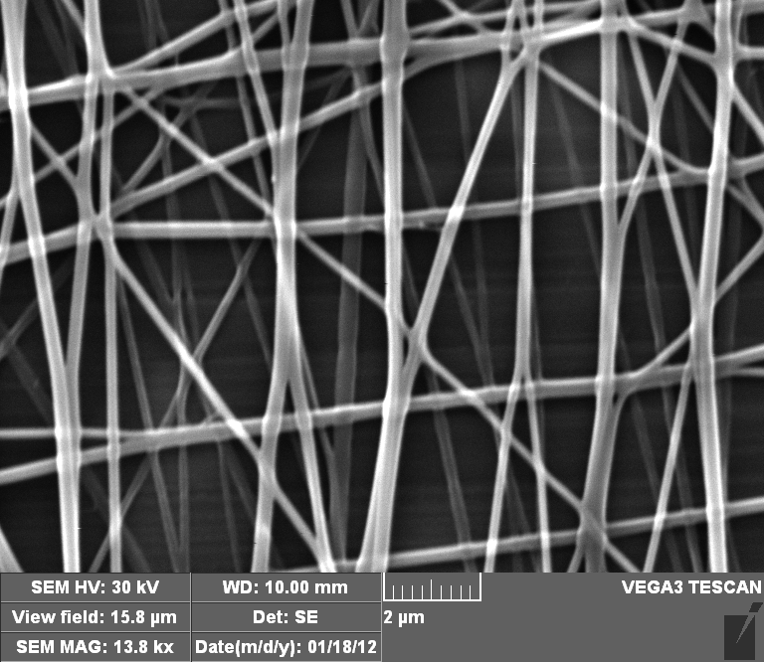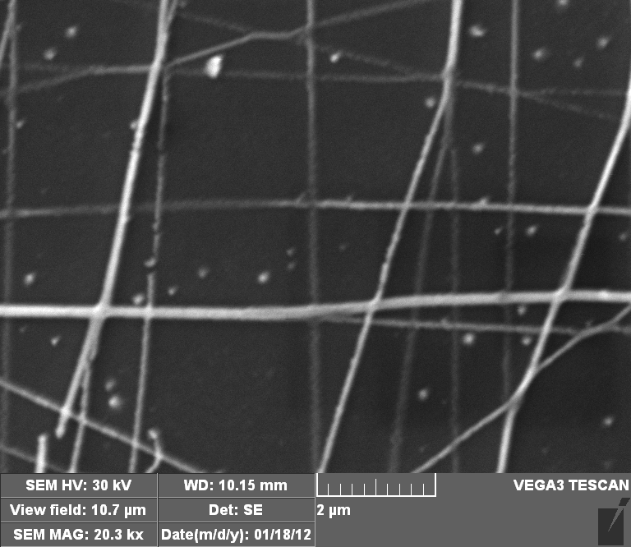

Supplementary Figure S1. SEM images of a) as-spun BFO/Nylon6 nanogrid b) BFO nanogrid calcinated at 600°C.

(b)

(a)

BFO nanogrids fabricated using the alignment of BFO/Nylon6 nanofibers and subsequent calcination at 600°C mimic the structure of conventional filters used in water treatment. The BFO nanogrids show potential for being used as filters for particulates in water in addition to the degradation of harmful contaminants. The size of the pores formed on the nanogrids between the rows and columns of the nanofibers can be optimized to fit the particulate size present in the water depending on the application in hand.