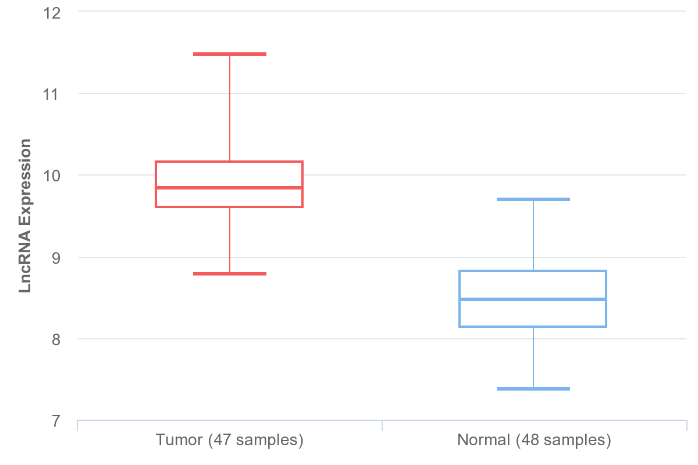
Figure S1. The NEAT1 expression profile analyzed by GEO database. The original data of GSE29079 were downloaded and analyzed by GEO 2R.

