Green synthesis of fluorescent Ag nanoclusters for detecting Cu²⁺ ions and its “Switch-on” sensing application for GSH
School of Science, Jiangnan University, Wuxi, China
Correspondence should be addressed to Guoqing Chen; jncgq@jiangnan.edu.cn

Table S1: The fluorescent lifetime of the Ag NCs.
$$τ_{1}$$ | $$τ_{2}$$ | $$τ_{3}$$ | $$χ^{2}$$
1.13ns | 3.98ns | 8.25ns | 1.103
13.87% | 51.57% | 34.56%

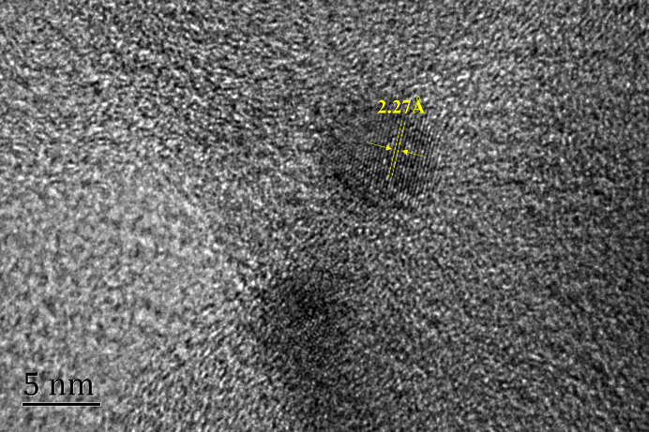
Figure S1: The HR-TEM image of the Ag NCs. The yellow line label the lattice distance of the Ag NCs.
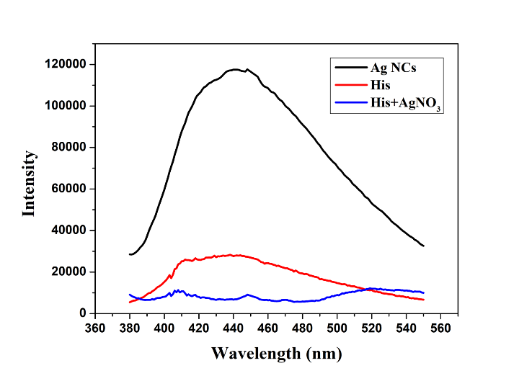
Figure S2: Fluorescence spectrum of His solution (red), solution mixed with His and AgNO₃ (blue) and Ag NCs solution (black) excited at 365nm.
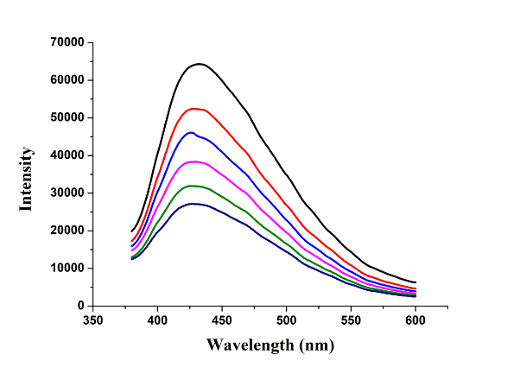
Figure S3: Fluorescence response of the Ag NCs upon addition of diﬀerent concentrations of Cu²⁺ from top to bottom: 0, 1 mM, 2 mM, 4 mM, 6 mM, 8 mM.
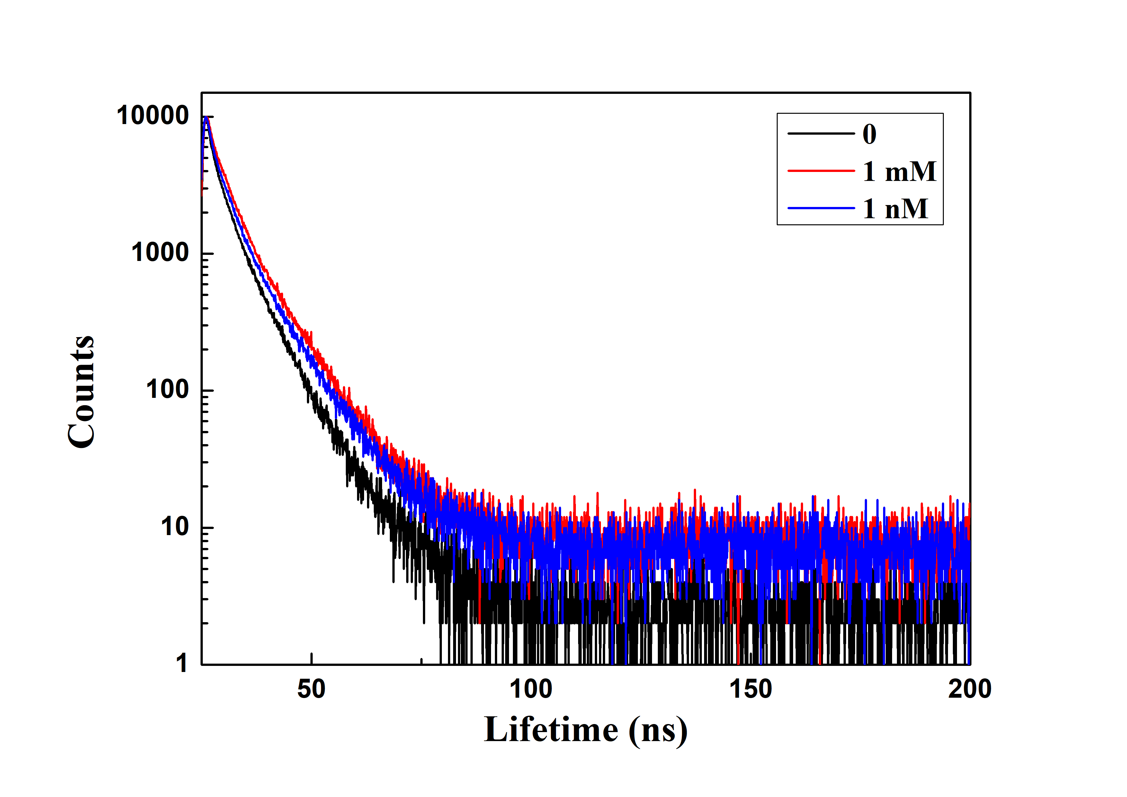
Figure S4: Time-resolved fluorescence spectrum of the Ag NCs upon addition of diﬀerent concentrations of Cu²⁺: 0,1 mM,1 nM.
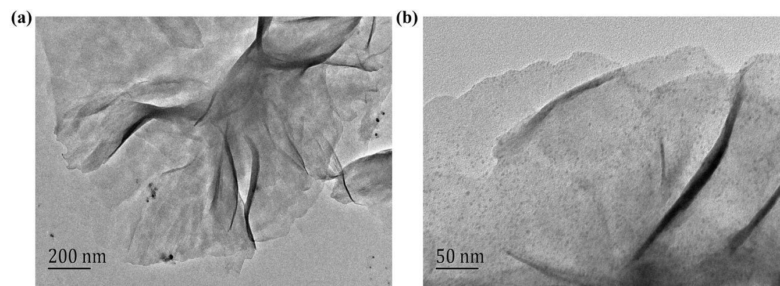
Figure S5: TEM images of the Ag NCs in the presence of Cu²⁺ (a)1 mM. (b)1 nM.

