A
B
Tukey's multiple comparisons test :Pla1a | Mean Diff. |  | 95% CI of diff. |  |  | Significant? |  |  | Summary
E14.25 vs. E15.25 | -1.761 |  | -168.4 to 164.9 |  |  | No |  |  | ns
E14.25 vs. E17.25 | 1.148 |  | -165.5 to 167.8 |  |  | No |  |  | ns
E14.25 vs. E20 | -581.8 |  | -748.5 to -415.1 |  |  | Yes |  |  | ****
E15.25 vs. E17.25 | 2.909 |  | -163.8 to 169.6 |  |  | No |  |  | ns
E15.25 vs. E20 | -580.0 |  | -746.7 to -413.4 |  |  | Yes |  |  | ****
E17.25 vs. E20 | -582.9 |  | -749.6 to -416.3 |  |  | Yes |  |  | ****
Tukey's multiple comparisons test :Pla2g2a | Mean Diff. |  | 95% CI of diff. |  |  | Significant? |  |  | Summary
E14.25 vs. E15.25 | 117.3 |  | -31.25 to 265.9 |  |  | No |  |  | ns
E14.25 vs. E17.25 | 0.6701 |  | -147.9 to 149.3 |  |  | No |  |  | ns
E14.25 vs. E20 | -343.6 |  | -492.1 to -195.0 |  |  | Yes |  |  | ****
E15.25 vs. E17.25 | -116.7 |  | -265.3 to 31.92 |  |  | No |  |  | ns
E15.25 vs. E20 | -460.9 |  | -609.5 to -312.3 |  |  | Yes |  |  | ****
E17.25 vs. E20 | -344.2 |  | -492.8 to -195.6 |  |  | Yes |  |  | ****
Tukey's multiple comparisons test :Pla2g4a |  | Mean Diff. |  | 95% CI of diff. | Significant? |  |  | Summary
E14.25 vs. E15.25 |  | 36.35 |  | 3.597 to 69.10 | Yes |  |  | *
E14.25 vs. E17.25 |  | 104.4 |  | 71.63 to 137.1 | Yes |  |  | ****
E14.25 vs. E20 |  | 89.31 |  | 56.56 to 122.1 | Yes |  |  | ****
E15.25 vs. E17.25 |  | 68.03 |  | 35.28 to 100.8 | Yes |  |  | ****
E15.25 vs. E20 |  | 52.96 |  | 20.21 to 85.71 | Yes |  |  | **
E17.25 vs. E20 |  | -15.07 |  | -47.82 to 17.68 | No |  |  | ns
Tukey's multiple comparisons test :Pla2g7 | Mean Diff. |  | 95% CI of diff. |  |  | Significant? |  |  | Summary
E14.25 vs. E15.25 | 7.641 |  | -67.56 to 82.84 |  |  | No |  |  | ns
E14.25 vs. E17.25 | -7.541 |  | -82.74 to 67.66 |  |  | No |  |  | ns
E14.25 vs. E20 | -134.7 |  | -209.9 to -59.45 |  |  | Yes |  |  | ***
E15.25 vs. E17.25 | -15.18 |  | -90.39 to 60.02 |  |  | No |  |  | ns
E15.25 vs. E20 | -142.3 |  | -217.5 to -67.09 |  |  | Yes |  |  | ***
E17.25 vs. E20 | -127.1 |  | -202.3 to -51.91 |  |  | Yes |  |  | ***
Tukey's multiple comparisons test :Pla2g1b | Mean Diff. |  | 95% CI of diff. |  |  |  | Significant? |  |  | Summary
E14.25 vs. E15.25 | 4.197 |  | -9.747 to 18.14 |  |  |  | No |  |  | ns
E14.25 vs. E17.25 | 5.874 |  | -8.071 to 19.82 |  |  |  | No |  |  | ns
E14.25 vs. E20 | -9.658 |  | -23.60 to 4.287 |  |  |  | No |  |  | ns
E15.25 vs. E17.25 | 1.677 |  | -12.27 to 15.62 |  |  |  | No |  |  | ns
E15.25 vs. E20 | -13.85 |  | -27.80 to 0.08962 |  |  |  | No |  |  | ns
E17.25 vs. E20 | -15.53 |  | -29.48 to -1.587 |  |  |  | Yes |  |  | *
Tukey's multiple comparisons test :Ptges | Mean Diff. |  | 95% CI of diff. |  |  | Significant? |  |  | Summary
E14.25 vs. E15.25 | -17.10 |  | -315.4 to 281.2 |  |  | No |  |  | ns
E14.25 vs. E17.25 | -194.4 |  | -492.7 to 103.9 |  |  | No |  |  | ns
E14.25 vs. E20 | -847.2 |  | -1145 to -548.9 |  |  | Yes |  |  | ****
E15.25 vs. E17.25 | -177.3 |  | -475.6 to 121.0 |  |  | No |  |  | ns
E15.25 vs. E20 | -830.1 |  | -1128 to -531.8 |  |  | Yes |  |  | ****
E17.25 vs. E20 | -652.8 |  | -951.1 to -354.5 |  |  | Yes |  |  | ****
Tukey's multiple comparisons test :Tbxas1 | Mean Diff. |  | 95% CI of diff. |  |  | Significant? |  |  | Summary
E14.25 vs. E15.25 | 3.172 |  | -16.93 to 23.27 |  |  | No |  |  | ns
E14.25 vs. E17.25 | 4.283 |  | -15.82 to 24.38 |  |  | No |  |  | ns
E14.25 vs. E20 | -36.77 |  | -56.87 to -16.66 |  |  | Yes |  |  | ***
E15.25 vs. E17.25 | 1.111 |  | -18.99 to 21.21 |  |  | No |  |  | ns
E15.25 vs. E20 | -39.94 |  | -60.04 to -19.84 |  |  | Yes |  |  | ***
E17.25 vs. E20 | -41.05 |  | -61.15 to -20.95 |  |  | Yes |  |  | ****
Tukey's multiple comparisons test :Akr1b1 |  | Mean Diff. |  | 95% CI of diff. | Significant? |  |  | Summary
E14.25 vs. E15.25 |  | 1179 |  | -90.49 to 2448 | No |  |  | ns
E14.25 vs. E17.25 |  | 1542 |  | 272.7 to 2812 | Yes |  |  | *
E14.25 vs. E20 |  | -1416 |  | -2685 to -146.1 | Yes |  |  | *
E15.25 vs. E17.25 |  | 363.2 |  | -906.3 to 1633 | No |  |  | ns
E15.25 vs. E20 |  | -2595 |  | -3864 to -1325 | Yes |  |  | ****
E17.25 vs. E20 |  | -2958 |  | -4227 to -1688 | Yes |  |  | ****
Tukey's multiple comparisons test :Ptgis |  | Mean Diff. |  | 95% CI of diff. | Significant? |  |  | Summary
E14.25 vs. E15.25 |  | 264.9 |  | -167.4 to 697.2 | No |  |  | ns
E14.25 vs. E17.25 |  | 1124 |  | 691.5 to 1556 | Yes |  |  | ****
E14.25 vs. E20 |  | 1120 |  | 687.4 to 1552 | Yes |  |  | ****
E15.25 vs. E17.25 |  | 858.9 |  | 426.6 to 1291 | Yes |  |  | ***
E15.25 vs. E20 |  | 854.8 |  | 422.5 to 1287 | Yes |  |  | ***
E17.25 vs. E20 |  | -4.094 |  | -436.4 to 428.2 | No |  |  | ns

Supplemental Figure S1. A) Differential expression of other genes related to the endocannabinoid pathway Pla1a, Pla2g2a, Pla2g4a, Pla2g7, Pla2g1b (Phospholipase A group, involved upstream in synthesis of Arachidonic acid) and Ptges, Tbxas1, Akr1b1, Ptgis (Downstream genes involved in metabolism of PGH2 derivatives) screened in Microarray (RatRef-12 arrays Illumina). X- Axes depict Gestational Ages E14.25, E15.25, E17.25 and E20. Y-Axes are the Microarray Hybridization Signals. B) Statistical Analyses by One way ANOVA –Multiple Comparisons between all four gestational age groups E14.25, E15.25, E17.25 and E20. Significance was ascribed where gene expression was changed by < 2 (∗
𝑃 < 0.05;∗∗ 𝑃 < 0.005; ∗∗∗ 𝑃 < 0.001; ∗∗∗∗ 𝑃 < 0.0001; and ns 𝑃 > 0.05).
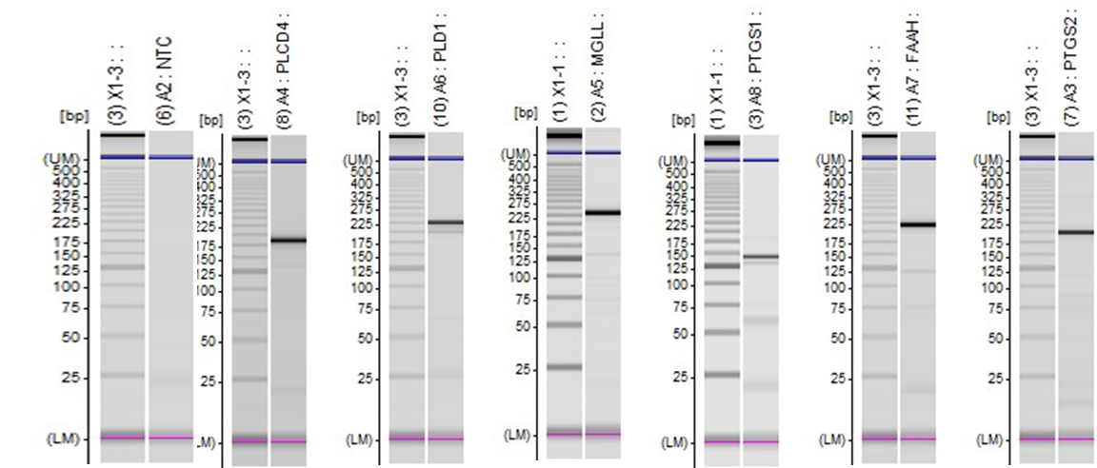

Supplemental Figure S2: Primer testing on PCR prior to qPCR experiments using Shimadzu MULTINA™.

