Spplementary material:
The way by which we prepared neonatal mouse cardiomyocytes is based on Dr. Qingping Feng lab’s protocol. According to anti-Troponin immunostaining, the purity of neonatal mouse cardiomyocytes is about 98%.
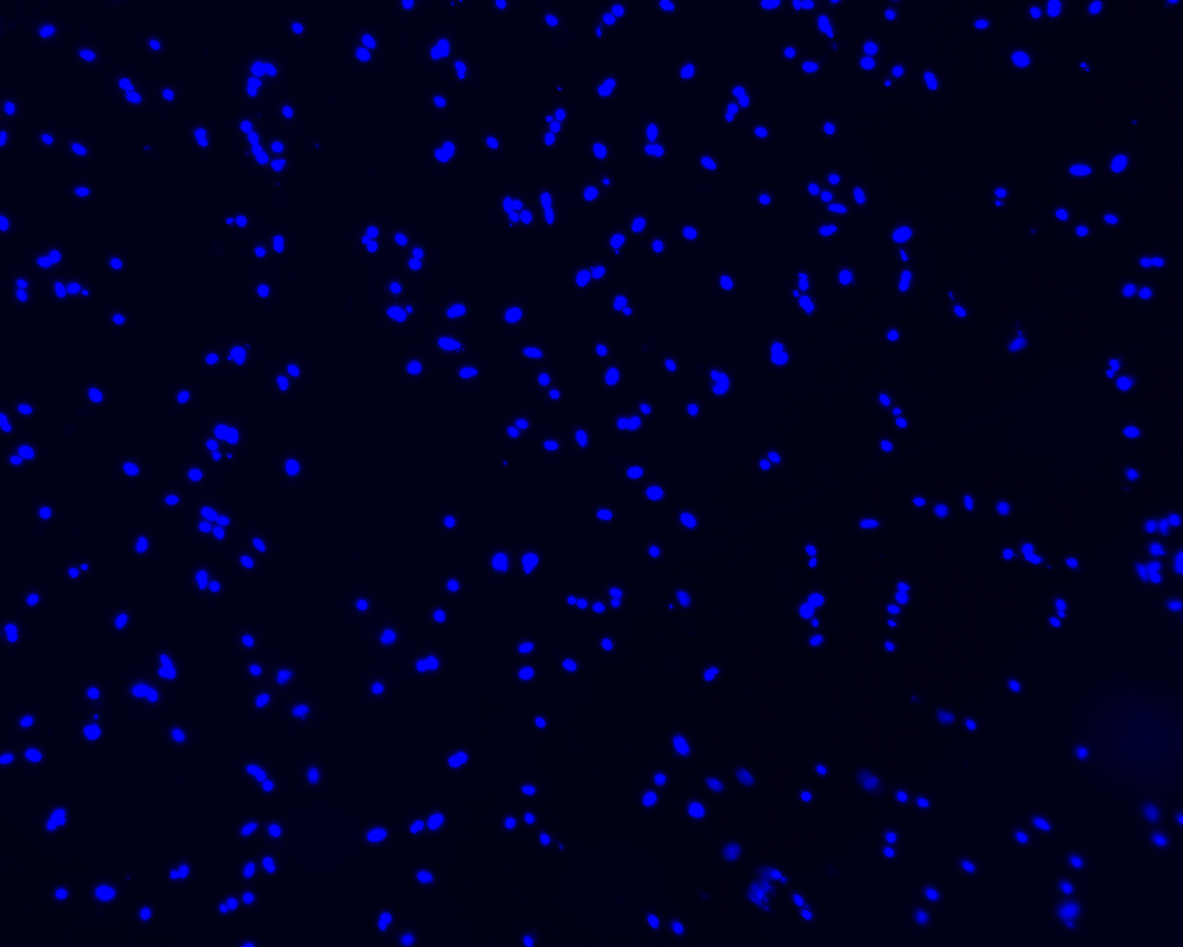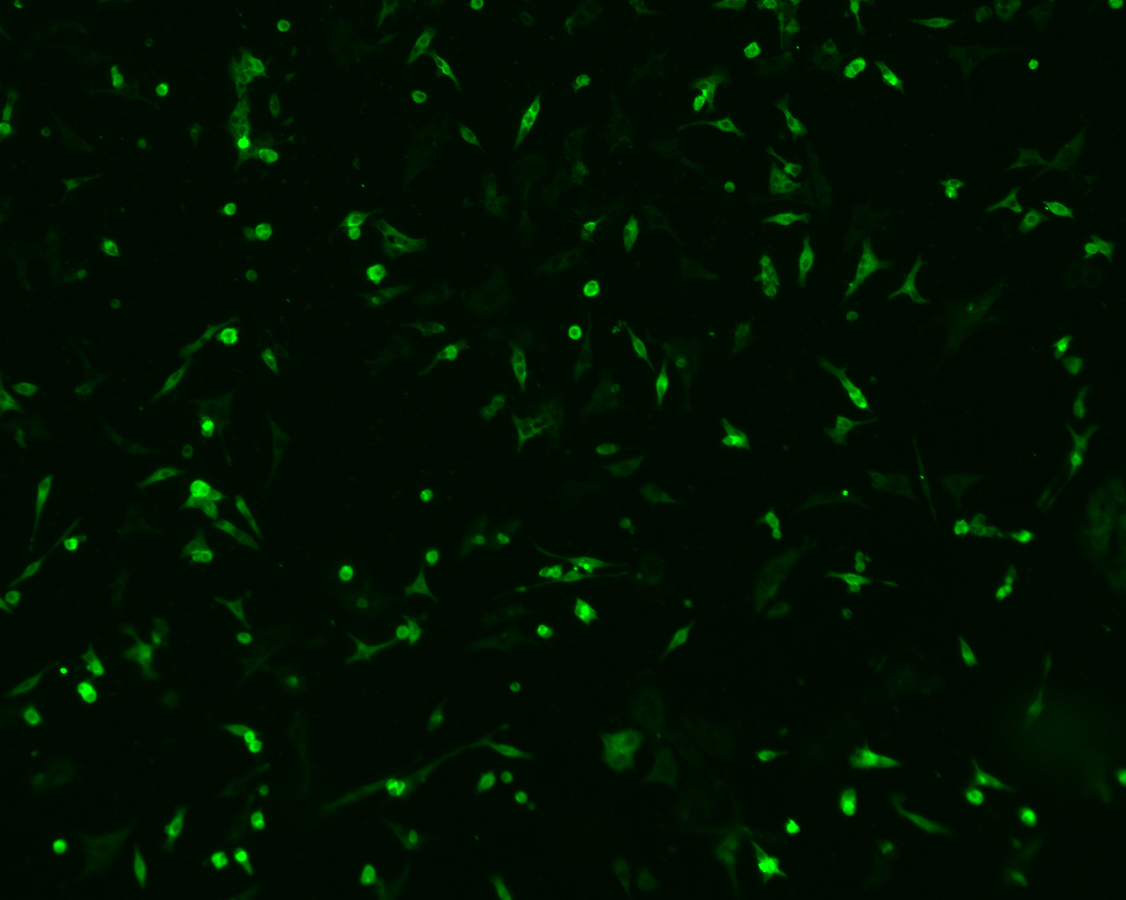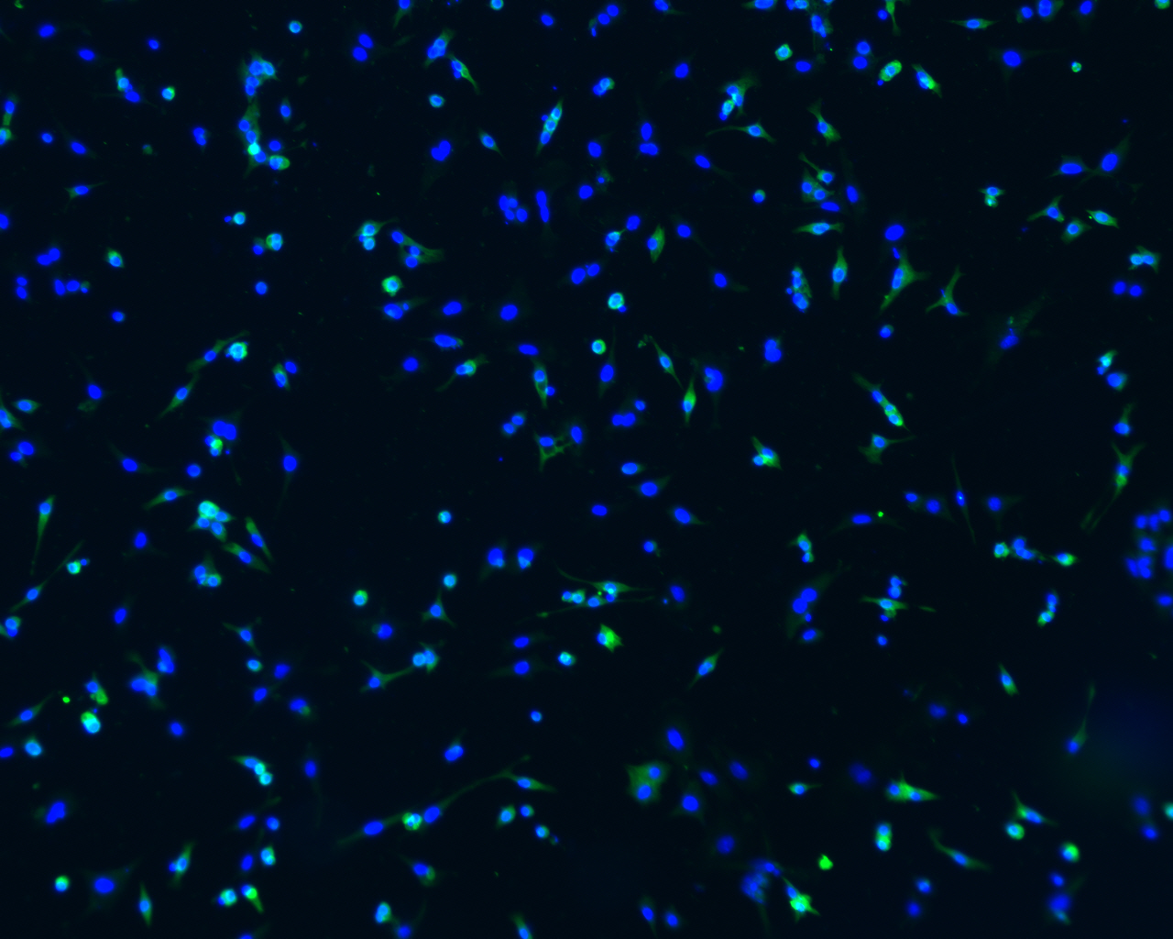
anti-Troponin
DAPI
Merge

