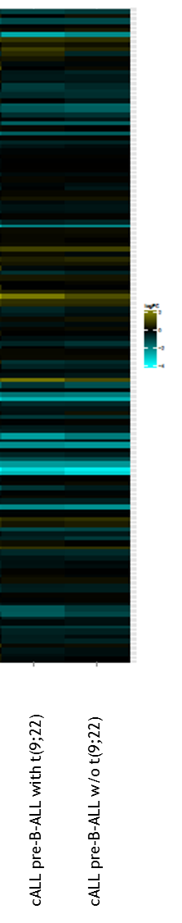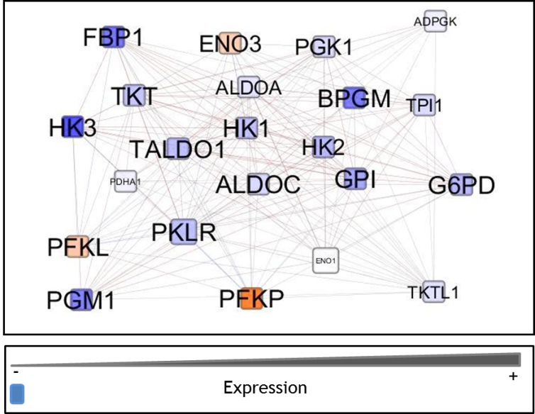

*B-actin*

*41bMI*

*FIN COS*

*SUP-B15*

*SD1*

*REH*

*HK-3*

*HK-2*



*HK-1*

**A.**

**C.**

**B.**