Proinflammatory cytokines are soluble mediators linked with ventricular arrhythmias and contractile dysfunction in a rat model of metabolic syndrome. (Supplemental Material)

**Supplemental Table 1**



Probes used in qPCR experiments.

**Supplemental Figure 1**



**Supplemental Fig. 1.** Gene expression of cytokines and their receptors from adipose tissue show important increase in IL6 and leptin receptor. A, B: Pooled data for gene expression from adipose tissue for cytokines (A) and corresponding receptors (B). (Black control group; White MS group) *p < 0.05 vs control. Control group: n = 6-8; MS group: n = 6-8.

**Supplemental Table 2**

Echocardiographic evaluation of cardiac function shows slight diastolic dysfunction. Pooled data for echocardiographic parameters from both groups at end of treatment. Values are means ± SEM. Control group: n = 8; MS group: n = 11.

**Supplemental Figure 2**

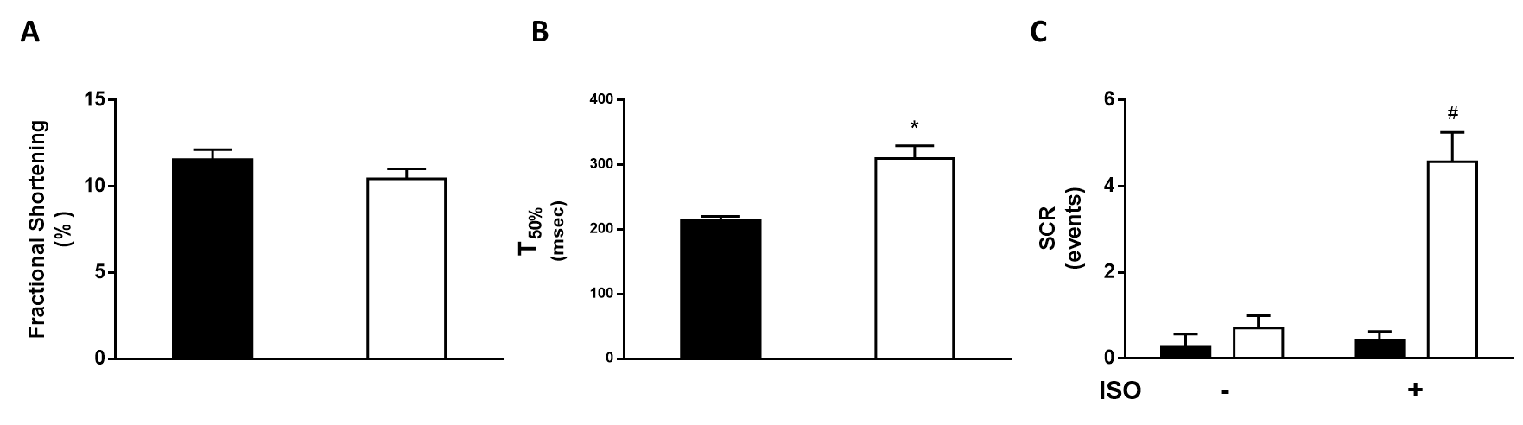

**Supplemental Fig 2.** Cardiomyocyte function of primary cells isolated from control and MS groups. A: pooled data for fractional shortening (%). B: pooled data for Ca+2 transient time to 50% decay (T50%). C: pooled data for spontaneous Ca2+ releases (events) under basal conditions and upon β-adrenergic stimulation (100 nM ISO). (Black control group; White MS group) *p < 0.05 vs control; # p < 0.05 vs ISO. Control group: n ≥ 6 cells/3 animals: MS group: n ≥ 8 cells/3 animals.