Supplementary Material
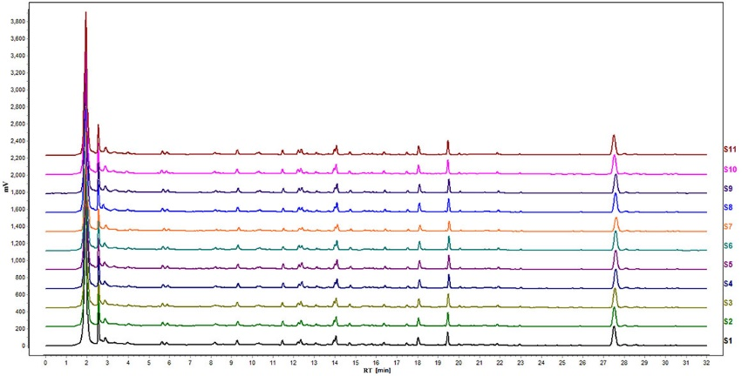
Figure S1: UPLC fingerprints of eleven batches of KXS. Similarity analysis was performed with “Similarity Evaluation System for Chromatographic Fingerprint of Traditional Chinese Medicine (version 2009)”. The similarity values of all imported chromatograms with respect to the reference fingerprint were greater than 0.96.

Table S1: List of selected ESI mode, MRM parameters, declustential (DP), entrance potential (EP), collision energy (CE), and cell exit potential (CXP) for each analyte.
Analyte | Q1 Mass(Da) | Q2 Mass(Da) | DP | EP | CE | CXP
GABA | 104.2 | 87.1 | 26 | 14 | 15 | 16
DA | 154.1 | 137.1 | 37 | 10 | 13 | 8
ACh | 146.2 | 87.2 | 52 | 3 | 20 | 4
Try | 205.2 | 188 | 40 | 4 | 14 | 12
Tyr | 182 | 136.1 | 53 | 8 | 17 | 7
5-HTP | 221.1 | 203.9 | 48 | 10 | 17 | 13
5-HT | 177.1 | 160.2 | 43 | 10 | 14 | 10
5-HIAA | 192.2 | 146 | 61 | 9 | 19 | 8
ME | 198.1 | 180.1 | 40 | 5 | 12 | 11
3-MT | 168.2 | 151.1 | 40 | 6 | 14 | 9
LTB₄ | 335 | 194.8 | -76 | -8 | -28 | -9
15-HETE | 319.2 | 301.1 | -64 | -11 | -18 | -8
12-HETE | 319.2 | 179.1 | -78 | -10 | -20 | -2
AA | 302.9 | 259.3 | -90 | -10 | -19 | -13
8-HETE | 319.2 | 154.6 | -65 | -10 | -22 | -11
TXB₂ | 369.2 | 169 | -66 | -8 | -27 | -5
5-HETE | 319.2 | 114.7 | -57 | -7 | -17 | -6
Abbreviations: GABA, γ-aminobutyric acid; DA, Dopamine; ACh, Acetylcholine; Try, Tryptophan; Tyr, Tyrosine; 5-HTP, 5-hydroxytryptophan; 5-HT, 5-hydroxytryptamine; 5-HIAA, 5-hydroxyindoleacetic acid; ME, metanephrine; 3-MT, 3-methoxytyramine; LTB₄, leukotriene-B₄; HETE, hydroxyeicosatetraenoic acid; AA, Arachidonic acid; TXB₂, thromboxane B₂

Table S2: The linearity data and for analytes in plasma using the proposed method.
Analyte | Concentration range  (ng·mL⁻¹) | Regression Equation (r)
GABA | 2.000-400.0 | y = 0.1592x - 0.0186(0.9930)
DA | 0.2000-40.00 | y = 1.4882x + 0.4831(0.9980)
ACh | 10.00-2000 | y = 0.0403x - 0.4433(0.9986)
Try | 1000-200000 | y = 0.0183x + 24.248(0.9991)
Tyr | 1000-200000 | y = 0.018x + 38.489(0.9971)
5-HTP | 2.000-400.0 | y = 0.0217x + 0.3107(0.9918)
5-HT | 5.000-1000 | y = 0.0638x + 0.2307(0.9927)
5-HIAA | 5.000-1000 | y = 0.0175x + 1.0199(0.9961)
ME | 0.2000-40.00 | y = 1.1451x + 1.0409(0.9955)
3-MT | 0.2000-40.00 | y = 1.4322x + 0.0127(0.9991)
LTB₄ | 2.000-400.0 | y = 0.012x + 0.0125(0.9971)
15-HETE | 2.000-400.0 | y = 0.9701x + 4.6166(0.9985)
12-HETE | 5.000-1000 | y = 0.6808x + 6.9551(0.9966)
AA | 1000-200000 | y = 0.003x + 1.1407(0.9997)
8-HETE | 2.000-400.0 | y = 0.0095x + 0.0406(0.9929)
TXB₂ | 20.00-4000.0 | y = 0.1013x + 0.493(0.9986)
5-HETE | 0.2000-40.00 | y = 0.2458x + 0.1672(0.9924)
All standard calibration curves of the analytes were in the linear range with a weighting factor of 1/x2, and the calibration regression coefficients of the analysis were greater than 0.99.

