Supplementary data
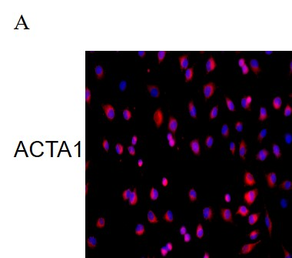
Rat primary cardiomyocytes were isolated from rat cardiac tissue and identified by ACTA1 immunofluorescence.

