- Supplementary Table 1

- Primary Antibodies for IHC.

- Supplementary Table 2

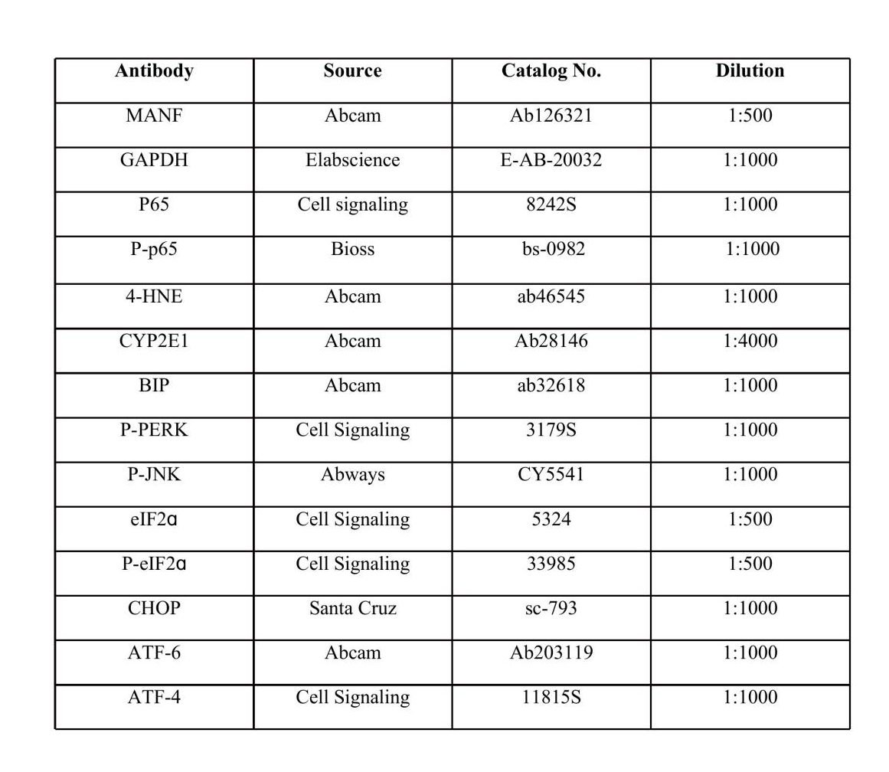

Primary Antibodies for Western blot.

- Supplemental Table 3

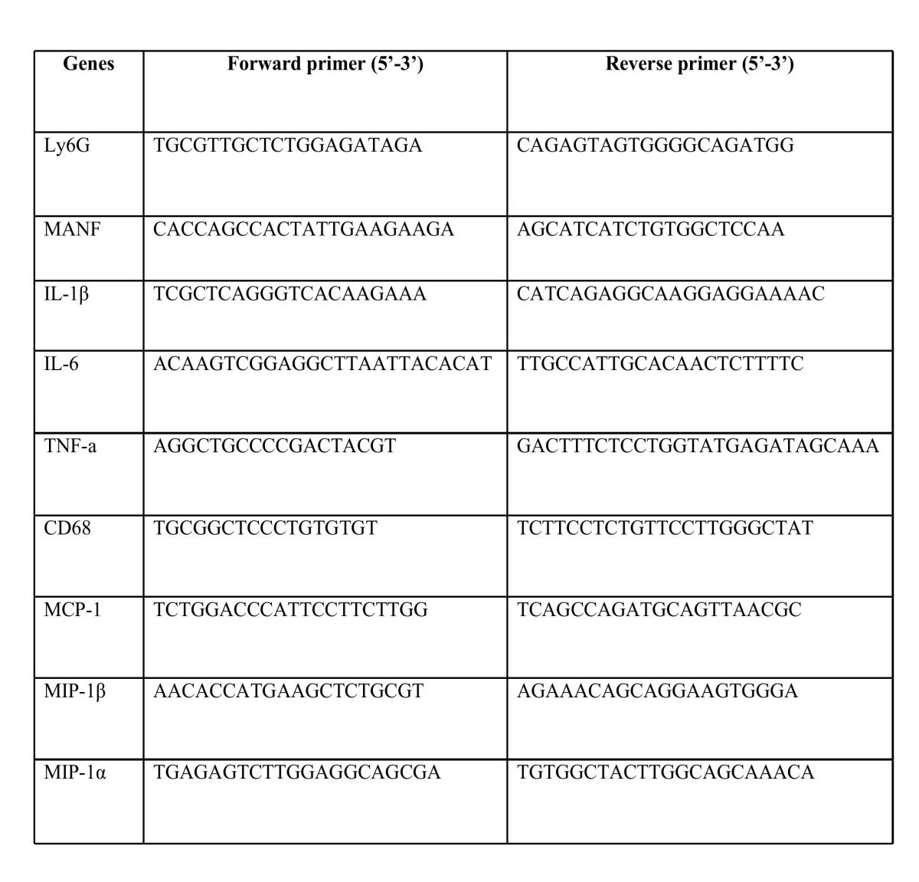

- Primer sequences for real-time PCR.

Supplementary figure 1

- liver-to-body weight ratio in WT and MANF^{ΔHep} mice. (B) TG level was examined by an assay kit. Values represent means ± SEM (n= 4-8). *P<0.5, **P<0.01, ***p<0.001.

Supplementary figure 2

The mRNA level of F4/80 was detected by quantitative real-time PCR. Values represent means ± SEM (n= 4-8). *P<0.5.

Supplementary figure 3

Supplementry figure 4
(A) The quantitative data of iNOS staining in panel A. (B) The quantitative data of p65 staining in panel A. . Values represent means±SEM. *p<0.05; **p<0.01; ***p<0.001.

Supplementary figure 4

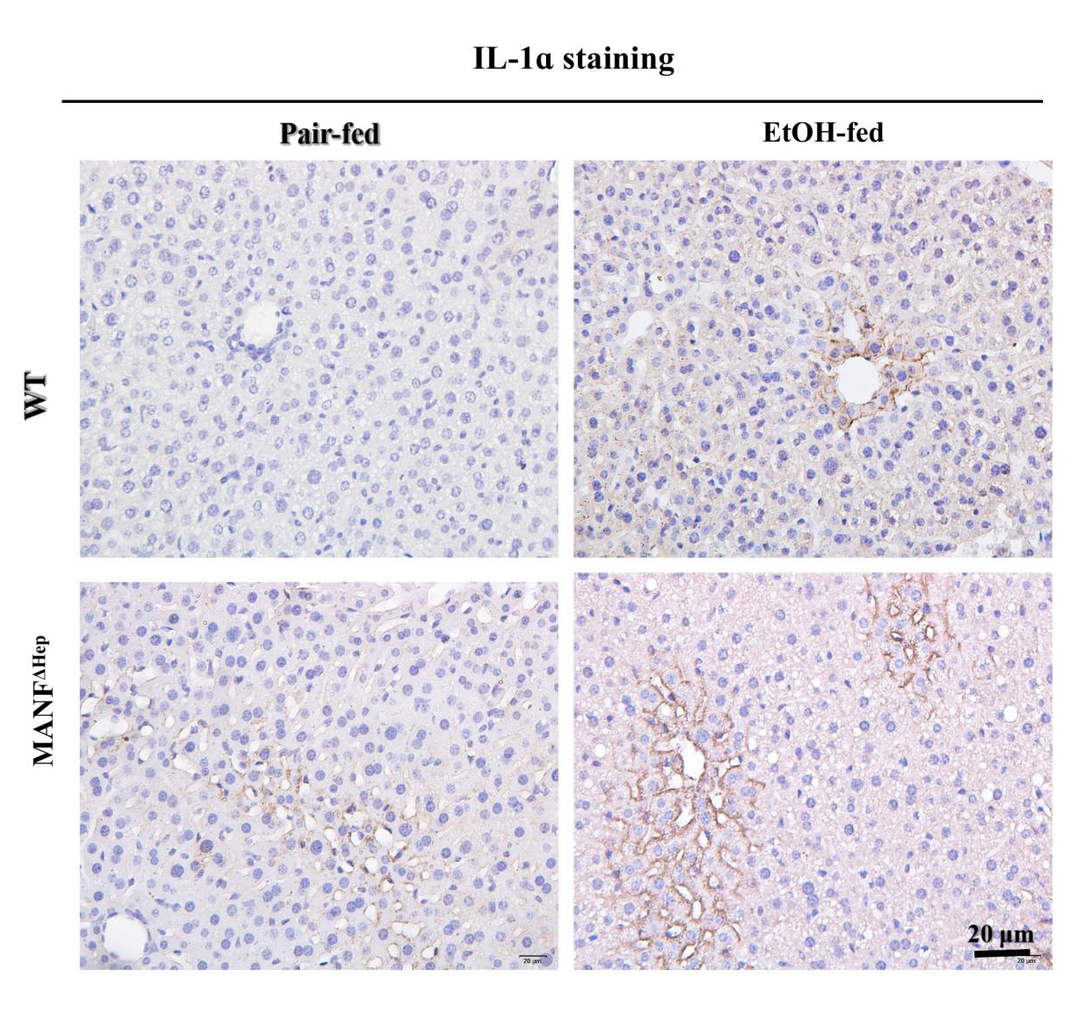

Figure S4. Detection of IL-1ɑ in WT and MANF^{ΔHep} mice.

IL-1ɑ⁺ cells were detected by immunohistochemical assay in WT and MANF^{ΔHep} mice fed with ethanol (EtOH). Scale bar=20 μm.

Supplementary figure 5

Figure S5. Detection of 3-nitrotyrosine in WT and MANF^{ΔHep} mice.
3-NT⁺ cells were detected by immunohistochemical assay in WT and MANF^{ΔHep} mice fed with ethanol (EtOH). Scale bar=20 μm.

Supplementary figure 6

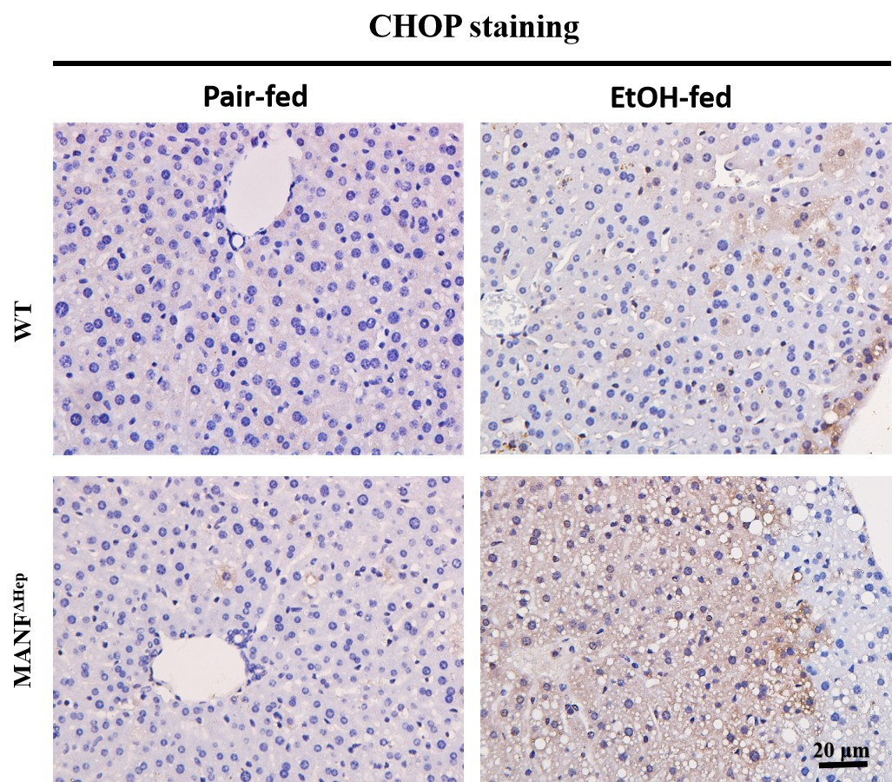

Figure S6. Detection of CHOP in WT and MANF^{ΔHep} mice.

CHOP⁺ cells were detected by immunohistochemical assay in WT and MANFΔHep mice fed with ethanol (EtOH). Scale bar=20 μm.

