Supplemental Figures

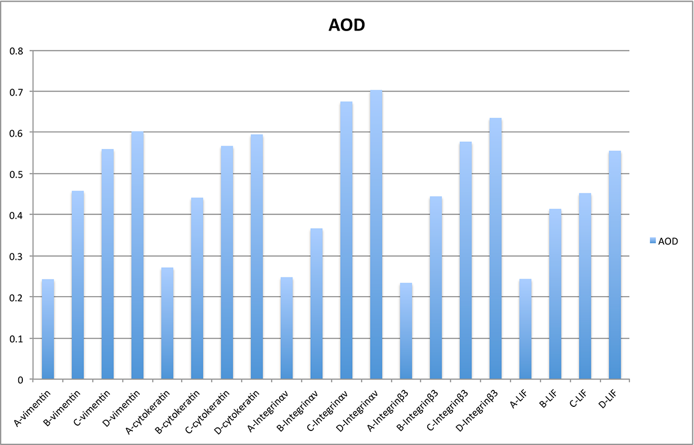
Supplemental Figure 1. AOD of markers for endometrial cells and endometrial receptivity with immunohistochemistry. A, B, C, D represent for control group, BMSC group, VEGF-BMSC group, and sham operation group.

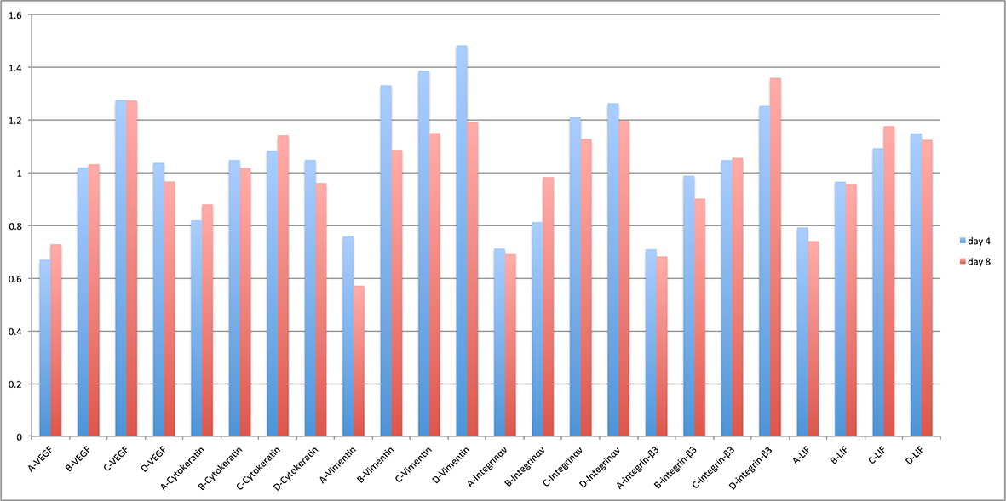
Supplemental Figure 2. Relative level of markers for endometrial cells and endometrial receptivity with Western Blotting. A, B, C, D represent for control group, BMSC group, VEGF-BMSC group, and sham operation group 4 days and 8 days after treatment.

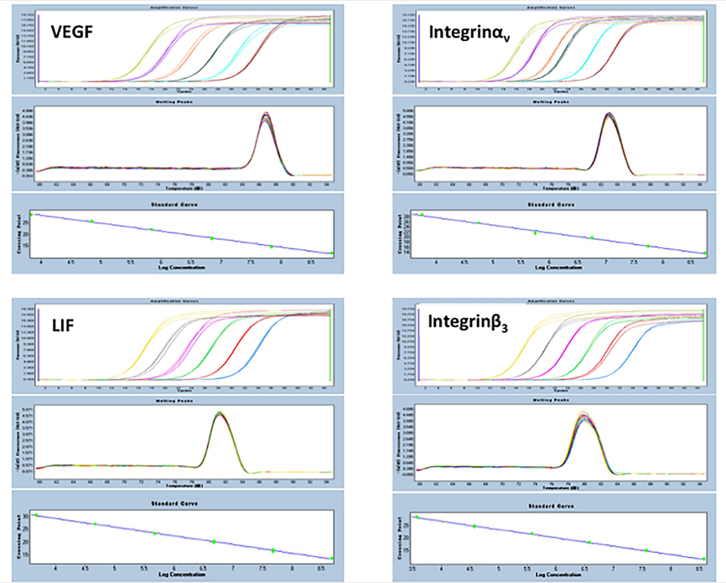
Supplemental Figure 3. Amplification curves, Melting curves, and Standard curves of PCR.

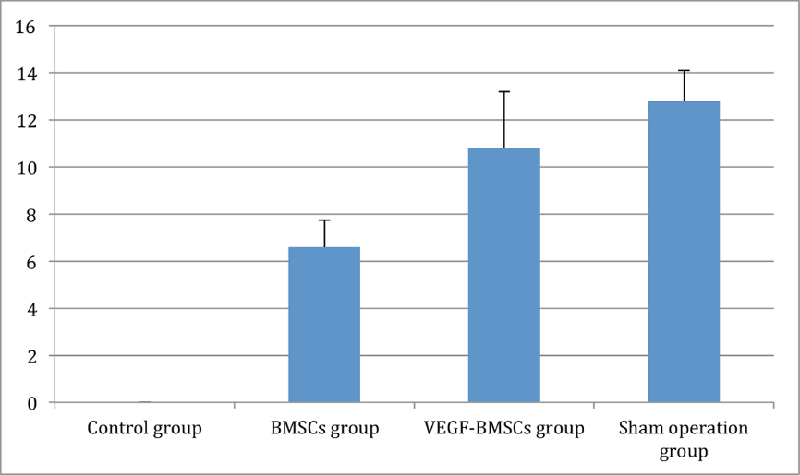
Supplemental Figure 4 Embryo implantation efficiency of control group, BMSC group, VEGF-BMSC group, and sham operation

