Marker Bcl2 HIF1A NF-κB BIRC3
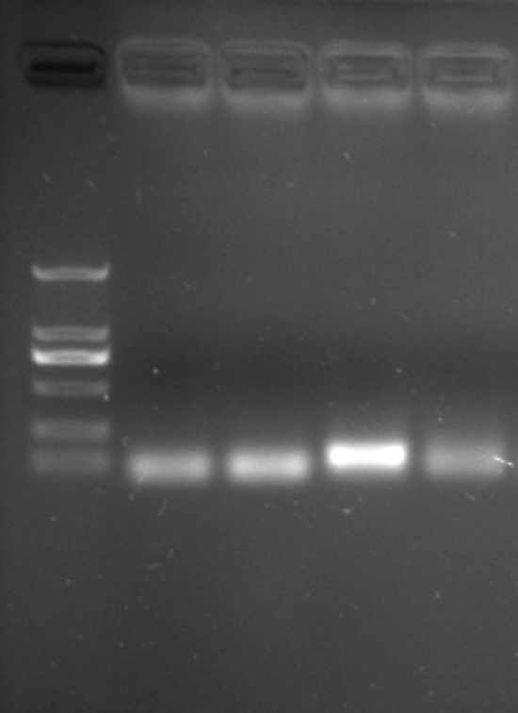
1000
750
500
250
100

bp
2000
Additional file 3 : Confirm the specificity of q-PCR primers using regular PCR. DNA marker: DL2000.

