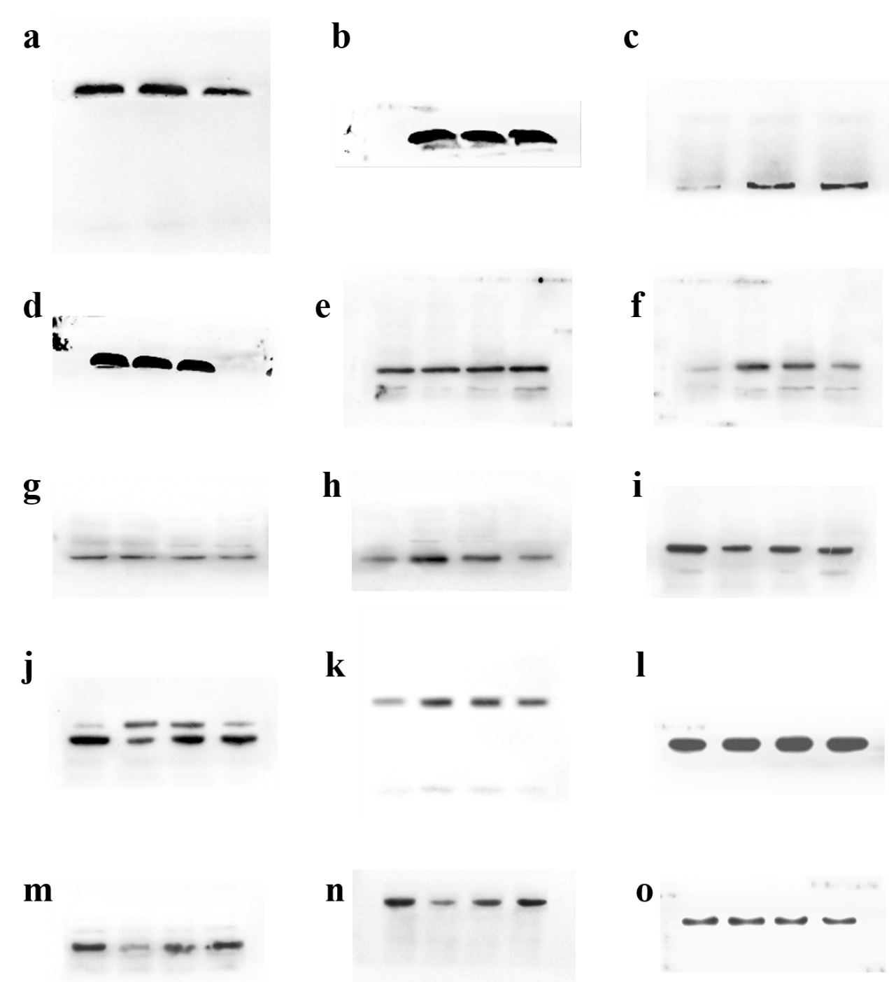
Supplementary Figure 1. Original Western blot. (A). Western blot of cleaved caspase-3. (B). Western blot of GAPDH. (C). Western blot of CD63. (D). Western blot of GAPDH. (E). Western blot of Akt. (F). Western blot of p-Akt. (G). Western blot of mTOR. (H). Western blot of p-mTOR. (I). Western blot of Beclin 1. (J). Western blot of LC3. (K). Western blot of p62. (L). Western blot of GAPDH. (M). Western blot of nephrin. (N). Western blot of podocin. (O). Western blot of GAPDH.

